For you as a SAP ABAP fresher and interview preparation candidate, the most important tools are:
1. SAP Logon + SE38 + SE80 ⭐ MOST IMPORTANT
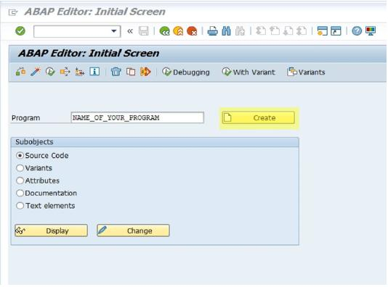
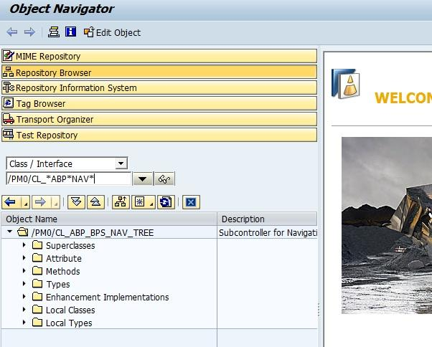
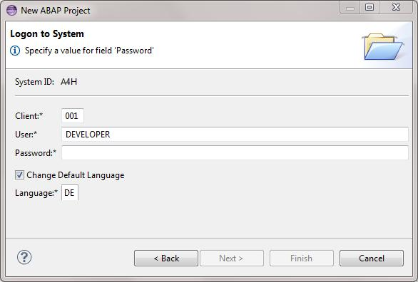
6
You should focus on this FIRST.
Because:
✅ Core ABAP development happens here
✅ Interviews mainly ask from this
✅ Used in almost every SAP project
✅ Required for:
- Reports
- ALV
- Smartforms
- Enhancements
- DDIC
- Function Modules
- OOPs ABAP

Important T-Codes for You
T-Code | Purpose
SE38 | ABAP Program
SE80 | Full Development
SE11 | Dictionary
SE37 | Function Modules
SE24 | Classes
SE93 | Transaction Creation
SM30 | Table Maintenance
SE16N | Data Browser

2. Eclipse ADT ⭐ VERY IMPORTANT FOR FUTURE
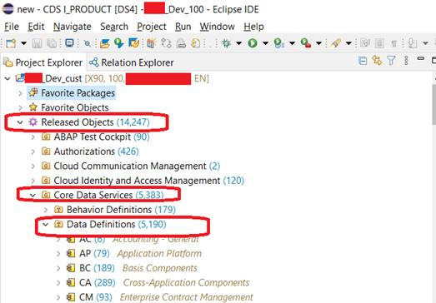
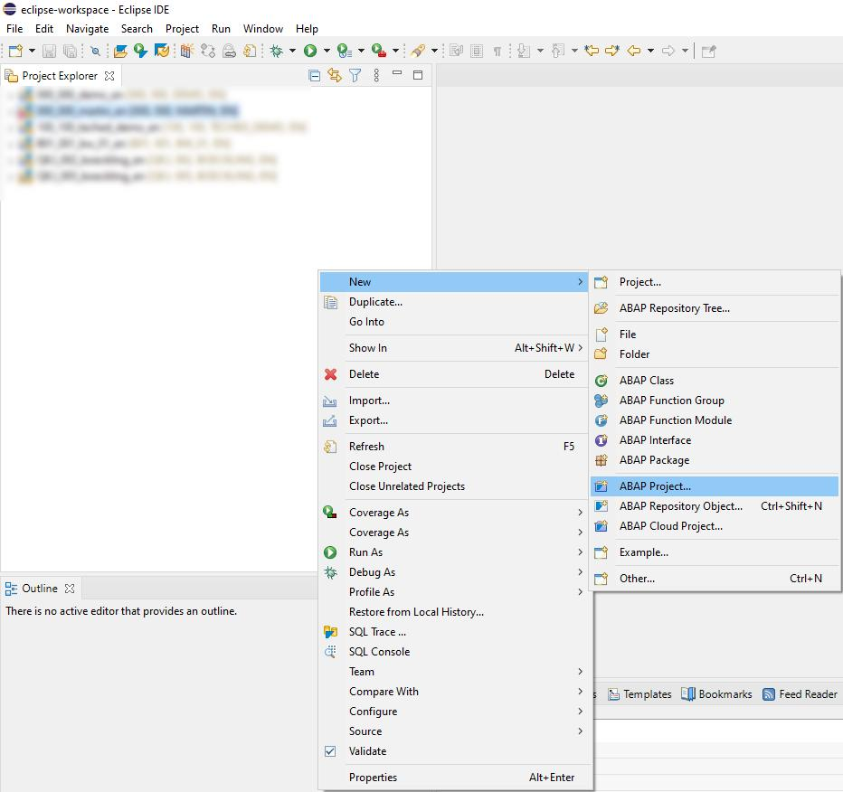
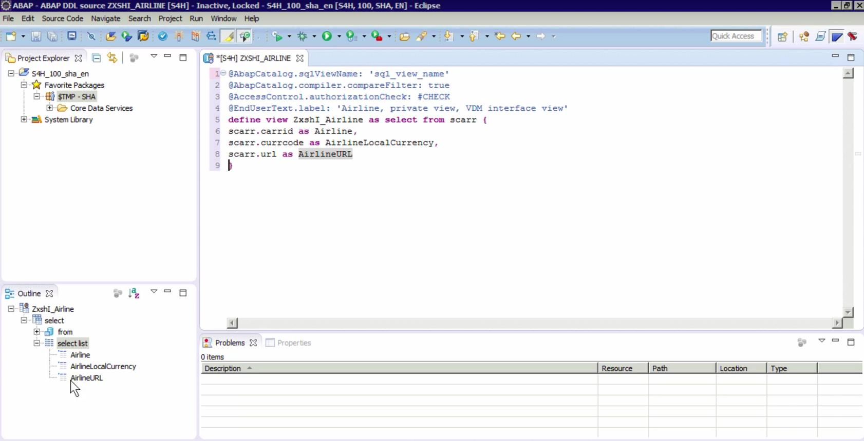
6
After core ABAP:
Learn Eclipse ADT.
Because:
✅ S/4HANA projects use it heavily
✅ Needed for:
- CDS Views
- RAP
- AMDP
- OData
- Fiori backend

3. SAP HANA Studio ⭐ MEDIUM PRIORITY
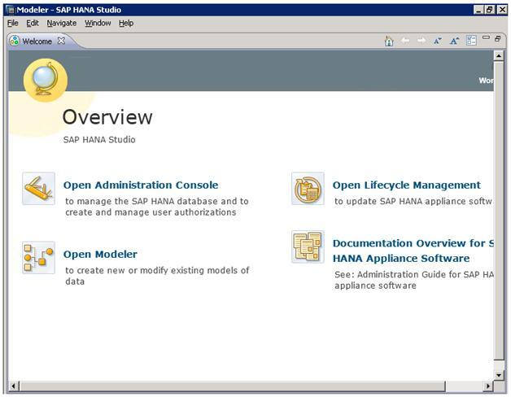
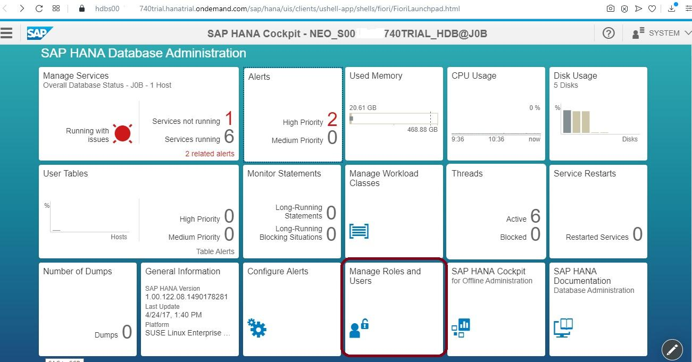
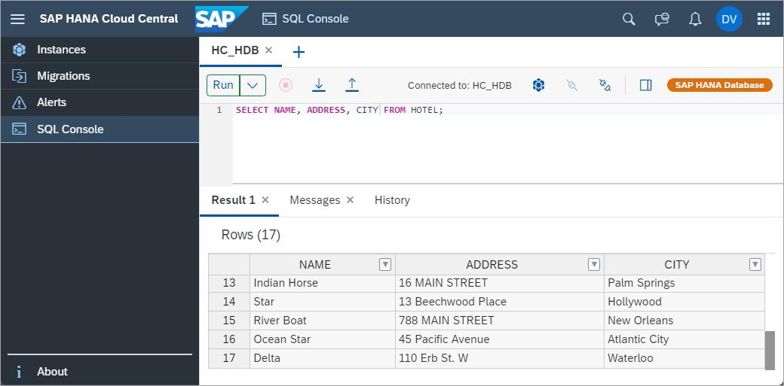
6
You only need:
- Basic SQL
- Basic HANA understanding
Not required deeply right now as fresher.

Your Best Learning Order
Step 1 → MOST IMPORTANT
Learn in SAP GUI:
SE38
SE80
SE11
ALV
Internal Tables
Smartforms
Enhancements
OOPs ABAP

Step 2
Then learn:
Eclipse ADT
CDS Views
AMDP
RAP
OData

Step 3
Then basic:
SAP HANA
SQL Optimization
Performance

For Interview Perspective
Freshers Mostly Asked From:
✅ SE38
✅ SE80
✅ DDIC
✅ ALV
✅ Internal Tables
✅ Reports
✅ Smartforms
✅ OOPs Basics

What Companies Expect Now
Experience | Expectation
Fresher | SAP GUI + Core ABAP
1-2 Years | OO ABAP + Enhancements
S/4HANA Developer | Eclipse + CDS + RAP

My Suggestion for You
Since you are already practicing:
- ALV
- DDIC
- Transport Requests
- Internal Tables
You should now focus strongly on:
SE38
SE80
ALV
OOPs
Smartforms
Enhancements
Then move to:
Eclipse ADT
CDS Views
That combination gives very strong interview preparation for SAP ABAP + S/4HANA roles.

