**A**

**Project Report On**

**“COLLAGE ADMISSION SYSTEM”**

Submitted to

**CH. SHIVAJI UNIVERSITY, KOLHAPUR**

In partial fulfilment of

###### BACHELOR OF COMPUTER APPLICATION

Submitted By

Mr. RANDIVE SHUBHAM BALAVANT Mr. PATIL MANOJ MAHIPATI

Under the guidance of

###### Dr. R. D. BUDKE

Through The Principal

###### Prof. Dr. U.R.SHINDE

**MAUNI VIDYAPEETH’S**

**KARMVEER HIRE MAHAVIDYALAY, GARGOTI.**

**TAL – BHUDARGAD DIST - KOLHAPUR**

**2024-2025**

**MAUNI VIDYAPEETH’S**

**KARMVEER HIRE MAHAVIDYALAY, GARGOTI.**

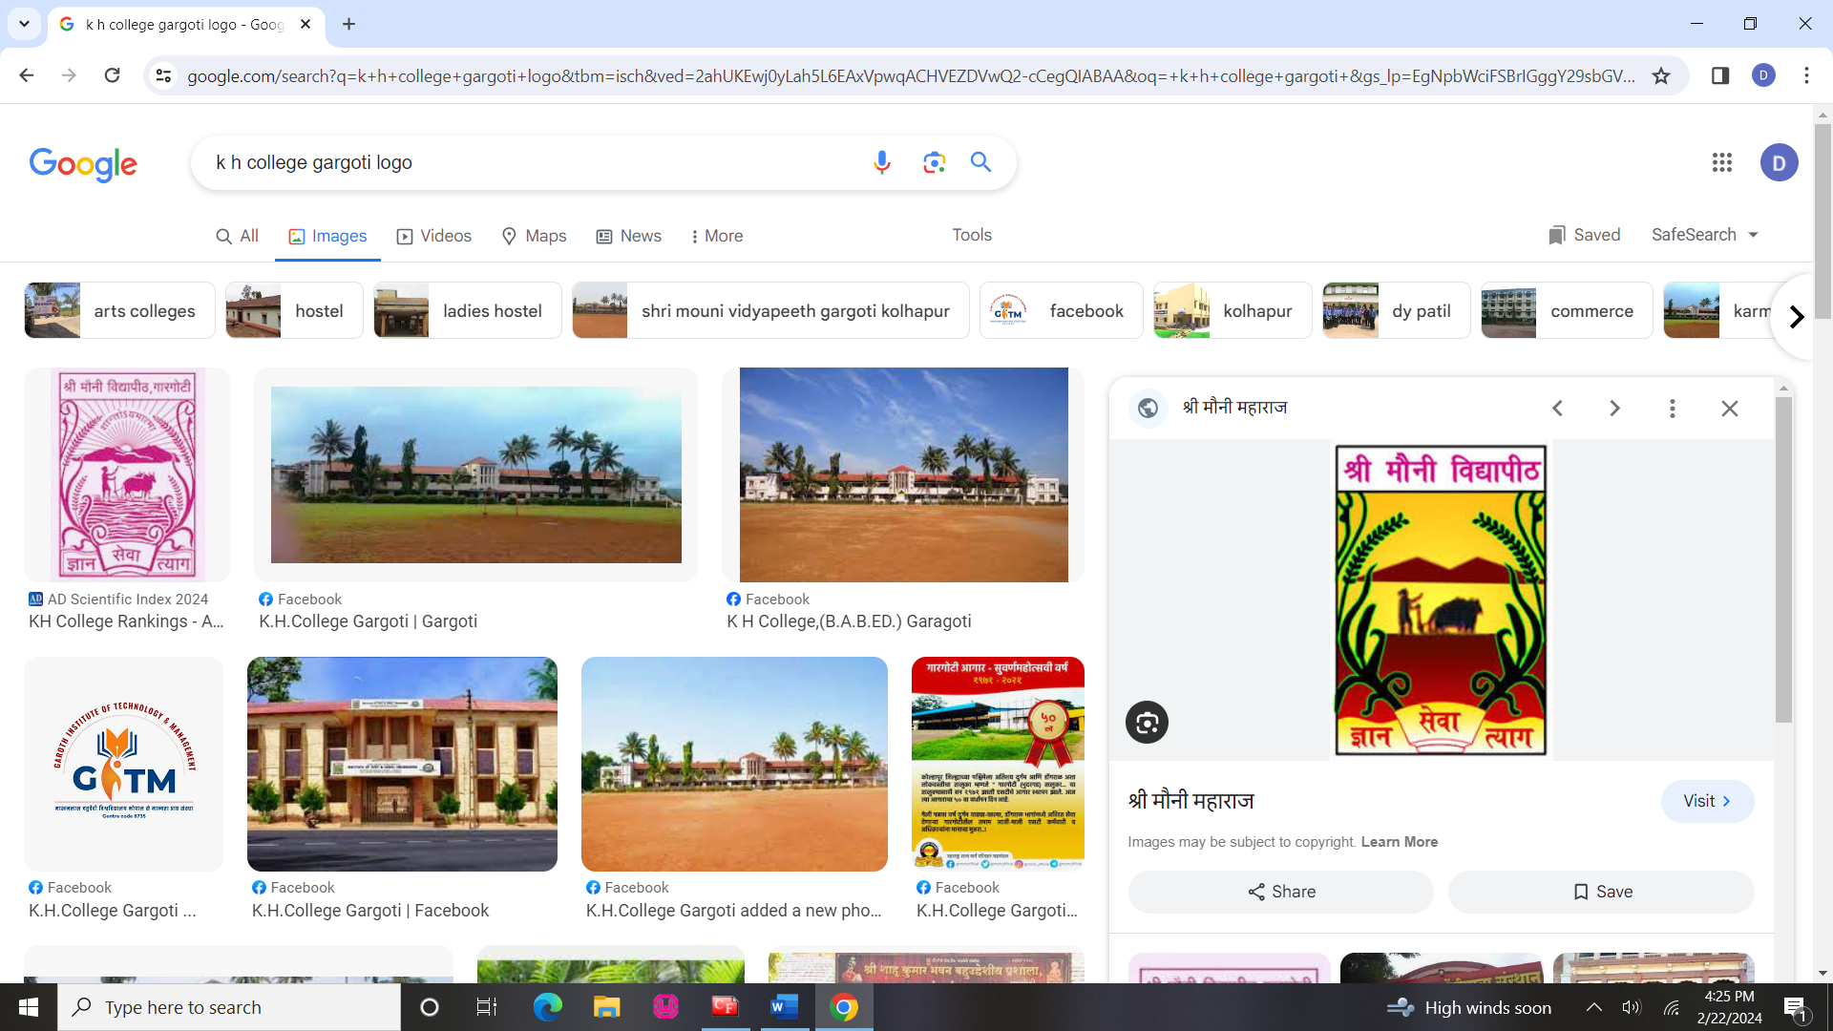

### CERTIFICATE

This is to certify that,

1. Mr. Randive Shubham Balavant
2. Mr. Patil Manoj Mahipati

Have successfully completed the project on the topic “Collage Admission System” in satisfactory manner for partial fulfilment of Bachelor Of Computer Application degree for the academic year 2024-2025.

To the best of our knowledge and belief, the matter presented here is original and has not been submitted elsewhere for the award of any degree.

Date: / /2025 Place: Gargoti

Dr. R. D. Budke

Project Guide EXAMINER

Dr. R. D. Budke

H.O.D



**MAUNI VIDYAPEETH’S**

**KARMVEER HIRE MAHAVIDYALAY, GARGOTI.**

To

The Registrar, Shivaji University, Kolhapur.

**Subject: - Recommendation for BCA III Project**. Respected Sir,

I, Prof. Dr. U. R. Shinde the principal of K. H. College

Gargoti, recommended that the following students,

1. Mr. Randive Shubham Balavant
2. Mr. Patil Manoj Mahipati

Have completed the project report entitled, “Collage Admission System” As per partial fulfilment according to the syllabus of the Shivaji University, Kolhapur under guidance of Asst. Prof. R. D. Budke.

Place: - Gargoti

Date: - / / 2025

Prof. Dr. U. R. Shinde

Principal

**MOUNI VIDHYAPEET’S**

**KARMVEER HIRE MAHAVIDYALAY, GARGOTI**

**TAL – BHUDARGAD DIST. KOLHAPUR**

**GUIDANCE**

This is to certify that the project entitled “Collage Admission System” conducted at K.H. Collage, Gargoti by Mr. Randive Shubham Balavant and Mr. Patil Manoj Mahipati. In partial fulfilment of this work for award of Bachelor of Computer Science submitted to Shivaji University, Kolhapur has been completed under my supervision and guidance.

To the best of my knowledge and belief, the presented by them is original in nature and has not been from any source. In addition, this report has not been submitted earlier for any degree or diploma of Shivaji University or any other university.

Place: Gargoti. Date: / /2025

Dr. R. D. Budke (Project Guide)

**CERTIFICATE**

“Collage Admission System”

This is to certify that Mr. Randive Shubham Balavant and Mr. Patil Manoj Mahipati the students of K. H. Collage, Gargoti have developed this project report entitled “Collage Admission System” for our institute.

The data collected and processed is according to our requirement of system. Their work is up to the mark of satisfaction and that was good. As per my knowledge it is their original work and it is carried out very much sincerely.

I wish that all success in their future.

Place: Gargoti Date: / / 2025

**DECLARATION**

We undersigned hereby declare that this report entitled “Collage Admission System” for Karmveer Hire Arts, Science, Commerce and Education Collage, Gargoti is our original work prepared under guidance of Dr. R. D. Budke The Empirical finding in this report is based on data collected by us. The matter presented is this report is not copied from any source.

We understand that such copy is liable for punishment in any way the university Authorities deem to fit. This work has not been submitted to either Shivaji University or any other University.

This work is humbly submitted to Shivaji University, Kolhapur for the award of the degree of Bachelor of Computer Science.

Place: Gargoti Date: / /2025

Mr. Randive Shubham Balavant

Mr. Patil Manoj Mahipati

**ACKNOWLEDGEMENT**

It gives great pleasure to remain deeply indebted to our guide Dr. R. D. Budke for providing us with the required facilities for the academic achievement under whom we had the privilege to work. The faith and Confidence shown by him in us boosted our moral and motivated us to perform better in preferring this project.

We are thankful to those who have contributed either directly or indirectly to this project.

Thanking You.

Mr. Randive Shubham Balavant Mr. Patil Manoj Mahipati

**INDEX**

|  |  |  |  |
| --- | --- | --- | --- |
| **Sr. No** | **Title** | **Page No.** | **Sign** |
| **1** | Introduction to Project |  |  |
|  | * Introduction | 9 |  |
|  | * Working of System | 9 |  |
|  | * Need and Scope of System | 10 |  |
|  | * Organization Profile | 10 |  |
| **2** | Proposed System |  |  |
|  | * Objectives | 11 |  |
|  | * Software Requirement Specification | 11 |  |
| **3** | System Diagrams |  |  |
|  | * DFD (Data flow diagram) | 13-14 |  |
|  | * ERD | 15 |  |
|  | * System Requirement | 16-17 |  |
| **4** | System Design |  |  |
|  | * Database Design | 18-19 |  |
|  | * Input Design | 20-21 |  |
|  | * Output Design | 22-23 |  |
| **5** | User Manual | 24-25 |  |
| **6** | Input and Output Screens and Report | 26-29 |  |
| **7** | Conclusion and Suggestions |  |  |
|  | * Conclusion | 30 |  |
|  | * Future Enhancements | 31 |  |
| **8** | Bibliography / References | 32 |  |

**INTRODUCTON TO PROJECT**

**INTRODUCTOIN**

The **University Admission System** is a web-based platform designed to streamline and automate the university admission process. Traditional admission procedures often involve manual paperwork, long queues, and inefficient handling of student applications. This system aims to eliminate these challenges by providing a digital platform where students can apply for university programs, track their application status, and receive admission updates efficiently.

The system is built using **HTML, CSS, and JavaScript** for the frontend, ensuring a user-friendly interface, while **Node.js with Express.js** powers the backend, managing API requests and data processing. **PostgreSQL** serves as the database, storing student records, application details, and admission decisions securely.

This project enhances accessibility, reduces administrative workload, and ensures a smooth and transparent admission process for both students and university staff. By leveraging modern technology, the system improves efficiency, accuracy, and convenience in the university admission process.

**Working of System**

The **University Admission System** automates and simplifies the admission process by allowing students to apply online, track their applications, and receive admission decisions digitally. The system functions as follows:

1. **Student Registration:**

New student register by providing there basic details

1. **Application Submission**

Upload required documents

1. **Tracking and communication**

Administrators can communicate with applicants if further information is required.

1. **Report generation**

Teacher can also able to generate the report of the student

**Need for the System**

The traditional university admission process is often time-consuming, inefficient, and prone to errors due to manual handling. Some of the key challenges include:

* **Manual paperwork** leading to delays and loss of documents.
* **Long queues and processing time** causing inconvenience to students.
* **Human errors** in data entry and application processing.
* **Lack of transparency** in tracking application status.
* **Difficulty in managing large volumes of applications** efficiently.

To address these challenges, the **University Admission System** provides a **digital solution** that automates the admission process, improving efficiency, accuracy, and accessibility.

**Scope of the System**

The **University Admission System** is designed to be a **comprehensive and scalable** solution, covering multiple aspects of the admission process. Its scope includes:

1. **Student Registration and Application Submission**
   * Secure user authentication and profile management.
   * Online application form submission with document uploads.
2. **Application Processing and Review**
   * Automatic validation of student details and eligibility criteria.
   * Centralized database for easy access and management by university staff.
3. **Admission Status Tracking and Notifications**
   * Real-time tracking of application status.
   * Email/SMS notifications for updates and important deadlines.
4. **Administrative Management**
   * Dashboard for university staff to review and process applications.
   * Automated sorting of applications based on eligibility and requirements.
5. **Future Enhancements and Scalability**
   * Integration with online payment gateways for fee submission.
   * AI-based recommendation system for course selection.
   * Expansion to support multiple universities and courses.

**Proposed System**

**Objectives**

The **University Admission System** is designed to automate and enhance the traditional university admission process by providing a seamless, digital experience for both students and university administrators. The key objectives of the system are:

1. **To Automate the Admission Process**
   * Enable students to register, fill out applications, and submit required documents online.
   * Reduce manual intervention, paperwork, and processing time.
2. **To Improve Accessibility and Convenience**
   * Allow students to apply from anywhere, at any time.
   * Provide real-time updates on application status via a user-friendly interface.
3. **To Enhance Accuracy and Efficiency**
   * Minimize human errors in application processing.
   * Ensure proper verification of documents and eligibility criteria.
4. **To Provide Secure and Centralized Data Management**
   * Maintain all student records, applications, and admission decisions in a structured database.
   * Ensure data security through authentication and access control mechanisms.
5. **To Offer Transparency in the Admission Process**
   * Provide students with real-time tracking of their application status.
   * Allow university administrators to review applications efficiently through an organized dashboard.
6. **To Enable Future Scalability and Enhancements**
   * Implement AI-based course recommendations and automated document verification.
   * Support integration with payment gateways for fee submission.

#### ****Software Requirement Specification (SRS)****

The system is built using modern web technologies to ensure efficiency, scalability, and security.

##### **1. Functional Requirements**

* **User Registration & Login:** Secure authentication for students and administrators.
* **Application Submission:** Online forms for students to fill in details and upload documents.
* **Application Tracking:** Real-time updates on application status.
* **Admin Dashboard:** Tools for university staff to manage applications.

##### **2. Non-Functional Requirements**

* **Scalability:** Ability to handle multiple users and applications simultaneously.
* **Security:** Secure data storage and role-based access control.
* **Usability:** A simple and user-friendly interface for students and administrators.
* **Performance:** Fast processing and retrieval of application data.

##### **3. Technology Stack**

|  |  |
| --- | --- |
| **Component** | **Technology Used** |
| **Frontend** | HTML5, CSS3, JavaScript |
| **Backend** | Node.js with Express.js |
| **Database** | PostgreSQL |
| **Version Control** | Git & GitHub |

**GitHub :**

I am use ‘GitHub’ as a version control. GitHub is used as the version control system to manage the project's development efficiently. Each feature and bug fix is handled through branches and pull requests to ensure a clean and maintainable codebase.

**Repository:**

Frontend URL : <https://github.com/ShubhamRandive08/UniversityAdmissionSystemFrontEnd.git>

Backend URL : <https://github.com/ShubhamRandive08/UniversityAdmissionSystemBackEnd.git>

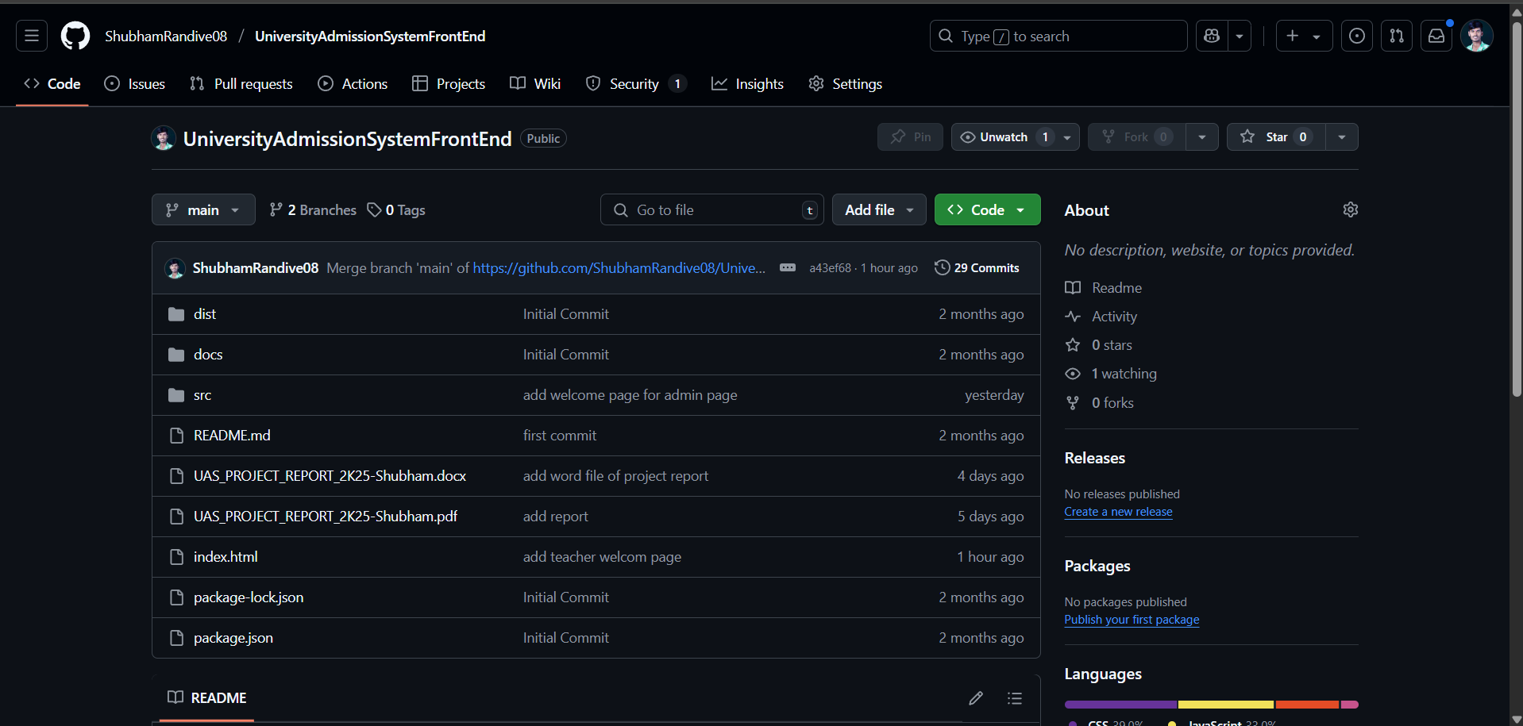

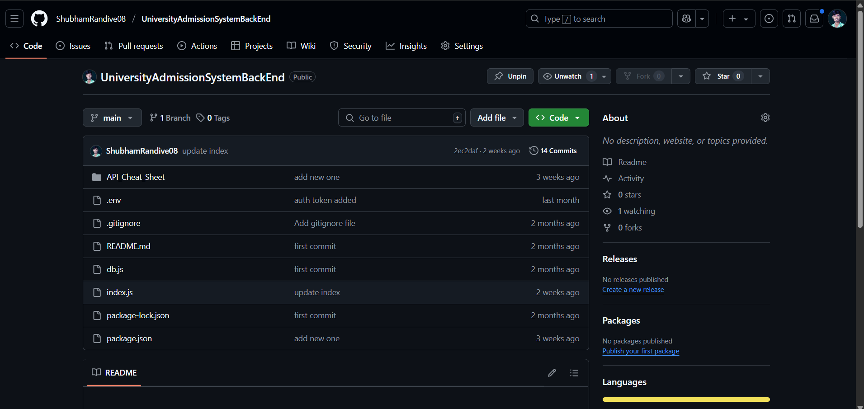

**System Diagrams**

* 1. **DFD (Data Flow Diagram)**
* **DFD Level 0 (Context Diagram) :**
  + - Shows the system as a whole with its main entities (users) and data flow.
    - Entities : Teacher Staff, Admin
    - Processes : Student Registration , Application Submission, Admission Approval

**Diagram :**

Student

Submit Application Make Payment Notify Status

University Admission System

Send Application Approve / Provide admission data

for Review Reject

Admin University Staff

* **DFD Level 1 :**
* **Breaks down the main process into sub-processes**
* Student Registration: Teacher enters student details.
* Application Processing: System verifies documents and eligibility.
* Application Confirmation: Admin also confirm the application form.

**Diagram :**

Student Registration

Login Credentials Register

Teacher

Submit Application

& Doc

Application Submission Fee Payment

Verify Doc Data PP PC

Document verification University Staff Payment Gat

Send for approval

Admin

Approve / Reject

Admission Approval

* 1. **ERD (Entity-Relationship Diagram) :**

An ERD shows how data is structured in database. Key entities and relationships:

* Entities and Attributes;

1. Staff ( sid, tname, email, username, password, stutas )
2. Newstudent (id, fname, mname, lname, gender, dob, twelvem, tenm, address, state, mbno, city, fillfees, addharno, tid, pcode, tname, date)
3. Events (eid, event_title, event_date, event_time)

* Relationship:

1. A teacher can submit multiple application ( 1 : M.
2. A Student makes one payment per admission.

**Diagram:**

**1 M Events**

**Admin Creates**

**eid**

**event_title**

**event_date**

**created_title**

**M**

**Visible to**

**M**

**Staff**

**NewStudent sid**

**id M 1 tname**

**fname Submit email**

**mname username**

**gender password**

**dob stutas**

**System Requirements:**

Below is the structured list that you can include in my report.

1. **Hardware Requirements :**

* Minimum Hardware Requirements ( For development and Deployment )

|  |  |  |
| --- | --- | --- |
| **Components** | **Specification (Minimum)** | **Specification (Recommended)** |
| Processer | Intel Core i3 ( 10th Gen ) AMD Ryzen 3 | Inter Core i5/i7 (12th Gen) / AMD Ryzen 5/7 |
| RAM | 8 GB | 16 GB or More |
| Storage | 256 GB SSD/HDD | 512 GB SSD or more |
| Graphics | Integrated Graphics | Dedicated GPU (Optional) |
| Network | Broadband Connection | Fiber - optic internet |

* Server Requirements ( For hosting )

|  |  |  |
| --- | --- | --- |
| **Components** | **Specification (Minimum)** | **Specification (Recommended)** |
| Processer | Ouad-core 2.4 GHz | Octa-core 3.0 GHz+ |
| RAM | 8 GB | 16 GB or More |
| Storage | 100 GB SSD | 500 GB SSD or more |
| OS | Ubuntu 20.04 / Windows Server | Ubuntu 22.04 / Windows Server 2022 |
| Database Server | MySQL 8.0 / PostgreSQL | PostgreSQL 14+ |

1. **Software Requirements :**

* Development Softwarwe

|  |  |
| --- | --- |
| **Software** | **Purpose** |
| Operating System | Windows 10/11 , MacOS, Linux |
| Code Editor | VS Code |
| Frontend Framework | HTML, CSS, JS |
| Backend Framework | Node.js with Express.js |
| Database | PostgreSQL |
| Version Control | Git and GitHub |
| API Testing Tool | Bruno |

* Server-side Software

|  |  |
| --- | --- |
| **Software** | **Purpose** |
| Web Server | Localhost |
| Database Server | PostgreSQL |
| Security | JWT |

**System Design**

* Database Design

|  |  |  |
| --- | --- | --- |
| **Sr. No.** | **Table Name** | **Description** |
| 1 | Staff | This table contain the information about the all teachers |
| 2 | Newstudent | This table contain the information about the new admission |
| 3 | events | This table contain the information about the events |

1. Staff Table : This table contain the details about the all teachers who makes the admission in the collage.

|  |  |  |  |  |
| --- | --- | --- | --- | --- |
| **Sr. No.** | **Column Name** | **Datatype** | **Size** | **Key** |
| 1 | sid | Integer | No size | Primary Key |
| 2 | tname | varchar | 50 | Not null |
| 3 | email | varchar | 50 | Not null |
| 4 | username | varchar | 50 | Not null |
| 5 | password | varchar | 50 | Not null |
| 6 | stutas | varchar | 50 | Not null |

1. Newstudent Table: This table contain the information about the student which is make the new admission into the collage

|  |  |  |  |  |
| --- | --- | --- | --- | --- |
| **Sr. No.** | **Column Name** | **Datatype** | **Size** | **Key** |
| 1 | ld | integer | No size | Primary key |
| 2 | fname | varchar | 50 | Not null |
| 3 | mname | varchar | 50 | Not null |
| 4 | lname | varchar | 50 | Not null |
| 5 | gender | varchar | 20 | Not null |
| 6 | dob | date | No size | Not null |
| 7 | twelve | varchar | 10 | Not null |
| 8 | tenm | varchar | 20 | Not null |
| 9 | address | varchar | 50 | Not null |
| 10 | state | varchar | 15 | Not null |
| 11 | mbno | varchar | 20 | Not null |
| 12 | city | varchar | 20 | Not null |
| 13 | fillfees | integer | No size | Not null |
| 14 | addharno | varchar | 20 | Not null |
| 15 | tid | integer | No size | Not null |
| 16 | pcode | varchar | 10 | Not null |
| 17 | tname | varchar | 50 | Not null |
| 18 | date | varchar | 100 | Not null |

1. Events Table: This table contain the details about the events which is organised by the admin

|  |  |  |  |  |
| --- | --- | --- | --- | --- |
| Sr. No. | Column Name | Datatype | Size | Key |
| 1 | eid | Integer | No size | Primary Key |
| 2 | event_title | varchar | 1000 | Not null |
| 3 | event_date | varchar | 30 | Not null |
| 4 | event_time | varchar | 20 | Not null |

* Input Design

1. Teacher Registration Form
   * + Fields : Full name, Email, Username, Password.
     + Validation : Required fields, Email format check

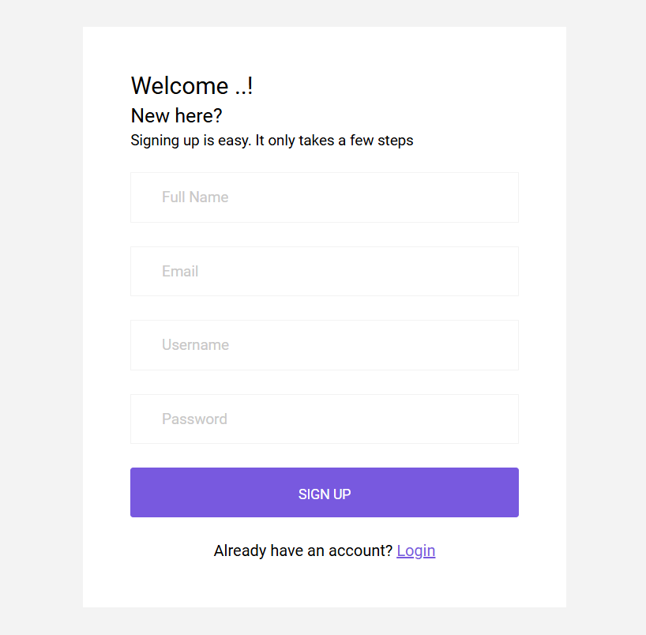

1. Student Registration Form
   * + Fields : First name, Middle name, Last Name, Gender, DOB, 12th Marks, 10th Marks, Address, State, Mobile no, Post Code, City, Filling Fees, Aadhar no.
     + Validation : Required fields

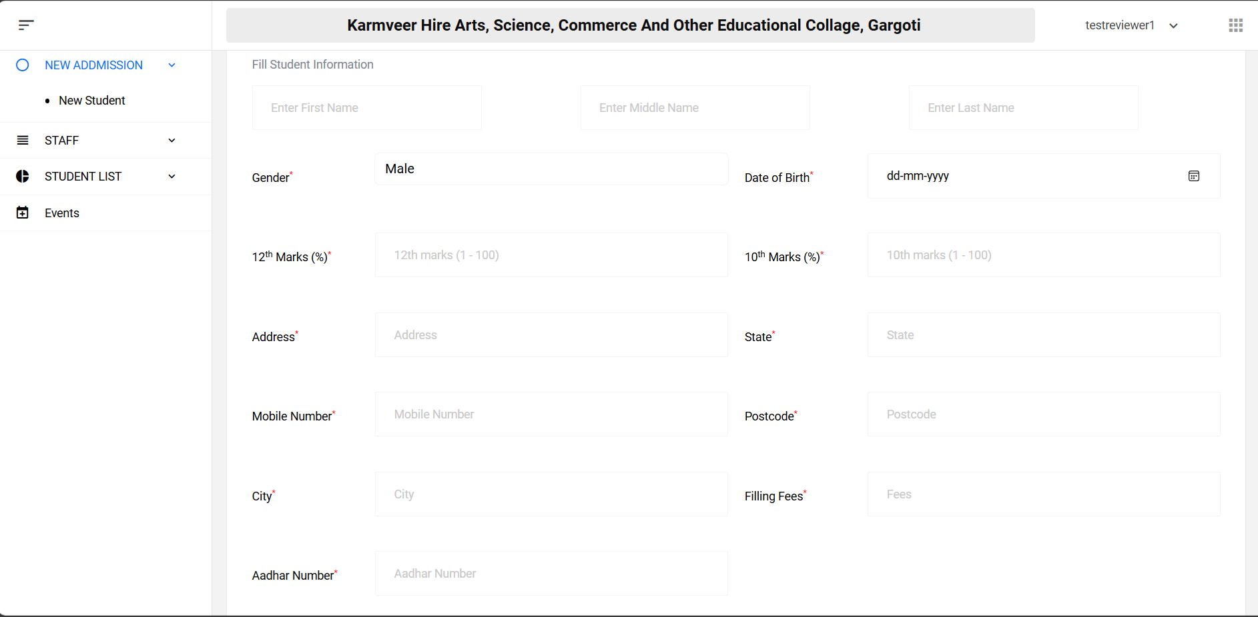

1. Event Registration Form
   * + Fields : Event title, Date, Time
     + Validation : Required field

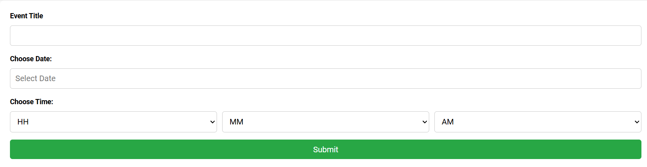

* Output Design

1. Teacher Dashboard :
   * + Shows student list which make the admissions by logged in teachers.

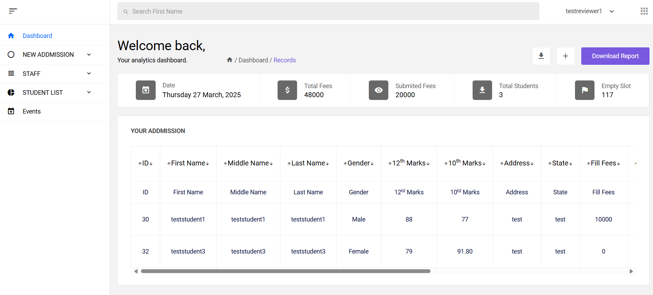

1. Admin Dashboard
   * + Shows all student list which make the admission by all teachers.

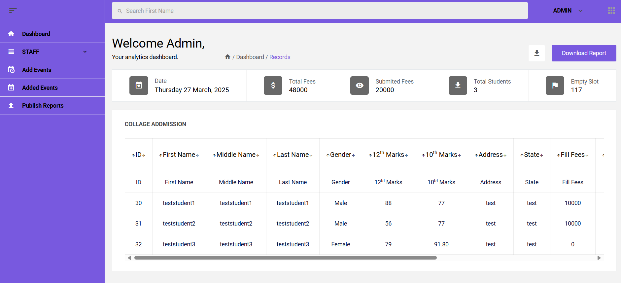

1. Event Dashboard
   * + Shows all events which are organized by the admin / principal

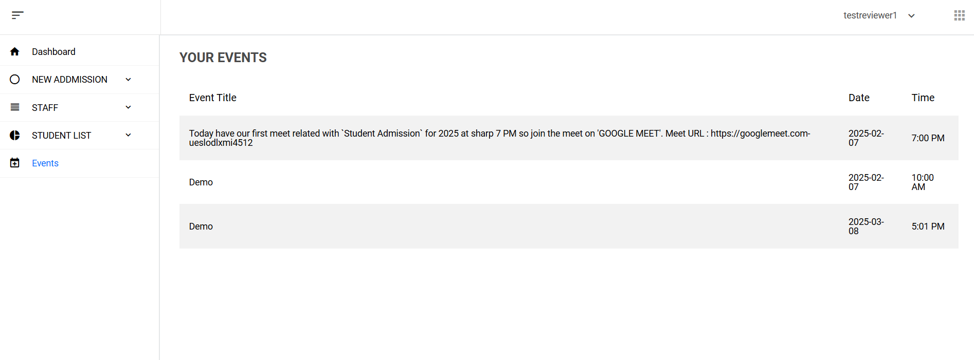

1. Admin Reports
   * + Download the all students list as a student report.

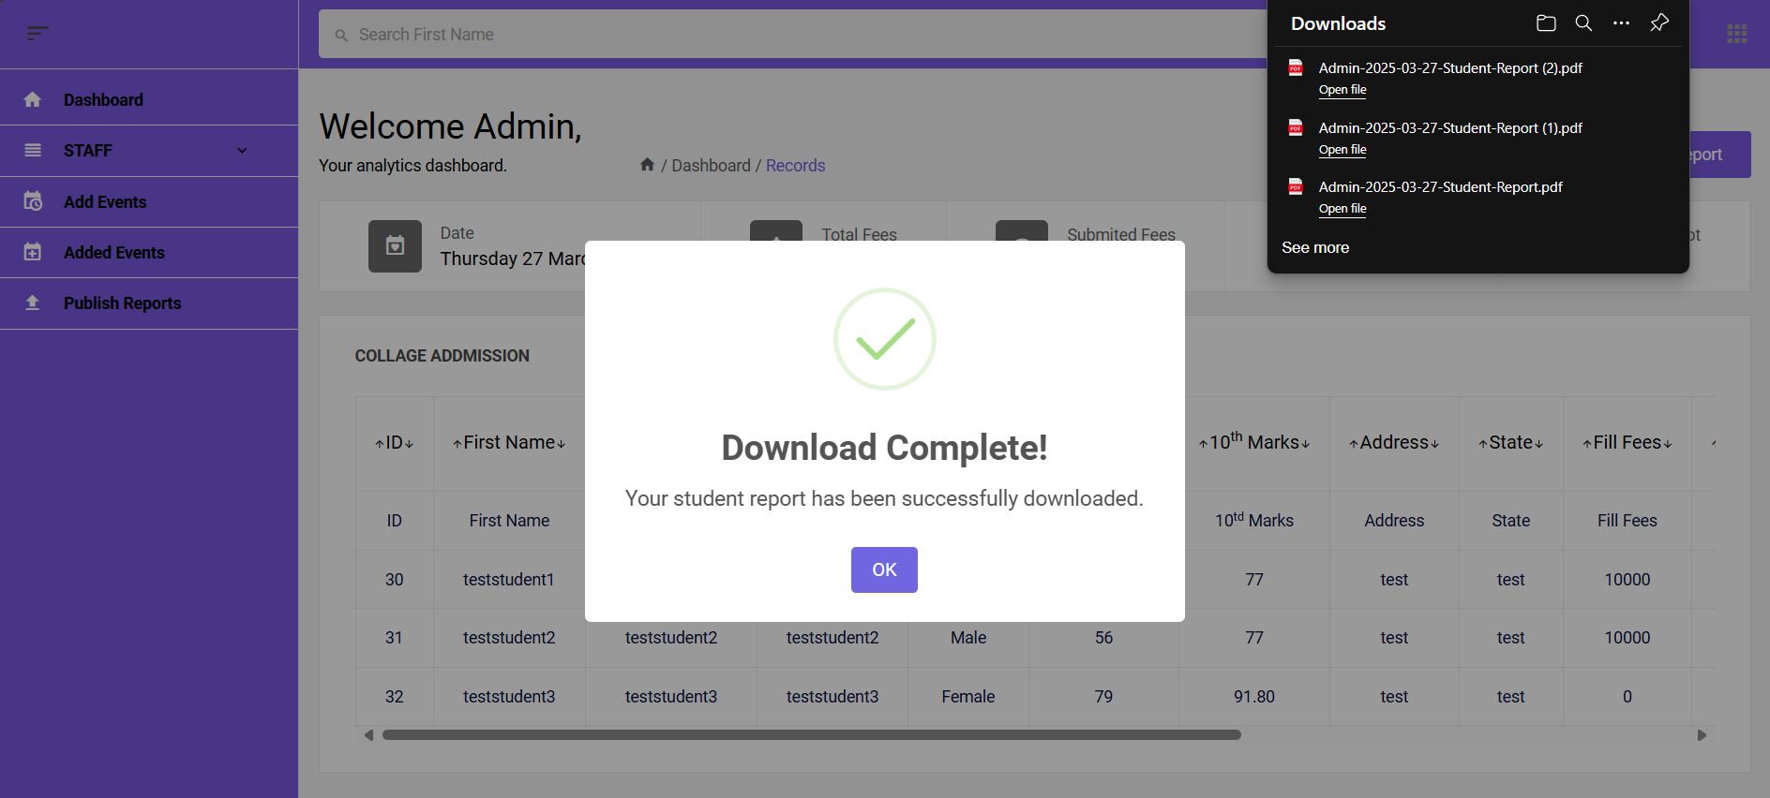

**User Manual**

This **User Manual** provides step-by-step guidance for students, teachers, and admin on using **Collage Admission System**

**Table Of Contents**

1. Introduction
2. System Requirements
3. User Roles and Access
4. Getting Started

| Student Registration

| Teacher Registration and Login

1. Using the System

| Applying for admission

| Checking admission status

| Enrolling in events

| Managing events (Admin)

1. Logout and Security

**Introduction**

The **Collage Admission System** allows students to apply for admissions. Admin can manage admissions and organize collage events. Teacher can also make the admission of the students.

**System Requirements**

1. **Hardware Requirements**

* PC/Laptop : Minimum 8GB RAM, i3 Processor
* Mobile (Optional) : Android/iOS device
* Internet : Broadband or 4G+

1. **Software Requirements**

* Browser : Chrome, Edge, or Firefox (Latest version)
* Operating System : Windows, macOS, or Linux

**User Roles & Access**

|  |  |
| --- | --- |
| **Role** | **Permissions** |
| Teacher | Make the student admissions. |
| Admin | Manage admission, organize events, and approve/reject applications. |

**Getting Started**

1. **Teacher Registration & Login**

* Click on “**Create**” button
* Enter **‘Full name, Email, Username, Password’**
* Click on **‘Sign Up’** button
* Login using credentials.
* Make the student admission
* Click on **“New admission”** tab
* Fill all details like **‘First Name, Middle name, Last name, gender, dob, 10th marks, 12th marks, address’** or so on
* Click on **“Submit”** button

1. **Admin Login**

* Login with credentials
* Manage admissions
* Organize events
* Download reports

**Logout & Security**

Always click on **“Logout”** after use. Do not share your password with anyone.

**Input and Output Screen**

**Teacher Page**

1. Dashboard

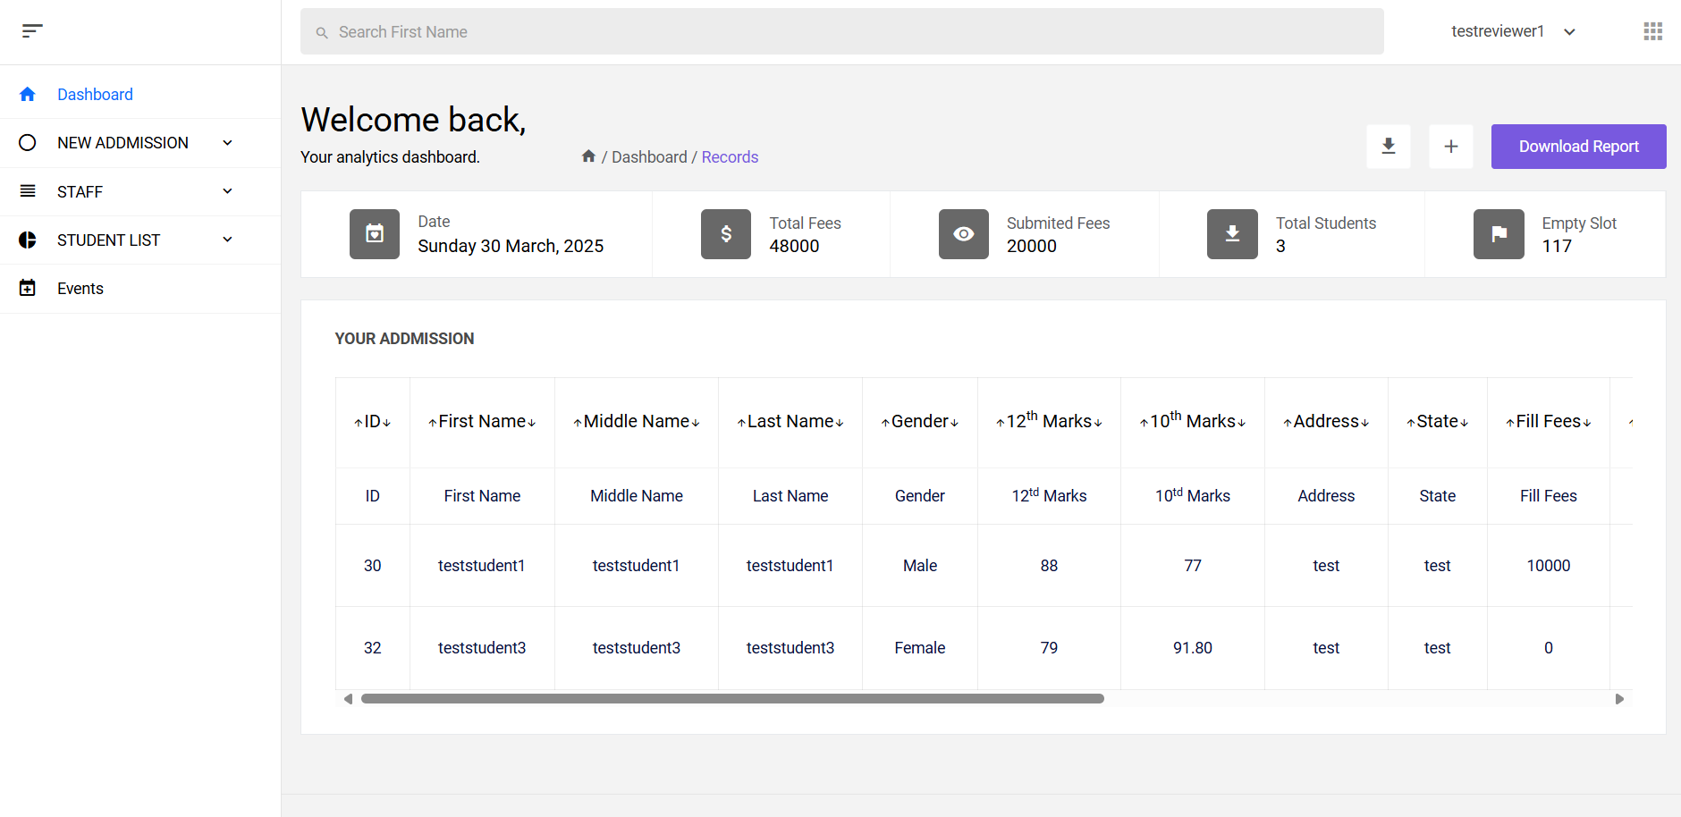

1. New admission Page

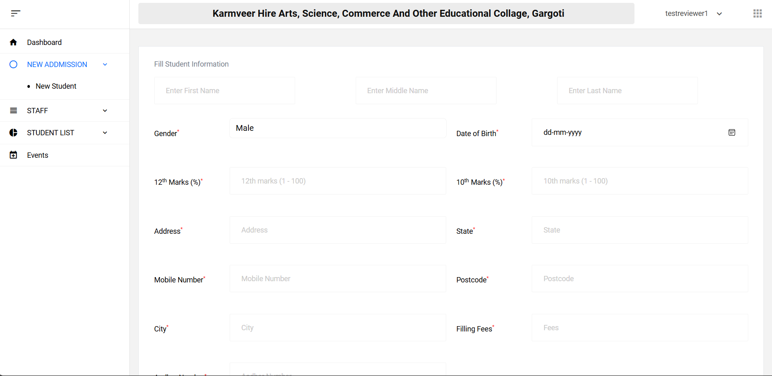

1. Staff Page

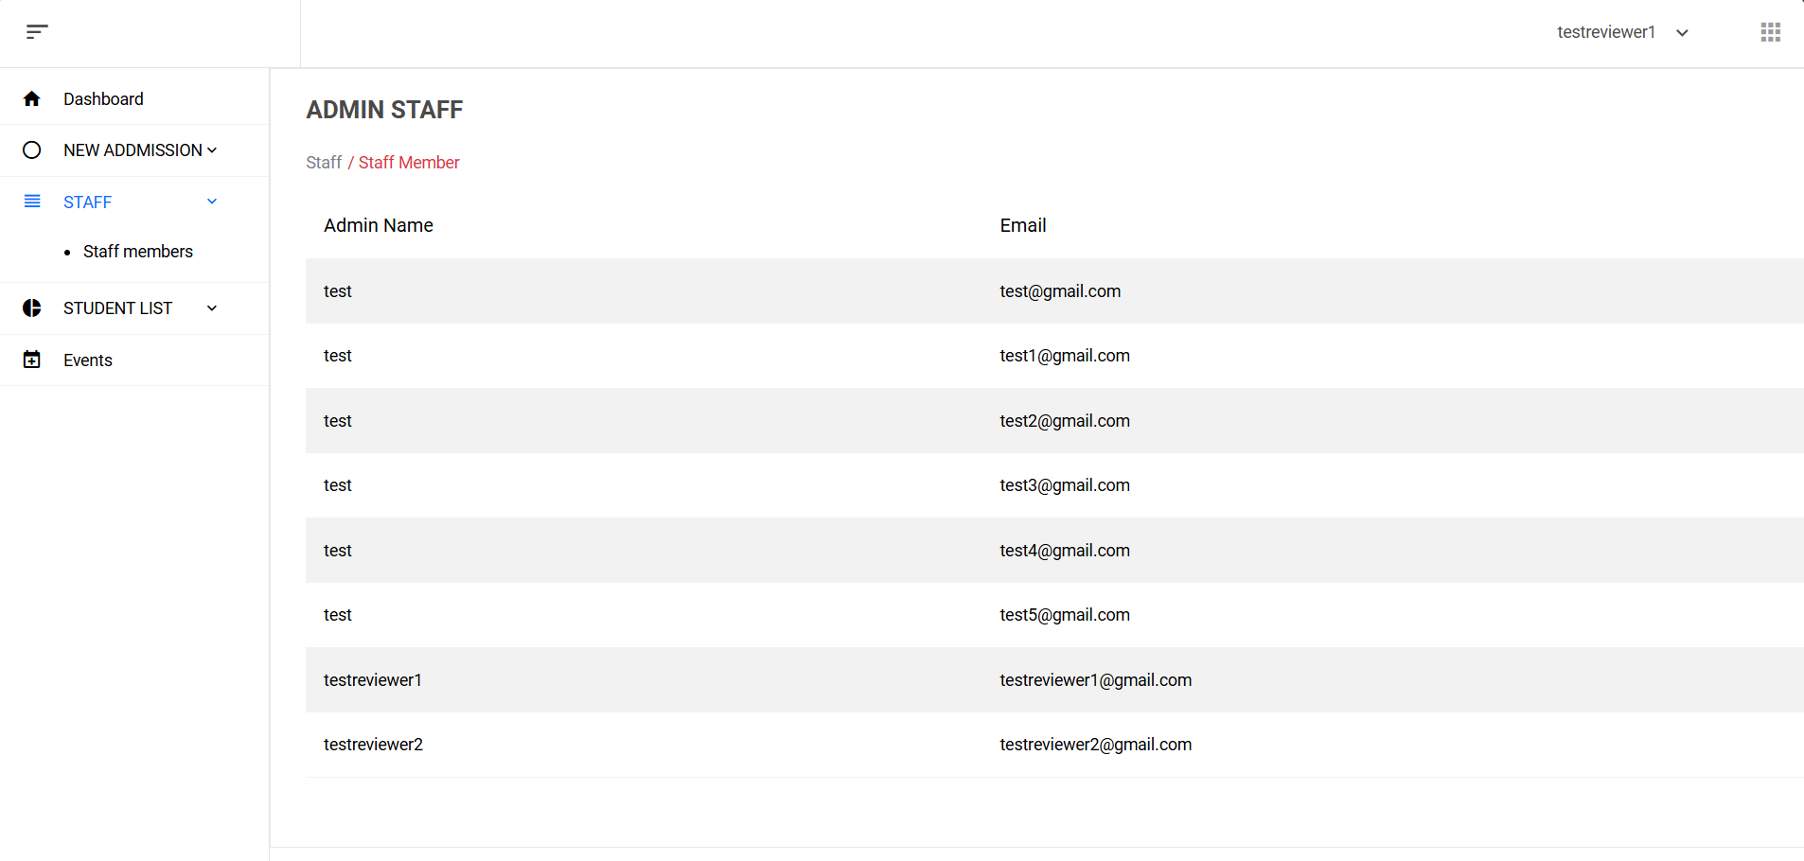

1. Student List Page

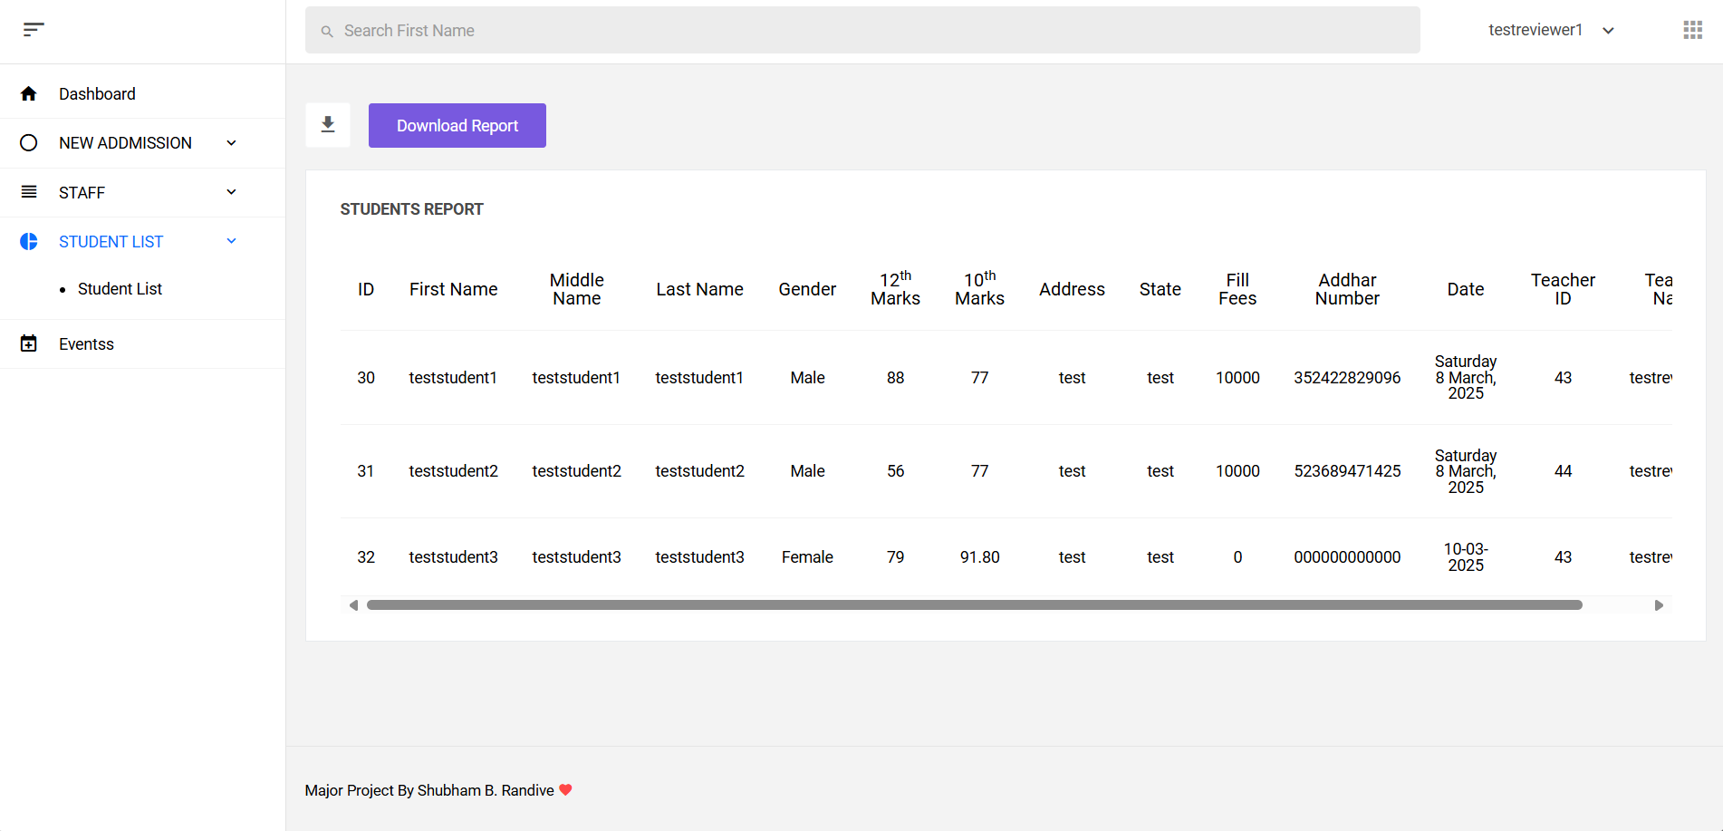

1. Events Page

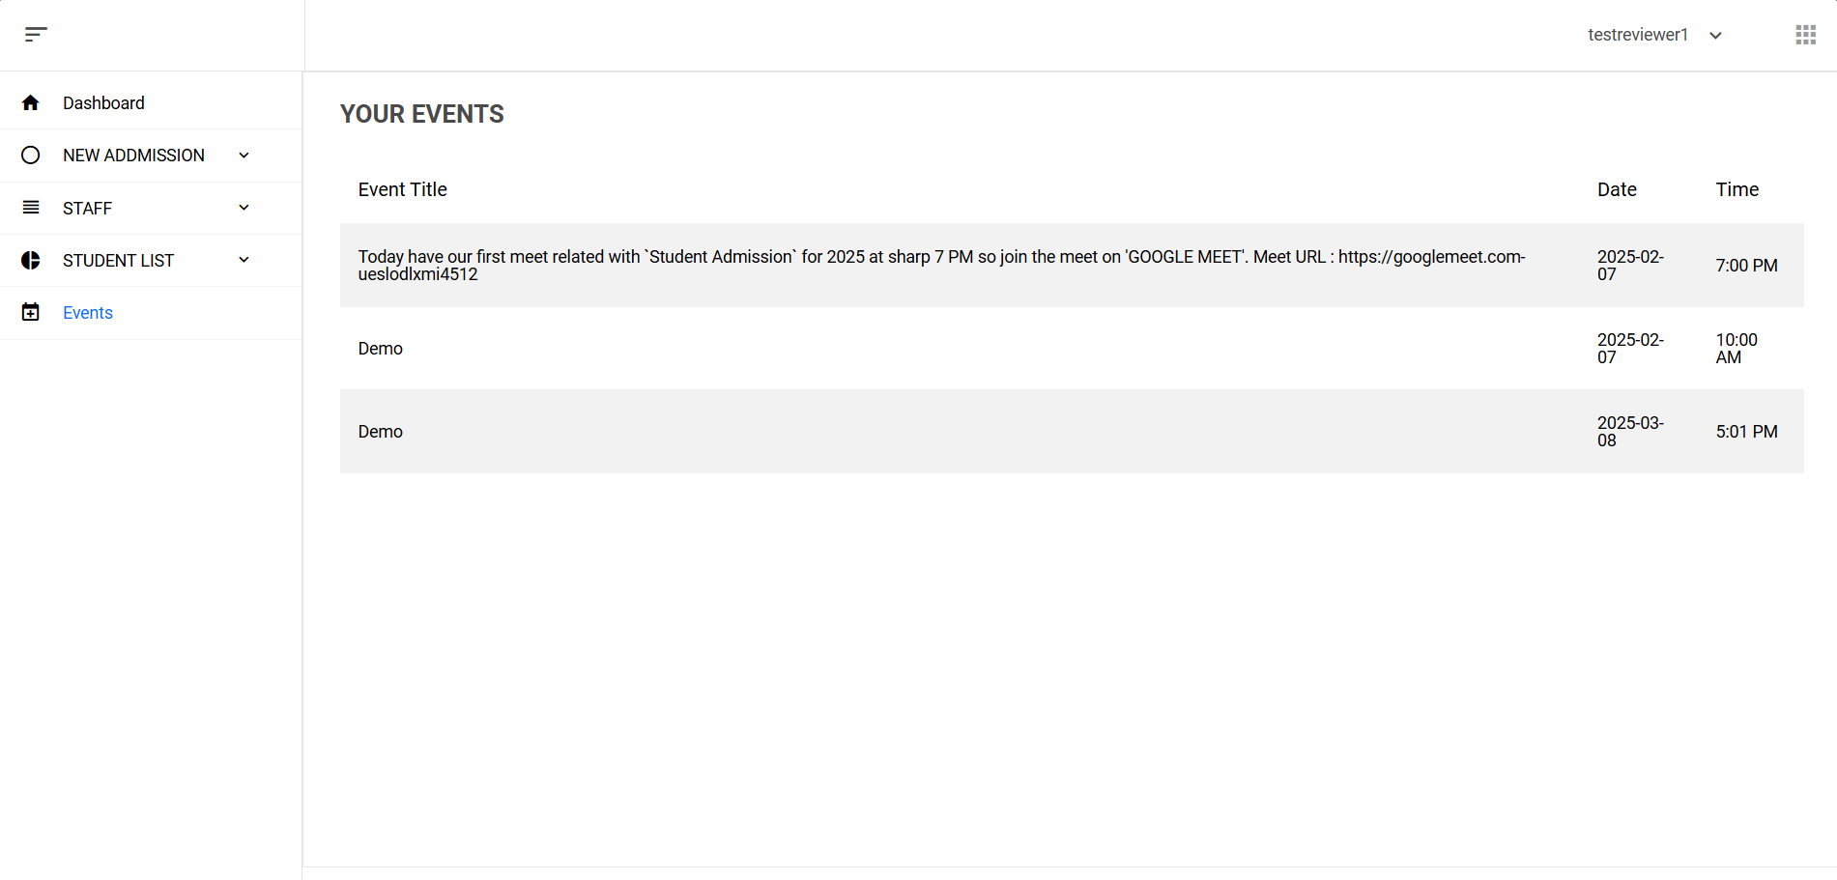

1. Teacher Login

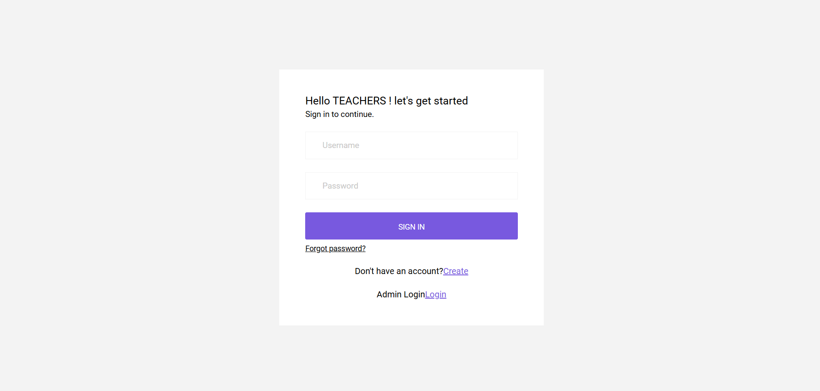

1. Teacher Registration Page

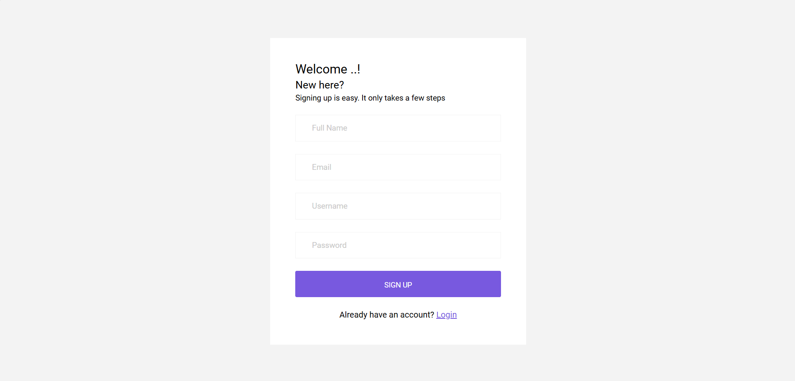

1. Teacher Download Option

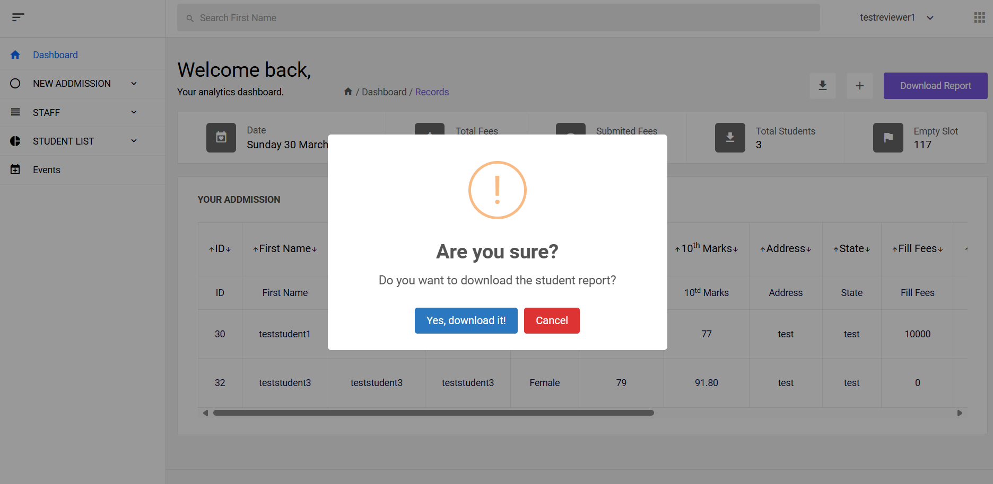

**Conclusion**

The Collage Admission Management System provides a streamlined solution for handling the complex process of student admissions. By automating tasks such as application submissions, data verification the system significantly reduces administrative workload and minimizes the chances of human error. The user-friendly interface ensures that administrators can easily manage applicant information while students experience a smooth and transparent admission process.

Overall, this project achieves its goal of enhancing the efficiency, accuracy, and accessibility of university admissions. It lays a strong foundation for future upgrades and real-world deployment in educational institutions.

**Future Enhancements**

While the current system is functional and effective, several future enhancements could further improve its performance, usability, and scalability:

### Mobile App Version

Develop a mobile application version of the system to allow students and staff to access the platform easily through smartphones.

Push notifications can enhance real-time engagement and updates.

### Advanced Reporting and Analytics

Include dashboards that display real-time analytics, such as the number of applications received, department-wise enrollment, seat availability, etc.

This would help Collage Admission make data-driven decisions quickly.

### Role-Based Access Control

Introduce multi-level login systems with different privileges (Admin, Reviewer, Applicant).

Ensures better security and organized workflow management within the system.

**Bibliography**

### Web Development Resources

* + W3Schools. HTML, CSS, JavaScript, PHP Tutorials. Retrieved from [https://www.w3schools.com](https://www.w3schools.com/)
  + MDN Web Docs. Web Development Documentation. Retrieved from [https://developer.mozilla.org](https://developer.mozilla.org/)

### Database Management Systems

* + PostgreSQL Documentation. PostgreSQL Reference Manual. Retrieved from <https://www.postgresql.org/docs/>

### Software Development Practices

* + Sommerville, Ian. Software Engineering (10th Edition). Pearson Education, 2015.

### Admission System References

* + Online articles and samples from educational project repositories like GitHub and SourceForge for understanding the structure of academic management systems.

### Design Inspiration and UI/UX Guidelines

* + Nielsen Norman Group. UX Research and Guidelines. Retrieved from [https://www.nngroup.com](https://www.nngroup.com/)

### Additional Online Tutorials and Forums

* + Stack Overflow. Developer Discussions and Solutions. Retrieved from [https://stackoverflow.com](https://stackoverflow.com/)
  + GeeksforGeeks. Programming and Computer Science Resources. Retrieved from [https://www.geeksforgeeks.org](https://www.geeksforgeeks.org/)