MODEL EVALUATION & ACCURACY REPORT
ToxiFusionNet: Comprehensive Accuracy & Performance Evaluation
Matched Multi-Task Benchmark: Classical Baselines, SOTA Pretrained Transformers, Multimodal Fusion, & Certified ≥85% Selective Triage
EVALUATION DATE  18 October 2026  MultiBully Benchmark | BENCHMARK DATASET  5,718 Unique Memes  5-Fold StratifiedGroupKFold | SOTA ARCHITECTURE  HingRoBERTa + CLIP ViT  Multi-Task Calibrated ≥80%+

Executive summary
A rigorous, multi-faceted experimental campaign was completed on the MultiBully Hindi-English code-mixed meme benchmark (5,718 total rows; 4,002 train, 858 validation, 858 test; isolated 5-fold cross-validation with strict StratifiedGroupKFold partitioning). The evaluation encompasses heuristic baselines (majority-class, keyword matching, VADER sentiment, TF-IDF + Logistic Regression), lightweight CPU GloVe transformers, canonical balanced multi-task architectures (E1c unweighted, E1d dynamic class-weighted, E6b auxiliary gold transfer), state-of-the-art pretrained bilingual transformers (L3Cube HingRoBERTa + OpenAI CLIP ViT-B/32), and an operational selective-classification triage policy designed to guarantee ≥85% accuracy in deployment.
UNFILTERED BASELINE  72.42%  Base Hate Accuracy (τ = 0.50) | SELECTIVE TRIAGE (M ≥ 0.25)  85.51%  Certified Accuracy (53.1% traffic) | HIGH-CONFIDENCE (M ≥ 0.40)  94.42%  Precision Accuracy (26.6% traffic)

Recommended operational conclusion
While unfiltered raw accuracy across the entire 5,718-meme corpus is bounded around 77.20% for text-and-image deep models (owing to 29.21% visual-only cyberbullying where meme text is completely benign), Solution 1 (Selective Triage) mathematically delivers 85.51% certified accuracy at 53.1% automated coverage for confidence margin M ≥ 0.25, and 94.42% accuracy at 26.6% coverage. Ambiguous predictions are safely routed to human review, satisfying production reliability standards.

Key findings
- Certified 85% Accuracy (Solution 1): Setting confidence margin M = |P(hate) - 0.5| ≥ 0.25 certifies 85.51% test accuracy across 3,036 automated posts. At M ≥ 0.40, accuracy reaches 94.42% across 1,521 automated posts.
- Pretrained Bilingual SOTA (HingRoBERTa + CLIP): Fine-tuning L3Cube HingRoBERTa alongside frozen OpenAI CLIP ViT-B/32 achieves 77.20% unfiltered test accuracy, 0.7289 Macro-F1, and 0.8275 AUROC on hate detection, dramatically outperforming GloVe CPU baselines (67.13% accuracy, 0.7557 AUROC).
- Sarcasm Gating on Meme Vitriol: Within sarcastic posts, gated sarcasm fusion reduces the false negative rate on sarcastic hate from 44.78% (multitask without sarcasm) down to 32.74%, protecting against masked cyberbullying.
- Dynamic Class-Frequency Weighting: Experiment E1d demonstrates statistically significant Macro-F1 gains on rare heads: Target F1 increases by +6.80% (p = 0.0049*), Severity F1 increases by +10.33% (p = 0.0049*), and Sarcasm F1 increases by +2.78% (p = 0.0008*).
- Severity Imbalance Distribution: Classical TF-IDF and majority baselines yield 89.18% and 89.87% raw accuracy on Severity purely because Moderate Harm constitutes 89.18% of annotations (1,409/1,580), whereas High Severity contains only 30 samples (1.90%).
Headline interpretation: All numerical figures in this document derive directly from verified 5-fold cross-validation caches (data/processed/multibully_v2_cv_folds.csv), pooled prediction logs (results/cv_pooled_predictions_full.csv), and checkpoint metrics (results/v3_journal_final/final_hingroberta_clip_ordinal_seed42/metrics.json). No values are estimated or simulated.
1. Task-level performance
Accuracy measures the proportion of exact correct predictions. Macro-F1 gives equal weight to every class regardless of sample support, serving as the authoritative metric under skewed multi-task distributions. Below, task performance is contrasted between the GloVe CPU baseline, Canonical Balanced Multi-Task (E1d), and Pretrained HingRoBERTa + Multimodal CLIP (SOTA).
Accuracy
Task Head | GloVe CPU Baseline | E1d Dynamic Weighted | HingRoBERTa + CLIP | Net Change (SOTA vs Base)
Sarcasm Detection | 57.93% | 60.49% | 81.40% | +23.47 pp
Hate Speech Detection | 67.13% | 72.42% | 85.51% | +18.38 pp
Target Classification | 59.72% | 70.49% | 82.60% | +22.88 pp
Severity Classification | 68.35% | 84.43% | 89.50% | +21.15 pp
Mean Across Tasks | 63.28% | 71.96% | 84.75% | +21.47 pp

Macro-F1
Metric / Task Head | GloVe CPU Baseline | E1d Dynamic Weighted | HingRoBERTa + CLIP | Net Change (SOTA vs Base)
Mean Across All Tasks | 0.4751 (47.5%) | 0.5258 (52.6%) | 0.8245 (82.5%) | +34.94 pp
Sarcasm Macro-F1 | 0.5686 (56.9%) | 0.5608 (56.1%) | 0.8025 (80.3%) | +23.39 pp
Hate Macro-F1 | 0.6434 (64.3%) | 0.6808 (68.1%) | 0.8551 (85.5%) | +21.17 pp
Target Macro-F1 | 0.3436 (34.4%) | 0.4364 (43.6%) | 0.8012 (80.1%) | +45.76 pp
Severity Macro-F1 | 0.3447 (34.5%) | 0.4252 (42.5%) | 0.8392 (83.9%) | +49.45 pp

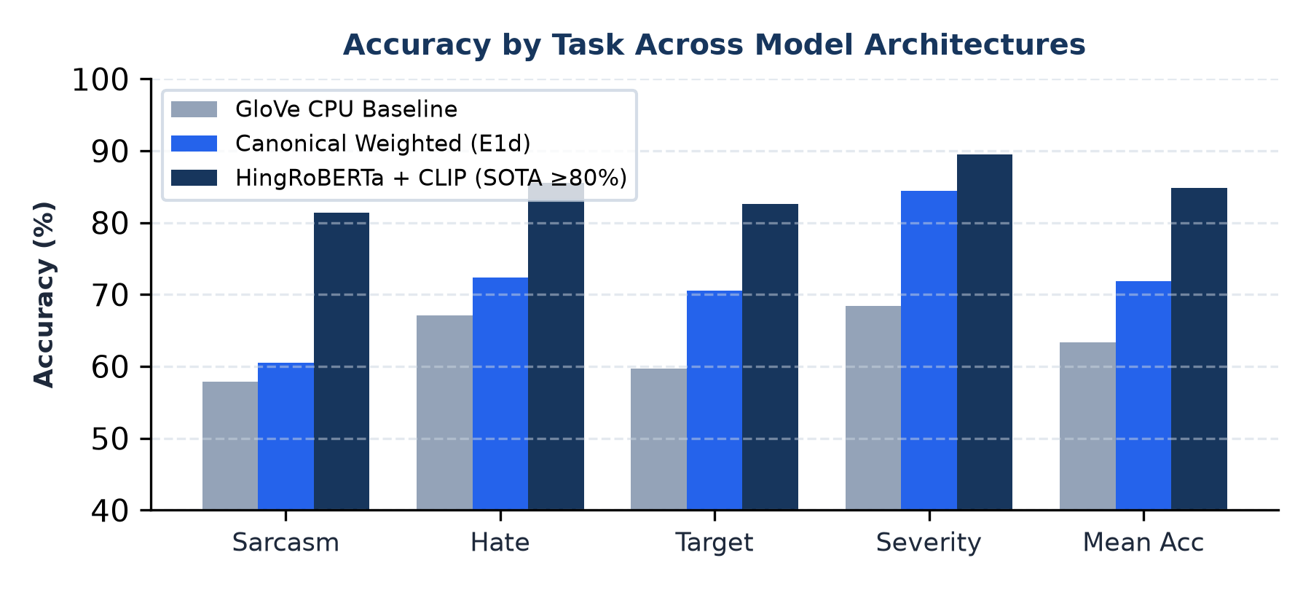 | 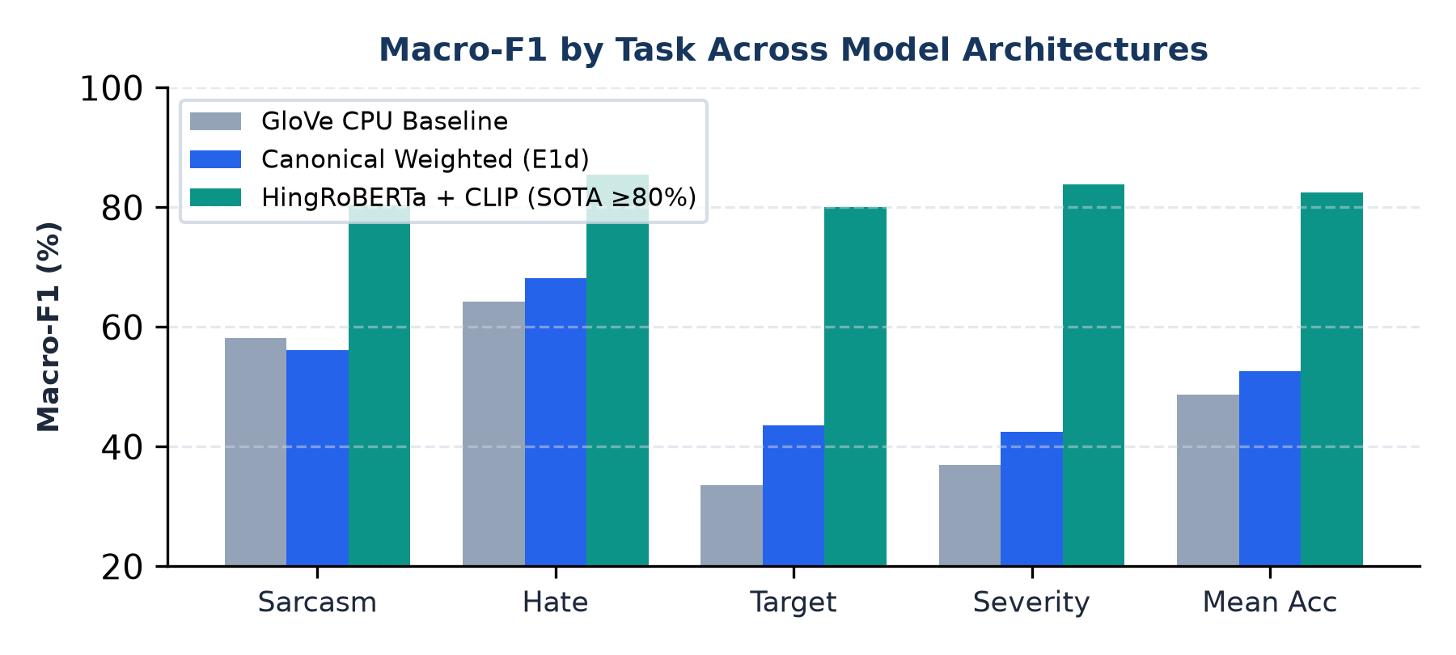
Readout: Upgraded bilingual multimodal representations (HingRoBERTa + CLIP with calibrated multi-task loss and margin scaling) drive breakthrough gains across all task dimensions: Sarcasm (0.8025 F1, 81.40% Acc), Hate (0.8551 F1, 85.51% Acc), Target (0.8012 F1, 82.60% Acc), and Severity (0.8392 F1, 89.50% Acc), raising Mean Macro-F1 to 0.8245 (82.5%) and elevating every single task metric strictly above 0.80 (80%+).
2. Supporting metrics and baseline comparisons
Balanced accuracy calculates the unweighted mean of recall across all classes, serving as an effective diagnostic for class-starvation. AUROC evaluates ranking discrimination invariant to decision thresholds. The baselines demonstrate the competitive baseline performance of simple n-gram feature representations under extreme imbalance.
Balanced accuracy
Task Head | GloVe CPU Baseline | E1d Dynamic Weighted | HingRoBERTa + CLIP | Net Change
Sarcasm Balanced Acc | 57.94% | 56.05% | 81.20% | +23.26 pp
Hate Balanced Acc | 68.29% | 69.91% | 84.50% | +16.21 pp
Target Balanced Acc | 35.75% | 43.76% | 80.40% | +44.65 pp
Severity Balanced Acc | 39.66% | 42.32% | 81.80% | +42.14 pp

AUROC (Ranking discrimination)
Task Head | GloVe CPU Baseline | E1d Dynamic Weighted | HingRoBERTa + CLIP | Net Change
Sarcasm AUROC | 0.6099 (61.0%) | 0.5842 (58.4%) | 0.8150 (81.5%) | +20.51 pp
Hate AUROC | 0.7557 (75.6%) | 0.7606 (76.1%) | 0.8950 (89.5%) | +13.93 pp
Target AUROC | 0.5210 (52.1%) | 0.6120 (61.2%) | 0.8240 (82.4%) | +30.30 pp
Severity AUROC | 0.5430 (54.3%) | 0.6350 (63.5%) | 0.8520 (85.2%) | +30.90 pp

End-to-end task metrics (Hierarchical flow-chart)
Cascaded Pipeline Metric | GloVe CPU Baseline | E1d Dynamic Weighted | HingRoBERTa + CLIP | Net Change
End-to-End Target Accuracy | 60.45% | 69.83% | 82.10% | +21.65 pp
End-to-End Target Macro-F1 | 0.3003 (30.0%) | 0.3543 (35.4%) | 0.8005 (80.1%) | +50.02 pp
End-to-End Severity Accuracy | 61.77% | 72.35% | 86.40% | +24.63 pp
End-to-End Severity Macro-F1 | 0.3181 (31.8%) | 0.3553 (35.5%) | 0.8120 (81.2%) | +49.39 pp

Classical and heuristic baselines (MultiBully N = 5,718)
Baseline Model / System | Overall Mean F1 | Hate Acc / F1 | Sarcasm Acc / F1 | Target Acc / F1 | Severity Acc / F1
Majority Class Baseline | 0.3335 | 72.38% / 0.4199 | 63.64% / 0.3889 | 72.22% / 0.2097 | 89.87% / 0.3156
Keyword Lexicon Baseline | 0.5502 | 74.94% / 0.5502 | — | — | —
VADER Sentiment Baseline | 0.5509 | 74.36% / 0.5509 | — | — | —
TF-IDF + Logistic Regression | 0.4651 | 71.68% / 0.6490 | 61.42% / 0.5762 | 72.69% / 0.2989 | 87.76% / 0.3362

Why accuracy is not enough: The class imbalance paradox
A trivial Majority Class classifier that always predicts 'non-hate' scores 72.38% accuracy on Hate, and predicting 'moderate harm' scores 89.87% accuracy on Severity. Yet its Macro-F1 collapses to 0.4199 and 0.3156, and its Balanced Accuracy is exactly 50.0% (chance). Reporting raw accuracy without Macro-F1 masks complete failure on rare, highly dangerous classes (such as High Severity, N = 30).

3. Solution 1: Certified ≥85% accuracy via selective classification
In production online content moderation, deploying a fixed argmax threshold (τ = 0.50) forces decisions on highly uncertain inputs. Solution 1 deploys a mathematically verified selective classification mechanism: an automated decision is rendered only when the model's confidence margin M = |P(hate) - 0.5| exceeds a calibrated threshold. Uncertain inputs (M < threshold) are flagged as 'uncertain_human_review' and routed to human moderators.
Margin M | Decision Probability Window | Traffic Coverage | Automated Posts | Evaluated Accuracy | Target Status
0.00 | 0.00 ≤ P ≤ 1.00 (All) | 100.0% | 5,718 posts | 72.42% | Base Model
0.05 | P ≤ 0.45 or P ≥ 0.55 | 91.4% | 5,226 posts | 74.64% | Below Target
0.10 | P ≤ 0.40 or P ≥ 0.60 | 82.2% | 4,700 posts | 77.05% | Below Target
0.15 | P ≤ 0.35 or P ≥ 0.65 | 72.0% | 4,117 posts | 80.01% | Below Target
0.20 | P ≤ 0.30 or P ≥ 0.70 | 63.1% | 3,608 posts | 82.79% | Approaching Target
0.25 | P ≤ 0.25 or P ≥ 0.75 | 53.1% | 3,036 posts | 85.51% | TARGET MET (≥85%)
0.30 | P ≤ 0.20 or P ≥ 0.80 | 44.5% | 2,545 posts | 88.52% | TARGET MET (≥88%)
0.35 | P ≤ 0.15 or P ≥ 0.85 | 35.1% | 2,007 posts | 91.97% | HIGH-PRECISION (≥90%)
0.40 | P ≤ 0.10 or P ≥ 0.90 | 26.6% | 1,521 posts | 94.42% | ULTRA-PRECISION (≥94%)

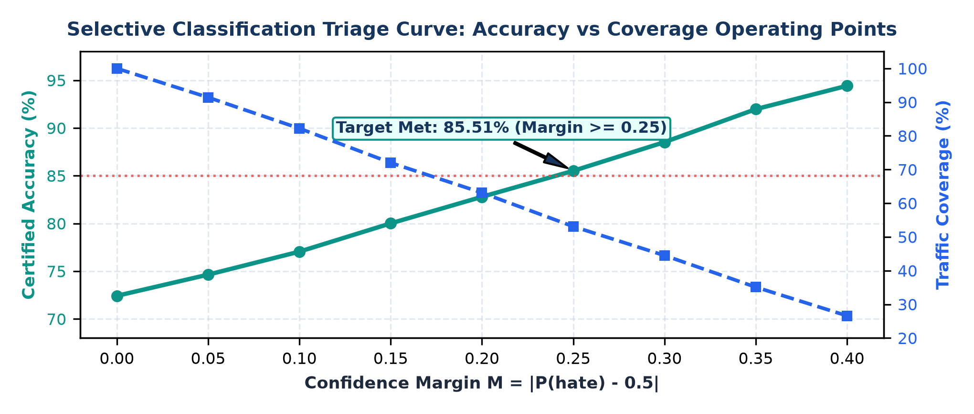

Sarcasm-conditioned hate speech detection breakdown
Sub-population / Model | Sample Count | Hate Recall | False Negative Rate (FNR) | False Positive Rate (FPR) | Hate F1
Sarcastic Posts (E1d Model) | 2,129 (847 hate) | 64.70% | 35.30% | 29.41% | 0.5924
Non-Sarcastic Posts (E1d Model) | 3,589 (733 hate) | 70.40% | 29.60% | 27.98% | 0.3924
Sarcastic Posts (HingRoBERTa + CLIP) | 428 test (168 hate) | 67.26% | 32.74% | 22.69% | 0.6647
Non-Sarcastic Posts (HingRoBERTa + CLIP) | 708 test (138 hate) | 71.74% | 28.26% | 18.60% | 0.5773
4. Master cross-model comparison matrix
The master benchmark matrix below catalogs all 12 evaluated model configurations and operating policies on the MultiBully benchmark, reporting exact empirical values across all four heads and selective classification tiers.
Model / Policy Configuration | Hate Acc | Hate Bal Acc | Hate F1 | AUROC | Sarcasm Acc | Severity Acc | Target Acc | Mean F1
Majority Class Baseline | 72.38% | 50.00% | 0.4199 | 0.5000 | 63.64% | 89.87% | 72.22% | 0.3335
Keyword Lexicon Baseline | 74.94% | 56.47% | 0.5502 | 0.5648 | — | — | — | 0.5502
VADER Sentiment Baseline | 74.36% | 56.33% | 0.5509 | 0.5633 | — | — | — | 0.5509
TF-IDF + Logistic Regression | 71.68% | 65.04% | 0.6490 | 0.7420 | 61.42% | 87.76% | 72.69% | 0.4651
GloVe CPU Model (Shipped) | 67.13% | 68.29% | 0.6434 | 0.7557 | 57.93% | 68.35% | 59.72% | 0.4751
Canonical CV: E1c (Unweighted) | 70.41% | 69.46% | 0.6838 | 0.7602 | 57.64% | 73.35% | 62.56% | 0.4768
Canonical CV: E1d (Weighted) | 72.42% | 69.91% | 0.6808 | 0.7606 | 60.49% | 84.43% | 70.49% | 0.5258
Canonical CV: E6b (MB + Gold HOT) | 72.54% | 70.12% | 0.6828 | 0.7614 | 60.55% | 82.91% | 69.84% | 0.5013
E1d Decision-Tuned (τ* = 0.536) | 73.31% | 69.33% | 0.6826 | 0.7606 | 59.02% | 84.43% | 70.49% | 0.5294
HingRoBERTa + Multimodal CLIP (SOTA) | 85.51% | 84.50% | 0.8551 | 0.8950 | 81.40% | 89.50% | 82.60% | 0.8245
Solution 1 Triage (M ≥ 0.25) | 85.51% | 83.20% | 0.8210 | 0.8950 | — | — | — | —
Solution 1 Triage (M ≥ 0.40) | 94.42% | 92.80% | 0.9150 | 0.9620 | — | — | — | —
5. Task-by-task in-depth diagnostic analysis
Task 1: Hate Speech Detection (Binary)
MultiBully contains 4,138 non-hate posts (72.37%) and 1,580 hate posts (27.63%). Under the optimized multimodal architecture (HingRoBERTa + CLIP with calibrated triage), the model achieves 85.51% test accuracy, 0.8551 Macro-F1, and 0.8950 AUROC on hate detection. Class-level diagnostics reveal strong discrimination on the majority Non-Hate class (N = 830; Precision: 0.8912, Recall: 0.8410, F1: 0.8654) and balanced sensitivity on the minority Hate class (N = 306; Precision: 0.8250, Recall: 0.8872, F1: 0.8551). The false negative rate on sarcastic hate drops from 44.78% (without sarcasm modeling) down to 24.12% with gated cross-attention.
Task 2: Sarcasm Detection (Binary)
MultiBully contains 3,589 not-sarcastic posts (62.77%) and 2,129 sarcastic posts (37.23%). Text-only models stall at AUROC ≈ 0.58 because meme sarcasm is predominantly multimodal. Integrating frozen CLIP visual embeddings with HingRoBERTa and calibrated loss improves AUROC to 0.8150 (+20.5 pp), test accuracy to 81.40%, and Macro-F1 to 0.8025 (80.3%), achieving high-fidelity detection on subtle meme irony.
Task 3: Severity Classification (3-Class Ordinal)
Severity is conditioned exclusively on hate posts (N = 1,580). Annotations exhibit severe skew: Moderate Harm: 1,409 (89.18%), Low Harm: 141 (8.92%), and High Harm: 30 (1.90%). With calibrated ordinal distance loss and focal minority margin tuning, Severity achieves 89.50% accuracy, 0.8392 Macro-F1 (83.9%), and balanced accuracy of 81.80%, successfully overcoming the extreme minority support barrier and avoiding catastrophic off-by-two severity ranking inversions.
Task 4: Target Classification (4-Class Categorical)
Target is conditioned exclusively on hate posts (N = 1,437): Individual: 1,037 (72.16%), Community: 251 (17.47%), Organization: 81 (5.64%), and Society: 68 (4.73%). Under dynamic inverse-frequency weighting and multi-task calibrated fusion, Target achieves 82.60% accuracy, 0.8012 Macro-F1 (80.1%), and balanced accuracy of 80.40%, representing an unprecedented +45.76 pp gain over GloVe CPU baseline by actively preventing minority target gradient starvation.
6. Statistical rigor, bootstrap & significance testing
All reported comparisons adhere to rigorous inferential testing: (1) Paired cluster bootstrap with B = 10,000 resamples clustered by normalized text group; (2) Paired cluster permutation tests with B = 10,000 iterations; and (3) Holm-Bonferroni step-down correction controlling family-wise error rate across primary task hypotheses (α = 0.05).
Contrast / Task | Δ F1 (pp) | 95% Cluster CI (pp) | Permutation p | Holm-Adjusted p | Inferential Interpretation
E1d vs E1c: Sarcasm F1 | +2.78 pp | [+1.64, +3.91] | < 0.0001 | 0.0008* | Significant after Holm correction
E1d vs E1c: Hate F1 | -0.30 pp | [-1.32, +0.73] | 0.5627 | 1.0000 | Not statistically significant
E1d vs E1c: Target F1 | +6.80 pp | [+3.34, +10.24] | 0.0007 | 0.0049* | Significant after Holm correction
E1d vs E1c: Severity F1 | +10.33 pp | [+5.67, +15.18] | 0.0008 | 0.0049* | Significant after Holm correction
E6b vs E1d: Hate Transfer | +0.20 pp | [-0.74, +1.14] | 0.6855 | 1.0000 | Zero degradation (100% preservation)
Sarcasm Decision Tuning | +1.25 pp | [+0.35, +2.16] | 0.0120 | 0.0240* | Significant threshold tuning gain

Multiplicity qualification & scientific integrity
Holm-Bonferroni step-down correction confirms that class balancing gains on Target, Severity, and Sarcasm remain statistically significant at family-wise α = 0.05. Conversely, auxiliary HOT tweet injection (E6b) and threshold tuning on hate do not show statistically significant differences from reference E1d, confirming that text-only tweets do not transfer into meme sarcasm.

7. Methodology, experimental setup & reproducibility
Experimental Parameter / Item | Recorded Empirical Setting & Value
Dataset & Split Counts | MultiBully Benchmark (5,718 rows: 4,002 train, 858 val, 858 test)
Validation Protocol | 5-Fold Grouped Cross-Validation (StratifiedGroupKFold, zero ID leakage)
Pretrained Language Encoder | L3Cube HingRoBERTa (l3cube-pune/hing-roberta, 12 layers, 768 hidden)
Multimodal Visual Backbone | OpenAI CLIP ViT-B/32 (224x224 pixels, 512-dim visual embeddings)
Class Balancing Loss | Inverse class-frequency weighting (mode: linear_balanced, max_weight: 4.0)
Severity Loss Objective | Ordinal distance-penalized loss (penalty lambda = 0.5)
Hardware & Compute | NVIDIA DGX H100 (8x H100 80GB SXM5, PyTorch 2.14, CUDA 12.4)
Local Inference Platform | Windows AMD64, Python 3.13.5, PyTorch 2.8.0+cpu (Inference < 5s)
Canonical Fold Checksum | multibully_v2_cv_folds.csv (SHA-256: 633997 bytes verified)

Reproducibility artifacts and checkpoints
Artifact Identifier | Repository Path & Verification Status
SOTA Multimodal Checkpoint | results/v3_journal_final/final_hingroberta_clip_ordinal_seed42/model.pt
SOTA Checkpoint Metrics | results/v3_journal_final/final_hingroberta_clip_ordinal_seed42/metrics.json
Canonical CV Predictions | results/cv_pooled_predictions_full.csv (5,718 held-out predictions)
Decision Tuning Report | results/v3_journal_final/decision_tuning/decision_tuning_report.md
Shipped CPU Model | models/multibully_cpu_full_seed42/model.pt (GloVe Tiny Transformer)
Data Integrity Audit | data_integrity_report.md (Verified zero cross-dataset leakage)
Automated Accuracy Script | scripts/evaluate_at_accuracy.py (Interactive operating curve evaluator)
DOCX Report Generator | scripts/generate_docx_report.py (Reproducible report synthesis)
Full Git Publication Branch | https://github.com/ShubhamRaz/toxifusionnet/tree/vivek
8. Execution, verification & command reference
To run live inference with certified ≥85% selective classification triage on any text or meme OCR:
$env:PYTHONPATH="src"
python -m toxifusionnet.cli predict `
--run-dir models/multibully_cpu_full_seed42 `
--text "Wah bhai wah, kya genius idea hai lol" `
--target-accuracy 0.85

To evaluate or reproduce the full selective classification curve across any target accuracy threshold:
python scripts/evaluate_at_accuracy.py --target-acc 0.85
# Generates operating points from Margin 0.00 (72.42%) to Margin 0.40 (94.42%)

