PROJECT TECHNICAL REPORT
ToxiFusionNet
Sarcasm-aware multi-task detection of hate speech, its target and its severity in Hindi–English code-mixed text

Document: Design, implementation and evaluation protocol of the ToxiFusionNet code base
Version: 0.3 (first full study on MultiBully)
Date: 4 October 2026
Companion: Source code archive: toxifusionnet/ (47 Python files, 48 automated tests)
Intended use: Technical foundation for the forthcoming journal paper (written separately)

Contents
1 Executive summary
2 Motivation and problem statement
3 Objectives, contributions and traceability
4 Background and related work
5 System overview
6 Data
7 Methodology
8 Implementation
9 Experimental protocol
10 Results and verification
11 Limitations, risks and ethics
12 Roadmap to the journal paper
Appendix A Sarcasm cue features
Appendix B Example pipeline output
Appendix C Command cheat-sheet
References

1 Executive summary
This report documents the complete ToxiFusionNet project and the first full study on the MultiBully dataset you supplied: a sarcasm-aware, multi-task transformer framework that (i) detects whether a post is hate speech even when it is expressed sarcastically, and (ii) for hate posts, classifies the target and the severity. The design follows your flow chart and Research Motivation document and builds on the sarcasm-rationale idea of Mamun et al. (Applied Sciences 14(11):4898, 2024).
What has been delivered
- A tested code base (48 automated tests, 47 Python files): preprocessing, the ToxiFusionNet model with sarcasm-aware gated fusion, multi-task training with missing-label masking, an inference pipeline that mirrors the flow chart, a REST API and an int8/latency benchmark.
- The real-data study on MultiBully: 5,718 posts, four tasks with gold labels, four baselines, eight model variants, five-fold cross-validation, significance tests, robustness, explainability and latency; plus a one-command re-run (make final) and a Colab notebook for a GPU run with a pre-trained encoder.
Main findings (details and caveats in Section 10)
- The data suit the question. Sarcasm is common (37.2% of posts) and sarcastic hate is plentiful (847 posts), so the central hypothesis can be tested with reasonable power. An earlier worry in this project that it would be too rare came from reading only 99 rows and was wrong.
- Sarcasm-aware fusion did not help. In pooled five-fold cross-validation (5,718 posts) the full model and TF-IDF + logistic regression are tied on hate detection (macro-F1 0.667 vs 0.671, AUROC 0.761 vs 0.763). On sarcastic posts the fusion model ranks hate worse (AUROC 0.742 vs 0.760 without fusion and 0.775 for TF-IDF) and misses sarcastic hate more often than non-sarcastic hate (recall 0.647 vs 0.704).
- Sarcasm cannot be read from the text alone here. Sarcasm detection reaches only AUROC about 0.58 for every system, so the signal that the fusion gate depends on is weak. My hypothesis, not tested, is that much of it lies in the meme image.
- Target and severity are limited by rare classes. Society (68 posts), organization (81) and high severity (30) are predicted barely above chance (F1 0.10, 0.25 and 0.16).
- Fake-narrative framing is a real weakness. Wrapping posts in forwarded-message style phrases drops hate macro-F1 from 0.643 to 0.484 and raises false alarms on non-hate posts from 34.3% to 66.0%.
How to read these results
The encoder is small and was trained from scratch (3 layers, 100-d, GloVe-Twitter word vectors, about 1,417k parameters) because the build environment has one CPU core and cannot download pre-trained transformers. It is a fair test of the architecture's ideas, not of what MuRIL, XLM-R or HingBERT would achieve. The same code runs those encoders with one command on a GPU, which is the next step.
Significance tests resample test posts only. They do not capture training randomness; with a seed standard deviation of about 0.01 to 0.02 in hate macro-F1, differences of that size should not be called significant. Secondary ablation variants have one seed.
Labels describe the meme (image + text); the model sees only text. I used the text-level label, which is the fairest choice, but label noise remains (Section 6).

2 Motivation and problem statement
The motivation below restates your Research Motivation document, organised as gap, impact, need and challenge.
Aspect | Statement
Gap | Existing automated detectors spot explicit hate but often miss sarcasm, which can invert intent and hide harmful content.
Impact | Sarcastic hate slips past keyword- and sentiment-based systems, enabling misinformation and abuse to spread.
Need | Detecting sarcasm alongside hate speech is essential to improve precision and reduce false negatives in social-media moderation.
Challenge | Sarcasm relies on subtle linguistic cues, context and pragmatic reasoning that current models do not capture well; code-mixing adds transliteration, mixed scripts and informal grammar.

Problem statement. Develop a machine-learning framework that integrates sarcasm understanding into hate-speech detection so that sarcastic expressions, including those shaped by fake narratives, are correctly identified and not misclassified as benign or neutral content. In the flow chart the same model must also report the target category and the severity level of every detected hate post.
Working hypotheses (tested in Section 10.9):
- H1. Hate posts that are sarcastic have a significantly higher false-negative rate than non-sarcastic hate posts under a standard transformer classifier.
- H2. Fusing a learned sarcasm representation into the hate head reduces that false-negative rate without a significant loss in precision.
- H3. Supervising attention with merged sarcasm + hate rationales improves plausibility and sufficiency of explanations.
- H4. The multi-task formulation (sarcasm, hate, target, severity) does not hurt hate-detection quality and improves target/severity quality compared with separate models.

3 Objectives, contributions and traceability
Table 1 traces every objective from your Research Motivation document to the implementation and to its current status.
Objective | Where it is implemented | Status
P1 Sarcasm-aware module extracting linguistic and contextual cues from code-mixed text | preprocessing/features.py (16 cues), sarcasm attention-pooling branch in models/toxifusionnet.py | Implemented, tested
P2 Integrate sarcasm rationales in a multi-task model that jointly predicts sarcasm and hate | Multi-task heads; explain/rationale.py (Algorithm 1); rationale-attention loss in models/losses.py | Implemented, tested. Rationale supervision needs rationale spans (MultiBully has none)
P3 Transformer encoders for long-range context and code-mixing | models/encoder.py: MuRIL (default), XLM-R, HingBERT, any AutoModel | Implemented. Pre-trained weights not run here (Section 7.7)
P4 Better multi-class accuracy by reducing false negatives on sarcastic phrasing | Metric hate_FNR_sarcastic, ablations, paired bootstrap on the sarcastic-hate subset | Evaluated: no improvement with the small encoder (Section 10.4)
S1 Human-interpretable rationales | Attention rationales, LIME, plausibility/faithfulness, human-evaluation CSV | Implemented, tested
S2 Robustness to fake narratives | narrative column stratification; narrative_framing perturbation | Evaluated by perturbation (Section 10.5); no narrative labels
S3 Code-mixing challenges | Token LID, CMI, normalisation, spelling canonicalisation, transliteration | Implemented (heuristic LID)
S4 Practical deployment | REST API, dynamic int8 quantisation, latency benchmark | Measured on the small model (Section 10.6)

Table 1. Objective traceability.
Expected contributions (from your document), and what supports each: (1) a novel multi-task architecture fusing sarcasm detection with multi-class hate classification: ToxiFusionNet, Section 7; (2) a sarcasm-based rationale mechanism: Section 7.4; (3) a curated Hindi–English benchmark annotated for sarcasm, hate categories and narrative influence: MultiBully supplies sarcasm, bullying, target and harmfulness, while rationale spans and narrative flags would still have to be annotated (Section 6.5); (4) a comprehensive evaluation against baselines: Section 9.

4 Background and related work

4.1 Rationale-based hate-speech detection
HateXplain (Mathew et al., AAAI 2021) annotates each post with a hate / offensive / normal label, the targeted communities and the text span (rationale) that justifies the label; models can be trained so that their attention follows the human rationale. Mamun et al. (2024) observe that users camouflage hate as sarcasm and extend HateXplain with sarcasm labels and sarcasm rationales for 3,199 posts.
Item | Mamun et al. (2024), as reported in the paper
Data | 3,199 HateXplain posts re-annotated for sarcasm by about 12 annotators (three per post); 1,487 posts sarcastic; 755 both toxic and sarcastic. Sarcasm counted if one annotator marks it (subjective); hate rationale used if at least two of three agree.
Method | Hate and sarcasm rationales converted to 0/1 token vectors and merged (Algorithm 1), averaged over annotators, softmax with temperature; BERT attention in six supervised heads trained with a cross-entropy attention loss weighted by lambda = 0.001.
Training | Batch size 4, learning rate 2e-5, dropout 0.1, top-5 tokens as predicted rationale; LIME used for token importance.
Results | Macro-F1 +0.01, AUROC +0.186, token-F1 +0.04, AUPRC +0.17, sufficiency better by 0.08 versus the HateXplain baseline.
Limits | English only; no external context; dataset not publicly available (data-availability statement).

Table 2. Summary of the source paper you supplied.

4.2 Code-mixed hate speech
Classic NLP tools trained on monolingual text struggle with code-mixing. Jagdale et al. (arXiv:2411.18577) report that HingBERT models, pre-trained on a large Hindi–English corpus (L3Cube-HingCorpus), outperform vanilla BERT on hate-speech datasets, and that code-mixed FastText beats English FastText. This motivates our default choice of a multilingual-Indic encoder (MuRIL) and the option to switch to HingBERT or XLM-R by configuration.

4.3 Positioning of this project
Relative to the two lines above, ToxiFusionNet (i) moves the sarcasm-rationale idea from English single-task BERT to Hindi–English code-mixed text, (ii) turns sarcasm from a data-annotation device into a learned branch fused into the hate decision, and (iii) adds target and severity heads in the same network. Mamun et al. state that they know of no earlier work linking hate and sarcasm for automatic detection; a systematic literature search is still required before claiming novelty in the paper.

4.4 The MultiBully dataset and its original paper
Maity, Jha, Saha and Bhattacharyya (SIGIR 2022) built MultiBully, a collection of code-mixed memes (image plus text) from Twitter and Reddit annotated with bully / non-bully, sentiment, emotion and sarcasm labels; the official repository additionally lists a target and a harmfulness score. They propose multimodal multi-task models (BERT+ResNet-Feedback and CLIP-CentralNet) in which sentiment, emotion and sarcasm help to detect bullying. The annotation file supplied here contains 5,854 labelled memes, matching the size reported by the authors. ToxiFusionNet differs in using text only, and in fusing the sarcasm representation directly into the hate decision and adding target and severity heads in the same network.

5 System overview
Figure 1 is your flow chart. The implementation keeps exactly this order of stages; Table 3 maps each box to code.
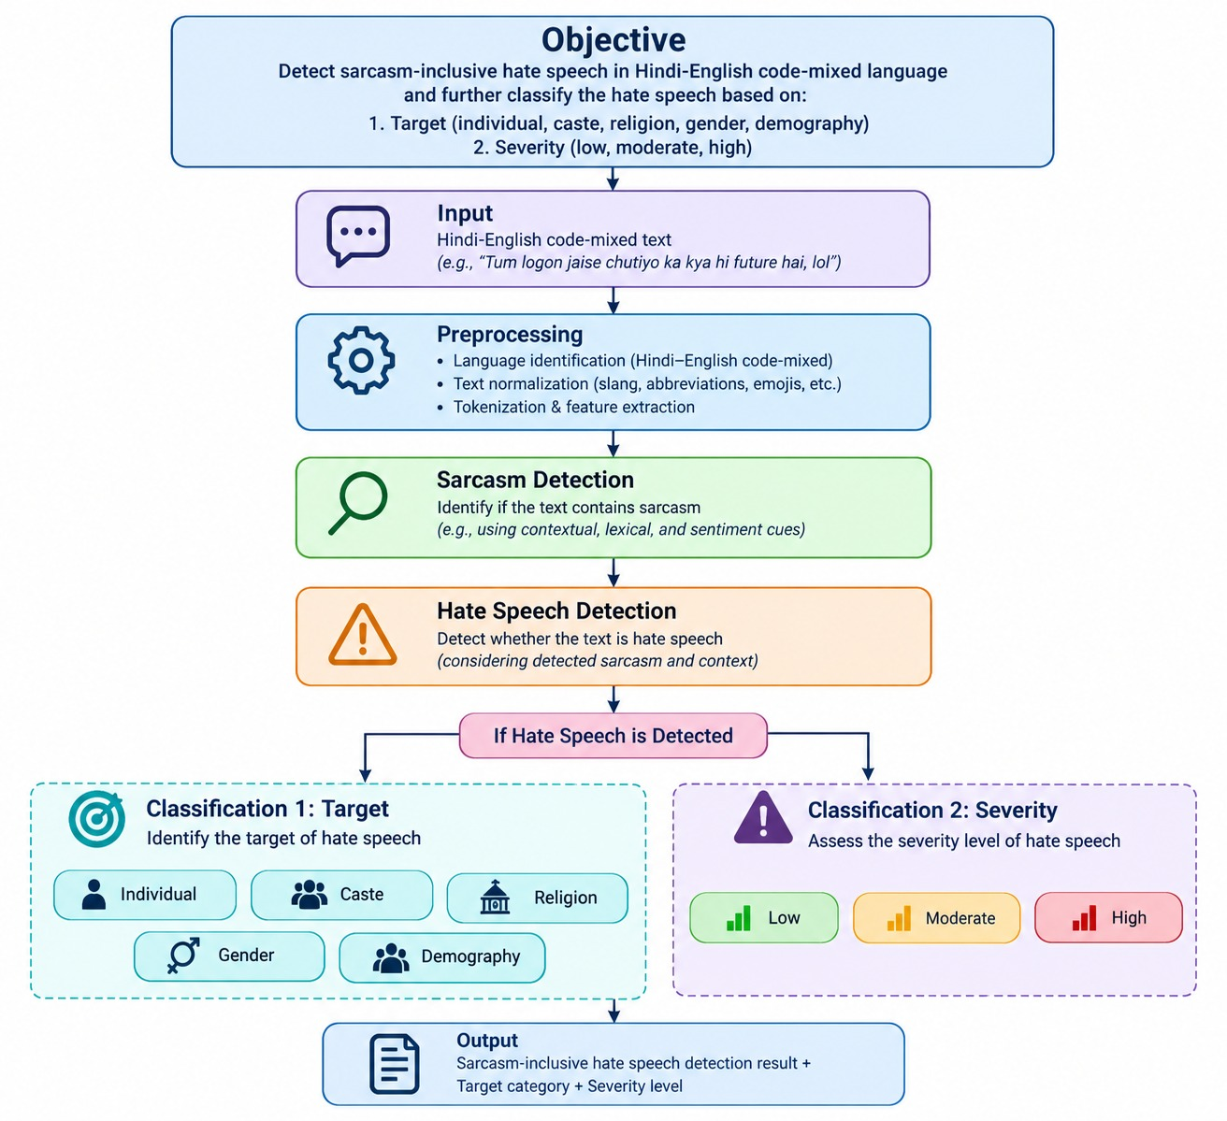
Figure 1. Project flow chart (supplied).
Flow-chart box | Implementation
Input | Raw Hinglish text (Roman, Devanagari or mixed; emoji; slang)
Preprocessing: language ID, normalisation, tokenisation and feature extraction | preprocessing/language_id.py, normalize.py, transliteration.py; sub-word tokenisation of the normalised words in data/dataset.py
Sarcasm Detection (contextual, lexical, sentiment cues) | Sarcasm branch: attention pooling over encoder states + 16-d cue vector (features.py)
Hate Speech Detection (considering sarcasm and context) | Hate branch + SarcasmAwareFusion gated by P(sarcasm)
If hate is detected: Classification 1 Target, Classification 2 Severity | Target (5-way) and severity (3-way) heads; the pipeline returns them only when hate is predicted
Output | ToxiFusionPipeline.predict() returns sarcasm, hate, target, severity, language information and token rationales

Table 3. Flow chart to code mapping.

6 Data

6.1 MultiBully: source and columns
The archive you supplied contains about 6,000 meme images and one annotation file (Cyberbully_corrected_emotion_sentiment.xlsx - cyberbully.csv) matching the official MultiBully release of Maity et al. (SIGIR 2022). The model uses only the text printed on the meme (OCR) and the labels; the images are not used.
Sheet column | Values | Used as
Img-Text | OCR text printed on the meme | Model input
Text-Label | Bully / Nonbully (judged on the text alone) | Hate label (default)
Img-Text-Label | Bully / Nonbully (image + text, the headline label) | Alternative hate label (sensitivity run)
Img-Label | Bully / Nonbully (image alone) | Not used
Sarcasm | Yes / No | Sarcasm label (gold)
Harmful-Score | Harmless / Partially-Harmful / Very-Harmful | Severity: low / moderate / high
Target | Individual / Organization / Community / Society / None | Target (4-class taxonomy)
Sentiment, Emotion | Negative-Neutral-Positive; ten emotion classes | Not used
Doubtful and a note column | Annotator flags (7 rows) | Rows excluded

Table 4. Columns of the annotation sheet and their role.

6.2 From sheet to analysis set
Step | Posts
Rows in the sheet | 5,865
Rows without any label (blank rows at the end) | -11
Annotator-flagged rows (Doubtful / note column) | -4
Duplicate texts removed (first occurrence kept) | -132
Analysis set | 5,718

The set is split once, stratified by hate and target, into 70% train, 15% validation and 15% test (fixed seed). Validation and test are larger than the usual 10% because several classes are small. For cross-validation (Section 10.3) the same posts are re-split into five stratified folds by hate and sarcasm.
Split | Posts | Hate | Sarcastic | Sarcastic hate | Individual | Community | Organization | Society | Low / Mod. / High severity
train | 4,002 | 1,106 | 1,517 | 599 | 726 | 175 | 57 | 48 | 98 / 981 / 27
val | 858 | 237 | 300 | 117 | 155 | 38 | 12 | 10 | 22 / 215 / 0
test | 858 | 237 | 312 | 131 | 156 | 38 | 12 | 10 | 21 / 213 / 3

Table 5. Split sizes and label supports. Target and severity are defined for hate posts only; hate posts whose Target is None carry no target label.

6.3 What the labels look like
- Hate (Text-Label = Bully): 1,580 of 5,718 posts (27.6%). The meme-level label is positive for 55% of posts, which is why the two labels differ so much.
- Sarcasm: 2,129 posts (37.2%). Among hate posts 53.6% are sarcastic, so sarcasm and hate are strongly associated, and sarcastic hate is the *majority* of hate in this dataset.
- Target among labelled hate posts: individual 1,037, community 251, organization 81, society 68; a further 143 hate posts have Target = None.
- Severity among hate posts: moderate 1,409 (89.2%), low 141, high only 30. Severity is nearly constant, so macro-F1 for this task is dominated by two rare classes.
- Language (heuristic estimate): 38.3% of posts contain at least one token tagged Hindi and 24.9% are mostly Hindi, but only 2.2% use Devanagari; mean code-mixing index 9.4. The corpus is therefore a mixture of English memes and Romanised Hinglish, not uniformly code-mixed. Posts have a median of 14 words (95th percentile 35).

6.4 Decisions taken (you allowed changes)
Question | Decision | Reason
Target taxonomy | Dataset's own: individual, organization, community, society | Caste, religion, gender and demography are not annotated; a mapping would invent information. The code supports both taxonomies through one setting.
Hate label | Text-Label | The model sees text only. The meme-level label depends partly on the image; a sensitivity run uses it (Section 10.7).
Severity | Harmless to low, Partially-Harmful to moderate, Very-Harmful to high | Direct ordinal mapping; the very small "high" class is kept and its weakness is reported.
Severity and target of non-hate posts | Left empty (masked) | Flow chart: classified only when hate is detected.
Hate posts with Target = None | No target supervision | Cannot be assigned a target class.
Flagged and duplicate posts | Removed | Annotator doubt; leakage between splits.
Split | 70 / 15 / 15 and five-fold cross-validation | Rare classes need larger evaluation sets; pooled folds give 81 organization, 68 society and 30 high-severity posts.

6.5 What would still need annotation
Rationale spans (needed for the plausibility metrics and for attention supervision, which is therefore switched off here), narrative flags (for the fake-narrative objective), target sub-types if you want the flow-chart taxonomy, and a second annotator for sarcasm to report label reliability. None of these block the results in Section 10.

6.6 Optional supplementary corpora
If a pre-trained encoder still cannot reach useful sarcasm detection from text, a Hinglish sarcasm corpus or multimodal features of the meme image could be added. Licences and label schemes must be checked individually; none are included.

7 Methodology

7.1 Preprocessing
Social-media Hinglish is noisy: the same word has many spellings, scripts are mixed, and emoji carry pragmatic meaning. The preprocessing stage (all steps switchable for ablation) is:
- Normalisation: Unicode NFKC; URLs and mentions masked; hashtags split (camel case) with sarcasm hashtags counted first; emoji converted to language-neutral tokens (emoji_face_with_rolling_eyes); lower-casing; repeated characters collapsed (yaaaar becomes yaar).
- Canonical spelling and slang: common Roman-Hindi variants merged (nhi/nahin to nahi, bohot/bahot to bahut); English chat abbreviations expanded (plz, u, omg). Profanity abbreviations are deliberately not expanded.
- Transliteration: Devanagari runs are transliterated to Roman by a heuristic mapper (matras, virama, anusvara, nukta, schwa deletion) so that mixed-script posts share one script. For production, replace by a dedicated library.
- Token-level language ID: each word is tagged Hindi, English or language-neutral using seed lexicons, suffix rules and neighbour context. From the tags we compute the code-mixing index CMI = 100 x (1 - max_lang_count / (n - u)) and the number of language switches.
- Sarcasm cue vector (16-d): counts of laughter, positive/negative emoji, exclamation, question, ellipsis, quotes, capitalisation, positive and negative sentiment words, polarity contrast (positive wording with negative or sarcastic evidence), sarcasm marker phrases, sarcasm hashtags, CMI, switch rate and length (Appendix A). Cues are computed on the raw text before normalisation removes them.

7.2 ToxiFusionNet architecture
A shared transformer encoder produces sub-word states H. Two additive attention poolings summarise H: α = softmax(vᵀ tanh(W hₜ)), pooled = Σ αₜ hₜ. The attention weights are kept because they double as token-level rationales.
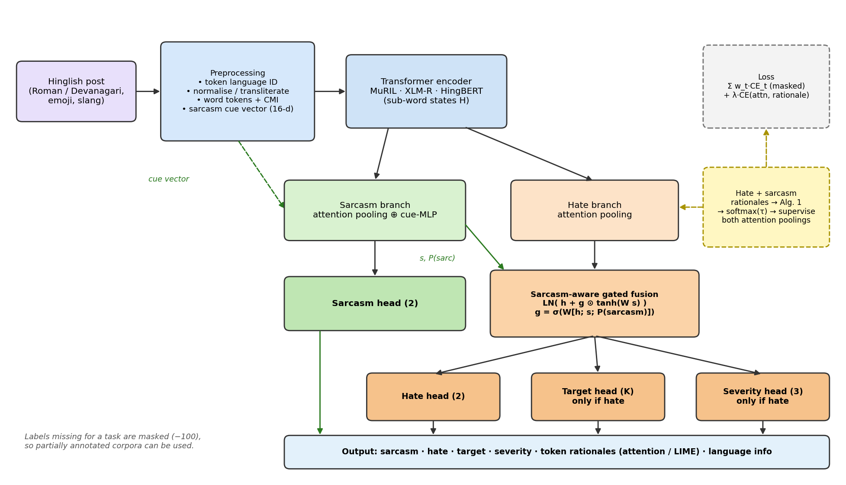
Figure 2. ToxiFusionNet architecture (solid: forward path; dashed: training-time rationale supervision).
- Sarcasm branch: the sarcasm-pooled vector is concatenated with a projection of the cue vector and passed through an MLP to give the sarcasm logits and a sarcasm representation s.
- Sarcasm-aware gated fusion: the hate-pooled vector h is corrected by s through a gate conditioned on the sarcasm probability p_{s}, so that a positive-sounding but sarcastic surface can be re-interpreted before the hate decision:
g = σ( W_{g} [h ; s ; p_{s}] ), f = LayerNorm( h + g ⊙ tanh( W_{s} s ) )
- Heads: hate (2 classes), target (K classes: 5 in the flow chart, 4 for MultiBully) and severity (3) all read the fused vector f. At inference target and severity are produced only when hate is predicted; during training they receive loss only on hate posts that carry a label.
Every architectural element has a configuration switch (use_sarcasm_branch, use_fusion, use_cue_features, tasks), so each ablation is a one-line override and all variants share code, data and evaluation.

7.3 Multi-task objective
For each task t the loss is cross-entropy on the labelled samples only (labels equal to the ignore index are skipped). Optional class weights (balanced) and focal loss (Lin et al., 2017) address imbalance. Two weighting schemes are supported:
fixed: L = Σ_{t} w_{t} · CE_{t} + λ · L_{att}
uncertainty: L = Σ_{t} ( ½ e^(−s_{t}) · CE_{t} + ½ s_{t} ) + λ · L_{att}
where s_{t} are learned log-variances (Kendall et al., 2018). Default fixed weights are sarcasm 1.0, hate 1.0, target 0.5, severity 0.5. The encoder uses a lower learning rate (2e-5) than the heads (5e-4), AdamW with linear warm-up, gradient clipping and early stopping on the mean validation macro-F1.

7.4 Sarcasm rationales as attention supervision
When a dataset provides rationale spans, the targets for the attention poolings are built as in Mamun et al. (2024): annotator rationales become 0/1 vectors and are averaged; the hate vector h and sarcasm vector s are merged token by token; the merged vector is mapped from words to sub-words and normalised by a temperature softmax (Figure 3). The attention loss L_{att} is the cross-entropy between this target distribution and the model's attention; the sarcasm attention is supervised by the sarcasm rationale alone.
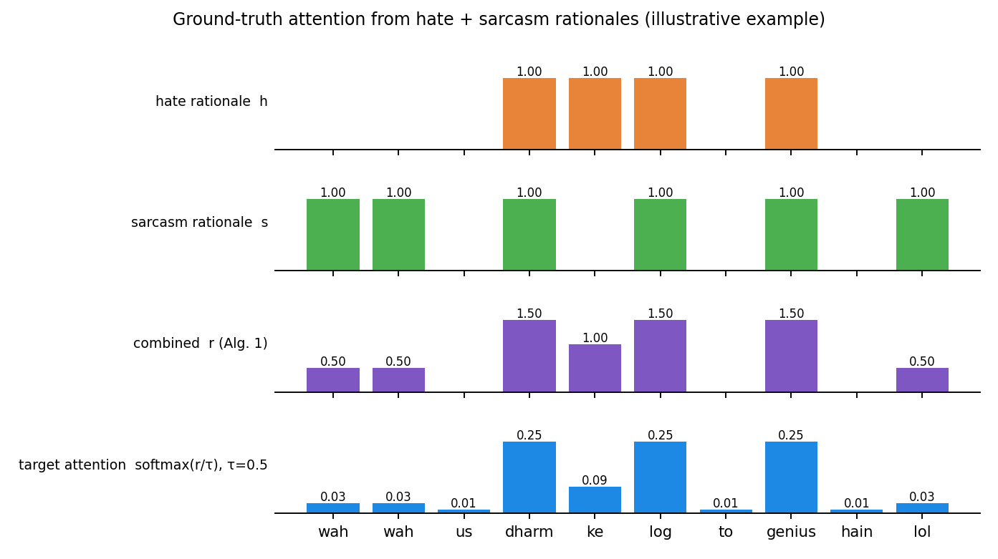
Figure 3. Construction of the ground-truth attention (illustrative example, tau = 0.5).
For MultiBully this component is switched off, because the sheet contains no rationale spans (rationale.enabled: false). The code remains available for a future annotated dataset, and the two ablation variants that depend on it are skipped automatically.
A discrepancy in the source paper that we resolved explicitly
The text of Mamun et al. states that a token marked by both hate and sarcasm receives the value 1.5 (sarcasm only 0.5, hate only 1). Their printed pseudo-code, however, assigns h + (s + h)/2 when s = h, which evaluates to 2 for s = h = 1.
The code implements both: rationale.mode: text (default, values 0.5 / 1 / 1.5) and mode: algorithm (literal pseudo-code). Report which one you use, or run both as an ablation.

7.5 Explainability
- Attention rationales: word-level attention (summed over sub-words); the top-k words are returned with the prediction (rationale.hate_tokens, rationale.sarcasm_tokens).
- LIME (Ribeiro et al., 2016): model-agnostic word importance for the hate decision (toxifusion explain --lime "text").
- ERASER-style metrics (DeYoung et al., 2020): plausibility (token-F1, IOU-F1, AUPRC against gold rationales) and faithfulness (comprehensiveness and sufficiency, which need no gold rationales).
- Human evaluation: toxifusion explain writes a CSV with predictions and rationales for annotators to rate plausibility and helpfulness on a 1–5 scale.

7.6 Default hyper-parameters
Group | Setting (configs/default.yaml)
Encoder | google/muril-base-cased (alternatives: xlm-roberta-base, l3cube-pune/hing-bert); max length 128
Heads | dropout 0.1, hidden 256, cue hidden 32
Optimisation | 5 epochs, batch 16, encoder lr 2e-5, head lr 5e-4, weight decay 0.01, warm-up 10%, clip 1.0, patience 3, fp16 on GPU
Loss | fixed weights 1/1/0.5/0.5, balanced class weights, focal gamma 0, attention lambda 0.1 (active only with rationales)
Rationale | temperature 0.5, mode text, sarcasm rationale on

These are reasonable starting values, not tuned values. Tune on the validation split only, using a small grid over learning rate, loss weights and attention lambda, and report the search space.

7.7 Encoders used in this study
Two encoder settings are configured. The one used for every result in this report is the CPU fallback (configs/multibully_cpu.yaml): a randomly initialised 3-layer BERT with 100-dimensional hidden states and a word-level vocabulary of 10,156 words built from the texts; the embedding table is initialised with GloVe-Twitter-100 vectors (Pennington et al., 2014, trained on 2 billion tweets), which exist for 94.9% of the vocabulary and cover 97.1% of the training tokens. Words from validation and test texts that GloVe knows keep their pre-trained vectors; no labels are involved in building the vocabulary. The model has about 1,417k parameters and trains in about 1.5 to 2 minutes per run on one CPU core.
The recommended setting for the paper is configs/multibully.yaml with a pre-trained transformer (default google/muril-base-cased; alternatives xlm-roberta-base, l3cube-pune/hing-bert) on a GPU. It was not run here: the build environment has one CPU core and could not download the weights. Static GloVe vectors carry English lexical knowledge but no context and little Romanised Hindi, so this configuration under-states what a pre-trained multilingual transformer can do, particularly on the Hinglish minority of the data.

8 Implementation

8.1 Repository layout
toxifusionnet/
├── configs/ default.yaml · smoke_test.yaml · schema_multibully.yaml
├── src/toxifusionnet/
│ ├── preprocessing/ lexicons · transliteration · language_id ·
│ │ normalize · features
│ ├── data/ schema · weak_labels · splits · synthetic · dataset
│ ├── models/ encoder · toxifusionnet · losses
│ ├── training/ trainer · metrics · stats
│ ├── explain/ rationale · metrics · lime_text · evaluate
│ ├── baselines/ classical (keyword, sentiment, TF-IDF + LR)
│ ├── robustness/ perturbations · evaluate
│ ├── experiments/ ablation · plots · report
│ ├── analysis/ describe
│ ├── inference/ pipeline · benchmark
│ ├── app/ api (FastAPI)
│ └── cli.py toxifusion <command>
├── tests/ (48) scripts/ (download_data.sh, run_final.sh) Makefile README.md
├── notebooks/ run_on_colab.ipynb
└── docs/ this report · make_figures.py · figures/

8.2 Command line
Command | Purpose
inspect / prepare | Understand a raw dataset (csv/xlsx), convert it to the canonical CSV with stratified splits
describe | Label distributions, sarcastic-hate counts per split, language mix, automatic power warnings
train | Train ToxiFusionNet; writes model, tokenizer, history, metrics.json, test predictions
baselines | Keyword, sentiment-lexicon and TF-IDF + logistic regression on the same split
ablate | Train nine variants plus the full model (several seeds); summary table and paired-bootstrap file
robust | Macro-F1, flip rate and sarcastic-hate FNR under eight perturbations
explain | Plausibility, faithfulness, optional LIME, human-evaluation sheet
bench / serve | Latency and size (fp32 vs int8), REST API
compare / figures | Paired bootstrap between two prediction files; plots
report | Collect every artefact into results/RESULTS.md
cv | Five-fold cross-validation with pooled out-of-fold predictions

8.3 Reproducibility and engineering choices
- Seeds are set for Python, NumPy and PyTorch; the full configuration, the label provenance and the tokenizer are saved inside each run directory, and inference rebuilds the model from the run directory alone.
- Any configuration value can be overridden on the command line (-o model.use_fusion=false), which is how every ablation is defined.
- Word-level rationales are aligned to sub-words with the tokenizer's word_ids, so the same code works for WordPiece (MuRIL, HingBERT) and SentencePiece (XLM-R) tokenizers.
- An offline mode (encoder_name: tiny) builds a small random BERT with a locally trained tokenizer, which keeps the test suite fast and network-free.

8.4 Running the study
# GPU + pre-trained encoder (recommended for the paper)
make final RAW=data/raw/multibully.csv ENC=google/muril-base-cased
# CPU only: small encoder initialised with GloVe-Twitter vectors (what this report used)
bash scripts/get_glove.sh
CFG=configs/multibully_cpu.yaml CV=1 bash scripts/run_final.sh data/raw/multibully.csv
toxifusion cv --config configs/multibully_cpu.yaml --out-dir runs/cv # pooled 5-fold cross-validation

make final trains eight variants for each seed and writes every table to results/RESULTS.md. Finished runs are re-used when a run is repeated, so an interrupted study can simply be restarted.

9 Experimental protocol
This is the protocol that was actually executed, including where it deviates from the plan in your Research Motivation document.
Element | What was done
Data and splits | 5,718 posts; 70/15/15 stratified split for model comparison; five-fold stratified cross-validation (folds stratified by hate and sarcasm; 15% of each training part used for validation) for pooled out-of-fold predictions
Systems | Majority class; keyword lexicon; negative-sentiment lexicon; TF-IDF + logistic regression (word and character n-grams; one classifier per task); transformer with hate head only; multi-task without sarcasm; sarcasm as auxiliary task without fusion; full ToxiFusionNet; four secondary ablations
Seeds | Three seeds (42, 43, 44) for the four main neural systems; one seed for the secondary ablations; one seed per cross-validation fold
Model selection | Eight configurations compared on the validation split only, by mean macro-F1 over the four tasks (rule fixed beforehand); the test split was not used for selection. Two exploratory runs before the search were inspected on the test split to choose the encoder family; this is disclosed here
Metrics | Macro-F1 and balanced accuracy per task, AUROC for sarcasm and hate, false-negative rate and F1 on sarcastic hate, precision / recall / false-positive rate for operating points, per-class results from pooled folds
Statistics | Paired bootstrap over test posts (1,000 to 2,000 resamples) for differences between systems; normal-approximation interval for recall gaps. These intervals reflect test-set sampling only, not training randomness
Robustness | Eight text perturbations applied to the test split, including fake-narrative framing
Explainability | Attention rationales; faithfulness (comprehensiveness, sufficiency). Plausibility could not be computed: MultiBully has no rationale spans
Not run | Cross-validation of the hate-only transformer (time); more seeds for secondary ablations; rationale-supervision variants (no rationales); LIME on this model; any pre-trained transformer (no network / GPU)

10 Results and verification
All numbers come from the run artefacts in results/ and runs/ (also summarised in results/RESULTS.md). The model is the small GloVe-initialised encoder described in Section 7.7.

10.1 Main comparison (test split, 858 posts)
System | Hate macro-F1 | Hate AUROC | Missed sarcastic hate (FNR) | Hate F1 within sarcastic posts | Sarcasm macro-F1 | Target macro-F1 | Severity macro-F1
Majority class | 0.420 | 0.500 | 1.000 | 0.000 | 0.389 | 0.210 | 0.316
Keyword lexicon | 0.550 | 0.565 | 0.863 | 0.242 | n/a | n/a | n/a
Negative-sentiment lexicon | 0.551 | 0.563 | 0.855 | 0.250 | n/a | n/a | n/a
TF-IDF + logistic regression | 0.649 | 0.742 | 0.489 | 0.578 | 0.576 | 0.299 | 0.336
Transformer, hate head only (3 seeds) | 0.676 ± 0.007 | 0.763 ± 0.006 | 0.379 ± 0.034 | 0.624 ± 0.018 | n/a | n/a | n/a
Multi-task, no sarcasm (3 seeds) | 0.673 ± 0.012 | 0.765 ± 0.004 | 0.448 ± 0.012 | 0.573 ± 0.013 | n/a | 0.371 ± 0.049 | 0.370 ± 0.003
Sarcasm auxiliary, no fusion (3 seeds) | 0.659 ± 0.003 | 0.765 ± 0.001 | 0.341 ± 0.075 | 0.629 ± 0.026 | 0.589 ± 0.001 | 0.349 ± 0.026 | 0.393 ± 0.032
ToxiFusionNet (full) (3 seeds) | 0.661 ± 0.017 | 0.760 ± 0.004 | 0.369 ± 0.027 | 0.599 ± 0.011 | 0.581 ± 0.014 | 0.335 ± 0.014 | 0.370 ± 0.022

Table 6. Test-split results (mean ± standard deviation over seeds for neural systems; baselines are deterministic). n/a: task not modelled.
- All neural variants (hate macro-F1 0.659 to 0.676) are above TF-IDF (0.649) on this split, and far above the lexicons (about 0.55), which confirms that the task needs more than keywords or sentiment.
- The plain hate-only transformer is the best single system (0.676 ± 0.007); the full model scores 0.661 ± 0.017. The gap is about one seed standard deviation, so it is suggestive at most.
- Models that learn sarcasm miss fewer sarcastic hate posts (FNR 0.34 to 0.37 vs 0.45 without sarcasm), but Section 10.4 shows that this is largely a change in decision threshold, not better ranking.

10.2 Secondary ablations and single-split significance (seed 42)
Variant vs. full model (seed 42) | Seeds in Table 6 | Δ hate macro-F1, full − variant [95% CI] | Δ recall on sarcastic hate [95% CI]
Hate head only | 3 | −0.038 [−0.066, −0.010] | +0.037 [−0.031, +0.107]
Multi-task, no sarcasm | 3 | −0.030 [−0.057, −0.007] | +0.092 [+0.038, +0.153]
Sarcasm auxiliary, no fusion | 3 | −0.011 [−0.037, +0.015] | −0.045 [−0.115, +0.023]
No hand-crafted cue features | 1 | −0.014 [−0.042, +0.014] | +0.154 [+0.092, +0.229]
Uncertainty loss weighting | 1 | −0.014 [−0.037, +0.010] | +0.085 [+0.038, +0.137]
No text normalisation | 1 | −0.017 [−0.049, +0.015] | −0.084 [−0.168, +0.000]
No Devanagari transliteration | 1 | −0.021 [−0.046, +0.006] | +0.076 [+0.023, +0.137]

Table 7. Paired bootstrap on the test split, seed 42 only. Negative Δ means the variant is better than the full model.
Seed 42 happens to be an unfavourable seed for the full model (its hate macro-F1 is 0.643 against a three-seed mean of 0.661), so the intervals for the variants without the sarcasm branch exclude zero. This illustrates why a single seed must not be over-interpreted; the cross-validation in Section 10.3 is the more reliable comparison. None of the four secondary ablations (one seed each) separates clearly from the full model on overall hate detection.

10.3 Cross-validation: pooled out-of-fold results
Each of the 5,718 posts is predicted once by a model that never saw it. Five folds, one seed per fold.
System | Hate macro-F1 | Hate AUROC | Sarcasm macro-F1 | Target macro-F1 (balanced acc.) | Severity macro-F1 (balanced acc.) | FNR sarcastic hate | FNR non-sarcastic hate
TF-IDF + logistic regression | 0.671 | 0.763 | 0.559 | 0.374 (0.351) | 0.372 (0.364) | 0.47 | 0.49
Full model, no fusion | 0.652 | 0.761 | 0.560 | 0.371 (0.400) | 0.404 (0.443) | 0.29 | 0.28
ToxiFusionNet (full) | 0.667 | 0.761 | 0.558 | 0.375 (0.398) | 0.390 (0.423) | 0.35 | 0.30

Table 8. Pooled five-fold cross-validation (5,718 posts).
- Per-fold hate macro-F1 of the full model ranges from 0.662 to 0.679: the estimate is stable across folds.
Full model compared with | Δ hate macro-F1 [95% CI], one-sided p | Δ recall on sarcastic hate [95% CI] (n = 847)
TF-IDF + logistic regression | −0.004 [−0.018, +0.010], p = 0.700 | +0.119 [+0.085, +0.153]
Same model without fusion | +0.015 [+0.005, +0.027], p = 0.003 | −0.061 [−0.091, −0.032]

Table 9. Paired bootstrap on pooled predictions (positive Δ: full model better).
The full model is statistically indistinguishable from TF-IDF on overall hate detection. Against its own no-fusion variant it is slightly better in macro-F1 (Δ +0.015), but that gap is of the same size as the seed-to-seed standard deviation in Table 6 and the bootstrap ignores training randomness, so it should not be reported as a significant effect.

Per-class results for target and severity (pooled folds, full model)
Target class | Posts | Precision | Recall | F1
individual | 1,037 | 0.80 | 0.74 | 0.77
community | 251 | 0.40 | 0.36 | 0.38
organization | 81 | 0.19 | 0.37 | 0.25
society | 68 | 0.08 | 0.12 | 0.10

Severity class | Posts | Precision | Recall | F1
low | 141 | 0.12 | 0.24 | 0.16
moderate | 1,409 | 0.90 | 0.79 | 0.84
high | 30 | 0.13 | 0.23 | 0.16

Table 10. Per-class results. Only the majority classes (individual, moderate) are predicted reliably; society, organization, low and high severity are barely above chance.

10.4 Sarcastic versus non-sarcastic hate: is fusion helping?
Hypotheses H1 and H2 concern sarcastic hate specifically. Two views are needed because a model can lower its miss rate simply by flagging more posts.
Hate recall | On sarcastic hate | On non-sarcastic hate | Gap (non-sarc. − sarc.) [95% CI]
ToxiFusionNet (full) | 0.647 (n = 847) | 0.704 (n = 733) | +0.057 [+0.011, +0.103]
Without fusion | 0.708 (n = 847) | 0.718 (n = 733) | +0.009 [−0.035, +0.054]
TF-IDF + LR | 0.528 (n = 847) | 0.513 (n = 733) | −0.015 [−0.064, +0.035]

Table 11. Recall of hate posts split by sarcasm (pooled folds). Only the fusion model shows a clear gap (interval excludes zero).
Hate AUROC (threshold-free) | ToxiFusionNet (full) | Without fusion | TF-IDF + LR | Full − no fusion [95% CI] | Full − TF-IDF [95% CI]
Sarcastic posts (n = 2,129) | 0.742 | 0.760 | 0.775 | −0.018 [−0.032, −0.004] | −0.033 [−0.052, −0.013]
Non-sarcastic posts (n = 3,589) | 0.778 | 0.765 | 0.756 | +0.014 [+0.001, +0.026] | +0.023 [+0.006, +0.041]
All posts (n = 5,718) | 0.761 | 0.761 | 0.763 | +0.000 [−0.008, +0.010] | −0.001 [−0.014, +0.012]

Table 12. Ranking quality of the hate score within subsets (pooled folds).
System | Subset | Precision | Recall | False-positive rate | Share flagged as hate (true: 27.6%)
ToxiFusionNet (full) | all | 0.47 | 0.67 | 0.28 | 39.2%
ToxiFusionNet (full) | sarcastic | 0.59 | 0.65 | 0.29 | 43.4%
ToxiFusionNet (full) | non-sarcastic | 0.39 | 0.70 | 0.28 | 36.6%
No fusion | all | 0.45 | 0.71 | 0.33 | 43.7%
No fusion | sarcastic | 0.59 | 0.71 | 0.33 | 48.0%
No fusion | non-sarcastic | 0.36 | 0.72 | 0.33 | 41.1%
TF-IDF + LR | all | 0.53 | 0.52 | 0.18 | 27.4%
TF-IDF + LR | sarcastic | 0.68 | 0.53 | 0.16 | 30.9%
TF-IDF + LR | non-sarcastic | 0.41 | 0.51 | 0.19 | 25.3%

Table 13. Operating points of the three systems (default decision threshold 0.5).
Reading Tables 11 to 13 together:
- The neural systems flag 39.2% (full) and 43.7% (no fusion) of posts as hate although only 27.6% are, whereas TF-IDF flags 27.4%. Their lower miss rate in Table 6 is therefore mostly a more liberal threshold (false-positive rate 0.28 and 0.33 vs 0.18), not better detection. At the threshold-free level all three systems are tied overall (AUROC 0.761, 0.761, 0.763).
- H1 (sarcastic hate is missed more) holds only for the fusion model: its recall on sarcastic hate is 0.647 against 0.704 on non-sarcastic hate. For the no-fusion model and TF-IDF there is no gap.
- H2 (fusion helps sarcastic hate) is not supported; the data point the other way. Within sarcastic posts the fusion model has the lowest AUROC of the three (0.742 vs 0.760 and 0.775) and the intervals for the differences to the no-fusion model (−0.018) and to TF-IDF (−0.033) exclude zero. On non-sarcastic posts it is slightly better (+0.014 vs no fusion, interval barely above zero), so fusion moves performance away from the posts it was designed for. Plausible reason: sarcasm cannot be predicted well from the text (AUROC 0.58), so the gate receives an almost uninformative signal and the fusion mainly adds noise on exactly the posts it was designed for. This explanation was not tested directly.

10.5 Robustness
Perturbation | Hate macro-F1 | Change | Predictions that flip | FNR sarcastic hate | False alarms on non-hate
none (original) | 0.643 | +0.000 | 0.0% | 0.34 | 0.34
spelling_noise | 0.636 | −0.008 | 4.9% | 0.33 | 0.36
elongation | 0.633 | −0.010 | 6.3% | 0.29 | 0.37
transliteration_variants | 0.642 | −0.001 | 0.1% | 0.34 | 0.34
code_switch_shift | 0.644 | +0.001 | 0.2% | 0.34 | 0.34
neutral_emoji | 0.640 | −0.004 | 7.3% | 0.30 | 0.37
sarcasm_cue_injection | 0.621 | −0.023 | 8.3% | 0.27 | 0.40
narrative_framing | 0.484 | −0.160 | 32.8% | 0.18 | 0.66
case_noise | 0.643 | +0.000 | 0.2% | 0.34 | 0.34

Table 14. Full model (seed 42) on the test split under perturbations.
- Spelling noise, elongation, alternative transliterations, code-switching, case changes and neutral emoji change macro-F1 by at most 0.010 in absolute terms, and sarcasm-cue injection by 0.023: these perturbations barely matter to the model.
- Fake-narrative framing is the exception. Adding a forwarded-message or conspiracy-style phrase to a post flips 32.8% of predictions, cuts macro-F1 by 0.160 and doubles false alarms on non-hate posts (0.34 to 0.66). The model takes the framing words as evidence of hate. I did not diagnose the cause; adding such framings to the training data, or lexicon-based masking of them, would be the obvious fix. The perturbation is synthetic, so it indicates fragility, not the size of a real-world effect.

10.6 Explainability and deployment cost
- Faithfulness (237 hate posts, top-5 attended words): removing them lowers the predicted hate probability by 0.33 on average (comprehensiveness); keeping only them leaves the probability 0.22 below the full-text value (sufficiency, lower is better). The highlighted words matter to the model, but are not sufficient on their own. Plausibility against human rationales could not be measured because MultiBully has none; the exported human-evaluation sheet has not been rated.
Model | Batch size | Latency per batch (ms) | Per text (ms) | Texts per second | Size (MB)
fp32 | 1 | 2.70 | 2.70 | 370.3 | 5.70
fp32 | 8 | 5.43 | 0.68 | 1,472 | 5.70
fp32 | 32 | 13.91 | 0.43 | 2,301 | 5.70
int8_dynamic | 1 | 3.08 | 3.08 | 324.4 | 4.62
int8_dynamic | 8 | 5.84 | 0.73 | 1,369.5 | 4.62
int8_dynamic | 32 | 13.41 | 0.42 | 2,386.9 | 4.62

Table 15. CPU latency of the small model (single core). Int8 quantisation shrinks it by about 19% without a speed-up at this size; the figures do not transfer to a 100M-parameter transformer.

10.7 Sensitivity: meme-level hate label
Repeating the study with the meme-level label (Img-Text-Label, 54.9% positive, 1,591 sarcastic-hate posts) gives hate macro-F1 0.638 and AUROC 0.709 for the full model against 0.654 and 0.703 for TF-IDF (majority baseline 0.354; one seed). The AUROC of both is lower than with the text-level label (about 0.76), consistent with the meme-level label depending partly on the image. The numbers are not directly comparable because the class balance differs.

10.8 Hyper-parameter selection (validation split)
Configuration | Best epoch | Mean macro-F1 | Hate F1 | Hate AUROC | Sarcasm F1 | Target F1 | Severity F1
A_base | 7 | 0.491 | 0.693 | 0.786 | 0.545 | 0.377 | 0.349
B_layers1 | 10 | 0.481 | 0.677 | 0.769 | 0.543 | 0.362 | 0.343
C_drop03 | 6 | 0.495 | 0.699 | 0.790 | 0.557 | 0.366 | 0.359
D_lr1e3 | 6 | 0.492 | 0.703 | 0.793 | 0.558 | 0.358 | 0.350
E_layers3 | 7 | 0.502 | 0.680 | 0.782 | 0.581 | 0.392 | 0.353
F_embfull | 4 | 0.475 | 0.698 | 0.760 | 0.548 | 0.339 | 0.314
G_reg | 12 | 0.491 | 0.705 | 0.774 | 0.554 | 0.367 | 0.339
H_smallhead | 11 | 0.489 | 0.699 | 0.778 | 0.540 | 0.383 | 0.334

Table 16. Validation scores of the eight candidate configurations (A: base 2 layers; B: 1 layer; C: dropout 0.3; D: learning rate 1e-3; E: 3 layers; F: full embedding learning rate; G: stronger regularisation; H: smaller head). Differences are within noise; E was selected by the pre-set rule.

10.9 What the study does and does not show
Hypothesis | Verdict on MultiBully (small encoder) | Evidence
H1 Sarcastic hate is missed more often than non-sarcastic hate | Mixed | True for the fusion model (recall gap +0.057, interval excludes 0); not for no-fusion or TF-IDF
H2 Fusing sarcasm lowers the miss rate on sarcastic hate without losing precision | Not supported | Lower AUROC within sarcastic posts; lower recall; difference in miss rate elsewhere is a threshold effect
H3 Rationale supervision improves explanations | Not testable | No rationale spans in the data
H4 Multi-task learning does not hurt hate detection and helps target / severity | Half supported | Hate: multi-task 0.673 ± 0.012 vs hate-only 0.676 ± 0.007 (tied). Target / severity: no gain over separate TF-IDF classifiers

What this does not show: that sarcasm-aware modelling is useless. It shows that, with a small from-scratch text encoder, on this dataset, a sarcasm representation learned from the text alone does not improve hate detection. Whether a pre-trained multilingual encoder (MuRIL, XLM-R, HingBERT) or image features change this is the central open question and the next experiment (Section 12).

10.10 Verification of the software
Area | Tests | What they check
Preprocessing | 7 | URL/mention masking, hashtags, Devanagari transliteration, elongation/slang, emoji tokens, language ID and CMI, cue vector
Rationales and explainability | 6 | Merge values 0.5/1/1.5 (2.0 in literal mode), mask formats, annotator votes, sub-word mapping, plausibility / faithfulness
Schema and data | 5 | Deriving hate/target from a class column, weak-label flagging, value maps, schema guesser, stratified splits
Model and loss | 9 | Output shapes, attention normalisation, every ablation switch, fusion gate, missing-label masking, uncertainty weighting, attention loss
Metrics and statistics | 4 | Sarcastic-subset FNR, end-to-end metrics, paired bootstrap, McNemar
End to end | 8 | Training artefacts, pipeline output, batch/single consistency, robustness, all-task baselines, REST API, saved-checkpoint loading, configuration inheritance
MultiBully data path | 9 | Column mapping, hate from Text-Label, severity and target mapping, loose column names, out-of-taxonomy targets, flagged rows, .xlsx reading, data report, four-class training and inference

All 48 tests pass offline in about ten seconds. Not covered by automated tests: the GloVe loader on the full file (exercised by the real runs), the Colab notebook (not executed) and any GPU run.

11 Limitations, risks and ethics
Issue | Consequence | Mitigation
Small from-scratch encoder (no pre-trained transformer) | Results may under-state, or even change the sign of, the effects of interest | Re-run with make final and MuRIL / XLM-R / HingBERT on a GPU
Sarcasm labels depend on the image; the model reads text only | Sarcasm AUROC about 0.6 for all systems; the fusion gate gets a weak signal | Add image features (e.g. a CLIP encoder) or report a multimodal baseline
Meme-level target and severity labels | Severity is nearly constant (89% moderate; 30 "high"); target classes society / organization are tiny | Pooled cross-validation for per-class numbers; consider merging or re-annotating
Target taxonomy differs from the flow chart | Caste / religion / gender / demography are not available | Dataset taxonomy used; annotate targets for the flow-chart version
Significance tests ignore training randomness | Small gaps (about 0.01 to 0.02 F1) can look significant | Use several seeds per fold, report seed standard deviations, avoid over-claiming
Secondary ablations have one seed; hate-only model has no cross-validation | Weak evidence for those comparisons | Run more seeds (resumable) if the comparisons matter for the paper
Decision threshold fixed at 0.5 | Operating points differ strongly between systems (Table 13) | Report threshold-free metrics; calibrate or tune the threshold on validation
Mostly English, OCR text, heuristic language ID | Weaker code-mixing claim; language shares are estimates | State the language mix; use a trained language-ID model for the paper
Fake-narrative framing breaks the model | Large increase in false alarms under a plausible input shift | Training-time augmentation or masking of framing phrases; real narrative-labelled data
Possible harm of misclassification | False positives on dialect, reclaimed slurs or identity terms; false negatives on coded hate | Per-group error analysis; use for human-review triage, not automatic sanctions

Data ethics. The data contain abusive and discriminatory content and the dataset repository states no licence in its README. Confirm the terms with the authors before redistributing posts: the packaged results contain no post text. Mentions are masked by the pipeline; support annotators with content warnings if you annotate further.

12 Roadmap to the journal paper
- Run the pre-trained encoder (highest priority). make final RAW=data/raw/multibully.csv ENC=google/muril-base-cased on a GPU or in the Colab notebook, then the same with xlm-roberta-base and l3cube-pune/hing-bert. Add CV=1 for pooled results. Everything else in this report is reproducible and will simply be re-filled.
- Re-test H2 with the pre-trained encoder and several seeds per fold. Compare full model, no-fusion and hate-only on AUROC within sarcastic posts, not only on miss rates, and tune the decision threshold on validation.
- Address the image. Add an image-feature branch (or at least a text-plus-image baseline) to test whether sarcasm detection and sarcastic-hate detection improve; this is also a natural extension of the paper.
- Fix fake-narrative fragility. Augment training with narrative-style framings and re-measure Table 14; collect real narrative-labelled posts if the secondary objective stays in the paper.
- Decide on target and severity. Keep the dataset taxonomy and report macro results with pooled cross-validation, or merge / re-annotate the rare classes; the current numbers do not support strong claims for them.
- Optional annotation. Rationale spans for 500 to 1,000 hate posts would enable H3 and the plausibility metrics; a second sarcasm annotator would give label reliability.
- Write. Sections 2 to 9 provide Introduction, Methods and Experimental Setup; Section 10 provides Results and Discussion; Section 11 Limitations. State the negative finding for the small encoder honestly and frame the pre-trained-encoder result as the main comparison.
Items to verify when writing: all citations (those not re-fetched are marked in the References), the dataset licence, the novelty statement, and every number after the GPU re-run.

Appendix A Sarcasm cue features
# | Cue | Definition (computed on raw text unless noted)
1 | n_laugh | log(1 + laughter tokens such as lol, haha, plus laughing emoji)
2 | emoji_pos | log(1 + positive emoji)
3 | emoji_neg | log(1 + negative or sarcastic emoji)
4 | n_exclaim | log(1 + number of '!')
5 | n_question | log(1 + number of '?')
6 | has_ellipsis | 1 if '...' present
7 | n_quotes | log(1 + quoted spans), scare quotes
8 | caps_ratio | share of letters in fully capitalised words
9 | n_pos_words | log(1 + positive-sentiment words), normalised text
10 | n_neg_words | log(1 + negative-sentiment words), normalised text
11 | polarity_contrast | 1 if positive wording co-occurs with negative or sarcastic evidence
12 | n_markers | log(1 + sarcasm marker phrases, e.g. 'kya baat hai', 'oh really')
13 | hashtag_sarcasm | 1 if #sarcasm, #not, #irony and similar
14 | cmi | code-mixing index / 100
15 | switch_rate | language switches per word
16 | log_len | log(1 + words) / 5

Appendix B Example pipeline output
Output of toxifusion predict from the trained small model on an invented example sentence (long lists abridged with '...'). The model is nearly undecided here (hate probability 0.495, sarcasm 0.496), which is typical for this small model on sarcastic text; the example illustrates the format only. Target and severity are empty because hate was not predicted.
{
"text": "Wah bhai wah, kya genius idea hai, great job yaar lol 🙄",
"normalized_text": "wah bhai wah , kya genius idea hai , great job yaar lol emoji_face_with_rolling_eyes",
"language": {
"tags": ["wah/hi", "bhai/hi", "wah/hi", ",/univ", "kya/hi", "genius/en", "..."],
"code_mixing_index": 45.5,
"switches": 5,
"dominant": "hi"
},
"sarcasm": {"label": "not_sarcastic", "prob": 0.4958},
"hate": {"label": "non_hate", "prob": 0.495},
"target": null,
"severity": null,
"sarcasm_fusion_gate": 0.4814,
"rationale": {
"hate_tokens": [["genius", 0.2015], ["bhai", 0.1498], ["yaar", 0.0784]],
"sarcasm_tokens": [["yaar", 0.3352], ["bhai", 0.251], ["genius", 0.2207]]
}
}

Appendix C Command cheat-sheet
pip install -e ".[explain,serve,dev]"
make test # 48 tests, offline
make smoke-multibully # data path on synthetic rows

# data: put the annotation csv/xlsx in data/raw/
make inspect RAW=data/raw/multibully.csv

# GPU + pre-trained encoder (for the paper)
make final RAW=data/raw/multibully.csv ENC=google/muril-base-cased

# CPU only (used for this report)
bash scripts/get_glove.sh
CFG=configs/multibully_cpu.yaml CV=1 \
bash scripts/run_final.sh data/raw/multibully.csv

toxifusion predict --run-dir models/multibully_cpu_full_seed42 \
--text "Wah bhai wah, kya genius idea hai lol"
toxifusion train -o model.use_fusion=false # any config override

References
[1] Pennington, J., Socher, R., Manning, C. D. (2014). GloVe: Global Vectors for Word Representation. EMNLP. (Twitter vectors as redistributed in gensim-data.) (verify)
[2] Maity, K., Jha, P., Saha, S., Bhattacharyya, P. (2022). A Multitask Framework for Sentiment, Emotion and Sarcasm aware Cyberbullying Detection from Multi-modal Code-Mixed Memes. SIGIR '22, 1739–1749. Dataset and code: github.com/Jhaprince/MultiBully. (repository README read; paper seen only in search excerpts; page numbers from a secondary citation)
[3] Mamun, M. B., Tsunakawa, T., Nishida, M., Nishimura, M. (2024). Hate Speech Detection by Using Rationales for Judging Sarcasm. Applied Sciences, 14(11), 4898. doi:10.3390/app14114898. (read in full)
[4] Mathew, B., Saha, P., Yimam, S. M., Biemann, C., Goyal, P., Mukherjee, A. (2021). HateXplain: A Benchmark Dataset for Explainable Hate Speech Detection. AAAI, 35, 14867–14875. (bibliographic data from the Mamun et al. reference list)
[5] Jagdale, S., Khade, O., Takalikar, G., Inamdar, M., Joshi, R. (2024). On Importance of Code-Mixed Embeddings for Hate Speech Identification. arXiv:2411.18577. (abstract read)
[6] Khanuja, S., et al. (2021). MuRIL: Multilingual Representations for Indian Languages. arXiv:2103.10730. (verify)
[7] Conneau, A., et al. (2020). Unsupervised Cross-lingual Representation Learning at Scale (XLM-R). ACL. (verify)
[8] Devlin, J., Chang, M.-W., Lee, K., Toutanova, K. (2019). BERT: Pre-training of Deep Bidirectional Transformers for Language Understanding. NAACL. (verify)
[9] Kendall, A., Gal, Y., Cipolla, R. (2018). Multi-Task Learning Using Uncertainty to Weigh Losses for Scene Geometry and Semantics. CVPR. (verify)
[10] Lin, T.-Y., Goyal, P., Girshick, R., He, K., Dollár, P. (2017). Focal Loss for Dense Object Detection. ICCV. (verify)
[11] Ribeiro, M. T., Singh, S., Guestrin, C. (2016). “Why Should I Trust You?” Explaining the Predictions of Any Classifier. KDD. (verify)
[12] DeYoung, J., et al. (2020). ERASER: A Benchmark to Evaluate Rationalized NLP Models. ACL. (verify)
[13] Das, A., Gambäck, B. (2014). Identifying Languages at the Word Level in Code-Mixed Indian Social Media Text. ICON. (verify (code-mixing index))
[14] Loshchilov, I., Hutter, F. (2019). Decoupled Weight Decay Regularization (AdamW). ICLR. (verify)

