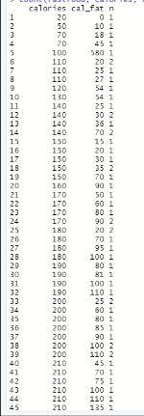

**Descriptive measure of calories over cal_fat**

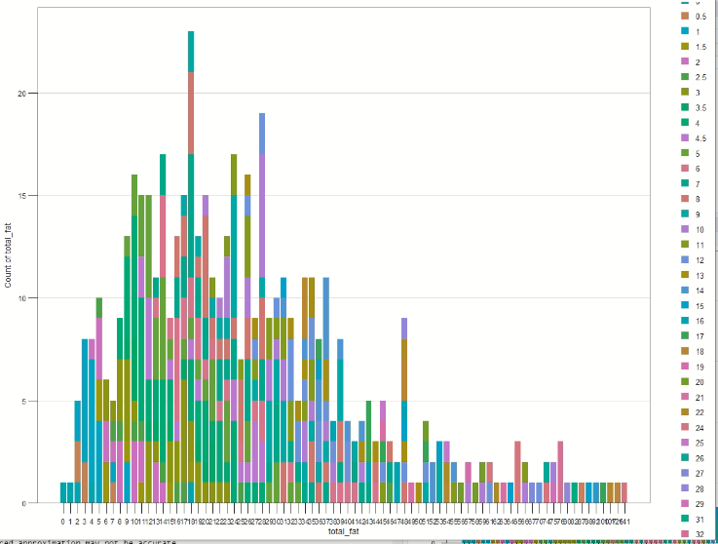

**Barchart of total fat by sat_fat**

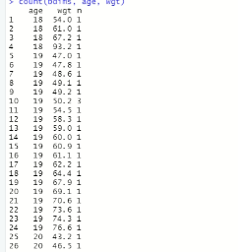

**Statistical view of wgt per hgt**

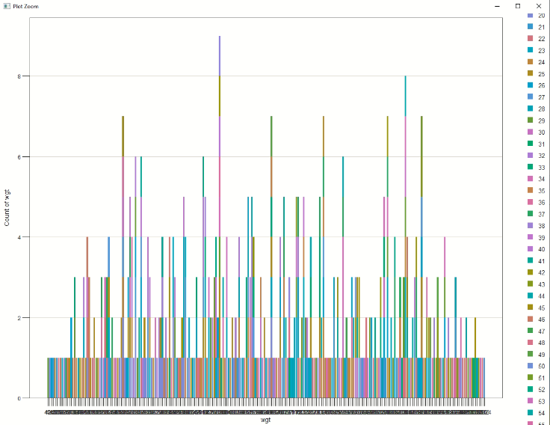

**Bar chart of wgt**

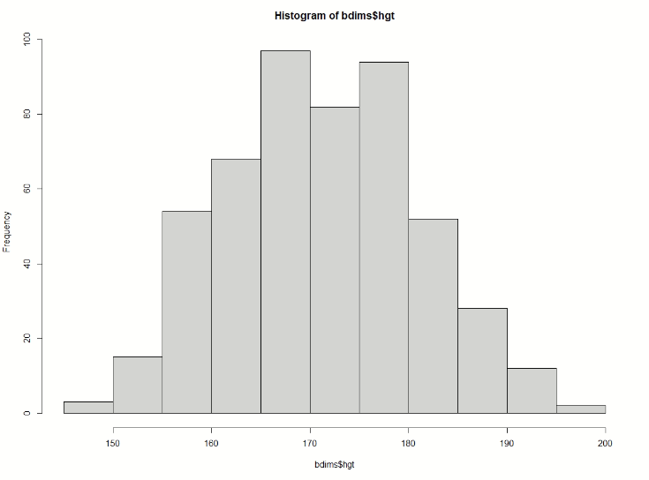

**Histogram of hgt in bdims**

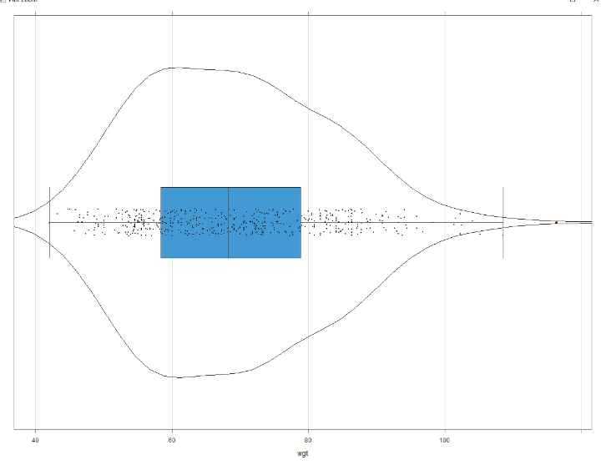

**Scatter Chart of wgt**