**Houseitt: Web Development Task**

A small ER model of a property search website:-

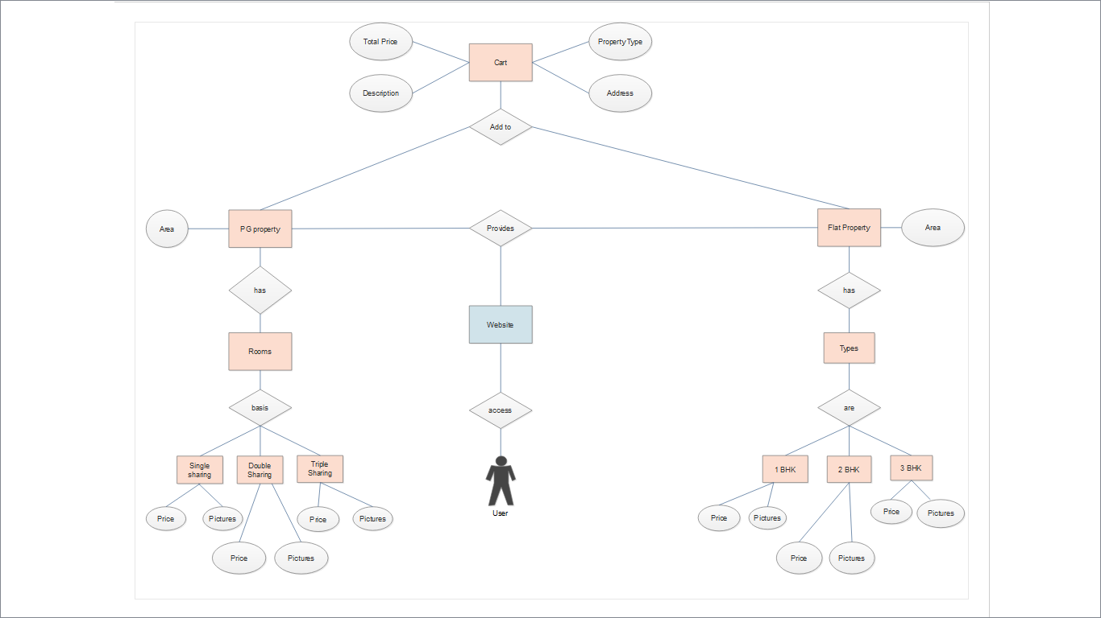

**Entities**: Website, PG property, Flat property, Cart, etc

**Relationships:** Provides, access, types, basis, etc

**Attributes:** Price, pictures, area, etc

**\*\*Corresponding Django model class for Cart**

* Defining a basic class Cart storing fields like Total Price, PropertyType, Address and Description as mentioned in the ER model selected by the user.

from django.db import models

class Cart(models.Model):

property_type: models.CharField(max_length = 128) #PG or Flat

description: models.CharField(max_length=200) #1,2 or 3 BHK or 1,2 or 3 sharing

address: models.CharField(max_length=200) #Address of the property

price: models.IntegerField() #total price of the property

**Also, we can define a class User to take user info:-

class User(models.Model):

name: models.CharField(max_length=200) #defines name

phone: models.IntegerField() #defines phone number

email: models.CharField(max_length=200) #defines email address

date_created: models.DateTimeField(auto_now_add=True) #request creation time

def __str__(self): #returns the name entered in above class as a string

return self.name

**These classes will work only by proper defining of views and templates and making migrations accordingly calling the MVT structure (Model Views Templates) which is the basis of Django framework.