**Experiment -4**

**To make UML user case diagram of website administration**

Some part of the administrative interfaces should be also available to the Help desk staff, as they need to be able to assist customers having issues while using the customer-oriented website.

Top level use case diagram below shows some administrative functions that administration website could provide.

Two [actors](https://www.uml-diagrams.org/use-case-actor.html) using administrative interfaces are **Website Administrator** and**Help Desk**. Help Desk uses a subset of functions available to the Website Administrator. All top level [use cases](https://www.uml-diagrams.org/use-case.html) shown are abstract as each represents some group or "package" of administrative functionality.

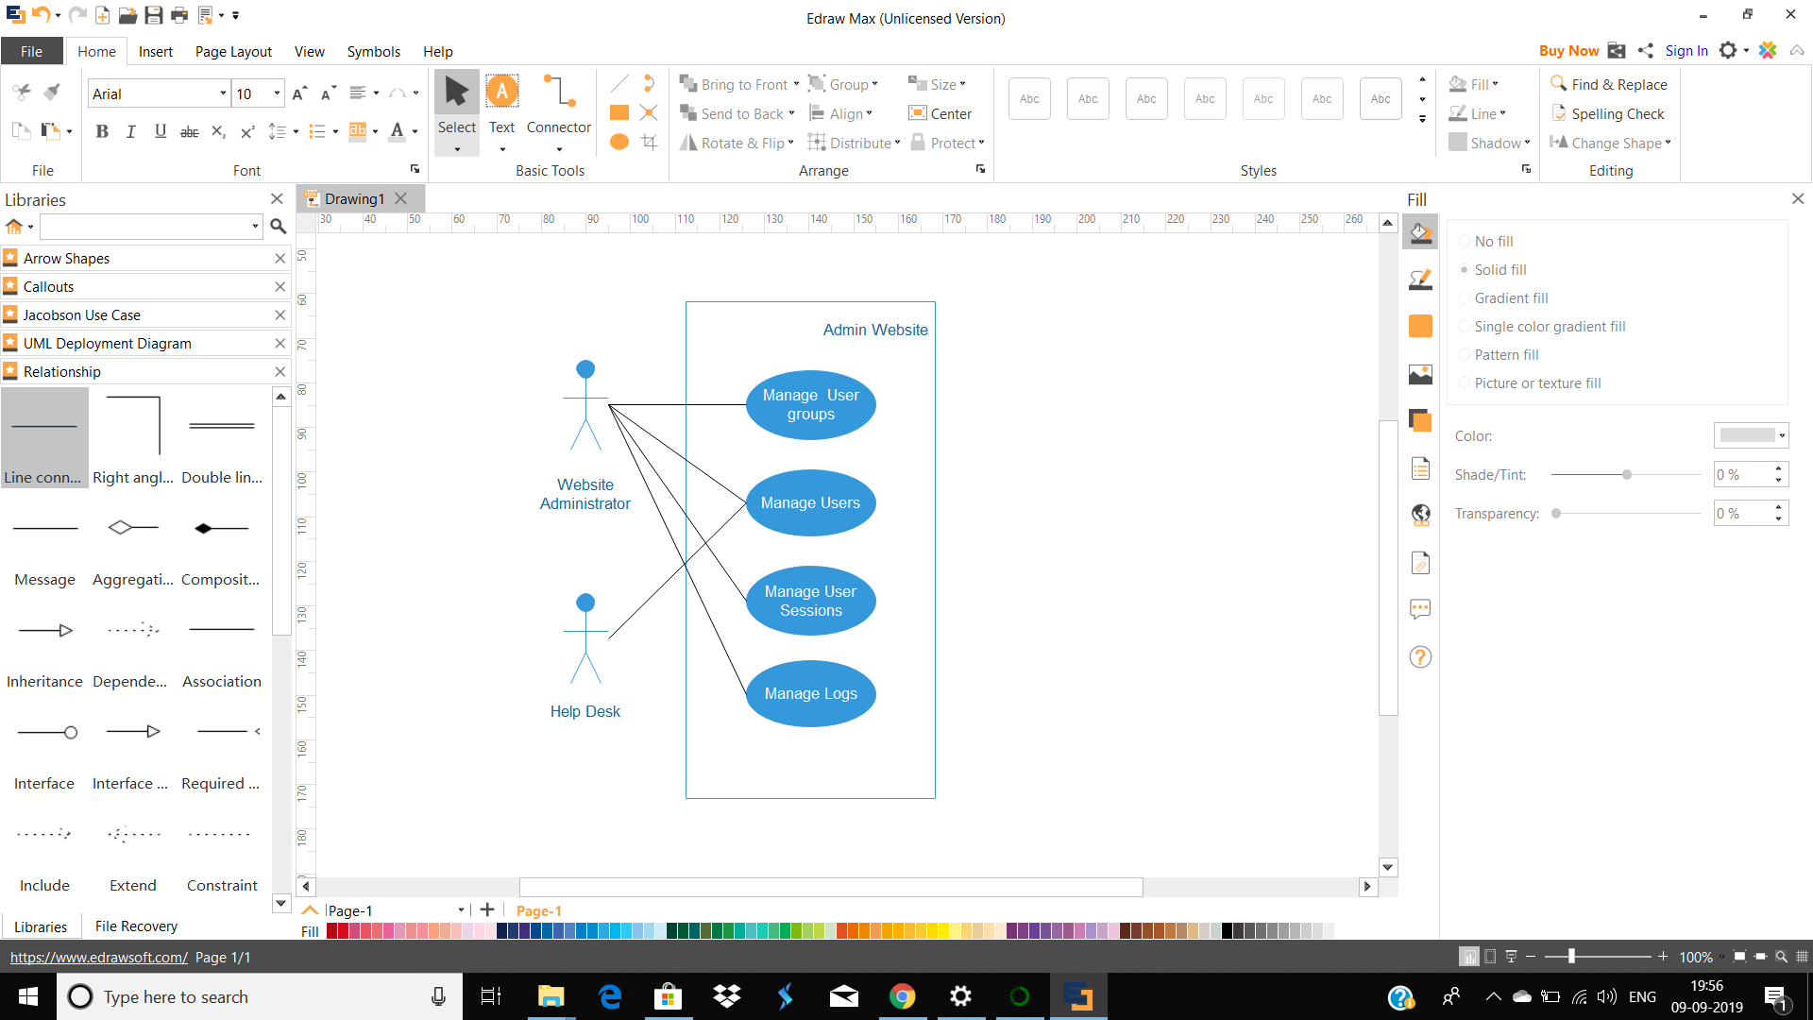

**Manage User Groups** abstract use case is specialized by **Create Group, Update Group**, and **Delete Group** use cases. The idea is that website administrator could create different user groups, for example, having different privileges or options, and later some user groups could be modified or even deleted.

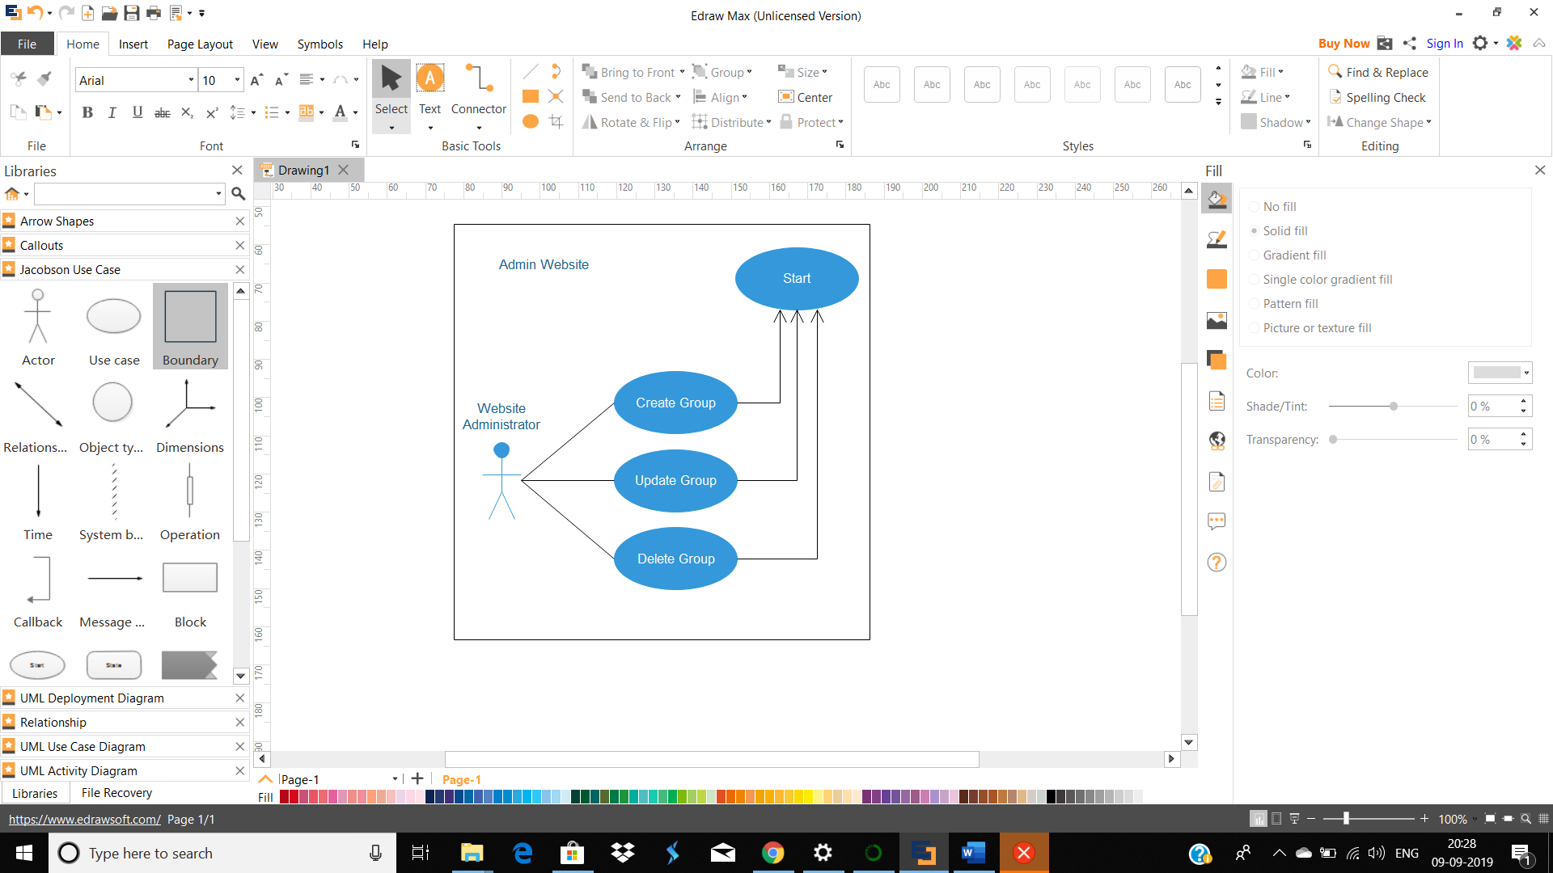  
User management use cases are available both to the **Website Administrator** and to the **Help Desk**. There is standard user CRUD (Create, Retrieve/Find, Update, Delete) functionality set.

Two other use cases, **Lock User** and **Unlock User** are specific to website security. For example, if during some predefined period of time there were several unsuccessful login attempts using wrong user password, user account should be locked for some predefined time to prevent possible brute force password guessing attack. This locking and unlocking is usually done automatically by intrusion detection or website authentication subsystem, but this functionality needs to be available in the manual mode too, just in case. For example, some user might call and ask to lock his or her account.

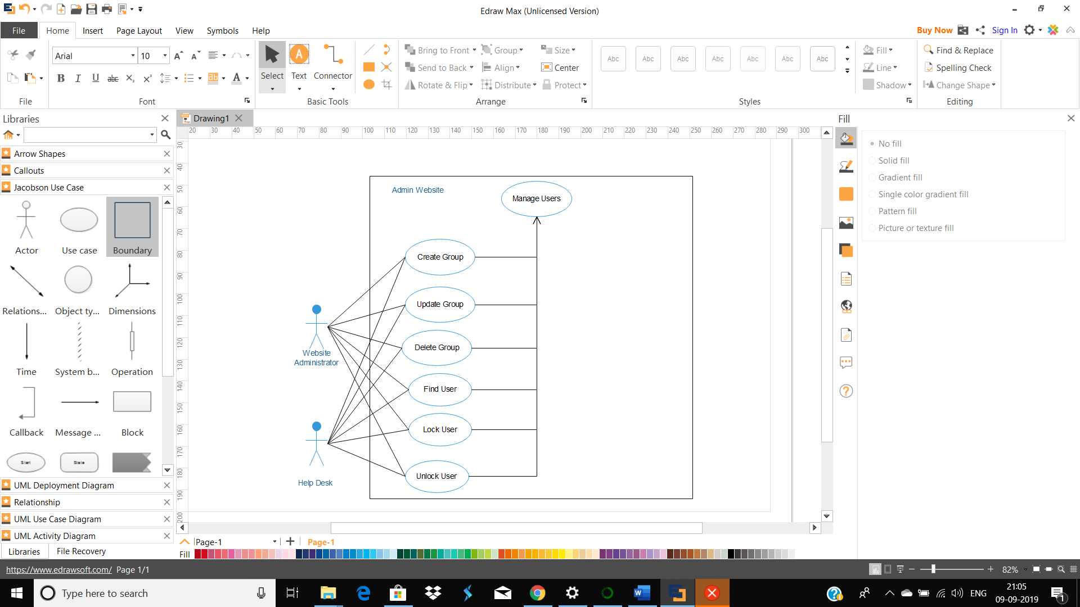

User session is created either for each new incoming request that is not yet part of a session, or/and after user was authenticated. Website administrator should have ability to see how many sessions were created, including some statistics about sessions, to find some specific session and see status of that session, and to cancel (delete) some session, if required.

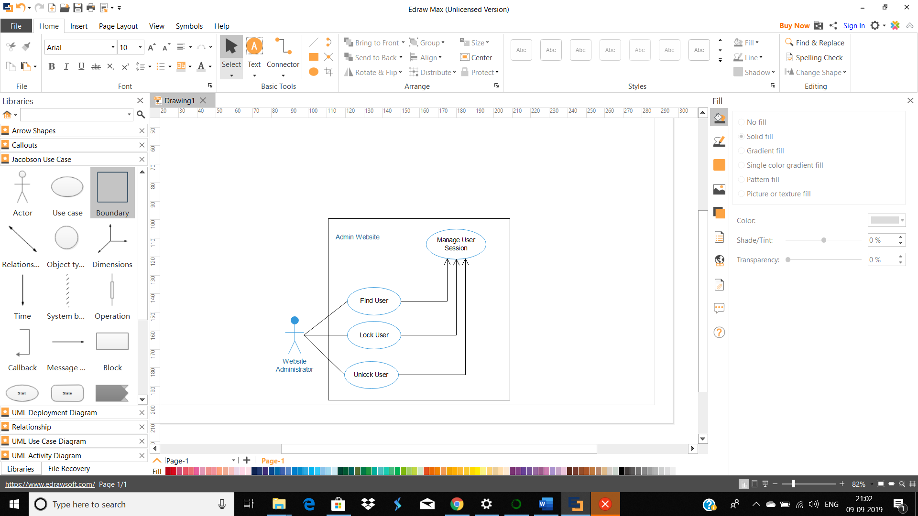  
List of administrative functions included in the **log management** depend on the security requirements supported and implemented by the website. Website administrator should be able to see status of logs. The status could include verification that logging is still functional (there is enough space on disk and/or connection to database is not stale), and that older log files are on schedule being moved to a permanent storage for archiving.

