**Problem Solving**

**Yammer Problem: -**

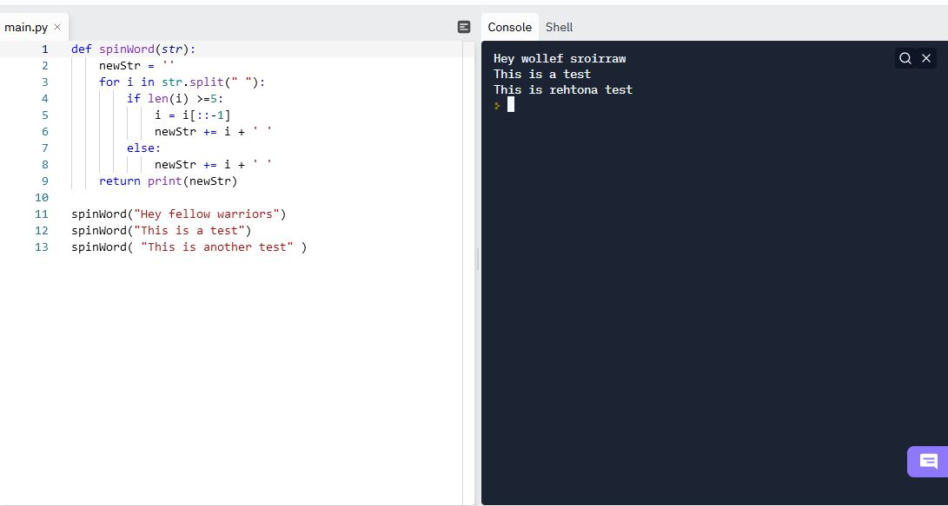

**Easy Problem:**

1929. Concatenation of Array:

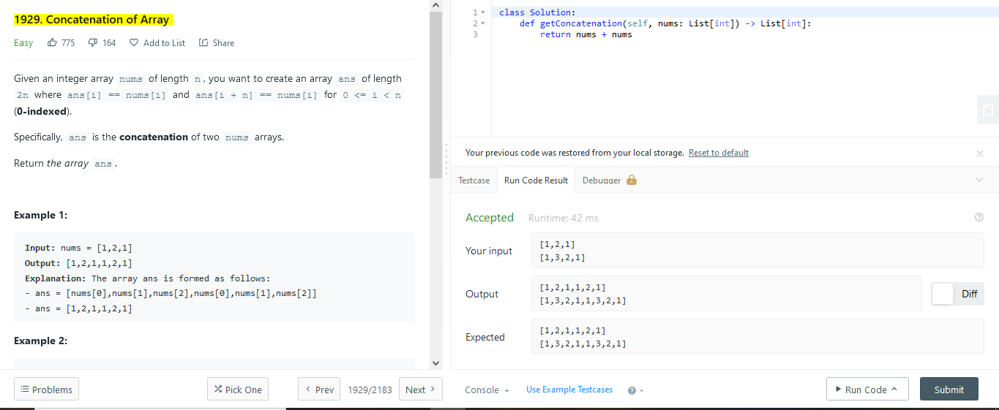

1480. Running Sum of 1d Array:

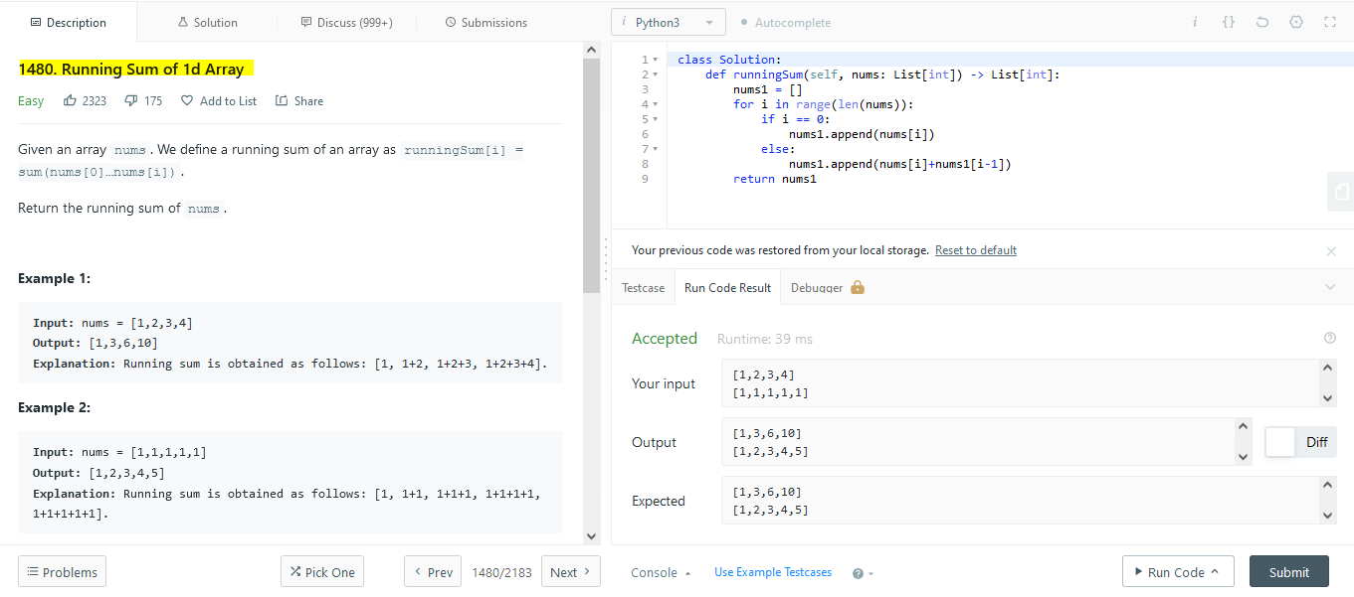

1365. How Many Numbers Are Smaller Than the Current Number:

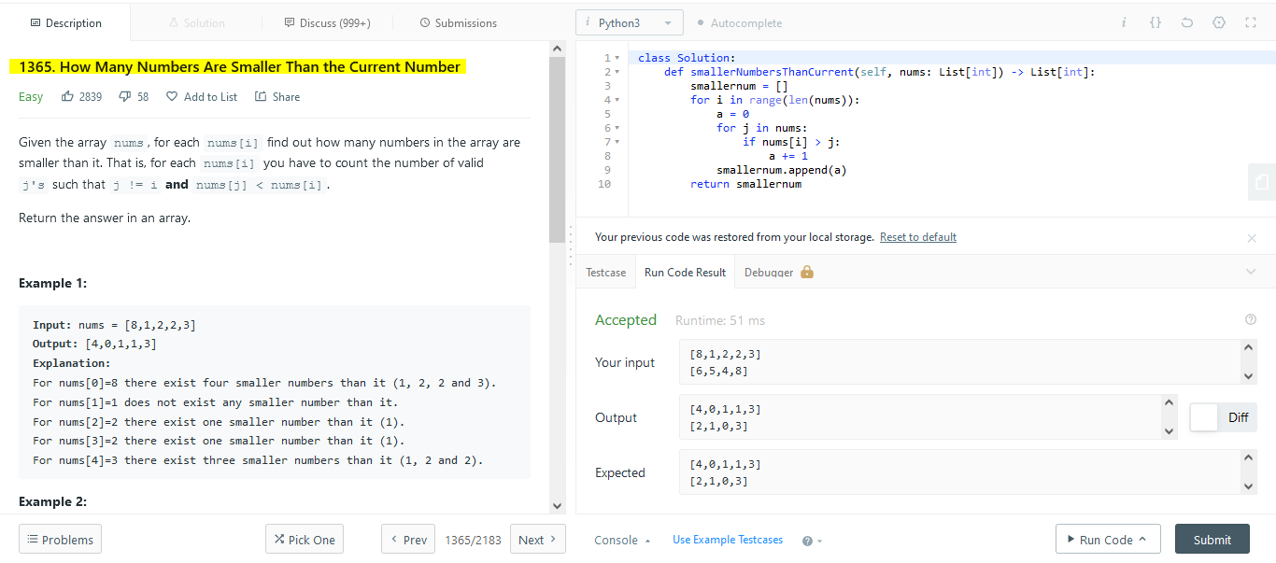

2006. Count Number of Pairs With Absolute Difference K: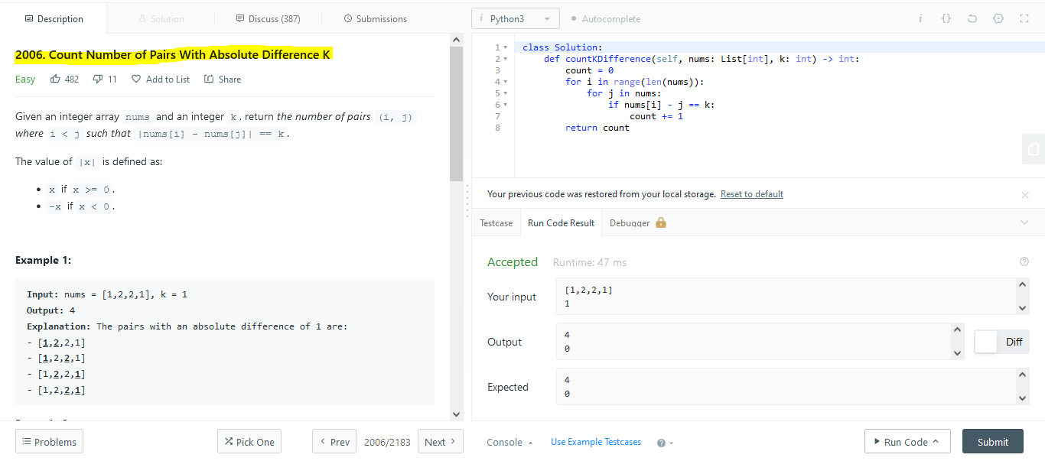

1662. Check If Two String Arrays are Equivalent:

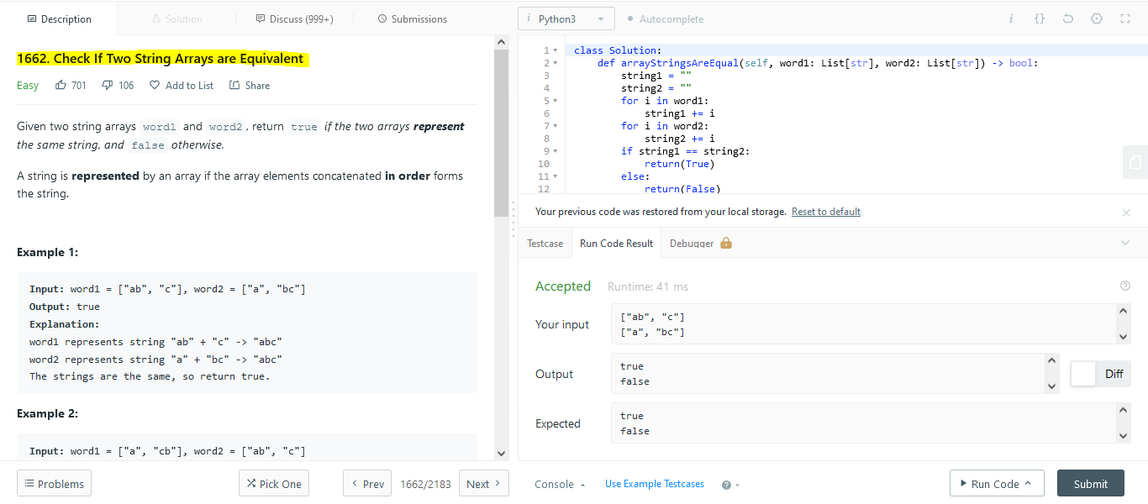

**Medium Problem:**

2. Add Two Numbers:

