MINI-PROJECT REPORT
Protocol Analysis with Wireshark
Unit 2: Network Models and Protocols
Student Name | Shubham Shinde
PRN | 2125UCSM1042
Course / Module | Unit 2: Network Models and Protocols
Project Title | Protocol Analysis with Wireshark (NPC Assignment 2)
Tools / Environment | Wireshark (v4.x) on Kali Linux (eth0)
GitHub Repository | Protocol-Analysis-with-Wireshark
GitHub Link | https://github.com/ShubhamShinde148/Protocol-Analysis-with-Wireshark

1. Aim
To capture and analyze network packets using Wireshark, identify the TCP three-way handshake (SYN, SYN-ACK, ACK), and observe the subsequent HTTP GET request.
2. Software and Requirements
- Kali Linux
- Wireshark (open-source network protocol analyzer)
- Mozilla Firefox or another web browser
- Internet connection
- Active network interface: eth0
3. Procedure
- Open Wireshark in Kali Linux and select the active network interface (eth0).
- Start packet capture.
- Open a web browser and navigate to http://neverssl.com.
- Wait for the webpage to load, then stop the packet capture.
- Apply the display filter 'http' to locate HTTP traffic.
- Identify the HTTP GET request and its corresponding TCP connection.
- Analyze the TCP three-way handshake: SYN, SYN-ACK, and ACK.
- Record the source and destination IP addresses and TCP port numbers.
- Save the packet capture in .pcapng format.
4. TCP Three-Way Handshake Observation
The captured TCP connection shows the standard three-way handshake used to establish a reliable TCP connection before HTTP data is exchanged.
Packet | Packet No. | Source IP | Source Port | Destination IP | Destination Port
SYN | 87 | 192.168.17.130 | 34078 | 34.223.124.45 | 80
SYN-ACK | 103 | 34.223.124.45 | 80 | 192.168.17.130 | 34078
ACK | 104 | 192.168.17.130 | 34078 | 34.223.124.45 | 80
5. HTTP GET Request
After the TCP connection was established, the client sent an HTTP GET request to the server. The observed request was:
GET / HTTP/1.1
The HTTP server responded successfully with an HTTP 200 OK response.
Packet | Source IP | Source Port | Destination IP | Destination Port
HTTP GET (105) | 192.168.17.130 | 34078 | 34.223.124.45 | 80
6. Transport Layer Analysis
The transport-layer protocol used in this communication is TCP. The client used the ephemeral source port 34078, while the web server listened on destination port 80, the standard port for HTTP. The TCP handshake established the connection before the HTTP GET request was transmitted.
7. Result
The network traffic was successfully captured and analyzed using Wireshark. The TCP three-way handshake and the subsequent HTTP GET request were identified successfully. The source and destination IP addresses and TCP port numbers were recorded from the capture.
8. Conclusion
This practical demonstrated how Wireshark can be used to inspect network protocols at the packet level. The analysis showed that a TCP connection is established using SYN, SYN-ACK, and ACK packets, after which the client can send an HTTP GET request over TCP port 80. Wireshark provides useful visibility into IP addresses, transport-layer ports, TCP flags, and application-layer HTTP traffic.
9. Screenshots
The following screenshots should be inserted in this section in the final submission:
Figure 1: TCP three-way handshake and HTTP GET packet (Packet 87, 103, 104, and 105).
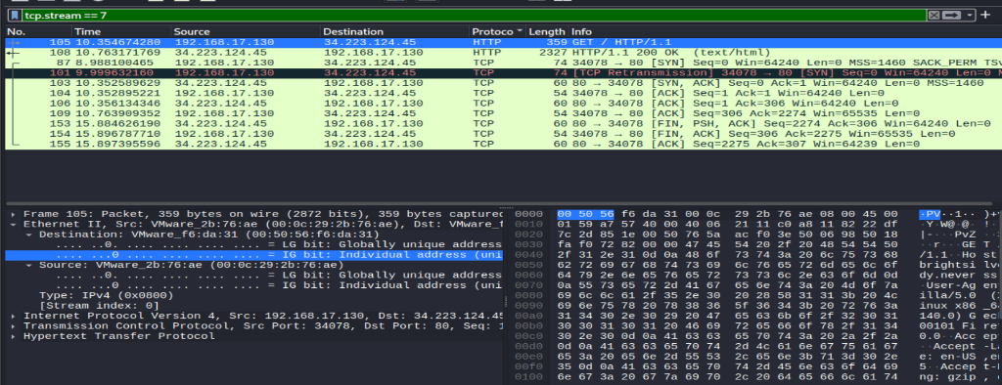
Figure 2: HTTP GET request and HTTP 200 OK response.
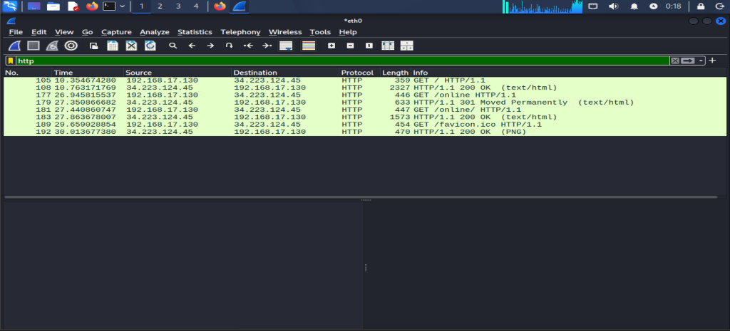
10. Submission Evidence Checklist
- ✓ GitHub Repository: https://github.com/ShubhamShinde148/Protocol-Analysis-with-Wireshark
- ✓ Wireshark Packet Capture file: protocol_analysis.pcapng
- ✓ TCP Handshake Screenshot: Figure_1_TCP_Handshake.png
- ✓ HTTP Traffic Screenshot: Figure_2_HTTP_Traffic.png
- ✓ Project Documentation Report: Protocol_Analysis_with_Wireshark_Report.docx & PDF

