**CONTACT**

**Shubham Shirbhate**

**Data Engineer**

**Phone**: 9823794667

**Email**: [Shubhamshirbhate310@gmail.com](mailto:Shubhamshirbhate310@gmail.com)

**Address**: Nakhate Wasti, Rahatni Main Road, Pune

**OBJECTIVE**

My objective is to work in a challenging position with an organization that encourages continuous learning, creativity and provides ample opportunities to learn and explore and to contribute in the field of Development and Operations.

**WORK SUMMARY**

**EDUCATION**

* Insightful knowledge of Docker, Kafka, Data Processing tool, Django (python), IOT, Web Development, GitHub, Linux and Monitoring applications
* Quick learner and excellent team player having ability to work on different environments
* Problem solving & technical skills with confident decisions making for enabling effective solutions leading to high customer satisfactions and low operation costs.
* Leading R&D team to work with various new technologies, taking hands on experience and find out needful insights and handover to respective teams.
* SME of Kafka and Docker, also part of end to end kafka POC, development and implementation using python.
* Good understanding in connector like source and sink
* Having insightful knowledge of connector and able to work with kafka by using python
* Good Knowledge on Postgres, MySQL DB and Python
* Good Knowledge of DevOps key concepts like Git, Repository, CI/CD Pipeline

**Bachlor of Engineering**

Sant Gadge Baba Amravati University, Amravati.

2016 – 2020

**HSC**

2014-2016

**SKILLS**

* **Python**
* **Kafka**
* **Linux/Window**
* **SQL**
* **Jenkins**
* **Docker**
* **Database**
* **AWS**
* **IoT**
* **Kong**
* **Airflow**
* **GitHub**
* **Ranger**

**WORK EXPERIENCE**

**Company: Tata Technologies Pvt. Ltd**. 2021 -2023

* It involved dockerization of 50+ applications integrating different technologies, tools and customized images as per developer requirements including binding with domain and managing ports with networks
* Hands on experience on apache, Red Hat and confluent kafka
* Experience on Kafka for real-time data Production from source and Consumption from topic including demonstration on dashboard and RDBS.
* Implementing source and sink connector for data production and consumption
* Writing python script for consuming data from topic and dumping it to destination like (RDBS, ELK, MongoDB)

 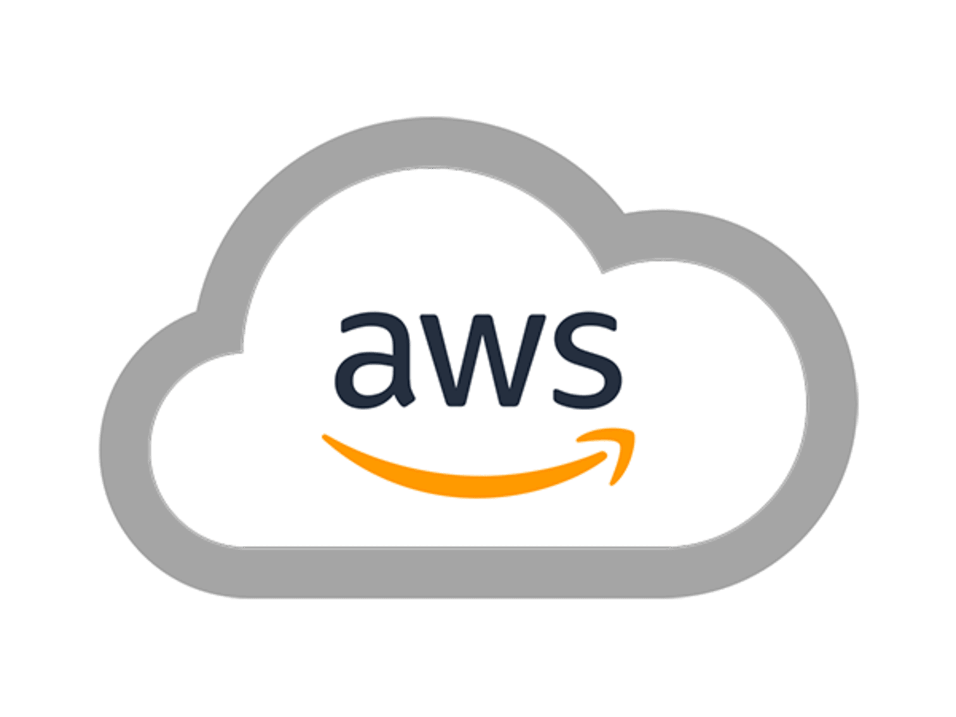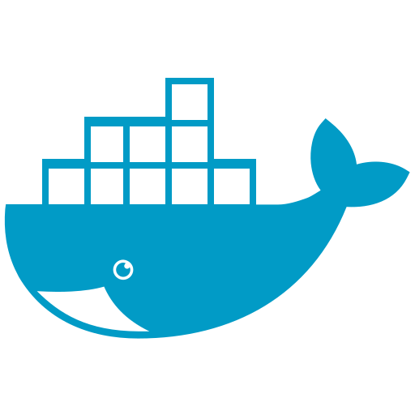

 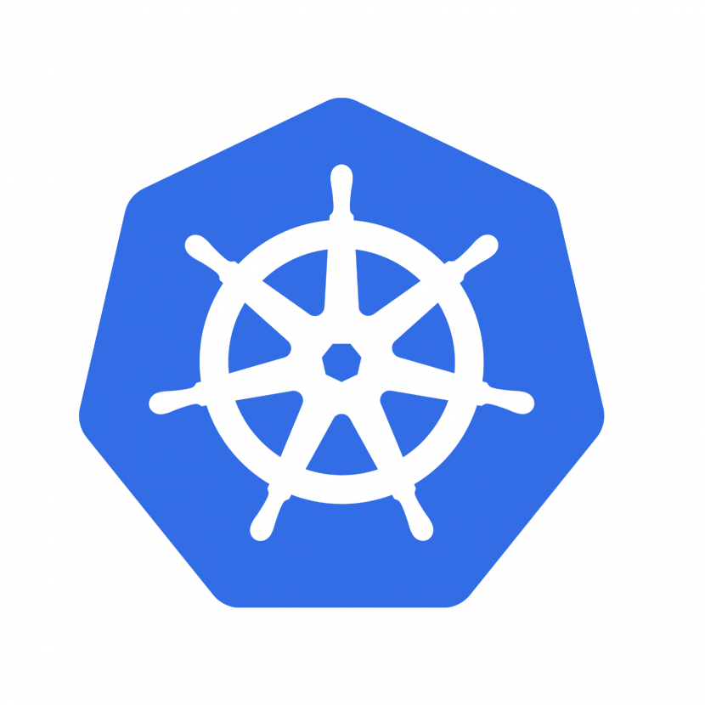

**DECLARATIONS**

I hereby declare that the above written particulars are true to the best of my knowledge and brief.

Date:

PLACE: (**Shubham Shirbhate**)

**RECOGNITIONS AND CERTIFICATIONS**

* Completed certification for **Running Container on Amazon Elastic Kubernetes Service (Amazon EKS)**
* Gained a reputation in my current organization wherein I am trusted to interview candidates for on-boarding for DevOps, Data and Kafka developer profile
* Organizational Skills
* Can work Effectively in Team as well as Individually
* Responsible and Capable
* Flexible
* Lifelong Learner
* Manage ssl, sasl and plain text kafka security on dockerized apache kafka
* Managing topics and their configuration according to requirement
* Setting up kafka configuration on kubernetes for auto scaling and high availability
* Implementing CICD pipeline on development and production environment.
* Writing code for flattening data or converting json or unstructured data to structured form
* Developed ETL pipeline and automated scripts in python, hands-on experience in python scripting.
* Use spark engine for large amount of data processing
* Used AWS EC2 running a dockerized airflow to manage workflow and AWS EMR with hadoop for map reduce jobs using spark
* Setting up kong infrastructure on docker with latest versions and integrating with existing api which is developed in python rest framework.
* EMR on EKS POC involved for optimization of spark Jobs, resource cost, and Job completion timing. Instead of yarn we used kubernetes for controlling resources and cluster.

**Personal** **Skill**