

Computer Networks Laboratory

IT 3095

# Lab instructions

# On

# DESIGN, CONFIGURATION AND SIMULATION OF A SIMPLE WIRED NETWORK USING CISCO PACKET TRACER

# **Aim:** To design, configuration and simulation of a simple wired network using cisco packet tracer.

# **Software Required:** CISCO Packet Tracer

# **Network Specifications:** Two Virtual Local Area Networks (VLANs), one VLAN for Web server.

# **Network Design:** The network scenario is as shown below:

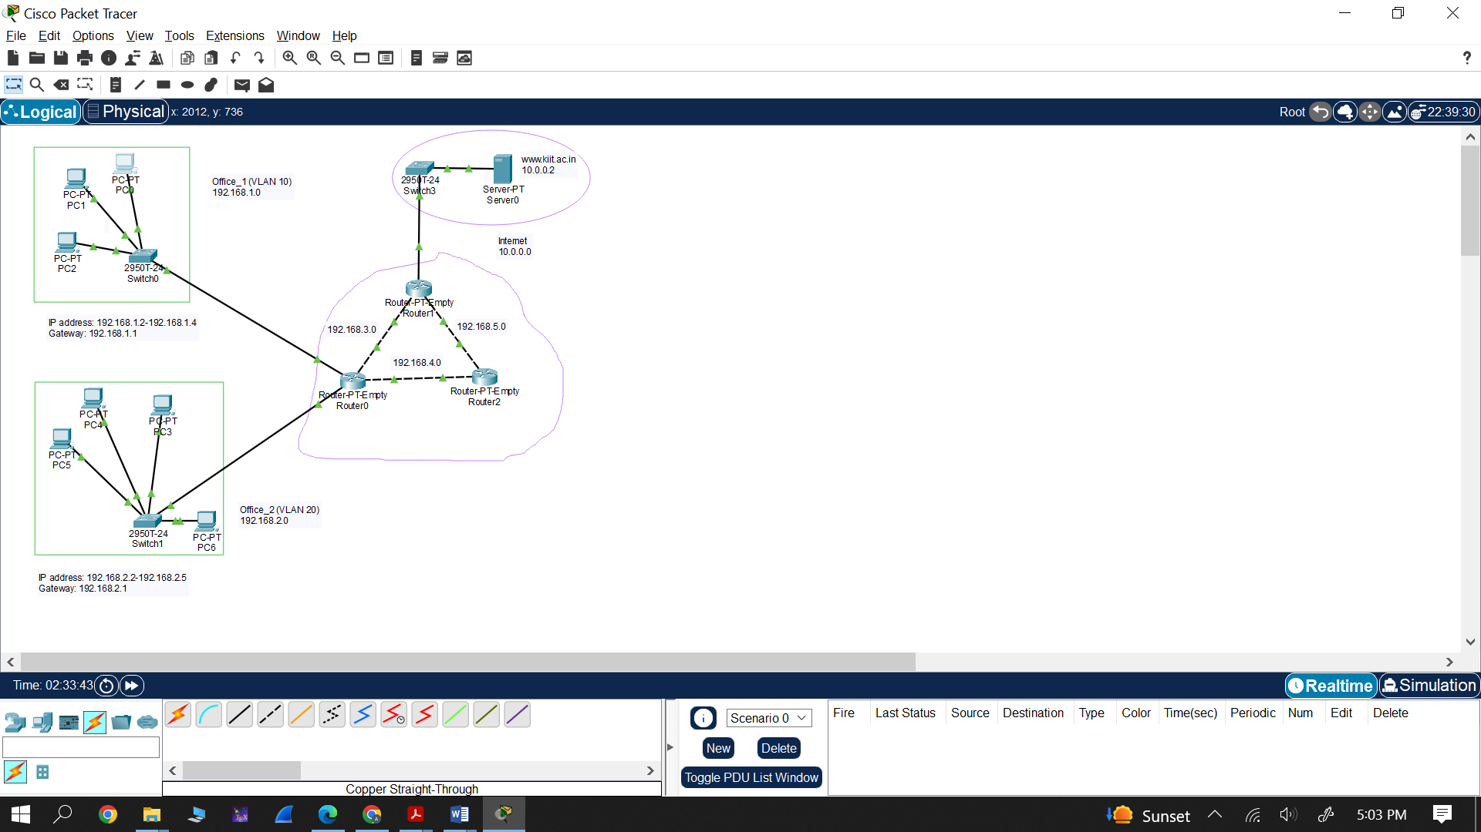

**Figure:** Network scenario.

**Network configuration:** The table below can be referred for the network configuration.

|  |  |  |  |  |
| --- | --- | --- | --- | --- |
| **VLAN No.** | **Name** | **Network Address** | **IP Configurations (Range of IP Address given to Laptop/PC)** | **Gateway** |
| VLAN 10 | Office_1 | 192.168.1.0/24 | 192.168.1.2-192.168.1.4 | 192.168.1.1  🡪 Router IP address |
| VLAN 20 | Office_2 | 192.168.2.0/24 | 192.168.2.2-192.168.2.5 | 192.168.2.1  🡪 Router IP address |

The network configuration in terms of IP address is shown below:

|  |  |  |  |  |
| --- | --- | --- | --- | --- |
| Network | Network address | IP address to end devices | Default gateway | Interface |
| Office_1 | 192.168.1.0 | 192.168.1.2-192.168.1.4 | 192.168.1.1  (for all end devices) | One interface of router to this network will have IP 192.168.1.1 |
| Office_2 | 192.168.2.0 | 192.168.2.2-192.168.2.5 | 192.168.2.1  (for all end devices) | One interface of router to this network will have IP 192.168.2.1 |
| Internet | 10.0.0.0 | 10.0.0.2 | 10.0.0.1  (for all end devices) | One interface of router to this network will have IP 10.0.0.1 |
| Between Ro and R1 | 192.168.3.0 | 192.168.3.1-192.168.3.2 | NA  (as it’s not an end device) | An interface of router Ro to this network will have IP 192.168.3.1. and an interface of router R1 to this network will have IP 192.168.3.2 |
| Between R0 and R2 | 192.168.4.0 | 192.168.4.1-192.168.4.2 | NA  (as it’s not an end device) | An interface of router Ro to this network will have IP 192.168.4.1. and an interface of router R2 to this network will have IP 192.168.4.2 |
| Between R1 and R2 | 192.168.5.0 | 192.168.5.1-192.168.5.2 | NA  (as it’s not an end device) | An interface of router R1 to this network will have IP 192.168.5.1. and an interface of router R2 to this network will have IP 192.168.5.2 |

Default subnet mask for all networks are: 255.255.255.0

### **Server Configuration**

### The server is located on Internet with Network Address: 10.0.0.0/8

### Server network is Class-A Networks default with subnet mask: 255.0.0.0

**Type of server:** HTTP(s) Server hosted on a Server.

**IP Address of Server machine** 10.0.0.2 (e.g., [www.kiit.ac.in](http://www.kiit.ac.in))

**Default Gateway:** 10.0.0.1

### Cable Specifications:

* + **(Between PC/Laptop/Server to Switch and Switch to Routers)**
    - Connections 🡪 Copper Straight-Through
  + **(Between Routers to Routers)**
    - Connections 🡪 Copper Cross –Over

### Switch Specifications:

* + Type: CISCO 2950T-24 (Switch with VLAN support)
  + IEEE 802.3 Fast Ethernet (FE-Copper)
  + Standard: 100-Base_TX
  + Configure VLANs

### Router Specifications

* + **Type:** Generic (Router-PT-Empty)
  + **Add Hardware interfaces:** Fast Ethernet 100 Mbps
  + **Network Interface Card (NIC):** Network Adaptor : IEEE 802.3 Fast Ethernet (FE-Copper)
  + **Standard:** 100-Base_TX
  + 4 NICs for Router 1 (R1) & Router 2 (R2)
  + 3 NICs for Router 3 (R3)
  + **Routing Protocol:** Routing Information Protocol v.1 (RIP v1)

### Intermediate Network specifications:

* + In between R1 – R2 (Network : 192.168.5.0/24)
  + In between R1 – R3 (Network : 192.168.6.0/24)
  + In between R2 – R3 (Network : 192.168.7.0/24)

### PC/laptop/ Server Specifications:

* + End Devices 🡪 Generic PC/laptop/Server

### Procedure:

1. **Basic Configuration:**
2. Start the Cisco Packet Tracer Software and OPEN it GUI using the icon.
3. Place all the components as shown in the network scenario.
4. Group the networks, Internet, etc. using rectangle, ellipse, etc. shapes for proper visualization.
5. Switch configuration:

VLAN Configuration: **(CLI Mode)**

* + Click on the switch which you want to configure. For e.g., **Switch 0**.
  + Click on **CLI**.

RETURN to get started. 🡪 Press **Enter**

Switch>en

Switch#config t

Enter configuration commands, one per line. End with CNTL/Z.

Switch(config)#vlan 10 🡪 as per the requirement

Switch(config-vlan)#name Office_1 🡪 as per the requirement

Switch(config-vlan)#exit

Switch(config)#exit

Switch#

%SYS-5-CONFIG_I: Configured from console by console

Press **Enter**

Switch#config t

Enter configuration commands, one per line. End with CNTL/Z.

Switch(config)#interface range fa0/1-4 🡪 as per the requirement

Switch(config-if-range)#switchport access vlan 10 🡪 as per the requirement

Switch(config-if-range)#exit

Switch(config)#exit

Switch#

%SYS-5-CONFIG_I: Configured from console by console

Press **Enter**

Switch#

Note: As per above command do configuration for all switches

1. Router configuration:

* Double-Click on Router to open menu. Switch off router first. Then add **PT-ROUTER-NM-1CFE** NIC card to it by dragging.
* Add such NIC card as per the network scenario. For e.g., for Router_0, we need 4 such NIC card.
* Refer the diagram shown below.

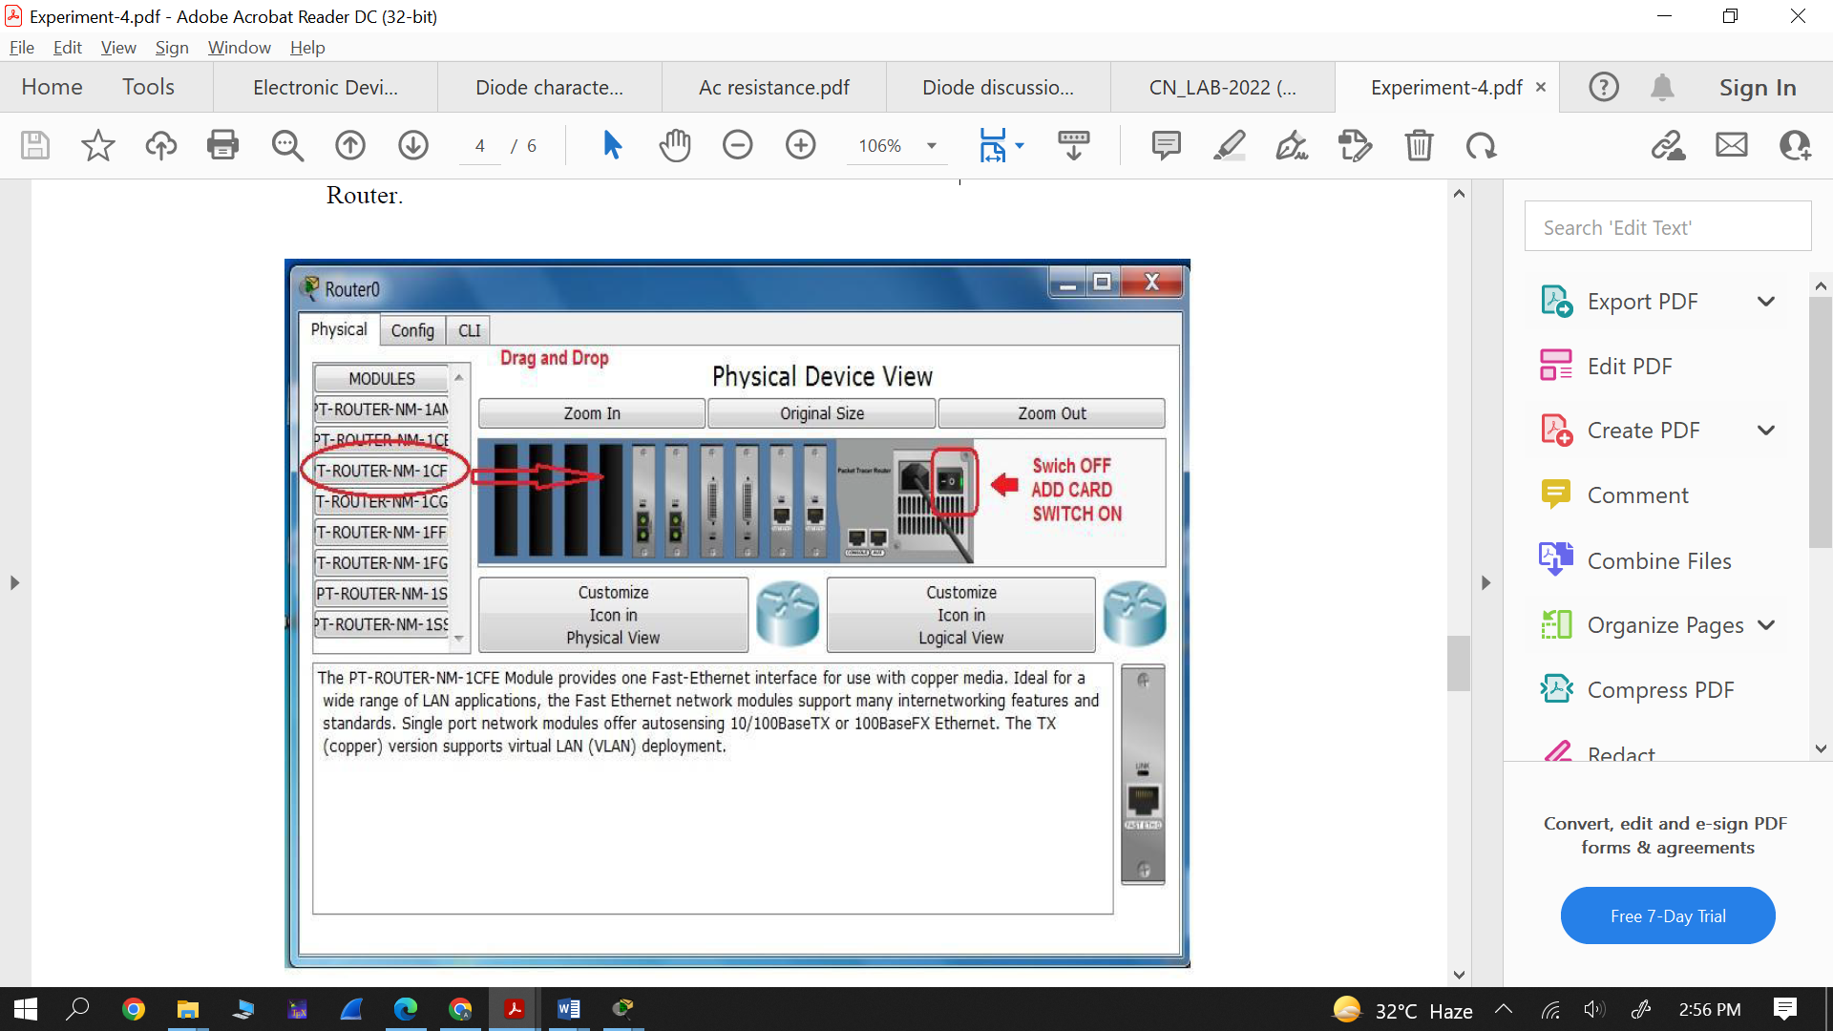

1. *Connect the all end devices and networking components using appropriate cables.*
   1. **(Between PC/Laptop/Server to Switch and Switch to Routers)**
      1. Connections 🡪 Copper Straight-Through
   2. **(Between Routers to Routers)**
      1. Connections 🡪 Copper Cross –Over
2. IP configuration of routers:

* Give the suitable IP address to all routers interfaces. Double click on router🡪 **config🡪 select the suitable interface 🡪 Give the IP address**.

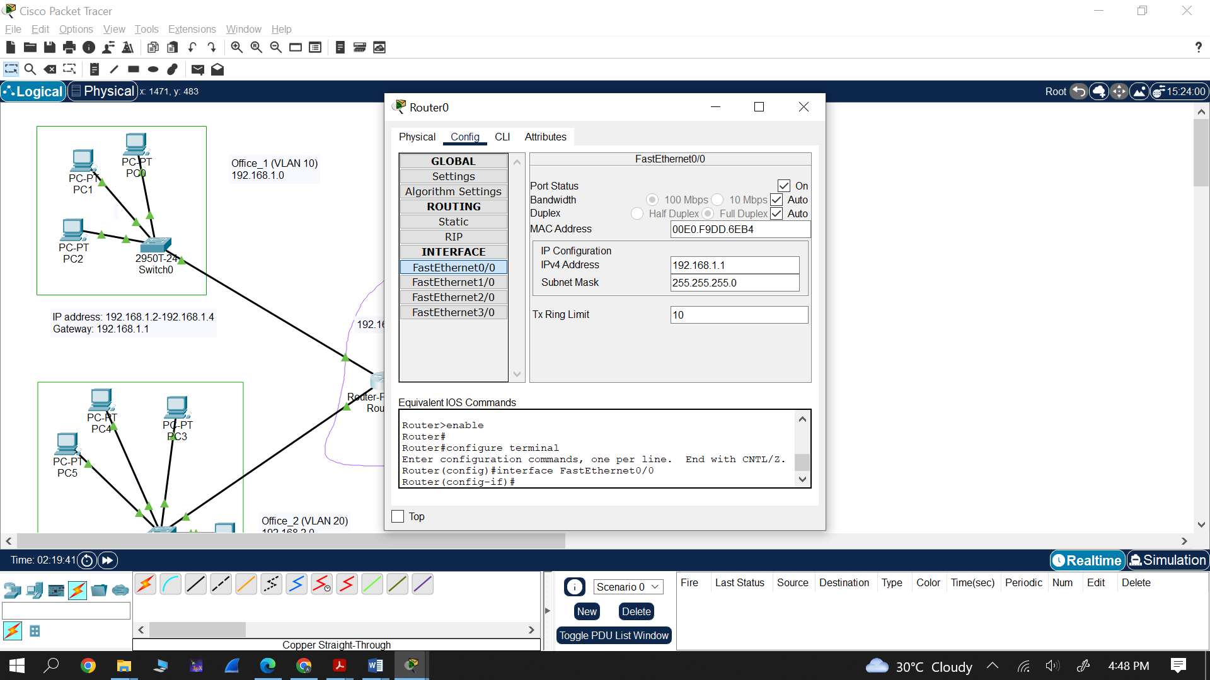

*n*

* Click on **config**, and
* Select corresponding NIC
* Give IP address (the second IP address)
* This IP will be used as default gateway for all devices on this network.
* 1st IP is not given to any device. It is used to just recognized the network. It used in Routing configuration.
* Ensure port status is **on**
* Repeat above steps (i.e., IP configuration for all routers)

Configure routing protocols in all routers

* Click on router which you want to configure.
* Select **RIP** as routing protocols.
* Add all network manually one by one.

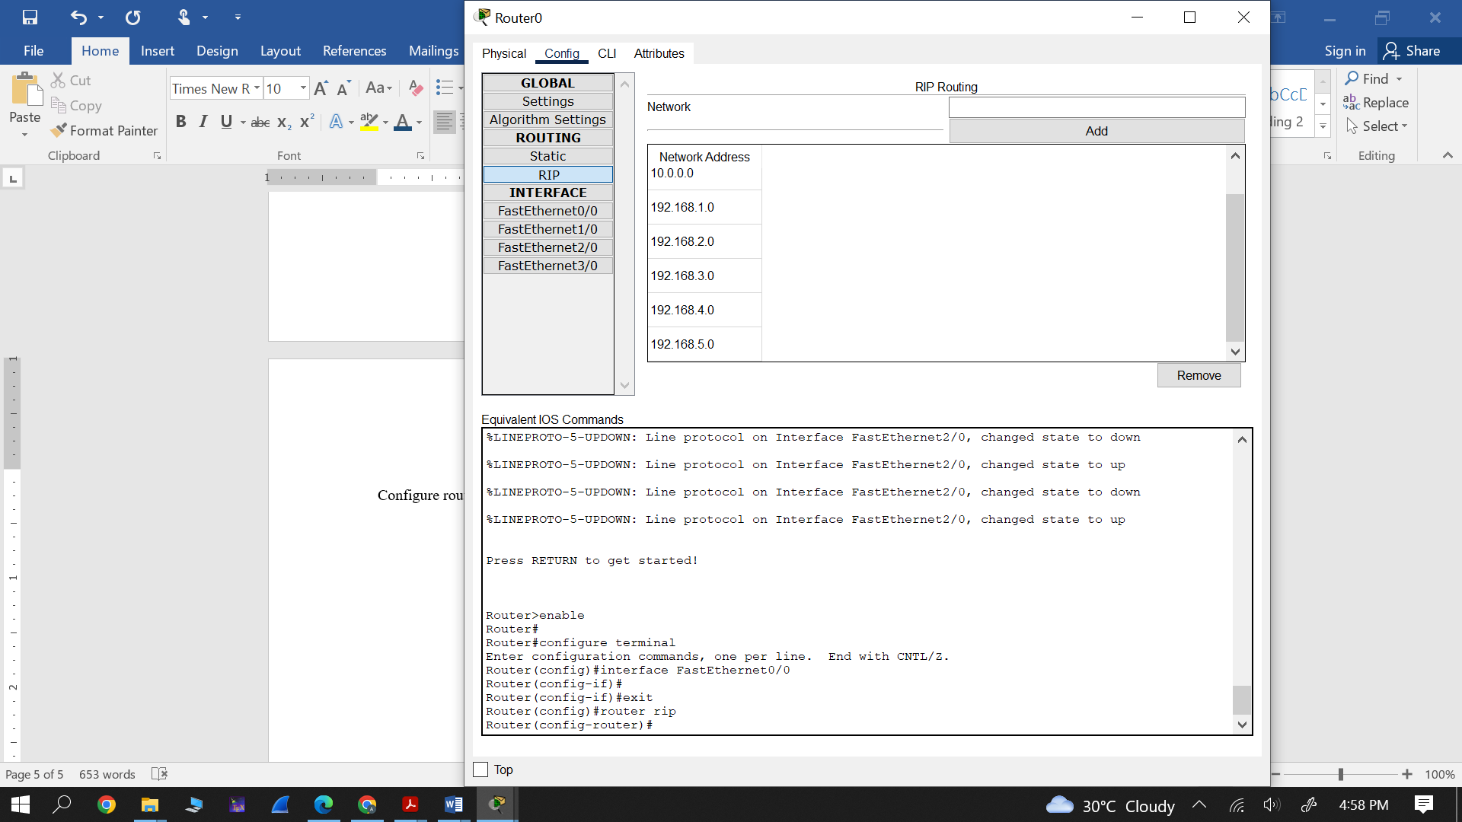

**Now configure each end devices (PC/Laptop, etc)**

* To provide IP address to end device
  + Select the end device
  + Select desktop🡪 IP configuration
  + And give the IP address very carefully. Default gateway will be the IP address given to the router interface connected to this VLAN network.

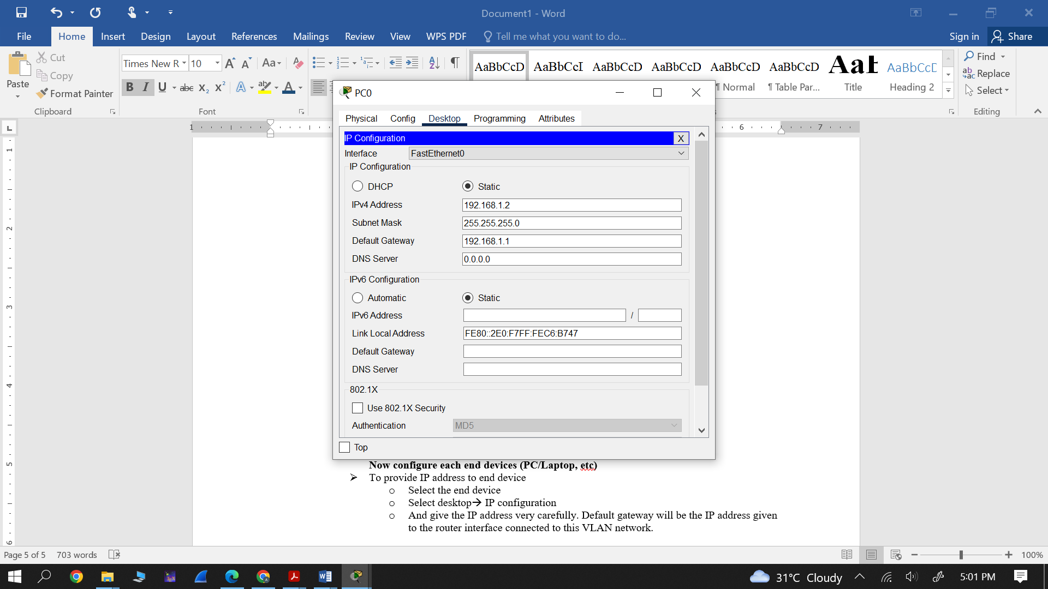

**Observation:**

* Observe the connectivity among different end devices.
* Observe the HTTP file hosted at the web server using web browser.
* Add simple PDU and observe the packets flow in simulation mode.
* Add complex PDU and observe the packets flow in simulation mode.

**Conclusion:** Write the conclusion in your won words.

**Note:** The following screen shorts you need to include in the lab record.