

Computer Networks Laboratory

IT 3095

# Lab instructions

# On

# DESIGN, CONFIGURATION AND SIMULATION OF A SIMPLE WIRELESS NETWORK USING CISCO PACKET TRACER

# **Aim:** To design, configuration and simulation of a simple wireless network using cisco packet tracer.

# **Software Required:** CISCO Packet Tracer

# **Network Specifications:** Two Wireless Local Area Networks (WLANs), and one Web server.

# **Network Design:** The network scenario is as shown below:

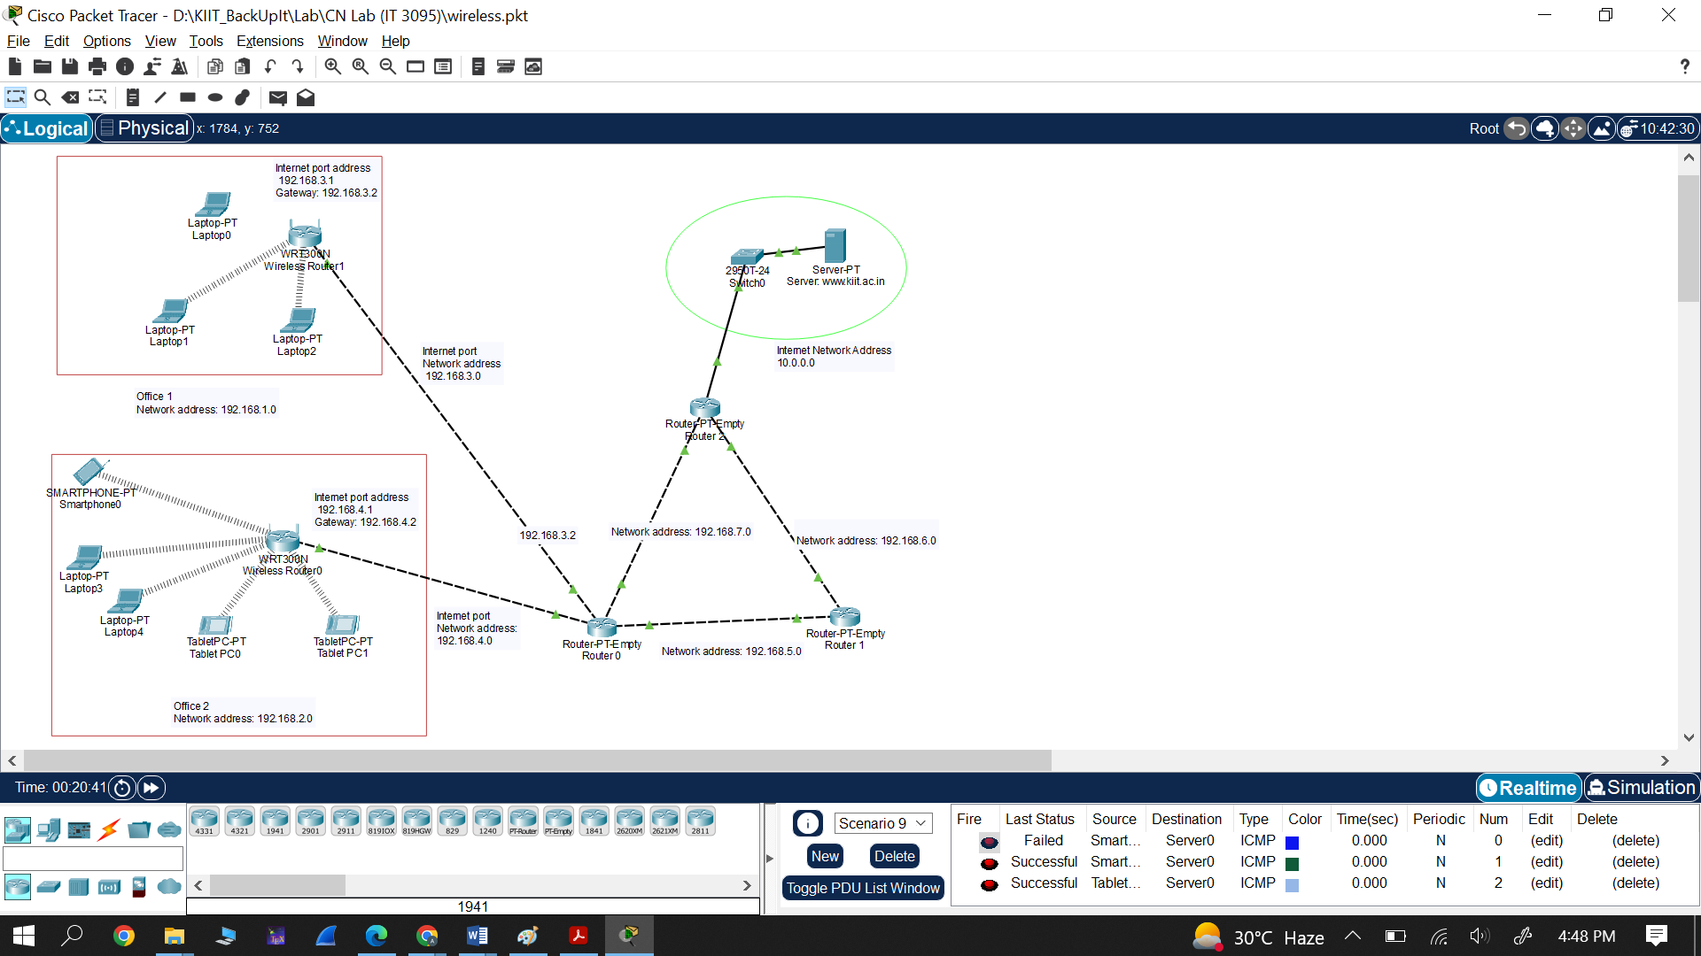

**Figure:** Network scenario.

**Network configuration:** The table below can be referred for the network configuration.

|  |  |  |  |
| --- | --- | --- | --- |
| **Name** | **Network Address** | **IP Configurations (Range of IP Address given to Laptop/PC)** | **Gateway** |
| Office_1 | 192.168.1.0/24 | Using DHCP in the range of  192.168.1.100-192.168.1.149 | 192.168.1.1  🡪 Router IP address |
| Office_2 | 192.168.2.0/24 | Using DHCP in the range of  192.168.2.100-192.168.2.149 | 192.168.2.1  🡪 Router IP address |

The network configuration in terms of IP address is shown below:

|  |  |  |  |  |
| --- | --- | --- | --- | --- |
| Network | Network address | IP address to end devices | Default gateway | Interface |
| Office_1 | 192.168.1.0 | Using DHCP in the range of  192.168.1.100-192.168.1.149 | 192.168.1.1  (for all end devices) | 192.168.1.1  is Router IP of Office-1 AP. Its Internet IP address is 192.168.3.1 with default gateway 192.168.3.2 |
| Office_2 | 192.168.2.0 | Using DHCP in the range of  192.168.2.100-192.168.2.149 | 192.168.2.1  (for all end devices) | 192.168.2.1  is Router IP of Office-2 AP. Its Internet IP address is 192.168.4.1 with default gateway 192.168.4.2 |
| Internet | 10.0.0.0 | 10.0.0.2 | 10.0.0.1  (for all end devices) | One interface of router to this network will have IP 10.0.0.1 |
| Between Ro and R1 | 192.168.5.0 | 192.168.5.1-192.168.5.2 | NA  (as it’s not an end device) | An interface of router Ro to this network will have IP 192.168.351. and an interface of router R1 to this network will have IP 192.168.5.2 |
| Between R0 and R2 | 192.168.7.0 | 192.168.7.1-192.168.7.2 | NA  (as it’s not an end device) | An interface of router Ro to this network will have IP 192.168.7.1. and an interface of router R2 to this network will have IP 192.168.7.2 |
| Between R1 and R2 | 192.168.6.0 | 192.168.6.1-192.168.6.2 | NA  (as it’s not an end device) | An interface of router R1 to this network will have IP 192.168.6.1. and an interface of router R2 to this network will have IP 192.168.6.2 |

Default subnet mask for all networks are: 255.255.255.0

### Intermediate Network specifications:

* + In between R0 – R1 (Network: 192.168.5.0/24)
  + In between R0 – R2 (Network: 192.168.7.0/24)
  + In between R1 – R2 (Network: 192.168.6.0/24)
  + Between AP of Office-1 to R0 (Network: 192.168.3.0)
  + Between AP of Office-2 to R0 (Network: 192.168.4.0)

### **Server Configuration**

### The server is located on Internet with Network Address: 10.0.0.0/8

### Server network is Class-A Networks default with subnet mask: 255.0.0.0

**Type of server:** HTTP(s) Server hosted on a Server.

**IP Address of Server machine** 10.0.0.2 (e.g., [www.kiit.ac.in](http://www.kiit.ac.in))

**Default Gateway:** 10.0.0.1

### Cable Specifications:

* + **(Between PC/Laptop/Server to Switch and Switch to Routers)**
    - Connections 🡪 Copper Straight-Through
  + **(Between same devices like Routers to Routers, switch to switch)**
    - Connections 🡪 Copper Cross –Over

### For wireless devices:

* Wireless connection will be configured

### Switch Specifications:

* + Type: CISCO 2950T-24 (Switch with VLAN support)
  + IEEE 802.3 Fast Ethernet (FE-Copper)
  + Standard: 100-Base_TX
  + Configure VLANs (if required)

### Router Specifications:

* + **Type:** Generic (Router-PT-Empty)
  + **Add Hardware interfaces:** Fast Ethernet 100 MM
  + **Network Interface Card (NIC):** Network Adaptor : IEEE 802.3 Fast Ethernet (FE-Copper)
  + **Standard:** 100-Base_TX
  + 4 NICs for Router 0 (R0)
  + 2 NICs for Router 1 (R1)
  + 3 NICs for Router 2 (R2)
  + **Routing Protocol:** Routing Information Protocol v.1 (RIP v1)🡪 to be configured later

### Access Point (with Wireless Router) Specifications:

* Type Linksys in components search tab and select **WRT300N** wireless router

### End devices Specifications:

* + As per the network scenario choose the end devices with wireless support

### Procedure:

1. **Basic Configuration:**
2. Start the Cisco Packet Tracer Software and OPEN it GUI using the icon.
3. Place all the components as shown in the network scenario.
4. Group the networks, Internet, etc. using rectangle, ellipse, etc. shapes for proper visualization.
5. **Router configuration as AP:**

* Select the wireless router to be configured as AP
* Configure **Wireless** part as shown below

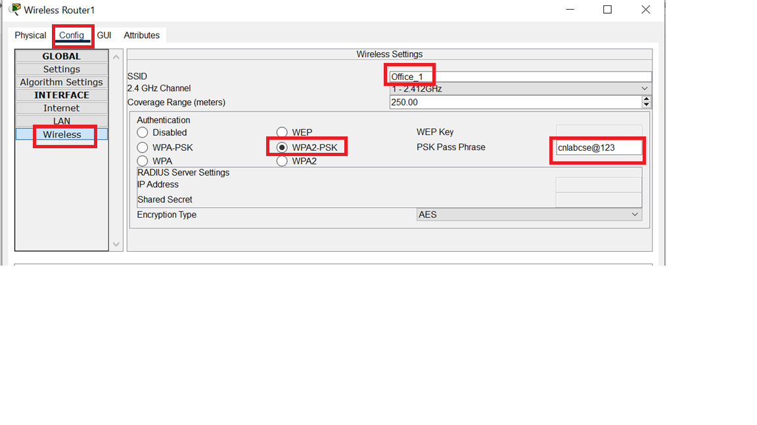

* Configure **Internet** part as shown below:

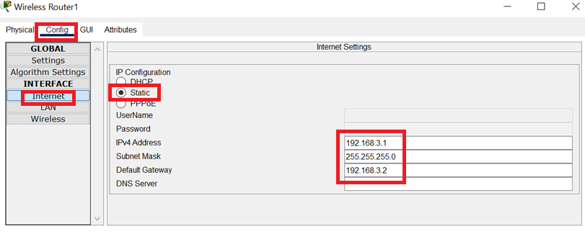

Go to GUI tab to configure **LAN** as shown below:

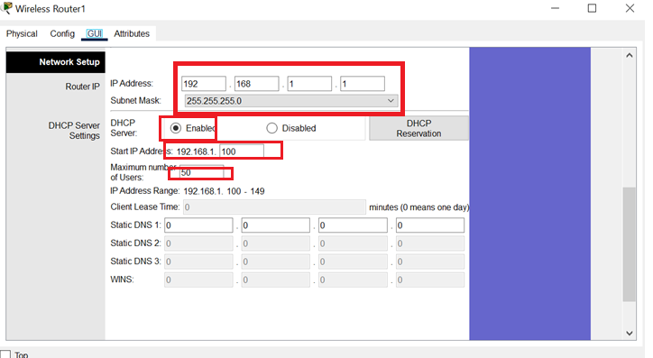

1. **Connect END devices to the corresponding AP**
   * **Note:** All end devices will be randomly connected to the wireless router. So, we need to change it.
   * For laptop, we need to add **wireless NIC** card as discussed below.
     + Power off laptop, remove the existing NIC card, insert WPC300N, and switch on the laptop. Refer the diagram shown below.

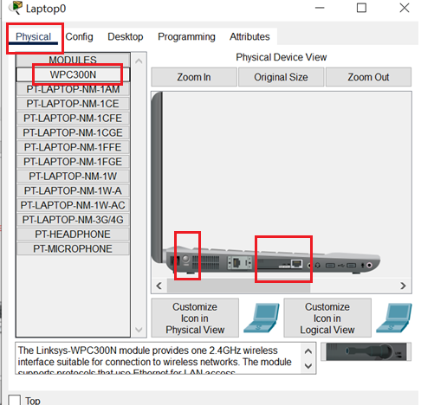

* + Select the device to be configured
    - Go to **wireless interface**: **config** 🡪 **Wireless** and configure as shown below.

**For Configure all end devices such as Laptop, tablet, smartphone as shown below**

* Change the following parameters as per the network scenario.
  + **SSID** 🡪 Office_1
  + Select **WPA2-PSK** and corresponding **password**
  + Ensure IP configuration is DHCP for IPv4 (***In case IP address is not reflected, refresh it by selecting static and then again DHCP.***
    - ***)***

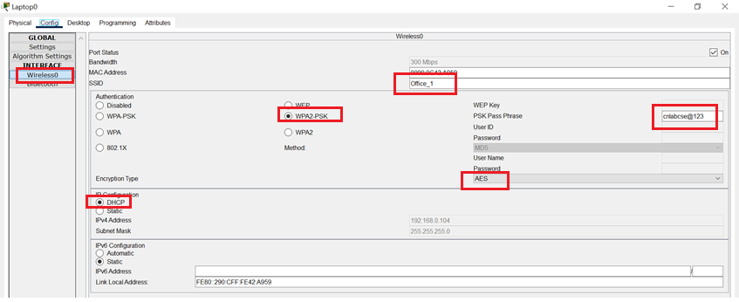

***Note:*** *The ip address of the end devices will still be the older one. So, to update the IP address, go to config 🡪 wireless 🡪 IP configuration, select static and then again select DHCP. It will be updated as shown below.*

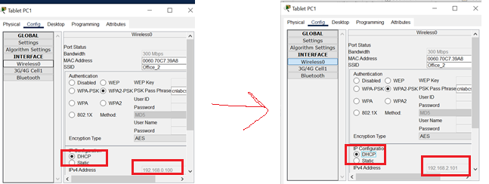

1. **Connect the WAN routers**
   * **(Between same device like Routers to Routers, switch to switch, etc.)**
     + Connections 🡪 Copper Cross –Over
     + Add NIC card on this router as per the network requirement.
     + 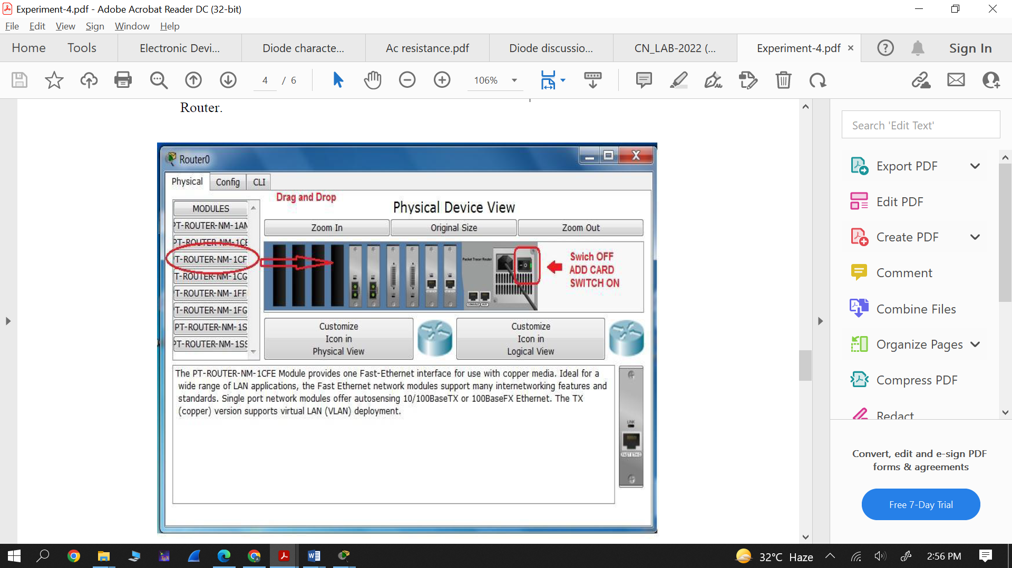
   * Configure IP address of all routers of WAN as per the network scenario.
   * Select the router to be configured.

* Select the corresponding Ethernet🡪 give IP address.
* Refer diagram shown below

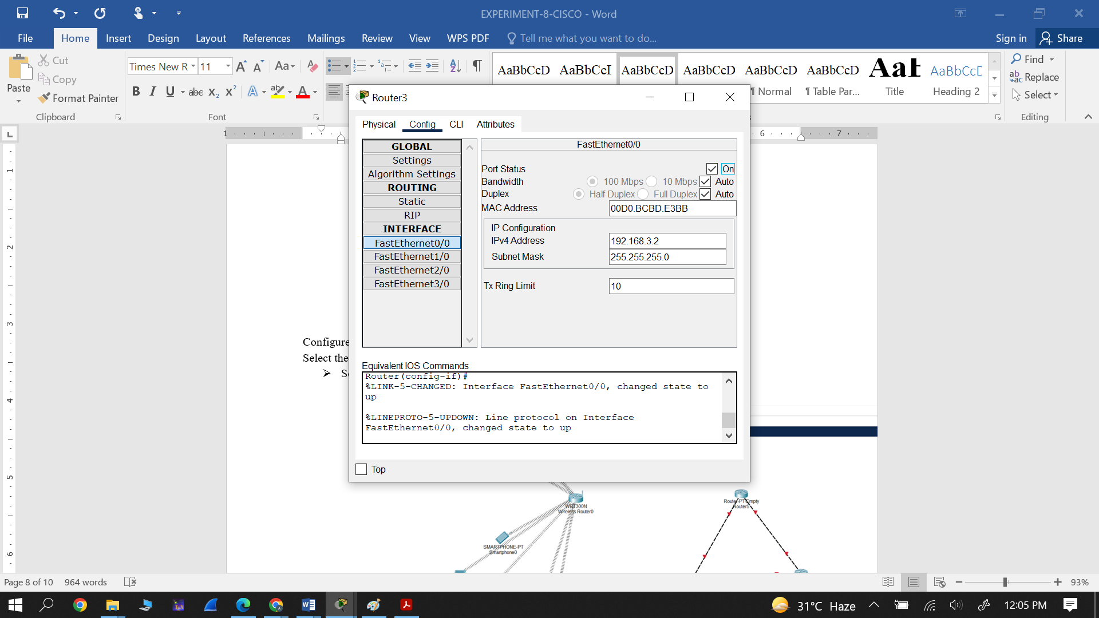

1. **Configure routing protocols in all routers**

* Click on router which you want to configure.
* Select **RIP** as routing protocols.
* Add all network manually one by one.

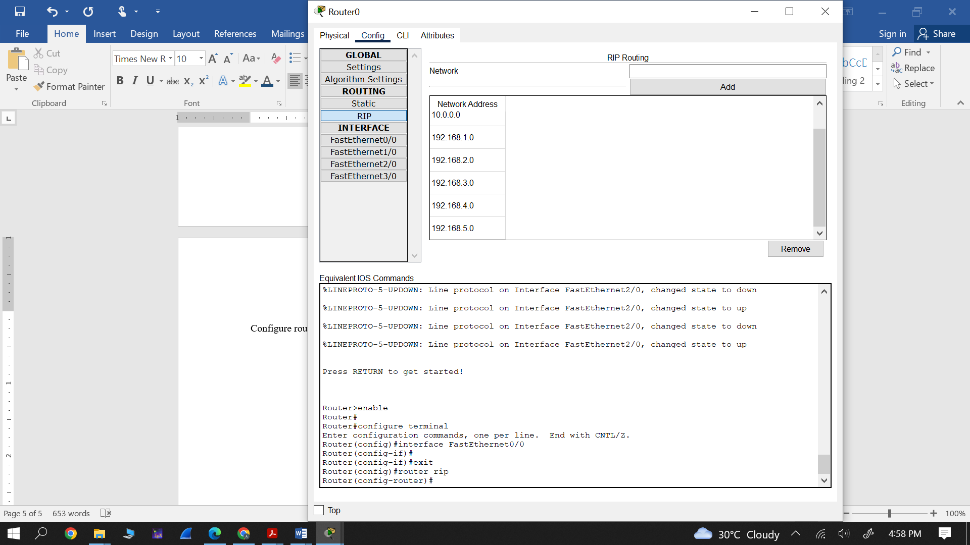

### Observation:

* Observe the connectivity among different end devices using PING command.
* Observe the connectivity among different devices using simple PDU.
* Observe the HTTP file hosted at the web server using web browser. Add your name and roll no in HTTP file and then take the screen shot.
* Add simple PDU and observe the packets flow in simulation mode.

Conclusion:Write the conclusion in your own words.

**Note:** The following screen shorts you need to include in the lab record.

* The screen shots in support of your observations in addition to the network design must be included in the lab record.