**NAME** - SHUBHAM TIWARI

**ROLL** - 20051488

**OS ASSIGNMENT**

**Question** : - Implement the following three question in C programming language using semaphore.

1. In a railway station, there are 3 rest rooms. In each rest room, only one passenger is allowed to take rest at a time. Write a solution using semaphore to synchronize among the passenger to avoid the race condition for accessing the rooms.

**CODE** : -

/*----In a railway station, there are 3 rest rooms. In each rest room, only one passenger is allowed to take rest at a time. Write a solution using semaphore to synchronize among the passenger to avoid the race condition for accessing the rooms.----*/

#include<stdio.h>

#include<stdlib.h>

#include<unistd.h>

#include<time.h>

#include<pthread.h>

#include<semaphore.h>

enum {empty,pack};

//Semaphore

sem_t passenger[10];

//Mutex

pthread_mutex_t mutex;

//Global Variable

int room_state[3] = {empty};

int room_occupied[10] = {-1,-1,-1,-1,-1,-1,-1,-1,-1,-1};

int num = 0;

//USER DEFINED FUNCTIONS

void *passenger_work(void *args);

void occupy_room(int );

void check_room_status(int );

void vacant_room(int );

void take_rest(int );

//Main

int main()

{

int i;

int *a;

pthread_t Thread[10];

//Initializing mutex

pthread_mutex_init(&mutex,NULL);

//Initializing semaphore passenger

for(i=0;i<10;i++)

sem_init(&passenger[i],0,0);

//Thread Creation

for(i=0;i<10;i++)

{

a=(int *)malloc(sizeof(int ));

*a = i;

if(pthread_create(&Thread[i],NULL,&passenger_work,a)!=0)

{

perror("Failed to create thread\n");

}

}

//Joining the threads

for(i=0;i<10;i++)

{

if(pthread_join(Thread[i],NULL)!= 0)

{

perror("Failed to join thread\n");

}

}

//Destroying the semaphore

sem_destroy(passenger);

//Destroying the mutex

pthread_mutex_destroy(&mutex);

free(a); //Free the space

return 0;

}

//Passenger_Work Function

void *passenger_work(void *args)

{

while(1)

{

occupy_room(*(int *)args);

take_rest(*(int *)args);

vacant_room(*(int *)args);

}

}

//Occupy_room Function

void occupy_room(int i)

{

pthread_mutex_lock(&mutex); //P(mutex)

check_room_status(i);

pthread_mutex_unlock(&mutex); //V(mutex)

sem_wait(&passenger[i]); // p(passenger[i])

}

//Check_Room_Status Function

void check_room_status(int i)

{

int rm_no = -1; // -1 because no room is occupied

if(room_state[0] == empty)

{

rm_no = 0; // Room '0' is occupied

}

else if(room_state[1] == empty)

{

rm_no = 1; //Room '1' is occupied

}

else if(room_state[2] == empty)

{

rm_no = 2; //Room '2' is occupied

}

if(rm_no != -1)

{

room_occupied[i] = rm_no; //It assigns the room , the passenger is occupying.

room_state[rm_no] = pack; //Room state is changed to pack

sem_post(&passenger[i]); // v(passenger[i])

}

}

//Vacant_Room Function

void vacant_room(int i)

{

int count;

pthread_mutex_lock(&mutex); //p(mutex)

room_state[room_occupied[i]] = empty; //Passenger vacated the //room

room_occupied[i] = -1; //Since the passenger vacated the room

//Looking for the passengers who are waiting....

for(count=0;count<10;num=(num+1)%10,count++)

{

if(room_occupied[num]==-1 && num!=i)

{

check_room_status(num);

num=(num+1)%10; //Similar to queue traversal

}

}

pthread_mutex_unlock(&mutex); //v(mutex)

}

//Take_Rest Function

void take_rest(int i)

{

printf("\nPassenger %d is in the rest room\n",(i+1));

sleep(1);

}

**OUTPUT** : -

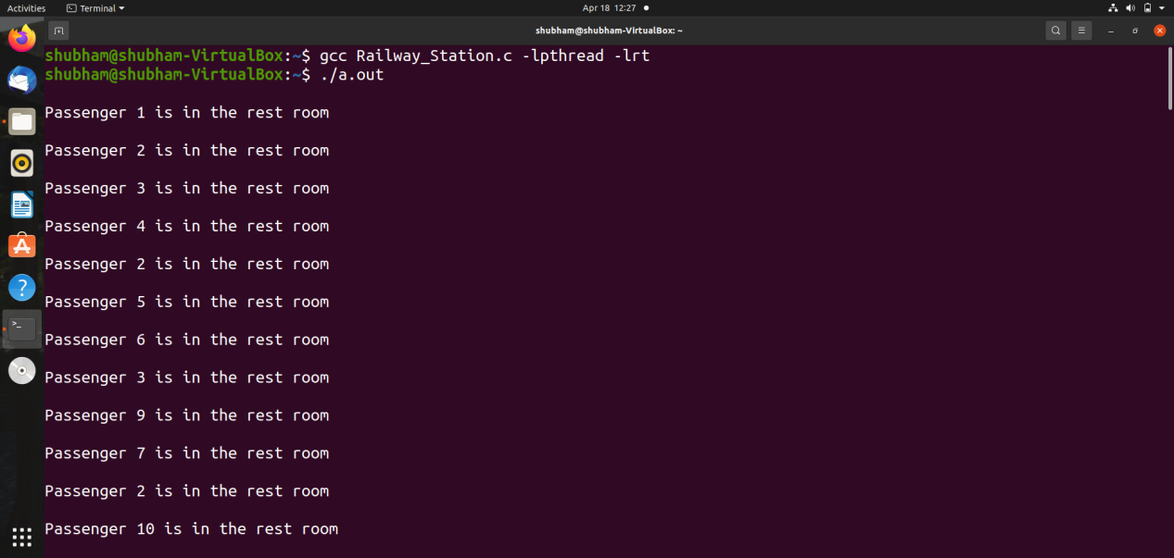

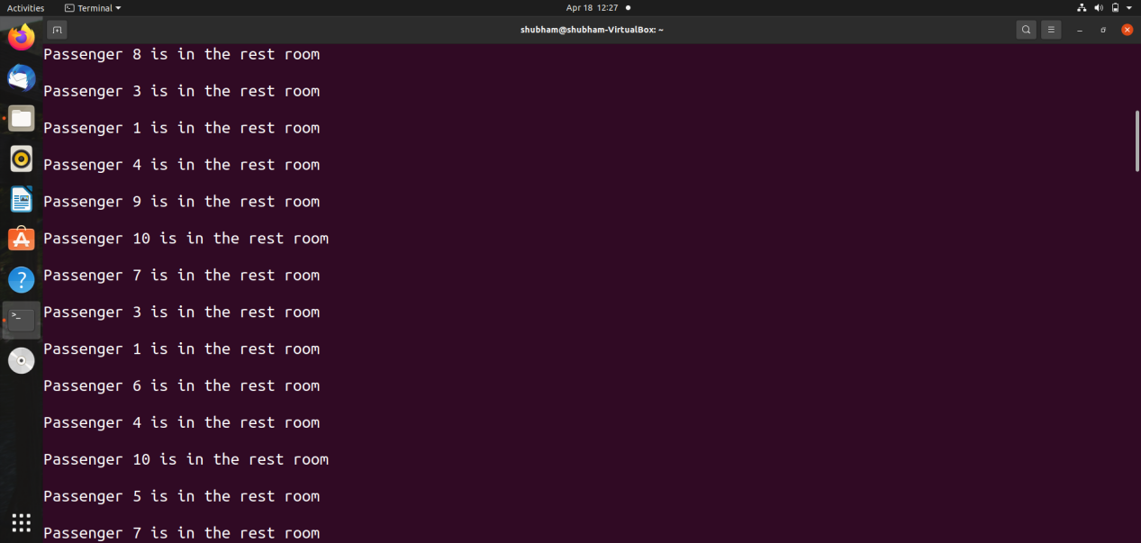

1. In a civilized society, a gentle man lives with his spouse and his elderly parents. Due to old age, his parents cannot be left alone in the house. So, at least any one of the spouse must be available in the house. Write a synchronize solution using semaphore for this problem.

**CODE** : -

/*------In a civilized society, a gentle man lives with his spouse and his elderly parents.

Due to old age, his parents cannot be left alone in the house. So, at least any one of the spouse must be available in the house. Write a synchronize solution using semaphore for this problem.----------*/

#include<stdio.h>

#include<stdlib.h>

#include<unistd.h>

#include<pthread.h>

#include<time.h>

#include<semaphore.h>

#define SPOUSE 2 //Either wife or husband

enum {out,in}; //enum for out and in status;

int spouse_state[2] = {out}; //An array of size 2 for the current status(out,in) of spouse

//Mutex

pthread_mutex_t mutex;

//Semaphore

sem_t spouse[SPOUSE];

//USER DEFINED FUNCTIONS

void *spouse_work(void *args);

void enter_house(int );

void check_spouse_status(int );

void takecare_parent(int );

void leave_house(int );

//Main

int main()

{

int i;

int *a;

pthread_t spouse_thread[SPOUSE];

//Initializing mutex

pthread_mutex_init(&mutex,NULL);

//Initializing semaphore spouse

for(i=0;i<SPOUSE;i++)

sem_init(&spouse[i],0,0);

//Thread Creation

for(i=0;i<SPOUSE;i++)

{

a=(int *)malloc(sizeof(int));

*a = i;

//Creating thread

if(i>0)

{

if(pthread_create(&spouse_thread[i] ,NULL,&spouse_work ,a) !=0)

{

perror("Failed to create thread\n");

}

}

else

{

if(pthread_create(&spouse_thread[i],NULL,&spouse_work, a) !=0)

{

perror("Failed to create thread\n");

}

}

}

//Joining the threads

for(i=0;i<SPOUSE;i++)

{

if(pthread_join(spouse_thread[i],NULL) != 0)

{

perror("Failed to join thread");

}

}

//Destroying the semaphore

sem_destroy(spouse);

//Destroying the mutex

pthread_mutex_destroy(&mutex);

free(a); //Free the space

return 0;

}

//Spouse_Work Function

void *spouse_work(void *args)

{

while(1) //Infinite Loop

{

enter_house(*(int *)args);

takecare_parent(*(int *)args);

leave_house(*(int *)args);

}

}

//Enter_house Function

void enter_house(int i)

{

pthread_mutex_lock(&mutex); //P(mutex)

spouse_state[i]=in; //Spouse 'i' returned back to home

if(i==0)

printf("\nHusband says - 'Wife , I have returned home'\n");

else

printf("\nWife says - 'Husband , I have returned home'\n");

sleep(1);

check_spouse_status((i+1)%2);

pthread_mutex_unlock(&mutex); //V(mutex)

}

//check_spouse_status Function

void check_spouse_status(int i)

{

if(spouse_state[(i+1)%2]==in)

{

spouse_state[i]=out; //Spouse 'i' went out

if(i==0)

printf("\nHusband says - 'Wife , I am going out!!'\n");

else

printf("\nWife says - 'Husband , I am going out!!'\n");

sem_post(&spouse[i]); //V(spouse[i])

}

sleep(1);

}

//leave_house Function

void leave_house(int i)

{

pthread_mutex_lock(&mutex); //P(mutex)

check_spouse_status(i);

pthread_mutex_unlock(&mutex); //V(mutex)

sem_wait(&spouse[i]); //P(spouse[i])

}

//takecare_parent Function

void takecare_parent(int i)

{

if(i==0)

printf("\nHusband says - ' I will take care of our parents '\n");

else

printf("\nWife says - 'I will take care of our parents '\n");

}

**OUTPUT** : -

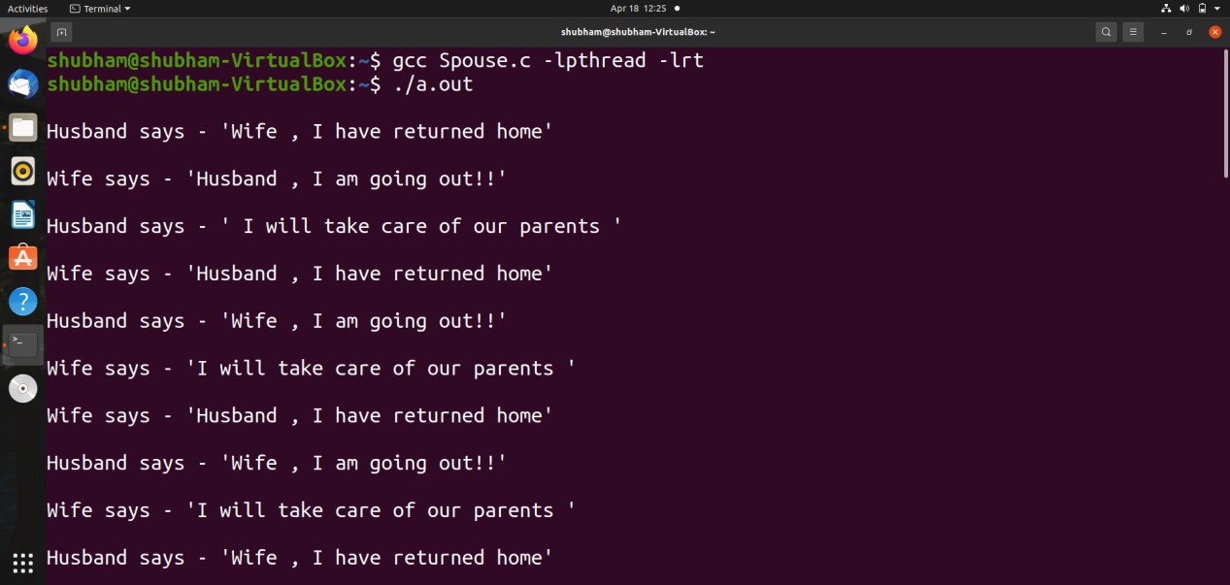

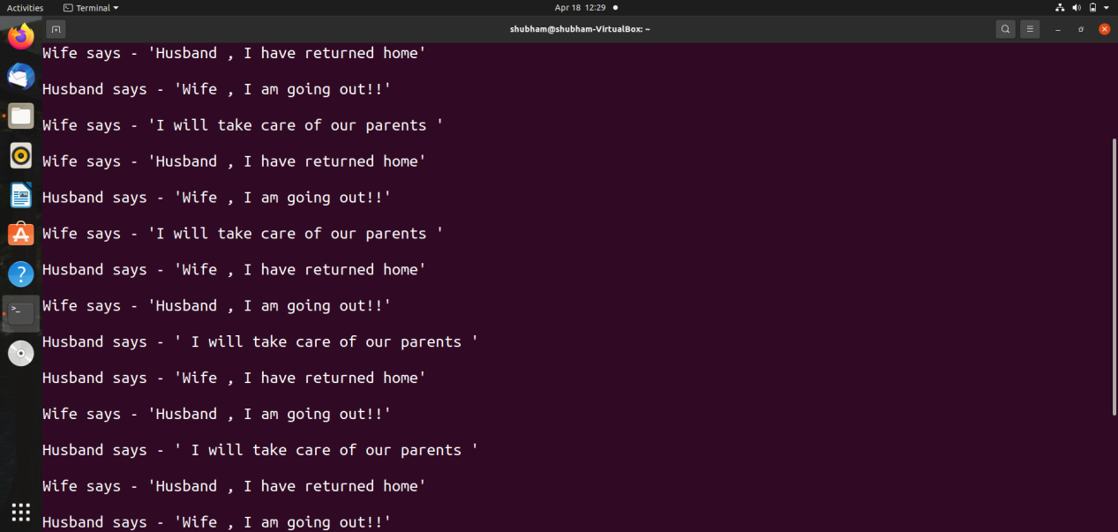

1. In a railway ticket booking office, maximum 10 persons, either male, female, or both are allowed to go inside. There are three ticket counters in the booking office. Among these 10 persons, a maximum of 3 persons are allowed to book the ticket at a time with a restriction that all these 3 persons can neither be male nor be female. It means that maximum of 2 males with 1 female or maximum of 2 females with 1 male is allowed to book the ticket. Write a solution using semaphore to synchronize among

the males and females to book their ticket.

CODE : -

/*------In a railway ticket booking office, maximum 10 persons, either male, female, or both are allowed to go inside. There are three ticket counters in the booking office. Among these 10 persons, a maximum of 3 persons are allowed to book the ticket at a time with a restriction that all these 3 persons can neither be male nor be female. It means that maximum of 2 males with 1 female or maximum of 2 females with 1 male is allowed to book the ticket. Write a solution using semaphore to synchronize among the males and females to book their ticket.---------*/

#include<stdio.h>

#include<stdlib.h>

#include<unistd.h>

#include<time.h>

#include<pthread.h>

#include<semaphore.h>

//Semaphore

sem_t person_cnt , female_cnt , male_cnt , counter;

//Global Variable

int count = 0;

//USER-DEFINED FUNCTIONS

void *Book_Ticket(void *args);

void Male(void);

void Female(void);

void Male_book_ticket(void);

void Female_book_ticket(void);

//Main

int main()

{

int i;

pthread_t Thread[2];

//Initializing semaphore

sem_init(&person_cnt,0,10);

sem_init(&female_cnt,0,2);

sem_init(&male_cnt,0,2);

sem_init(&counter,0,3);

//Creating Threads

for(i=0;i<2;i++)

{

if(i==0)

{

if(pthread_create(&Thread[i],NULL,&Book_Ticket,NULL)!=0)

{

perror("Failed to create thread\n");

}

}

else

{

if(pthread_create(&Thread[i],NULL,&Book_Ticket,NULL)!=0)

{

perror("Failed to create thread\n");

}

}

}

//Joining the threads

for(i=0;i<2;i++)

{

if(pthread_join(Thread[i],NULL)!=0)

{

perror("Failed to join the threads\n");

}

}

//Destroying the semaphore

sem_destroy(&person_cnt);

sem_destroy(&female_cnt);

sem_destroy(&male_cnt);

sem_destroy(&counter);

return 0;

}

void *Book_Ticket(void *args)

{

//20 number of people are arriving to book ticket but 10 persons are //allowed at a time

for(;count<20;count++)

{

Male(); //Male Ticket Book Function

Female(); //Female Ticket Book Function

}

}

//Male Ticket Book Function

void Male(void)

{

sem_wait(&person_cnt); //p(person_cnt)

sem_wait(&male_cnt); //p(male_cnt)

sem_wait(&counter); //p(counter)

Male_book_ticket();

sem_post(&person_cnt); //v(person_cnt)

sem_post(&male_cnt); //v(male_cnt)

sem_post(&counter); //v(counter)

}

//Female Ticket Book Function

void Female(void)

{

sem_wait(&person_cnt); //p(person_cnt)

sem_wait(&female_cnt); //p(female_cnt)

sem_wait(&counter); //p(counter)

Female_book_ticket();

sem_post(&person_cnt); //v(person_cnt)

sem_post(&female_cnt); //v(female_cnt)

sem_post(&counter); //v(counter)

}

//Male_book_ticket Function

void Male_book_ticket()

{

printf("\nMale Booked Ticket\n");

}

//Female_book_ticket Function

void Female_book_ticket()

{

printf("\nFemale Booked Ticket\n");

}

**OUTPUT :** -

