**TITLE**

TALAASH (Track and Trace Anything Lost Anywhere Anytime Simply from Home)

**INVENTORS LIST:-**  
  
1. Name- Divya Ranjan Pathak BA-JMC 2nd Semester (Uttatranchal School Of Journalism and Media Sciences)  
Address- Keshav Nagar, Kanthitand, Opposite Old Radio Station, Ratu, Ranchi, Jharkhand  
  
2. Name- Shubham Tiwary B-Tech(CSE) 2nd Semester (Uttaranchal Institute of Technology)   
Address- Padumpukhuri, Near Hindi College, (Block-5) Dimapur Sadar, Dimapur Nagaland

**DESCRIPTION OF THE INVENION**

TALAASH is an Application that creates a Digital environment for users to track missing persons, personal property or pets.

It uses Location Based API to navigate the possible coordinates where the subject was last spotted or is currently Present.

After which it alerts the other users present on the network as well as government officials

available within the designated proximity.   
Allowing them to provide aid to the missing subject ASAP by sharing its live location  
  
Not only this it using its dual channel sign in Module.  
This will also help the Police department to share their databases of wanted suspects/criminals privately resulting in an easy and less time consuming method to control crime and build better connectivity between the Law enforcement bodies across the nation.

Moreover, the Application will allow advanced real time tracking and surveillance of the assigned subjects *via the Talaash Trackers components:-*

1. **T-Toe : For Human beings**
2. **T-Tag : For Items**

**3. T-Tame: For Pets**  
  
  
  
**A. PROBLEM ADDRESSED BY THE INVENTION :-**

India has a worrying number of cases of missing persons.  
**PEOPLE**- In 2019,  ***(National Crime Report Bureau)*** *data revealed that****4,22,439 women and 2,70,433 men****were reported missing in India.* It is a disturbing total of **693,003** women and men missing across our country; and **121** transgenders too. Reports;-**NCRP** National Crime Report Bureau (Ministry of Home Affairs)

# Statistics show that (Approximately) 88 women, kids, and men go missing by the hour, **2,130 people** go missing every day. 64,851 people every month, Over 59,000 Children Went Missing In India In 2020.According to a *Report by NDTV* 73,138 Children were Reported Missing in 2019:- Reports;- Statistica.com More than 63 million women 'missing' in India, statistics show *Reports:- The Gaurdian.com*

## ITEMS- 134 cellphones and 8 Laptops lost, stolen daily in city, FIR registered in 3% of the cases thieves or those using stolen phones are having a heyday as out of the total 52,883 phones that were lost, an FIR for stolen or missing phones is registered only in 1,853 cases or just 3.5 per cent of them, shows data obtained under the *RTI Act by The Indian Express.* PEOPLE WITH SPECIAL NEEDS- It can be used by Family members of People who are Suffering from Mental disorders and Memory Loss Problems like Alzheimer and Autism etc.

* **VEHICLES**- **1,905** vehicles stolen only in Thane Maharastra in 2022 *Reports:- The Indian Express*  
  **PETS**- “Every day, we come across**five-six cases** of pets abandonment.” India scored a measly 2.4 on a 10-point scale on the Pet Homelessness Index. The low rating underlines the need for a more coordinated effort to address the challenge of pet homelessness in the country. Report:- *The Indian Express*  
  **Trafficked Cases-** During the reporting period, the National Crime and Records Bureau **(NCRB)** issued its 2019 Crime in India Report. In 2019, the government reported **2,088** trafficking cases under the IPC compared with **1,830** trafficking cases in 2018 and **2,854** trafficking cases reported in 2017.

The above mentioned data is only a fraction of what the Problem is and that also in India specifically, Can you Imagine this data globally?  
Yet, to the remedy to this problem there is not a single Application or Tracking and Tracing Interface available in the Digital space.   
Maybe Its late But No longer you need to wait, TALAASH is here to stand by in your hard times and provide you an User-friendly experience and pin point precised Tracking.

**B. STATE OF ART RESEARCH GAP**

|  |  |  |
| --- | --- | --- |
| PATENT NUMBER | ABSTRACT | DIFFERENCE |
| US8031067B2 | Uses Global Positioning System to track people and pets  compatible with GSM technology | A interactive system for tracking and tracing has been introduced |
| US10163042B2 | Deep Learning is used to store facial details of People and pets. | Physical Trackers are used for Tracking and real time survillience on People Pets and Personal belongings |

**DETAILED DESCRIPTION**  
  
**Flowcharts:-**   
**A.**  **EXXPLANATION OF FEATURES AND**  
**THE WORKING OF THE APPLICATION:**

* **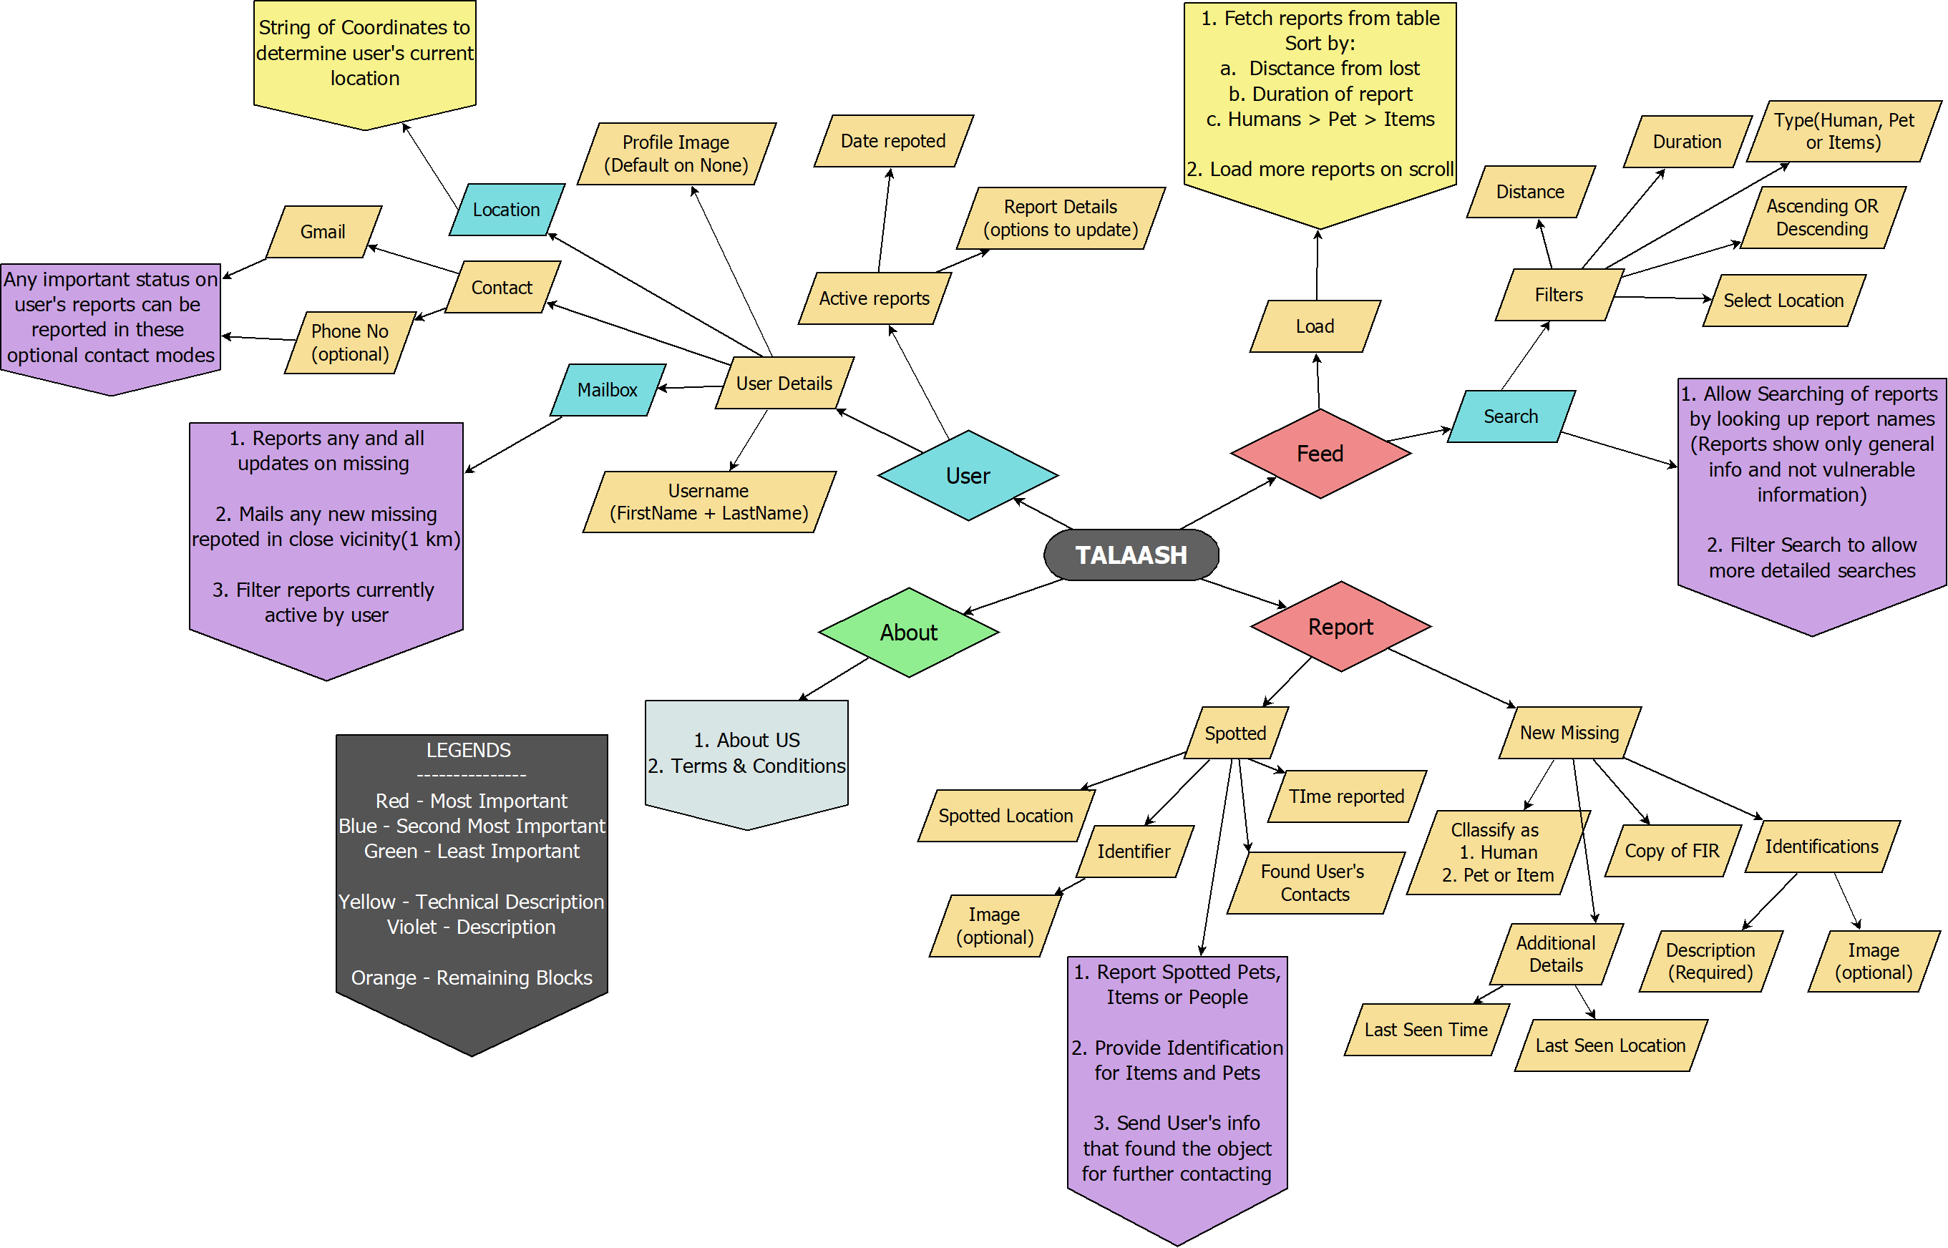  
  FLOWCHART OF FEATURES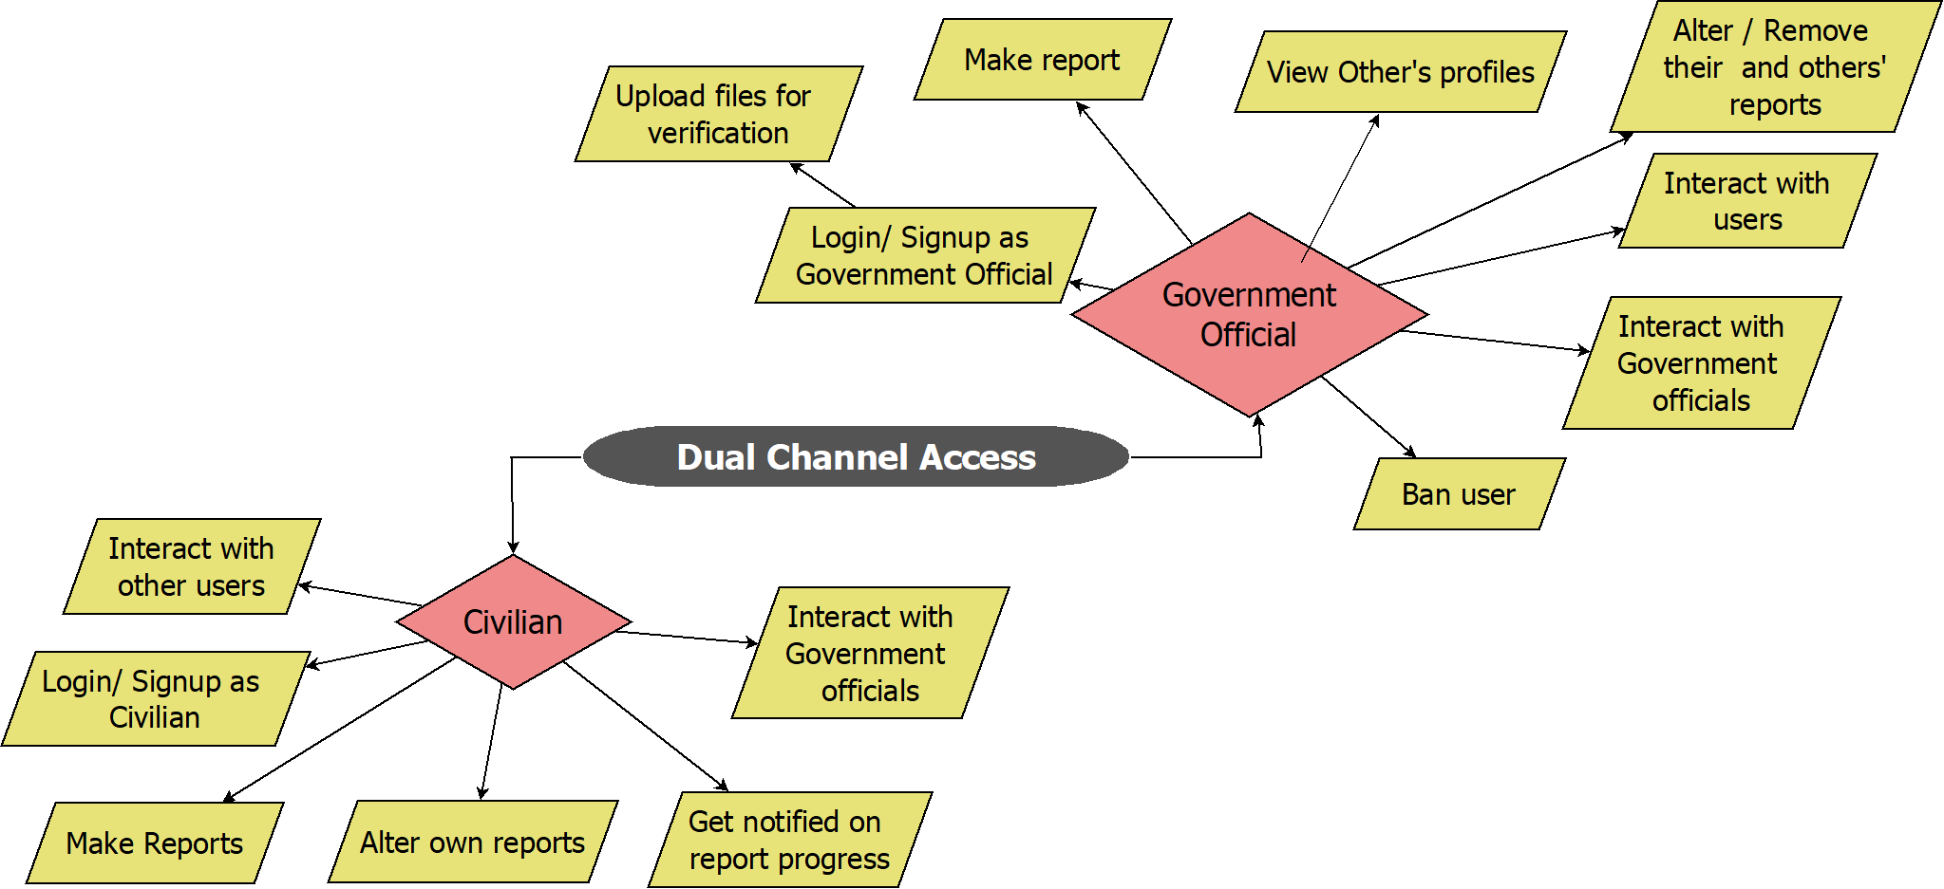 FLOWCHART DISPLAYING DUAL CHANNEL ACCESS:-   
    
    
    
    
    
    
    
    
  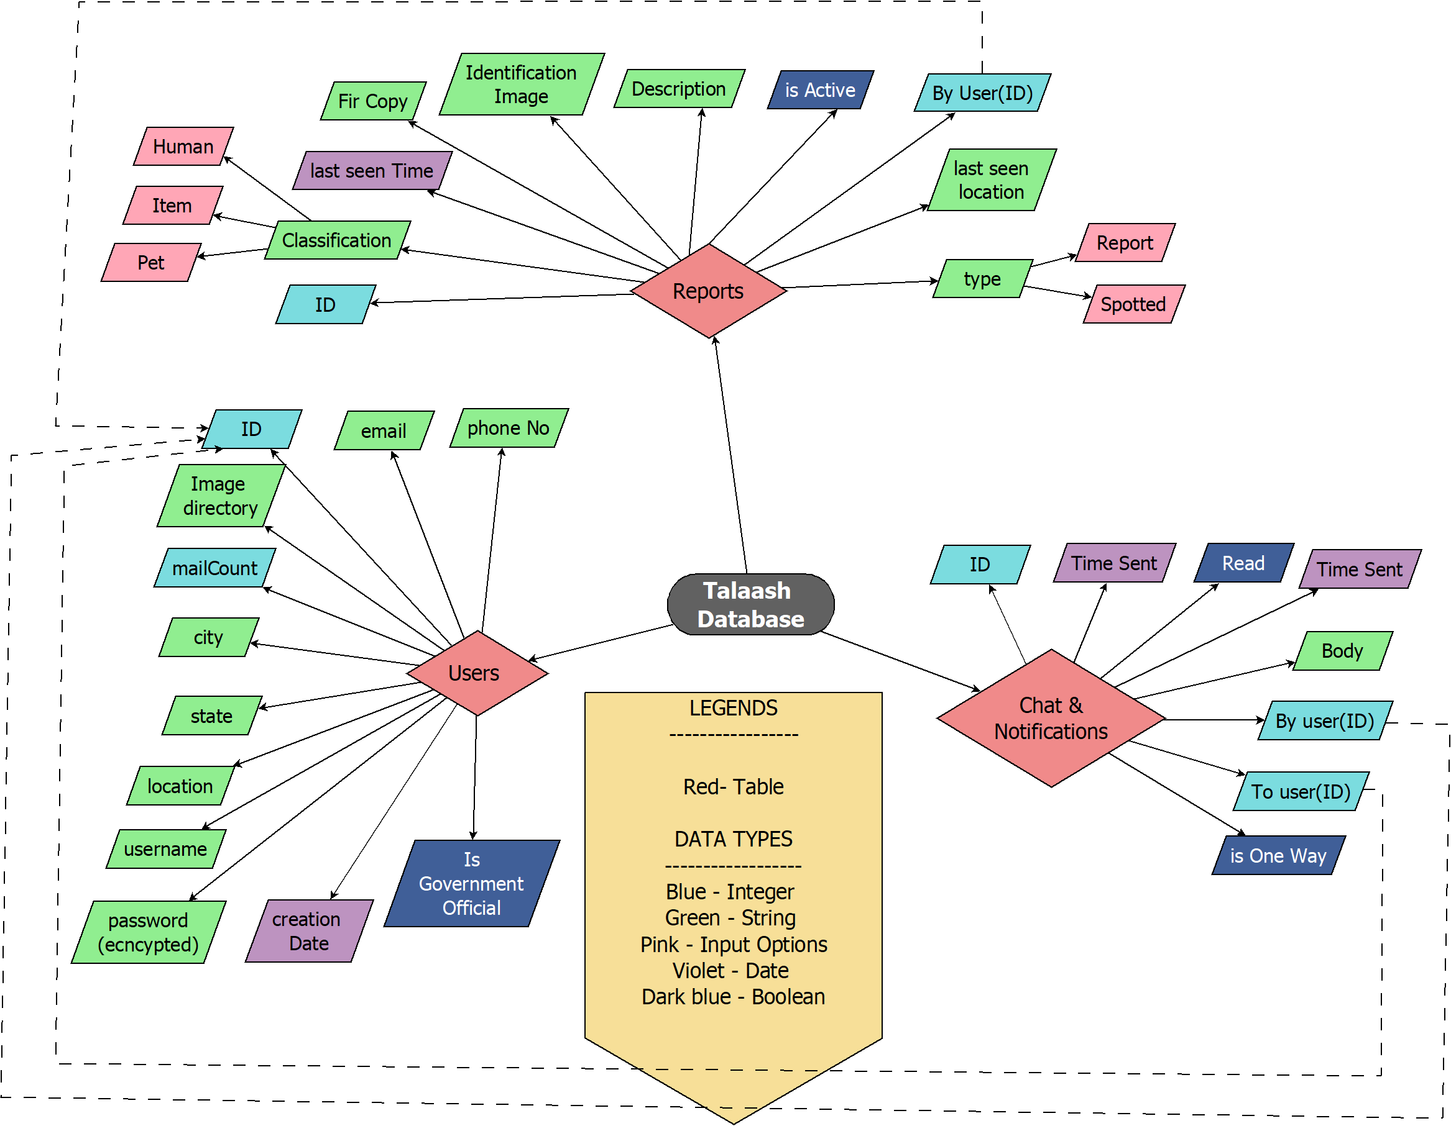FLOWCHART SHOWING BACKEND DATABASE STRUCTURE  
    
    
    
    
    
    
    
  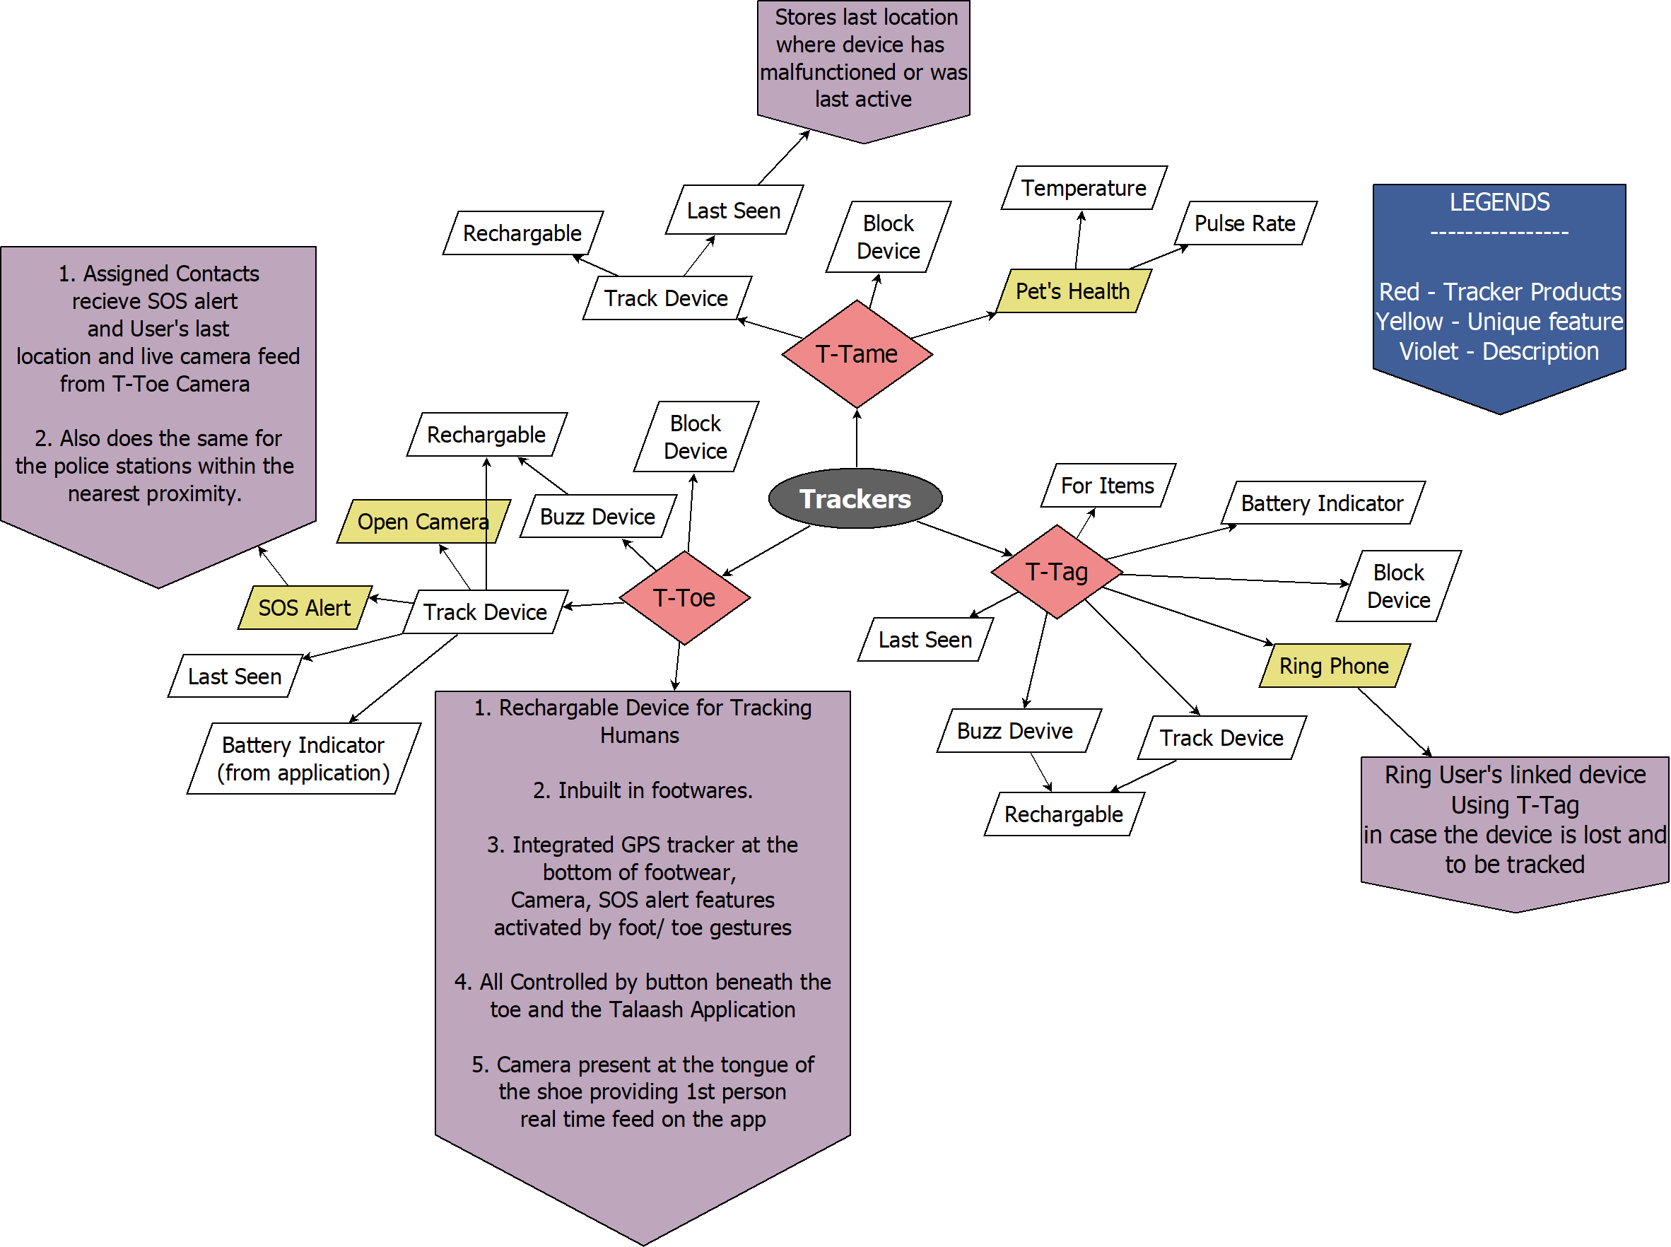FLOWCHART OF GENERAL OVERVIEW OF TALAASH TRACKERS.  
    
  D. ADVANTAGES OF THE INVENTION: \**  
    
  The pain of loosing a person, pet or a property is miserable. The application ‘TALAASH’ aims to counter this problem by acting as a bridge between the lost and the users/authorities trying to locate the lost Subject.  
    
    
  **Motive**- TALAASH does not claims to completely eradicate the problem but it aims to Reduce the existing number of cases as much as possible and bestow its Services and contribution the in Fields of Women Safety, Stealth, Child Abduction, tracking wanted Criminals and Human Trafficking.
* The TALAASH app will not only work as a medium of tracking and tracing People, Pets or belongings but will also enable real time interaction between the Users and government authorities trying to find the missing/ lost object.
* This will make information sharing more convenient and tracking more easier,loss of data during data transfer can be reduced.
* Keeping the confidentiality of government reports and data in mind we introduce a dual channel Access Module were the Features and accessible data for both the civilians and the Authorities will be customized
* Access to view details of unknown profiles or authorities will be completely prohibited for general users.
* Using TAALASH Law enforcement authorities can communicate with each other in any state of the Nation to the other and vice-versa Resulting in tracking and sharing inputs of Criminals or wanted suspects who have migrated to other states and remote location to escape the Police.
* It can be a better alternative to replace the FTP and Fax system to share database and images between Police Stations with better connectivity and clarity in a fraction of minutes.

1. **NOVELTY OF THE INVENTION**

* We implemented a dual channel Access Module were the Features and accessible data for both the civilians and the Authorities will be customized, each with their own set of authorization.
* Introducing a scope of interaction between the government and the public on subject such as missing, stealth and an interface to store wanted and missing records more efficiently among the users in the network.
* Integrated the application with the TALAASH Trackers namely the  
  1. T- Toe: For humans  
  2. T-Tame: For Pets

3. T-Tag: For Personal Belongings  
  
(For more Details refer to the Flow Chart of TAALASH Trackers)