**Name: Shubham Sahu**

**Sap Id: 500111692**

**Enrollment no: R2142221516**

**Branch &Year: Btech CSE AIML & IInd year**

**Subject: Web Technologies**

**WIREFRAME- WITH REAL DATA**

**Home Page —> Register Now —> LogIn —> Added Features —> Interactive Map —> Page redirected —>State Locations —> Description —>Customize Itenary**

**Extra features: Chatbot ,Quiz TRIVIA**

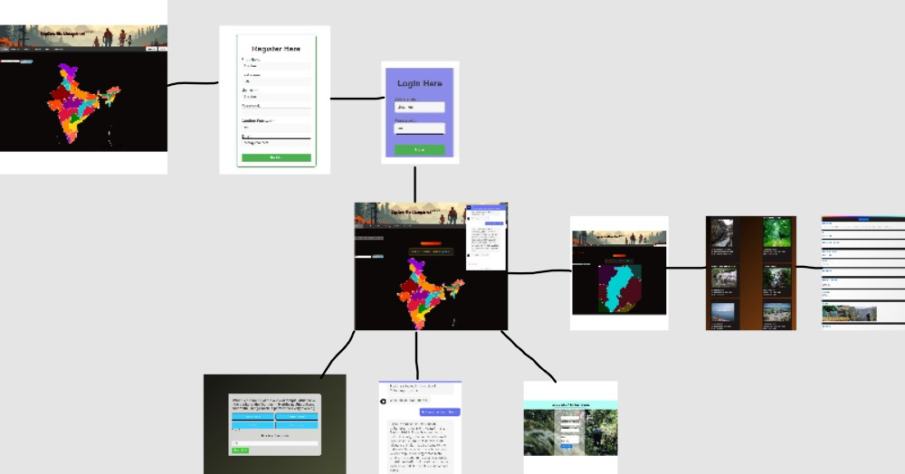

**Table of Contents:**

**1. Introduction**

**- Purpose**

**- Scope**

**2. Overall Description**

**- Product Features**

**3. System Features**

**- Interactive Mapping**

**- Location Insights**

**- Travel Planning**

**- Tourism Quiz**

**- Chat Bot**

**- User Authentication**

**4. Interfaces**

**- User Interfaces**

**- Hardware Interfaces**

**- Software Interfaces**

**5. Non-functional Requirements**

**- Performance**

**- Security**

**- Usability**

**6. Other Requirements**

**- Legal and Regulatory**

**- Documentation**

**Software Requirements Specification (SRS) for Unexplored Places Exploration Website**

**1. Introduction**

1.1 Purpose

This document outlines the requirements for developing a dynamic web application aimed at facilitating exploration of uncharted destinations. The application will integrate interactive mapping, detailed location insights, personalized travel planning, an engaging tourism quiz, and user authentication features.

1.2 Scope

The web application aims to provide users with an immersive platform to discover and learn about lesser-known travel destinations worldwide. Users can interact with maps, access rich location descriptions, tailor travel itineraries, participate in a quiz to test their tourism knowledge, and engage with a chat bot for assistance. User registration and login functionality will enhance personalization and engagement.

**2. Overall Description**

2.1 Product Features

Interactive Mapping

Location Insights

Customized Travel Planning

Engaging Tourism Quiz

Interactive Chat Bot

User Authentication

**3. System Features**

3.1 Interactive Mapping

Users explore unexplored destinations through an interactive map interface.

3.2 Location Insights

Detailed information about each location, including attractions, accommodations, and travel tips, is provided.

3.3 Customized Travel Planning

Users can create and personalize travel itineraries based on their interests and preferences.

3.4 Engaging Tourism Quiz

A fun and informative quiz challenges users' knowledge of travel destinations, with features such as a timer and hints.

3.5 Interactive Chat Bot

A responsive chat bot assists users with queries, provides recommendations, and enhances user engagement.

3.6 User Authentication

Secure user registration and login functionality ensure personalized experiences and data security.

**4. External Interface Requirements**

4.1 User Interfaces

Intuitive and visually appealing interfaces for seamless navigation and interaction.

4.2 Hardware Interfaces

Compatibility with standard web browsers and devices.

4.3 Software Interfaces

Integration with mapping APIs, chat bot platforms, and databases for seamless data exchange.

**5. Non-functional Requirements**

5.1 Performance

Fast loading times and responsiveness to ensure a smooth user experience.

5.2 Security

Robust authentication mechanisms and data encryption to safeguard user information.

5.3 Usability

Accessibility features and user-friendly design to accommodate diverse user needs.

**6. Other Requirements**

6.1 Legal and Regulatory

Compliance with data protection regulations and privacy policies.

6.2 Documentation

Comprehensive documentation for system installation, usage guidelines, and maintenance procedures.

**7. Interface**

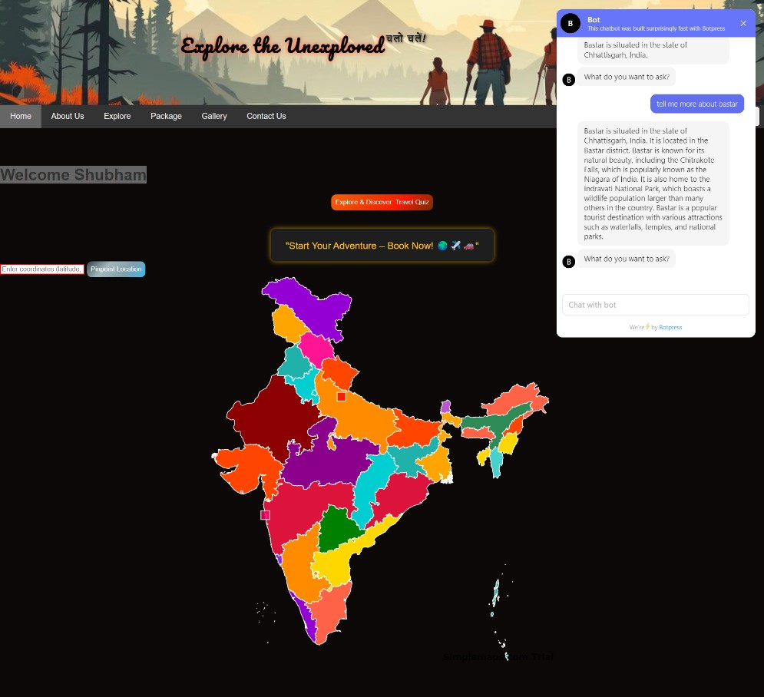

**UML Diagram:**

Use case diagram of this website-

