e-Commerce
Business Requirement Document

V 1.0

PREPARED BY | Infobell IT sol.
DATE | 22-May-23

Document Control:

VERSION | AUTHOR | DATE | CHANGE DESCRIPTION | APPROVER & DATE

Table of Contents
1. Introduction 3
1.1. Purpose 3
1.2. Scope 3
1.2.1. In-Scope 3
1.2.2. Out of Scope 3
2. Summary of Requirements 3
3. Home Page 5
4. Category Page 6
5. Product detail page 7
6. Similar item page 8
7. Cart page 9
8. Invoice Page 11
9. Registration 12
10. Login page 13
11. Admin page 14
12. Payment page 15
13. General Information 16
14. Point Of Contact 16

Introduction

This document is prepared for the requirements to Build world-class ecommerce retail application

Purpose
The purpose of the functional requirement (or business requirement) document is to define and document a complete and accurate description of the requirements/specifications of the product to be developed for e-Commerce website.

Scope

In-Scope
All requirements specified as “Mandatory” or “Must to have” are in the scope of this project. All such requirements are required in order for the product to be considered complete for this project.

Out of Scope
All requirements specified as “Optional” or “Nice to have” may be considered as out of scope of this project. All such requirements are not required for the product to be considered complete however if feasible, the product shall include these requirements. Future projects may be initiated to deliver optional requirements not included in the scope of this project.

Note: All requirements shall be considered mandatory unless specified otherwise.

Summary of Requirements

Following requirements and functionalities to be considered for development of project.
 | Development requirement | Priority
01 | Site should Use layered architecture - Database layer, Business Logic Layer, RESTAPI/Web Services Layer, UI Layer. | Mandatory
02 | Break down requirement into components and Design Architecture diagram | Mandatory
03 | Document the REST API for each of the component | Mandatory
04 | Design mockup diagram using Figma for UI | Mandatory
05 | Database design ER-diagram | Mandatory
06 | Implement singleton design pattern for database connection management | Mandatory
07 | Code should be written handling all scenarios with proper exception handling | Mandatory
08 | Dockerize the application & deploy in OpenShift | Mandatory
 | Development requirement | Priority
09 | Develop the code as per coding guidelines | Mandatory
10 | Write automated unit testing code for the REST APIs and do the manual testing for UI | Mandatory
11 | Create 2 git repos for the project, with all other members access.(Backend and UI) Create private branches and work on it and merge to master every 2 days after code review by peer members. | Mandatory

 | Functionality | Priority
01 | Entire site should be database driven | Mandatory
02 | Multilingual Site | Nice to have
03 | About page | Low
04 | Contact Us | Low
05 | Navigation to “Item list” page from “Category” page by on-click of image instead of link “More…” | Nice to have
06 | Link & functionality to apply for cart | Mandatory
07 | Mouse-over menu for Top-menu bar (and wherever applicable) | Nice to have
08 | “Back” option of browser to be blocked (provide back button on each page) | Optional
09 | Print Invoice | Mandatory
10 | Invoice generation in .PDF format | Low
11 | Integrate with gmail for login | Optional

Most of the pages will look like as Fig. –1 and Fig. –2. This can be treated as a template. User should able to navigate thru top menu bar and / or left link panel.

From categories container user can browse thru various categories like Home Appliances, Electronics, Fashion, Beauty,etc.

Left link panel is optional. However, if done, the links on left link panel should be collapsible links (wherever applicable) to show the sub categories. (For ex. Electronics may have sub categories as TVs, Home Theatre, Music systems, etc.).

Each category page should have a multiple selection choices. Using this user should able to filter the products based on brand and/or price. User should able to add any product in cart from Item List page.

Any person shall able to view (& navigate) the entire pages however; one has to be a register member of site to purchase.

Home Page

The homepage will feature a range of promotional schemes and discount offers prominently displayed. It will also showcase a diverse selection of categories and highlight top offers. Additionally, the inclusion of advertisements from our esteemed partners and sponsors will enhance the overall user experience. The navigation bar will provide convenient access to specific category searches, the shopping cart, and the login/register pages.

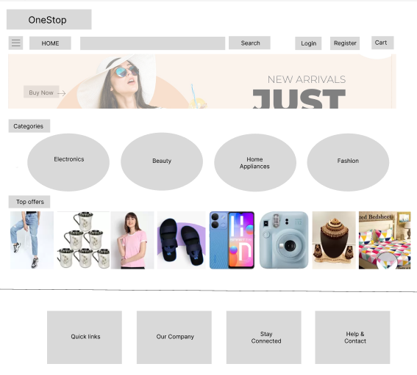

Users have the ability to refine their product search based on brand and/or price range. This can be achieved by selecting a brand from the dropdown list and/or specifying a price range from the available options. Upon clicking the "Go" button, the system will navigate to the Item List page, where all products within the chosen category that meet the specified selection criteria will be displayed. In the event that no products match the selection criteria, a relevant message will be presented to the user.

Category Page

The Item List page will present an organized display of all subcategories or products within the selected category. Additionally, the page may feature advertisements from our esteemed partners and sponsors. By clicking on a specific product, users will be seamlessly redirected to the respective product page for more detailed information and purchasing options.

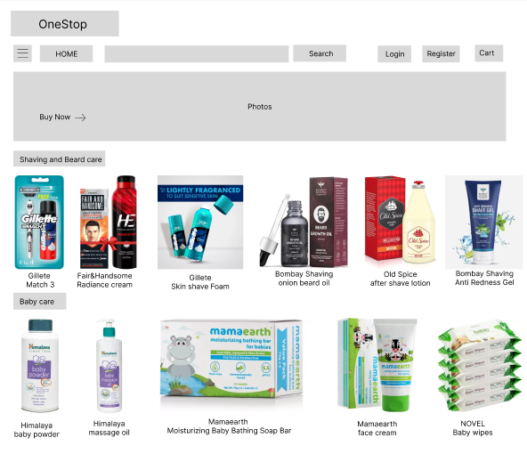

Product detail page

Within this page, users will find a comprehensive description and pricing information for the selected product. They will be presented with the option to either add the item to their cart or proceed with an immediate purchase. Upon clicking the "Add to Cart" link, the item will be successfully added to the user's cart. To review and finalize the cart items, users can navigate to the dedicated cart page. Alternatively, selecting the "Buy Now" option will directly redirect users to the checkout page for a streamlined purchasing process.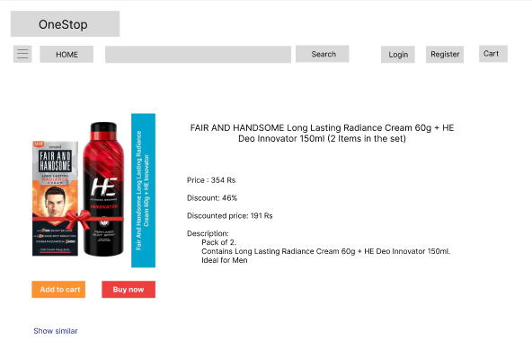

6.Similar item page

If a user wishes to explore similar items like a particular item, they can click on the "Show similar..." link on the product page. This action will present a dedicated page showcasing multiple choices that are similar to the desired item.

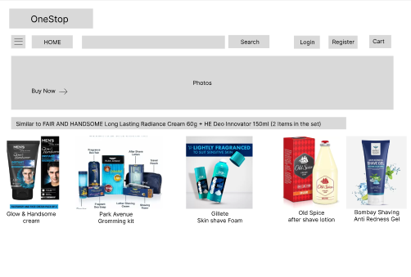

Cart page

On the "Cart page," customers will be provided with a comprehensive overview of the items they have added to their cart. This page offers convenient features such as the ability to remove items from the cart and adjust quantities as needed. By default, the quantity is assumed to be 1 when an item is added to the cart. Additionally, customers will have the option to update their ship-to address, while the customer name and bill-to address fields will be pre-filled for ease of use.

To proceed with the purchase, customers can simply click the checkout button, which will direct them to the invoice page for finalization. In the event that the customer has not added any items to the cart, a relevant message will be displayed to guide them accordingly.

- Cart page (With items)

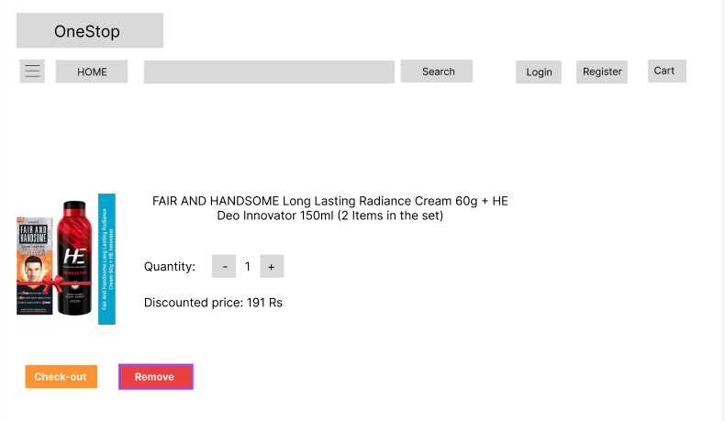

Cart page (Empty)

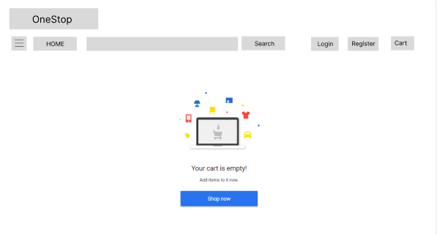

Invoice Page

This page will be displayed once customer checks-out. The complete invoice will be displayed on this page. The page will have “Modify” “Cancel”, “Pay” buttons. The cancel button will empty the cart and will take user to home page. “pay” will take to the credit card verification page. On successful payment, relevant message should be displayed and invoice should be sent to customer preferably in .PDF format.

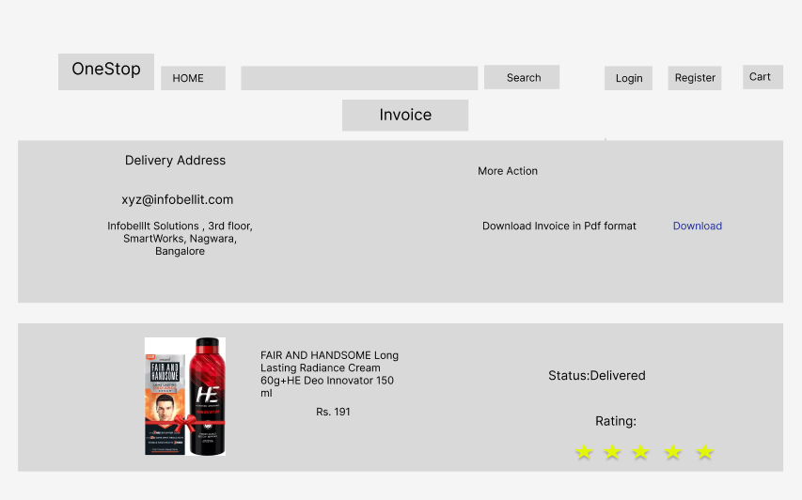

Registration

This page will be used as a application form for member registration for web site. This form will typically collect the customer information such as Name, address, contact details, e-mail id, etc. The page will have “Register” and “Clear” button. The “clear” button will clear the form and “Register” will save the data. On “Register” the Customer number will be generated and the same will be used to store user data in database.

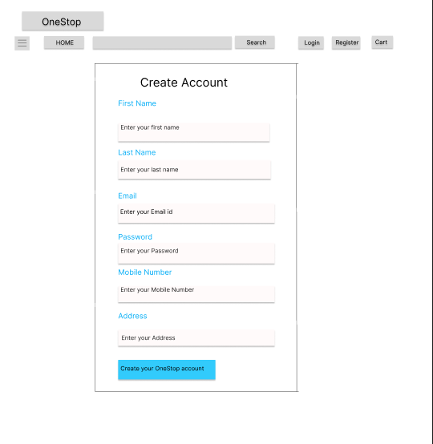

Login page

This page is designed for registered members to securely log in to our website. The entered email and password will be carefully verified against the information stored in our customer database. Once authenticated, users will gain access to add items to their shopping cart and make purchases.

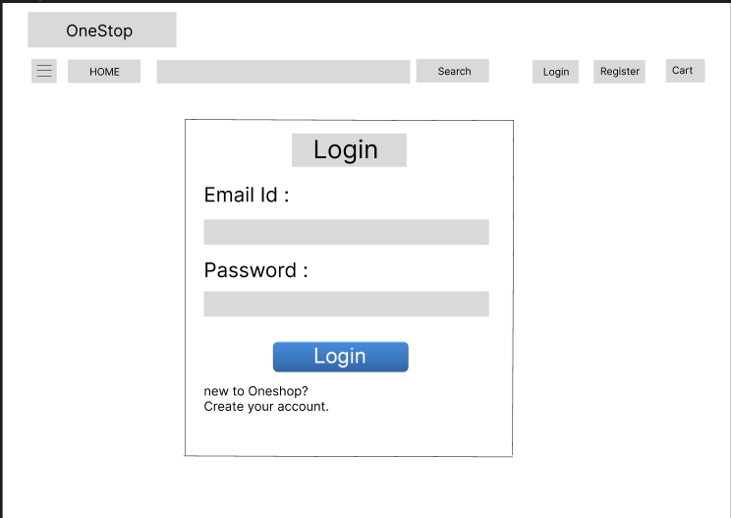

Admin page

This secure login portal is exclusively designed for authorized administrators. Once authenticated, you will gain access to a comprehensive user interface that allows you to modify, delete, and display various tables directly from our database.

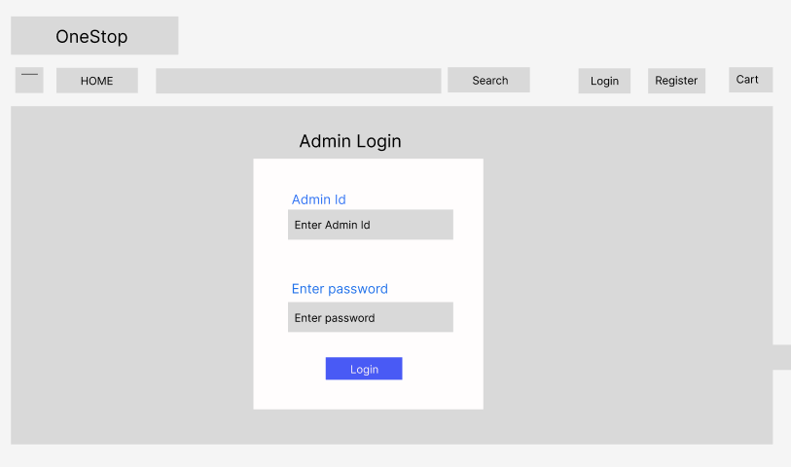

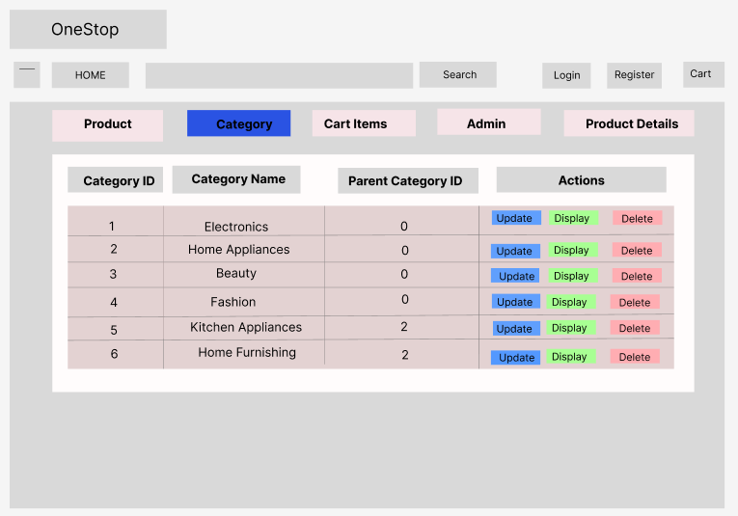

Payment page

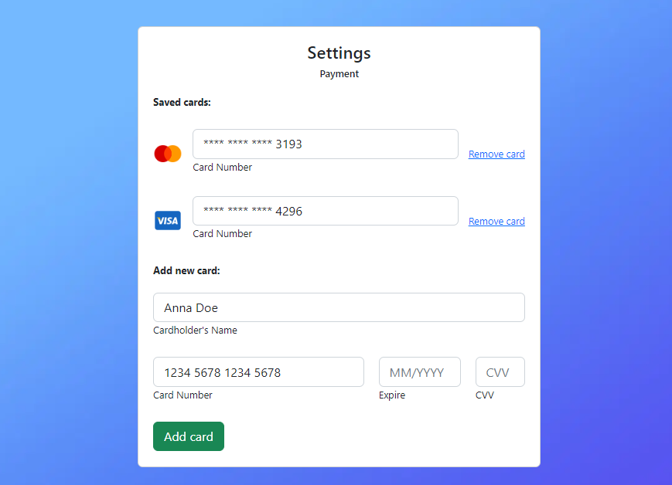

General Information

- Team leader need to submit report every week.
- All milestone should to be submitted as per schedule
- Documents need to be approved by seniors before submitting.

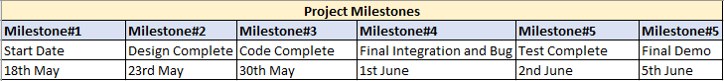

Point Of Contact

All queries may be sent to respective Team lead or may be discuss in person. The detail of team and POC is as below.

