MUSIC PLAYLIST WITH UNDO SKIP
[Doubly Linked List]

1. Problem Statement
Design and implement a console-based music playlist in C++ using a doubly linked list. The user can add songs, move to the next or previous song, skip a song, undo the most recent skip, and display the playlist. When a song is skipped, it is not permanently deleted. Instead, the skipped song is stored in a skip history stack containing the last five skips. The undo operation restores the skipped song to its exact original position in the playlist.
2. Objectives
- To implement a doubly linked list using pointers and classes in C++.
- To understand insertion, deletion, and relinking of nodes.
- To implement a stack using a linked list for maintaining skip history.
- To implement input validation using a menu-driven program.
- To understand how a skipped node can be restored to its exact original position without permanently deleting it.
- Algorithm
- Start the program.
- Initialize head, tail, current, and the skip stack as empty.
- Display the menu containing the options: Add, Next, Previous, Skip, Undo, Display, and Exit.
- Read the user's choice and validate the input. If the choice is invalid, ask the user to enter a valid choice again.
- Add Song: Create a new song node. If the list is empty, make the new node the head, tail, and current node. Otherwise, attach the new node after the tail and update the tail pointer.
- Play Next: Check whether current->next exists. If it exists, move current to the next node. Otherwise, display the message "End of playlist".
- Play Previous: Check whether current->prev exists. If it exists, move current to the previous node. Otherwise, display the message "Already at first song".
- Skip Song: Store p = current->prev and n = current->next. Relink the surrounding nodes by setting p->next = n and n->prev = p. If p is NULL, update head to n. If n is NULL, update tail to p. Push the skipped song and p onto the skip-history stack. If the stack contains more than five records, remove the oldest record. Move current to n if n exists; otherwise move current to p.
- Undo Skip: Check whether the skip stack is empty. If it is empty, display a suitable message. Otherwise, pop the most recent skip record. Find n = p->next when p is not NULL; if p is NULL, use the current head as n. Relink the skipped song between p and n. Update head or tail if required, and make the restored song the current song.
- Display Playlist: Traverse the doubly linked list from head to tail and print every song. Mark the current song to indicate which song is currently playing.
- Repeat the menu and corresponding operations until the user chooses the Exit option.
- Stop the program.

- Flowchart
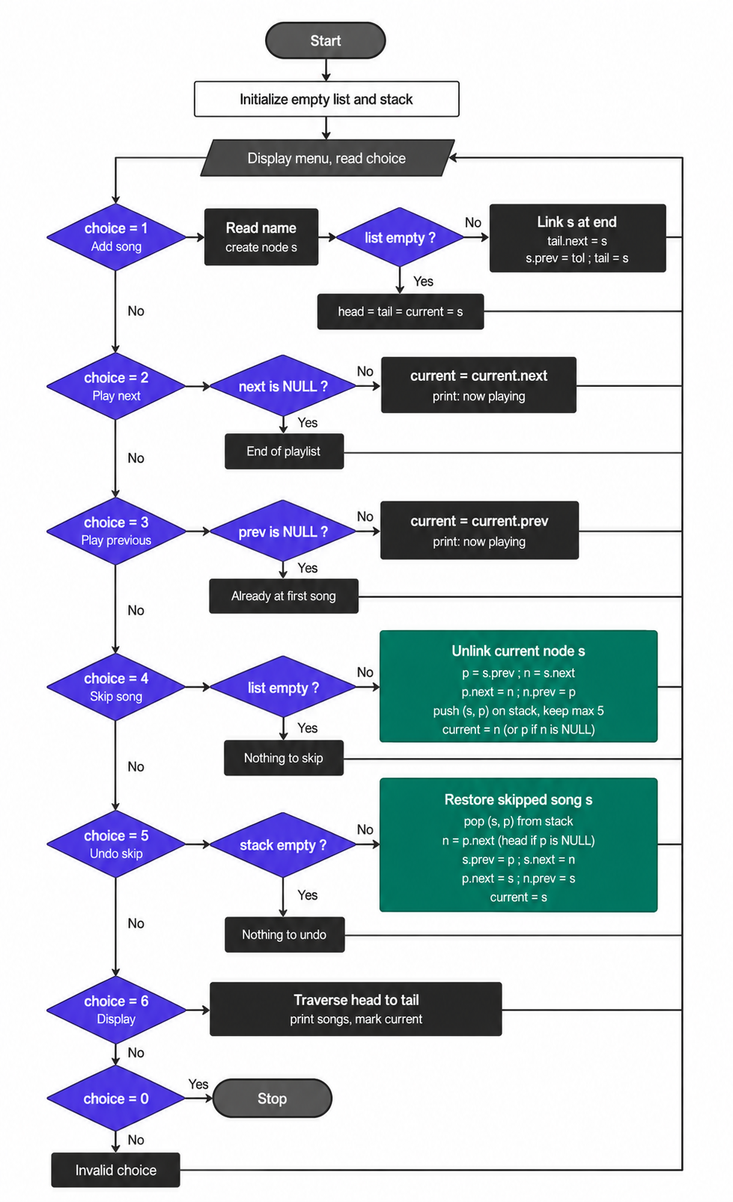
- Code

#include <iostream>
#include <string>
using namespace std;
struct Node
{
string name;
Node *prev;
Node *next;
};
// Playlist pointers
Node *head = NULL;
Node *tail = NULL;
Node *cur = NULL;
// Stack for skipped songs
Node *skipped[5];
Node *oldPrev[5];
int top = -1;
// --------------------------------------------------
// ADD SONG
// --------------------------------------------------
void addSong()
{
Node *s = new Node;
cout << "Enter song name: ";
cin >> s->name;
s->prev = tail;
s->next = NULL;
if (head == NULL)
{
head = s;
tail = s;
cur = s;
}
else
{
tail->next = s;
s->prev = tail;
tail = s;
}
cout << "Song added successfully.\n";
}
// --------------------------------------------------
// NEXT SONG
// --------------------------------------------------
void nextSong() {
if (cur == NULL)
{
cout << "Playlist is empty!\n";
}
else if (cur->next == NULL)
{
cout << "Already at the last song.\n";
}
else
{
cur = cur->next;
cout << "Now playing: " << cur->name << endl;
}
}
// --------------------------------------------------
// PREVIOUS SONG
// --------------------------------------------------
void previousSong()
{
if (cur == NULL)
{
cout << "Playlist is empty!\n";
}
else if (cur->prev == NULL)
{
cout << "Already at the first song.\n";
}
else
{
cur = cur->prev;
cout << "Now playing: " << cur->name << endl;
}
}
// --------------------------------------------------
// SKIP CURRENT SONG
// --------------------------------------------------
void skipSong()
{
if (cur == NULL)
{
cout << "Playlist is empty!\n";
return;
}
Node *s
Node *p = s->prev;
Node *n = s->next;
// Remove current song from playlist
if (p != NULL)
p->next = n;
else
head = n;
if (n != NULL)
n->prev = p; else
tail = p;
// Stack is full
if (top == 4)
{
// Remove oldest skipped song from stack.
// Do NOT delete the node here because it may
// still be needed by playlist/undo logic.
for (int i = 0; i < 4; i++)
{
skipped[i] = skipped[i + 1];
oldPrev[i] = oldPrev[i + 1];
}
top = 3;
}
// Push skipped song into stack
top++;
skipped[top] = s;
oldPrev[top] = p;
// Disconnect skipped node from playlist
s->prev = NULL;
s->next = NULL;
// Select next song, otherwise previous song
if (n != NULL)
cur = n;
else
cur = p;
cout << "Skipped: " << s->name << endl;
if (cur != NULL)
cout << "Now playing: " << cur->name << endl;
else
cout << "No songs remaining in playlist.\n";
}
// --------------------------------------------------
// UNDO SKIP
// --------------------------------------------------
void undoSkip()
{
if (top == -1)
{
cout << "Nothing to undo!\n";
return;
}
Node *s = skipped[top];
Node *p = oldPrev[top];
// Remove from stack
top--;
Node *n; // Find the song that should come after s
if (p != NULL)
n = p->next;
else
n = head;
// Insert skipped song back
s->prev = p;
s->next = n;
if (p != NULL)
p->next = s;
else
head = s;
if (n != NULL)
n->prev = s;
else
tail = s;
// Make restored song current
cur = s;
cout << "Undo successful.\n";
cout << "Restored song: " << s->name << endl;
}
// --------------------------------------------------
// SHOW PLAYLIST
// --------------------------------------------------
void show()
{
cout << "\n-----------------------------\n";
cout << " MUSIC PLAYLIST\n";
cout << "-----------------------------\n";
if (head == NULL)
{
cout << "Playlist is empty.\n";
cout << "-----------------------------\n";
return;
}
Node *t = head;
while (t != NULL)
{
cout << t->name;
if (t == cur)
cout << " <-- PLAYING";
cout << endl;
t = t->next;
}
cout << "-----------------------------\n";
} // --------------------------------------------------
// DELETE ALL SONGS
// --------------------------------------------------
void cleanup()
{
Node *temp = head;
while (temp != NULL)
{
Node *nextNode = temp->next;
delete temp;
temp = nextNode;
}
head = NULL;
tail = NULL;
cur = NULL;
// Clear stack references
for (int i = 0; i < 5; i++)
{
skipped[i] = NULL;
oldPrev[i] = NULL;
}
top = -1;
}
// --------------------------------------------------
// MAIN
// --------------------------------------------------
int main()
{
int c;
do
{
cout << "\n=================================\n";
cout << " MUSIC PLAYLIST SYSTEM\n";
cout << "=================================\n";
cout << "1. Add Song\n";
cout << "2. Next Song\n";
cout << "3. Previous Song\n";
cout << "4. Skip Song\n";
cout << "5. Undo Skip\n";
cout << "6. Show Playlist\n";
cout << "0. Exit\n";
cout << "=================================\n";
cout << "Enter your choice: ";
cin >> c;
switch (c)
{
case 1:
addSong();
show();
break; case 2:
nextSong();
show();
break;
case 3:
previousSong();
show();
break;
case 4:
skipSong();
show();
break;
case 5:
undoSkip();
show();
break;
case 6:
show();
break;
case 0:
cout << "Exiting program...\n";
break;
default:
cout << "Invalid choice! Please try again.\n";
}
} while (c != 0);
cleanup();
return 0;
}

------------------------------------------------------End ---------------------------------------------------------
