Q1 : Write a Java program to create a new array list, add some elements (string) and print out the collection by using for-each loop.

import java.util.\*;

class Arrli

{

public static void main(String args[])

{

ArrayList<String> elements= new ArrayList<String>();

elements.add("ONE");

elements.add("TWO");

elements.add("THREE");

elements.add("FOUR");

elements.add("FIVE");

elements.add("SIX");

elements.add("SEVEN");

System.out.println(elements);

for(String s:elements)

{

System.out.println(s);

}

}

}

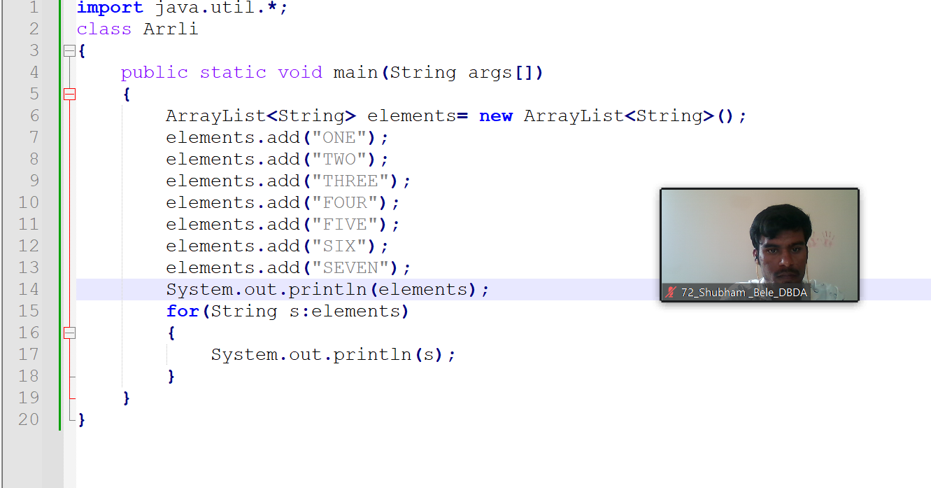

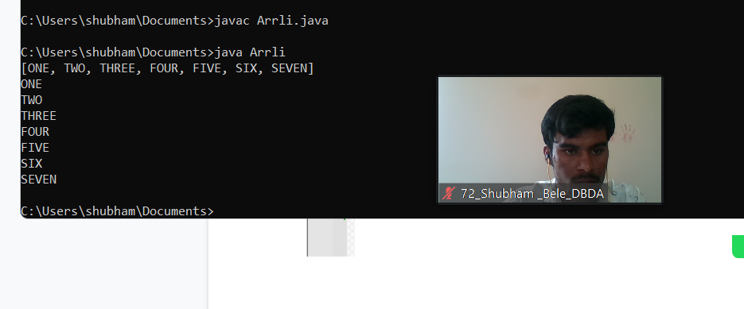

Q2 : Develop a class BankAccount having following data members : (10 Marks) int accno double balance Write appropriate constructors to initialize data members Define the following functions : withdraw : balance will reduce deposit : balance will increase show : display accno and balance If user tries to withdraw more than the balance, use exception handling code. Demonstrate the concept of exception handling in main() function.

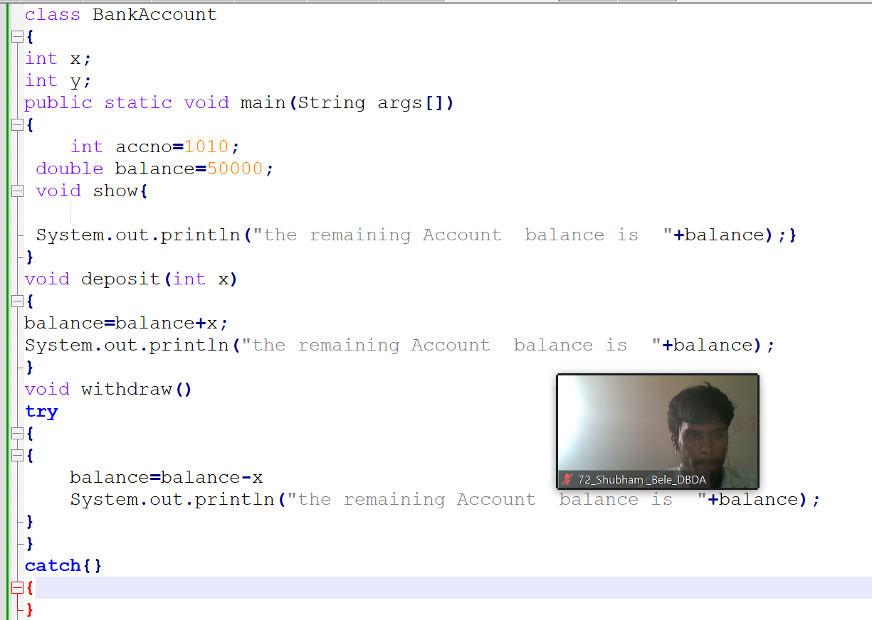

Q3 : Write a program to create a class named shape. In this class we have three sub classes circle, triangle and square, each class has two member function named draw () and erase (). Create these using Runtime Polymorphism concepts. (10 Marks

class shape

{

void draw()

{

System.out.println("we are draving the shape here ");

}

void erase()

{

System.out.println("we are erasing the shape here ");

}

}

class circle extends shape

{

void draw()

{

System.out.println("we are draving circle shape here ");

}

void erase()

{System.out.println("we are erasing circle shape here ");}

}

class tringle extends shape

{

void draw()

{System.out.println("we are draving the tringle shape here ");}

void erase()

{System.out.println("we are erasing tringle the shape here ");}

}

class square extends shape

{

void draw()

{System.out.println("we are draving squre shape here ");}

void erase()

{System.out.println("we are erasing square the shape here ");}

}

class run

{

public static void main(String args[])

{

shape c= new circle();

shape t=new tringle();

shape s=new square();

c.draw();

c.erase();

t.draw();

t.erase();

s.draw();

s.erase();

}

}

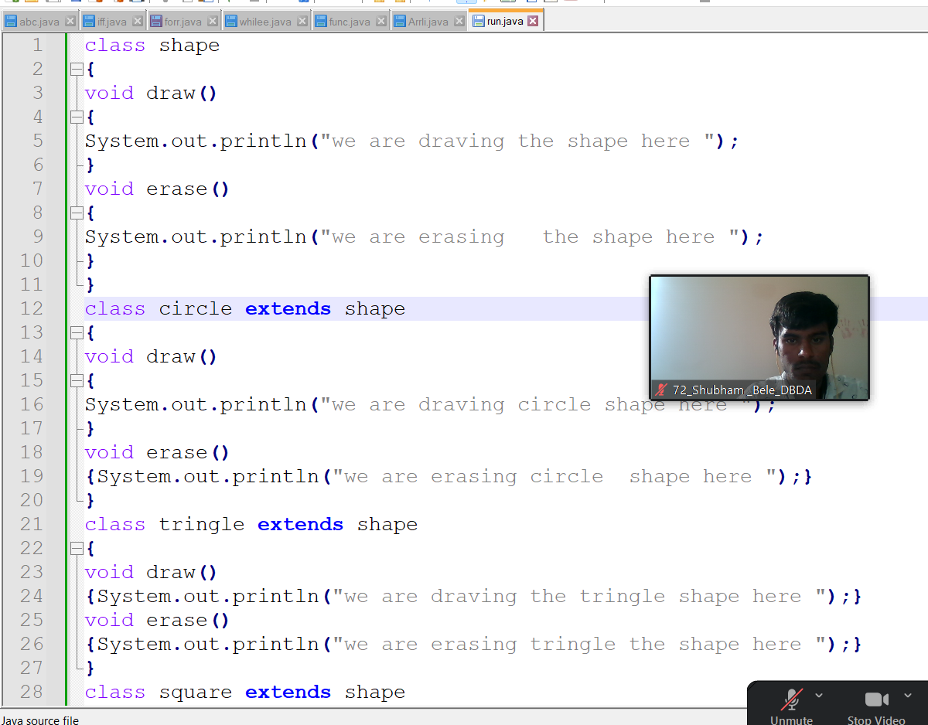

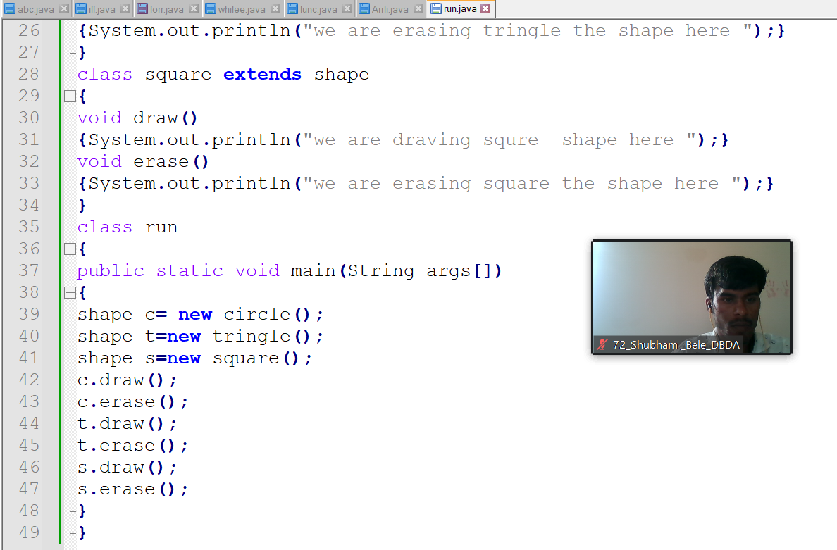

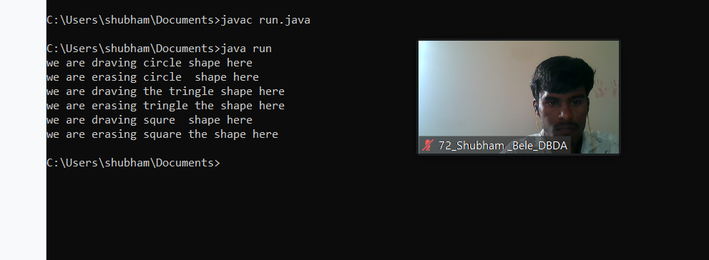

Q4)

