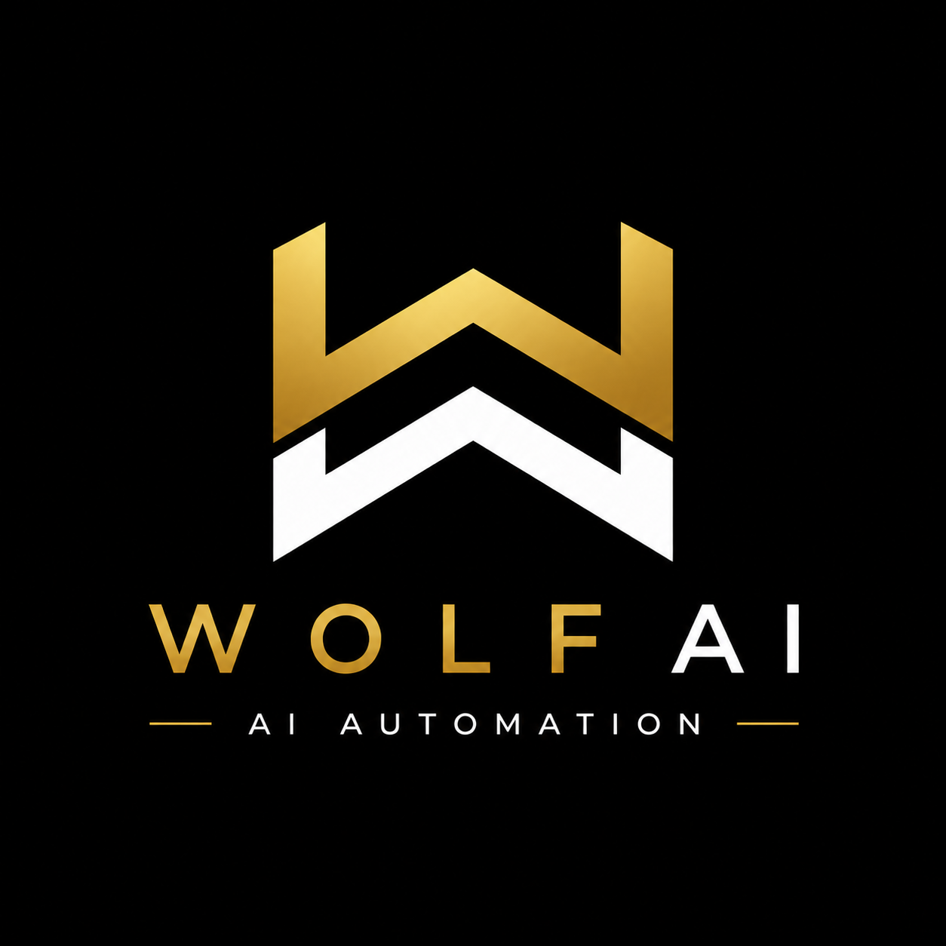
AI Quote Engine
Every enquiry returns a drafted quote within minutes of arrival.

Prepared for: [ Business name ] Date: [ DD Month YYYY ]

Why this exists
In service work, the operator who responds in two minutes wins the enquiry. The operator who responds in four days loses it. Response speed is the actual competition, and it has been for years.
Closing the response-speed gap has historically required one of two things: more staff, or longer operating hours. Neither suits the operators Wolf AI works with. Hiring is expensive. Longer hours come out of the operator's life.

Wolf AI builds systems that make response speed automatic. The AI Quote Engine is the first of them.

An inbound enquiry returns a drafted quote on the operator's phone within minutes of arrival. The operator approves with a single action. The customer receives a branded PDF and booking link before any competitor has opened the same enquiry.

What we believe: a good operator should not lose work to a faster admin team. The system removes the admin from the equation.

What you get
The AI Quote Engine produces finished, branded quotes from photographs and addresses. Every tier includes the complete feature set. Tier selection is based on monthly quote capacity only.

Every package includes:
- Quotes drafted in your pricing. Trained on 20 of your historical jobs. Accuracy held within ±10%.
- Operator approval workflow on every quote. Send, Edit, or Schedule site visit. Nothing leaves without your action.
- Branded PDF in your logo, colours, terms, and contact details.
- Dedicated Australian quoting number. All inbound enquiries route through it.
- Outbound coverage of your service area. Properties identified, decision-maker contacts attached.
- Email and SMS delivery to every customer, with a booking link inside the quote.
- Conversion dashboard. Status tracked per quote: opened, viewed, accepted, cold.
- Unlimited template, pricing, and service updates throughout the engagement.
- 30 days of post-launch tuning to stabilise performance against real quote data.

Select your package by monthly volume.
 | Starter | Growth | Scale
Quotes per month | Up to 50 | Up to 200 | Up to 500
Operator profile | Solo or two-crew | Established, peak season | Multi-crew, multi-region
Setup (one-off) | $1,299 | $1,499 | $1,699
Monthly | $199 | $299 | $499

All prices AUD, exclude GST. Setup fee split 50% on signing, 50% on go-live. Month-to-month after the first 30 days. No lock-in, no exit fee.

What we need from you
All operator inputs are collected on Day 1. The build clock starts when these inputs are received.
- 20 of your past quotes. PDF, photo, spreadsheet, or screenshot. Any format accepted.
- Services list and pricing rules. Base rates, minimums, surcharges, and discount conditions.
- Brand assets. Logo, colours, ABN, and any standard terms required on quotes.
- Operator phone number. Approval cards deliver to this number.
- Customer reply email address. Inbound replies from customers route to this inbox.
- 30 minutes on Day 6. Walkthrough call and template sign-off before go-live.

No accounting system access required. No internal team onboarding. No additional software for the operator to install or learn.

What we'll do
The build, deployment, and ongoing operation are delivered end to end.

- Engine build tailored to your industry, service area, and historical pricing.
- Pricing logic calibration, back-tested against your historical data until accuracy lands inside ±10%.
- Dedicated Australian quoting number provisioned and connected.
- Pre-launch testing. Ten dummy enquiries processed end-to-end. Edge cases handled before customer-facing deployment.
- Operator handover on Day 7. Dashboard walkthrough, approval-card demonstration, override controls.
- Ongoing operation and maintenance. No additional fees for tuning, template updates, or pricing changes.
- Active monitoring. Issues detected and resolved without operator intervention.

Timeframe for setup
Seven days from the moment inputs are received to the first live quote going out.
Day | Activity
Day 1 | Kickoff call. Past quotes, brand assets, and pricing rules received. Dedicated quoting number provisioned.
Day 2 | Vision model tuned to your specific industry and property types.
Day 3 | Pricing logic built and back-tested. Accuracy validated within ±10% of your historical pricing.
Day 4 | Branded quote template completed. Approval-card workflow wired. Booking link embedded. Conversion dashboard configured.
Day 5 | End-to-end testing. Ten dummy enquiries processed through the full flow. Edge cases handled.
Day 6 | Operator walkthrough. Dashboard, approval card, and override controls demonstrated. Quote template signed off.
Day 7 | Go-live. First live quote sends. 50% balance invoiced. 30 days of post-launch tuning begins.

Ongoing monthly cost
Single flat fee per tier. All operating costs are included.
Package | Monthly | Capacity included
Starter | $199 / mo | Up to 50 quotes per month, fully managed
Growth | $299 / mo | Up to 200 quotes per month, fully managed
Scale | $499 / mo | Up to 500 quotes per month, fully managed

- No per-quote charges. The monthly fee is the only invoiced amount.
- No usage fees. All SMS, email, scans, drafts, and dashboard operations are included.
- Unlimited template and pricing updates throughout the engagement.
- Overflow rolls forward. Capacity exceeded in one month rolls to the next.
- Month-to-month terms. One month's notice to cancel. No lock-in, no exit fee.

Next step
Confirm the selected tier via wolf-ai.com.au. A 30-minute scope call can be booked through the same address if preferred.

Within seven days of inputs being received, the first live quote sends.

Wolf AI
wolf-ai.com.au

