Topics: Descriptive Statistics and Probability

- Look at the data given below. Plot the data, find the outliers and find out $μ, σ, σ^{2}$

Name of company | Measure X
Allied Signal | 24.23%
Bankers Trust | 25.53%
General Mills | 25.41%
ITT Industries | 24.14%
J.P.Morgan & Co. | 29.62%
Lehman Brothers | 28.25%
Marriott | 25.81%
MCI | 24.39%
Merrill Lynch | 40.26%
Microsoft | 32.95%
Morgan Stanley | 91.36%
Sun Microsystems | 25.99%
Travelers | 39.42%
US Airways | 26.71%
Warner-Lambert | 35.00%

Answer-
Mean: 33.2
Variance: 284.028
Standard Deviation: 16.853

Code-
import pandas as pd
import matplotlib.pyplot as plt
data = {"Name of Company": ['Allied Signal', 'Bankers Trust', 'General Mills', 'ITT Industries', 'J.P.Morgan & Co.', 'Lehman Brothers', 'Marriott', 'MCI', 'Merrill Lynch', 'Microsoft', 'Morgan Stanley', 'Sun Microsystems', 'Travelers', 'US_Airways', 'Warner-Lambert'],
"measure X": [24.23, 25.53, 25.41, 24.14, 29.62, 28.25, 25.81, 24.39, 40.26, 32.95, 91.36, 25.99, 39.42, 26.71, 35.00]}

# Creating a DataFrame
df = pd.DataFrame(data)
df['measure X'] = df['measure X'].round().astype('int')

# Plotting the DataFrame
df.plot(kind='bar', x='Name of Company', y='measure X')
plt.show()

#Finding mean,Varience and Standard deviation
print("Mean:", df['measure X'].mean())
print("Variance:", df['measure X'].var())
print("Standard Deviation:", df['measure X'].std())

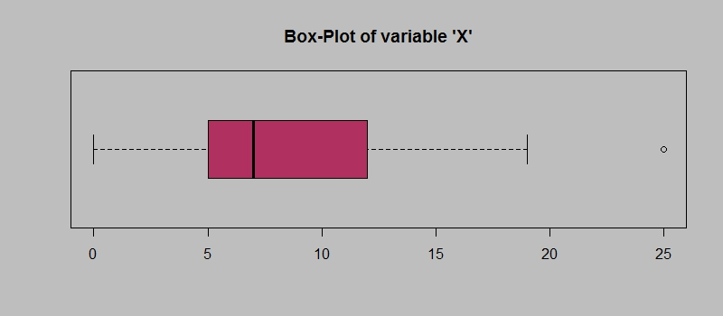
Answer the following three questions based on the box-plot above.
- What is inter-quartile range of this dataset? (please approximate the numbers) In one line, explain what this value implies.
Answer-
IQR =Q3-Q1=12-5=7
IQR=7
It describes spread of the middle 50% of the data.
- What can we say about the skewness of this dataset?
Answer-
Positively skewed
- If it was found that the data point with the value 25 is actually 2.5, how would the new box-plot be affected?
Answer-
The new Box plot will not have any outlier in the data
It will affect skewness, The new data will be normally distributed, there will be skewness in the dataset.
3.

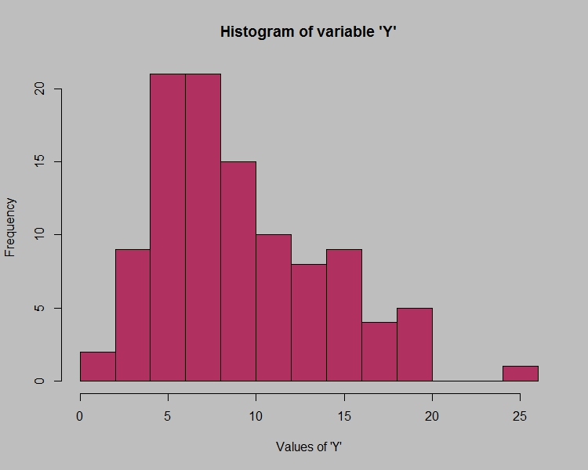
Answer the following three questions based on the histogram above.
- Where would the mode of this dataset lie?
Answer-
The mode lie on the 7 on the X – axis
- Comment on the skewness of the dataset.
Answer-
Right skewed
- Suppose that the above histogram and the box-plot in question 2 are plotted for the same dataset. Explain how these graphs complement each other in providing information about any dataset.
Answer-
They both are right-skewed and both have outliers the median can be easily visualized in box plot where as in histogram mode is more visible.

- AT&T was running commercials in 1990 aimed at luring back customers who had switched to one of the other long-distance phone service providers. One such commercial shows a businessman trying to reach Phoenix and mistakenly getting Fiji, where a half-naked native on a beach responds incomprehensibly in Polynesian. When asked about this advertisement, AT&T admitted that the portrayed incident did not actually take place but added that this was an enactment of something that “could happen.” Suppose that one in 200 long-distance telephone calls is misdirected. What is the probability that at least one in five attempted telephone calls reaches the wrong number? (Assume independence of attempts.)

Answer-
Probability of call getting misdirected = (1/200)
Hence probability of call not getting misdirected = 1-(1/200) = 199/200
Number of phone calls attempted = 5
Therefore, probability that at least one in 5 attempted call reaches the wrong number is:
=1-(199/200) ^5= 0.025

- Returns on a certain business venture, to the nearest $1,000, are known to follow the following probability distribution
x | P(x)
-2,000 | 0.1
-1,000 | 0.1
0 | 0.2
1000 | 0.2
2000 | 0.3
3000 | 0.1

- What is the most likely monetary outcome of the business venture?
Answer-
most likely monetary outcome of the business venture is $ 2000 as it has maximum Probability 0.3
- Is the venture likely to be successful? Explain
Answer
Venture is successful if X is + ve
Hence if X is 1000 , 2000 or 3000
Probability is 0.2 + 0.3 + 0.1 = 0.6
as 0.6 > 0.5 Hence venture likely to be successful

- What is the long-term average earning of business ventures of this kind? Explain
Answer-
long-term average earning of business ventures = E(X)
E(X) = ∑ X.P(X) = $ 800

- What is the good measure of the risk involved in a venture of this kind? Compute this measure
Answer-
Risk involved in a venture
Var (X) = E(X²) - { E(X) }²
= 2800000 - 800²
= 2160000 ( Quite High)
SD = √Var ≈ $ 1470
As Variability is Quite high hence Risk is high

