Hotel Virat – Room Booking User Guide
1. Login to the System
Step 1: Open the browser and go to the following URL:
https://hotelvirat.com/admin/login
Step 2: Enter the login credentials (Username and Password).
Step 3: Click on the Login button.
After successful login, the system will open the Admin Dashboard.

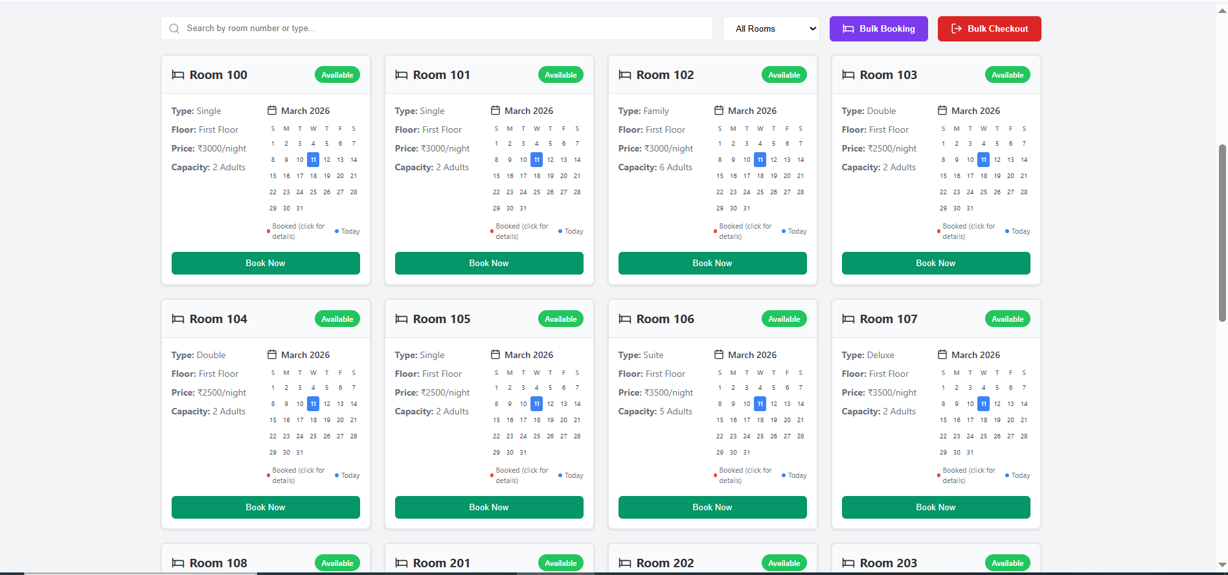

2. View Room Layout
After login, the system will display the room layout or room list.
The screen will show:
• Available Rooms
• Booked Rooms
• Room Numbers
Available rooms can be selected for booking.

3. Select Room Number
Step 1:
Identify the available room number from the room layout.
Step 2:
Click on the room number you want to book.
After selecting the room, booking options will appear.

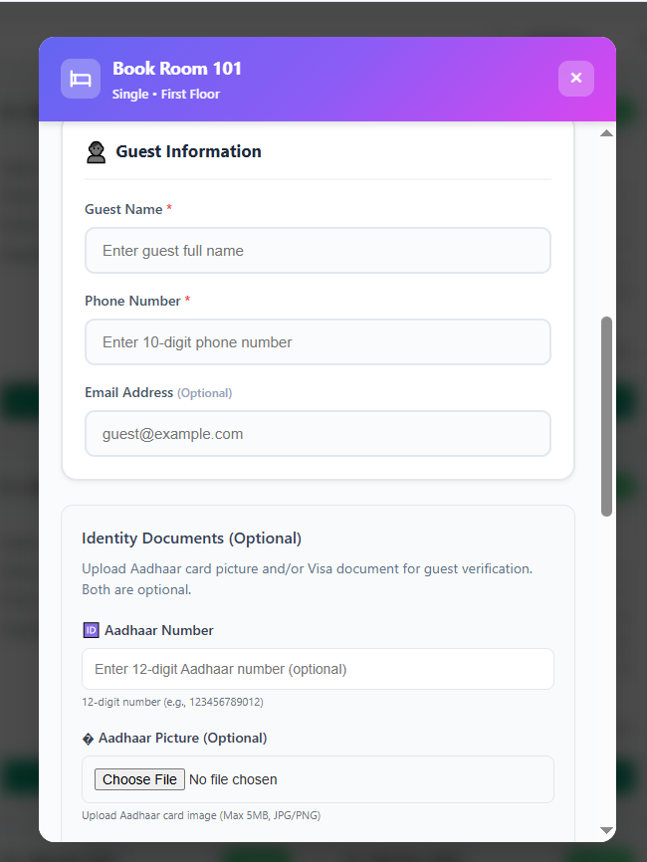
4. Select Booking Duration
While booking a room, the admin must also select the room booking duration.
The system allows booking rooms for the following time slots:
• 3 Hours
• 6 Hours
• 9 Hours
• 12 Hours
Step 1:
Select the required booking duration based on the guest’s request.
Step 2:
Ensure the correct duration is selected before confirming the booking.
The system will calculate the booking based on the selected time duration
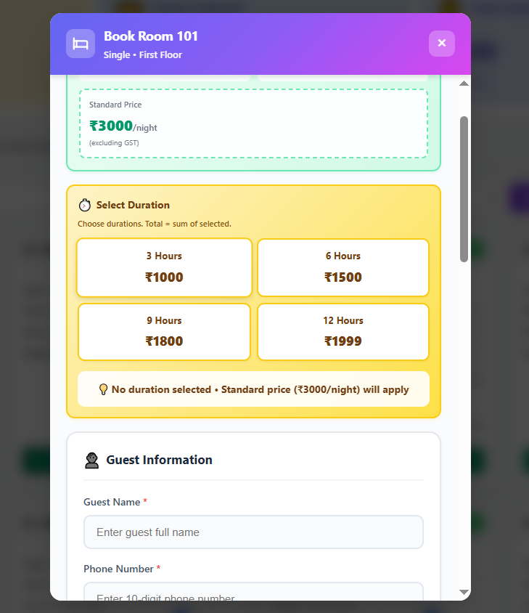

5. Start Room Booking
After selecting the room:
Step 1: Click the BOOK NOW button.
The system will open the Guest Information Form.

6 . Enter Guest Information
Fill in the required guest details.
Required Information
• Guest Name
• Mobile Number
• Address
• ID Proof Details
• Check-in Date
• Check-out Date
• Number of Guests
• Additional Remarks (if any)
Make sure all information is entered correctly.

7. Confirm the Booking
After entering all guest details:
Step 1: Click the Confirm Booking button.
Step 2: The system will process the booking and save the details.

8. View Advance Bookings
After completing the room booking, the booking details can be viewed in the Advance Booking section.
Step 1: Click on Advance Booking in the menu.
Step 2: The system will display a list of all advance bookings.
The booking list may include the following details:
• Room Number
• Guest Name
• Mobile Number
• Check-in Date
• Check-out Date
• Booking Status
• Booking Date

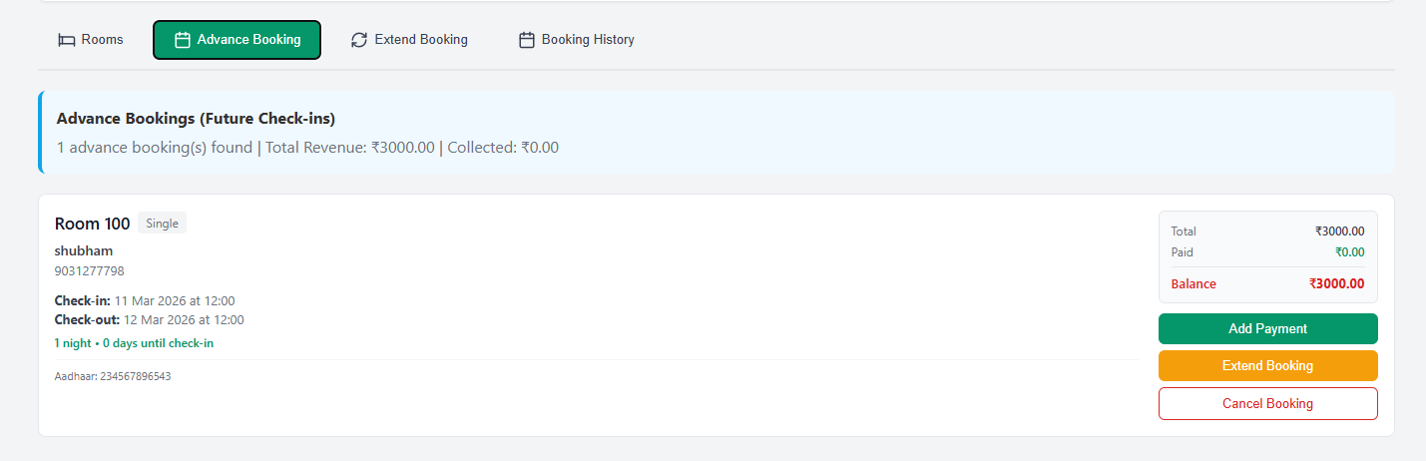
9. Cancel Room Booking
If a booking needs to be cancelled, it can be done from the Advance Booking section.
Step 1: Go to the Advance Booking page.
Step 2: Find the booking record you want to cancel.
Step 3: Click on the Cancel Booking option.
Step 4: The system will ask for confirmation.
Step 5: Click Confirm Cancel.

10. Extend Stay / Current Booking Details
The Extend Stay section shows the current active booking and allows the receptionist to manage the guest stay.

Information Displayed
• Room Number
• Guest Name
• Phone Number
• Check-in Date
• Check-out Date
• Total Amount
• Amount Paid
• Balance Due
From this section the receptionist can:

• Add payment
• Extend stay
• Add restaurant bill
• Checkout the guest
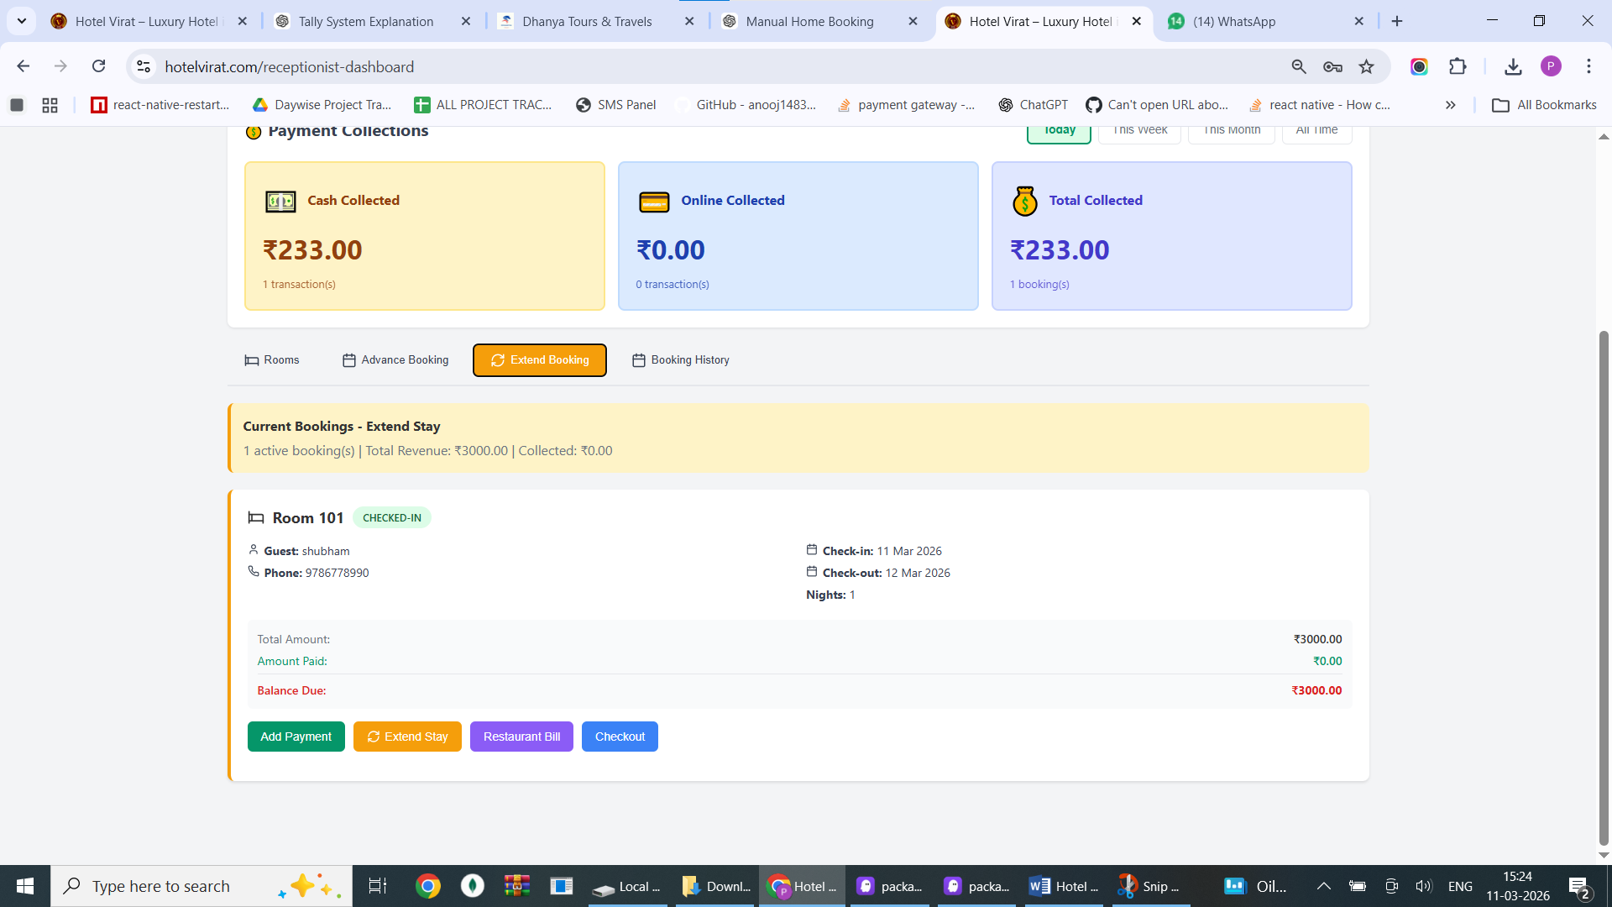
11. Add Payment
If the guest makes a payment, the receptionist can manually add the payment.

Step 1 : Click the Add Payment button.

Step 2 : Enter the payment amount.

Step 3 : Select the payment method:
• Cash
• Online

Step 4 : Click Add Payment.
The payment will be recorded and the balance due will be updated automatically.
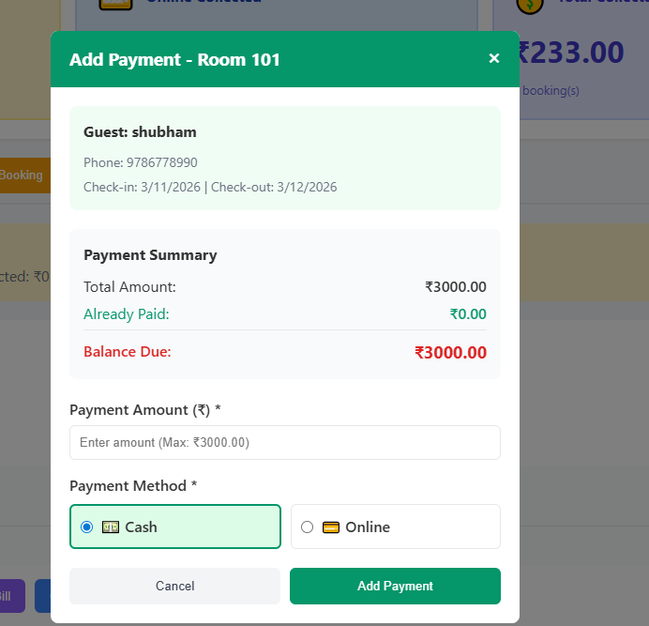

12. Add Restaurant Bill
If the guest orders food or room service, the restaurant bill can be added to the room booking.

Step 1 : Click Restaurant Bill.

Step 2 : Enter the following details:
• Bill Amount
• Description (Example: Lunch, Dinner, Room Service)

Step 3 : Click Add Bill.

The restaurant bill will be added to the room booking total amount.
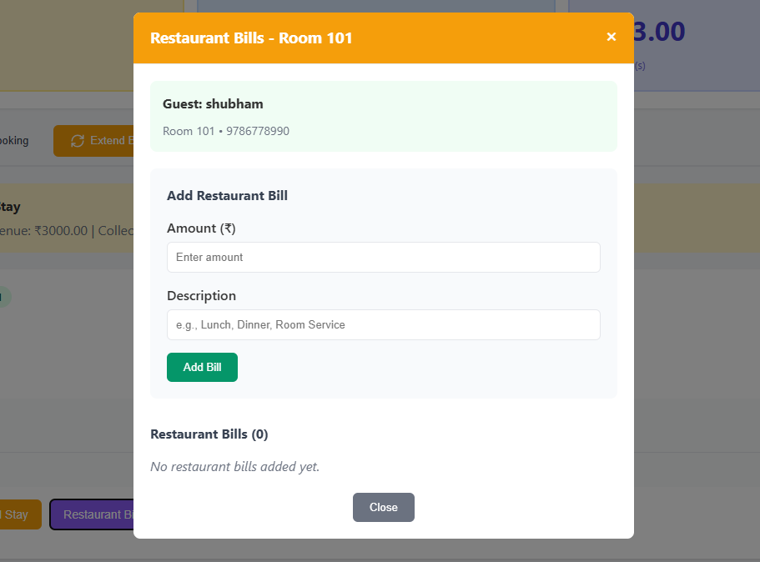
13. Checkout Guest
When the guest is ready to leave, the receptionist must complete the checkout process.

Step 1 : Click the Checkout button.

Step 2 : The system will display:
• Guest Details
• Stay Details
• Payment Summary
• Balance Due

Step 3 : If any balance is pending, add the payment.

Step 4 : Confirm the checkout.
After checkout, the room will become available for new booking.
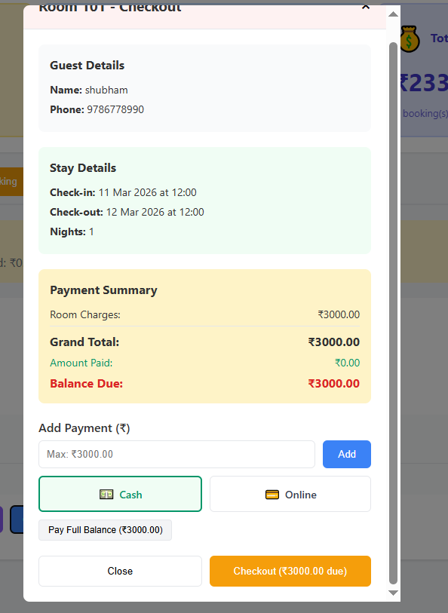

14. Booking History
The Booking History section allows the receptionist to view all past bookings and transactions.

Step 1 : Click on Booking History.

Step 2 : The system will display:
• Room Number
• Guest Name
• Check-in Date
• Check-out Date
• Payment Details
• Booking Status
This section helps track all previous bookings and financial transactions.

