Name : Shubham Kadam

Student ID: **AF0429486**

Exercise Questions on Sort and Filter Lab

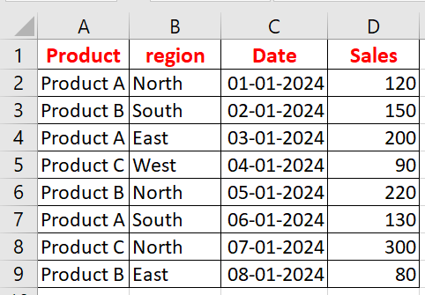

please refer the above dataset for the following task.

1. Sort the dataset alphabetically by the Product name in column A.

2. Sort the dataset by Sales in descending order.

3. Sort the dataset first by Region in alphabetical order, and then by Sales in ascending order within each Region.

4. Apply a filter to display only the rows where the Product is "Product B".

5. Apply a filter to display only the rows where the Sales are greater than 150.

6. Apply a filter to display only the rows where the Date is in January 2024.

 7. Sort the dataset first by Date in chronological order, and then by Sales in descending order within each Date.

1. Sort the dataset alphabetically by the Product name in column A.

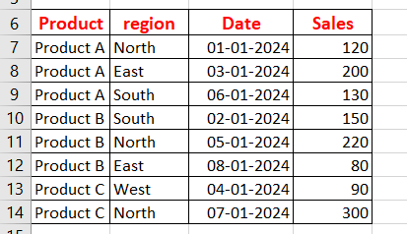

1. Sort the dataset by Sales in descending order.

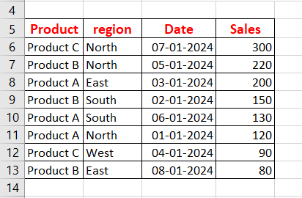

1. Sort the dataset first by Region in alphabetical order, and then by Sales in ascending order within each Region.

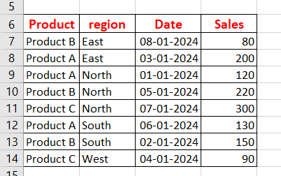

1. Apply a filter to display only the rows where the Product is "Product B".

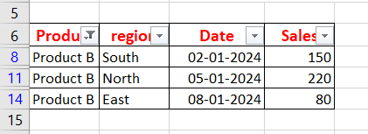

1. 5. Apply a filter to display only the rows where the Sales are greater than 150.

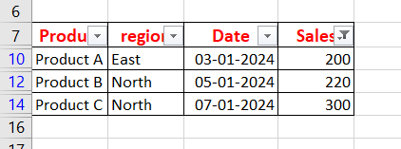

1. 6. Apply a filter to display only the rows where the Date is in January 2024.

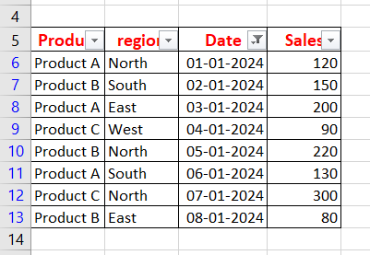

1. 7. Sort the dataset first by Date in chronological order, and then by Sales in descending order within each Date.

