**Need For Database**

A database is a structured collection of data that is organized and stored in a way that enables efficient retrieval, management, and manipulation of information. The need for databases arises from several fundamental requirements in the field of information management. Here are some key reasons why databases are essential:

* **Data Organization:**

Databases provide a systematic and structured way to organize large amounts of data. Information is stored in tables, and relationships between different pieces of data can be defined. This structure makes it easier to manage and navigate through the data.

* **Data Integrity:**

Databases enforce data integrity by implementing rules and constraints. This ensures that the data stored is accurate and consistent. For example, primary keys in a database table ensure that each record is uniquely identified.

* **Data Retrieval:**

Databases enable efficient retrieval of information through queries. Users can easily search, filter, and sort data based on specific criteria. This quick access to relevant information is crucial for decision-making processes.

* **Concurrency Control:**

In scenarios where multiple users or applications need to access and modify data simultaneously, databases provide mechanisms for concurrency control. This ensures that data remains consistent and accurate even in a multi-user environment.

* **Data Security:**

Databases offer security features to control access to data. Authentication and authorization mechanisms restrict access to authorized users, protecting sensitive information from unauthorized access.

* **Scalability:**

As data volumes grow, databases can scale horizontally or vertically to handle increased loads. This scalability is essential for accommodating business growth and evolving data requirements.

* **Data Redundancy Reduction:**

Databases help minimize data redundancy by storing information in a centralized location. This reduces the chances of inconsistencies and ensures that updates are made in a single place, avoiding duplication and errors.

* **Data Maintenance:**

Databases simplify data maintenance tasks such as updates, inserts, and deletions. Changes can be made efficiently without affecting the overall integrity of the data.

* **Data Independence:**

Databases provide a level of abstraction between the logical structure of the data and the physical storage details. This independence allows developers and users to focus on working with the data without being concerned about its underlying storage mechanism.

**SQL Queries**

1. Create Database

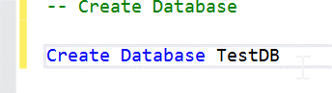

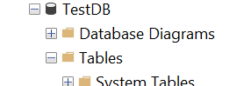

1. Create Table

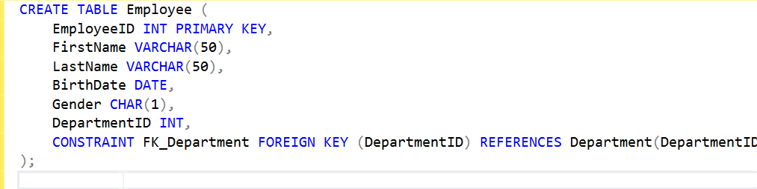

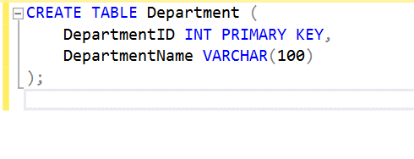

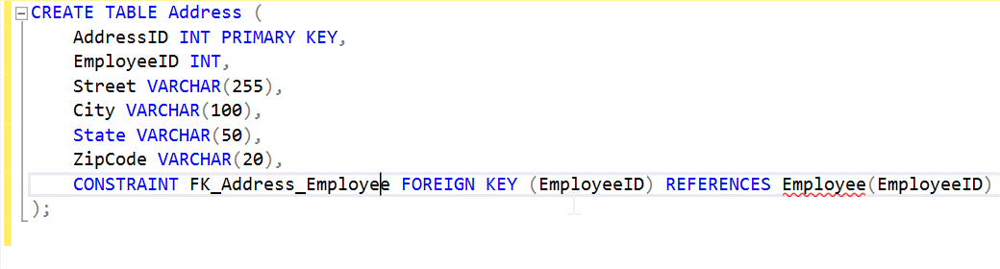

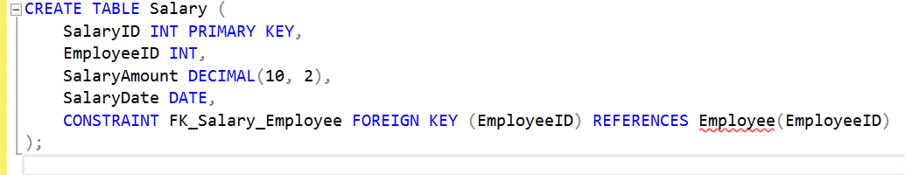

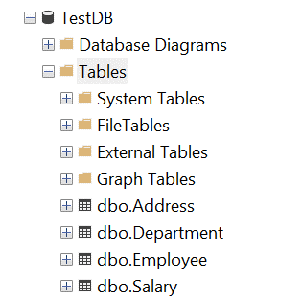

1. Insert Statements

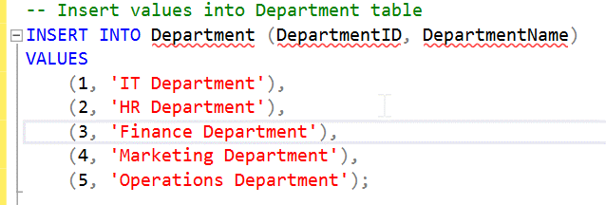

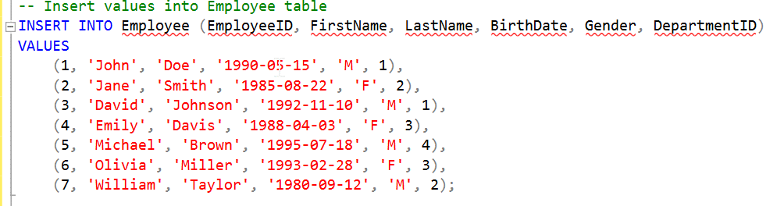

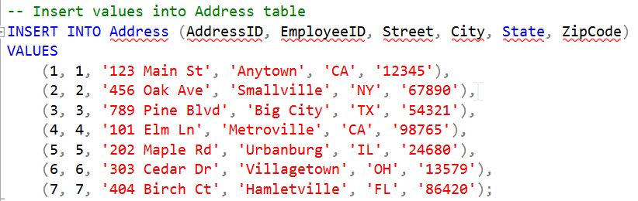

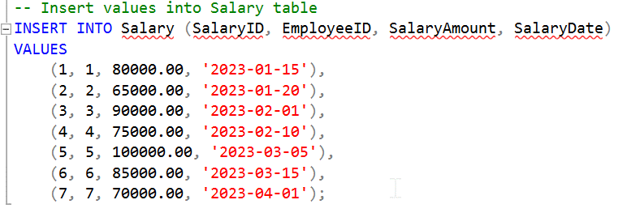

1. Select Statements

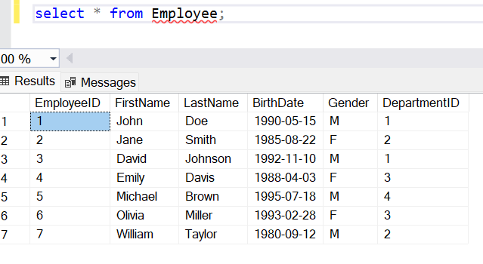

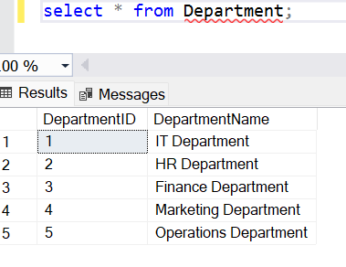

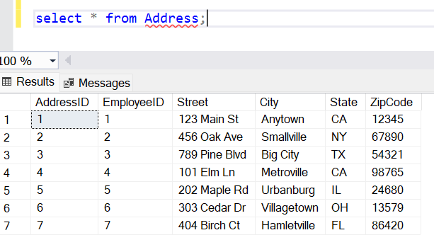

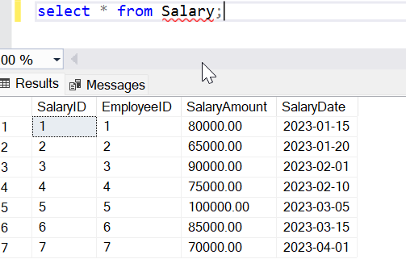

1. Select Distinct

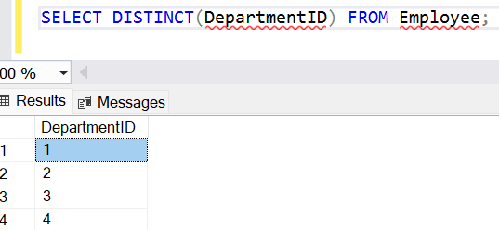

1. Where, And & Or

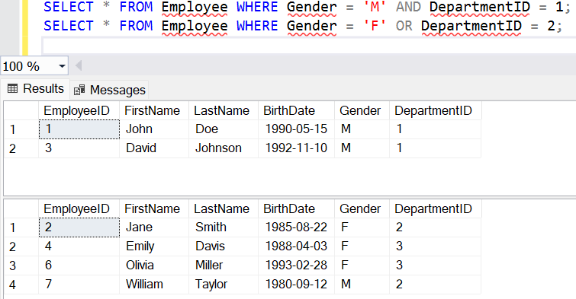

1. Order By

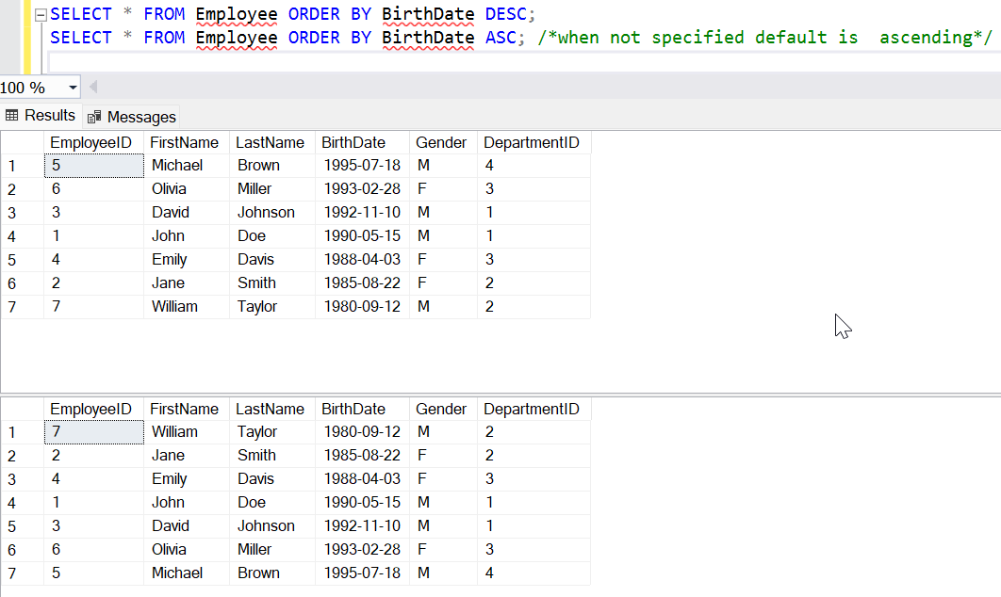

1. Update

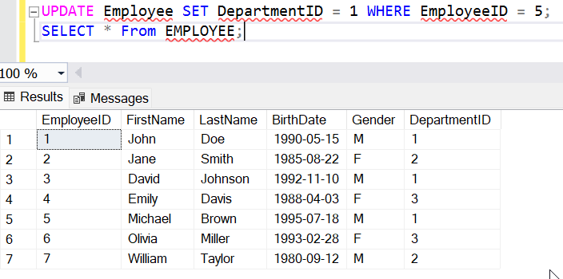

1. Delete

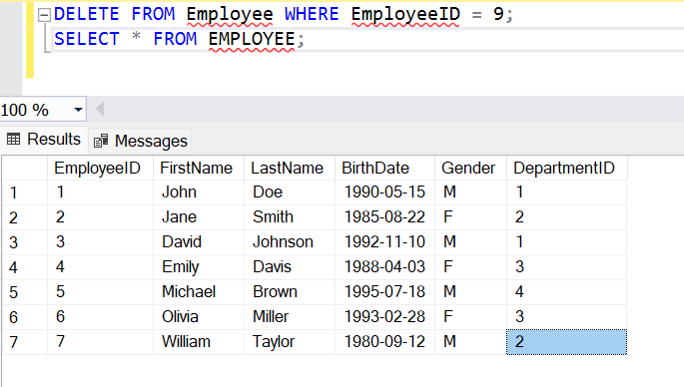

1. Select Top

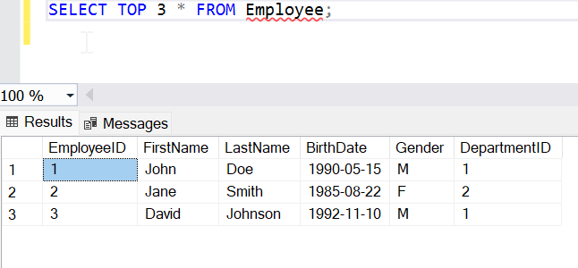

1. Like, Wildcards

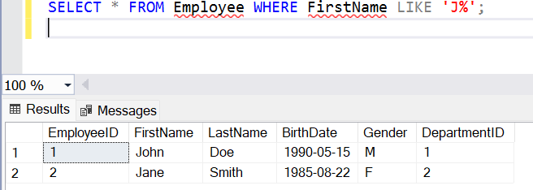

1. IN

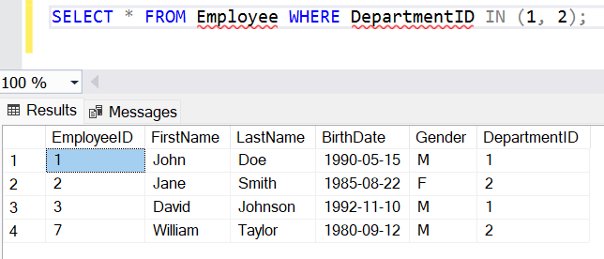

1. Between

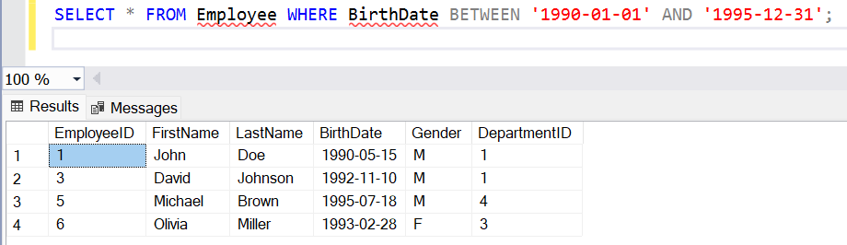

1. Aliases

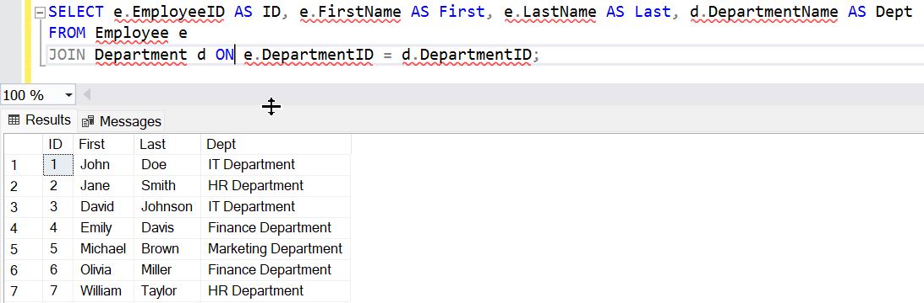

1. Joins

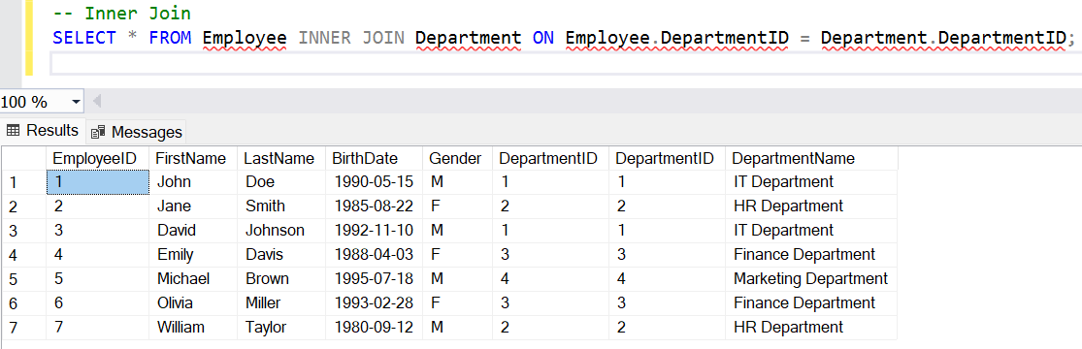

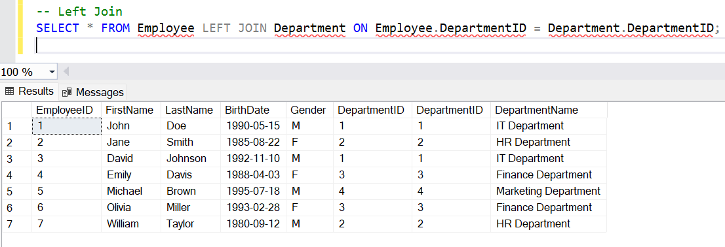

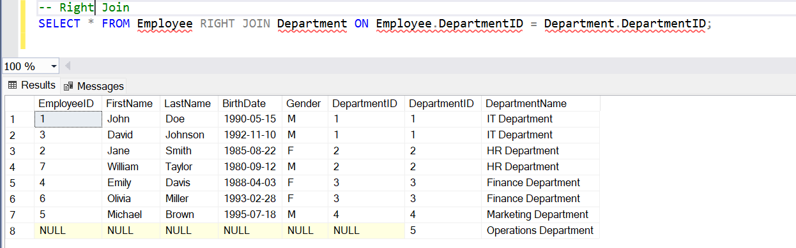

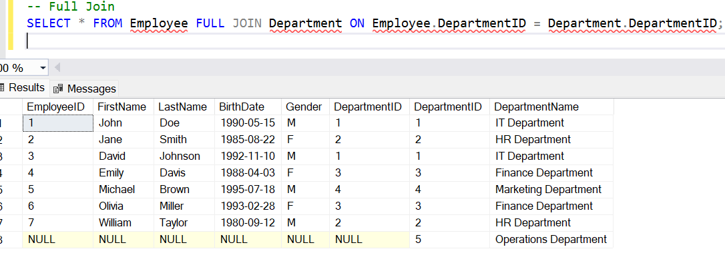

1. Union

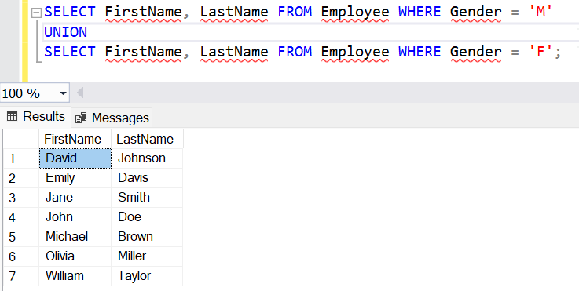

1. Select Into



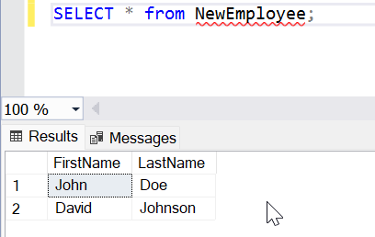

1. Insert Into Select

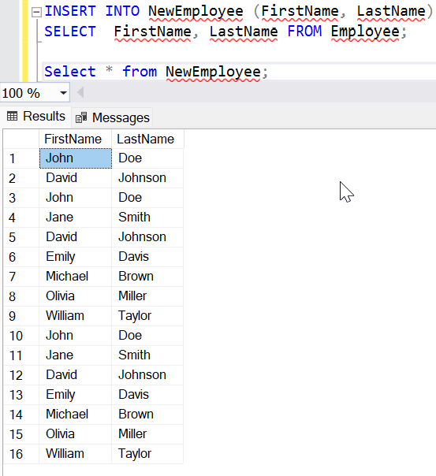

1. Alter Table

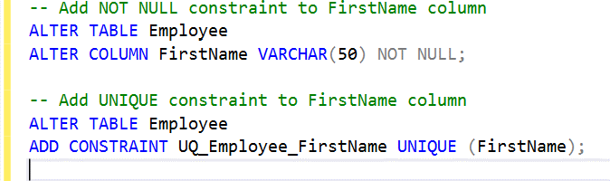

1. Index



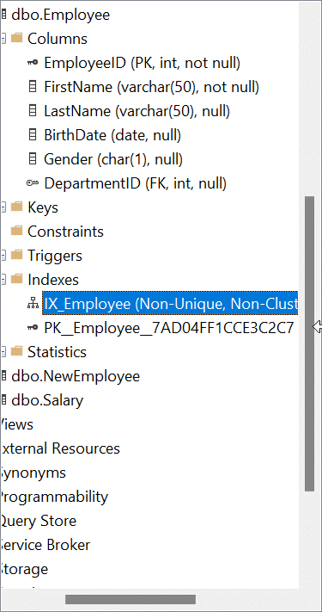

1. Views

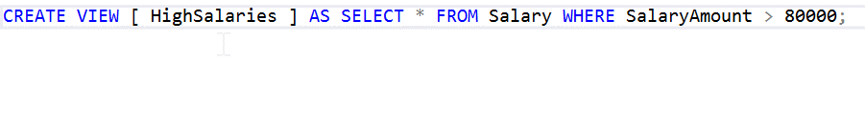

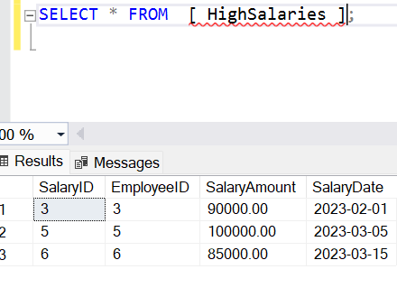

1. Null values

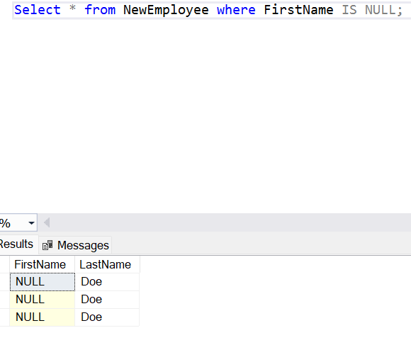

1. Group By, Having

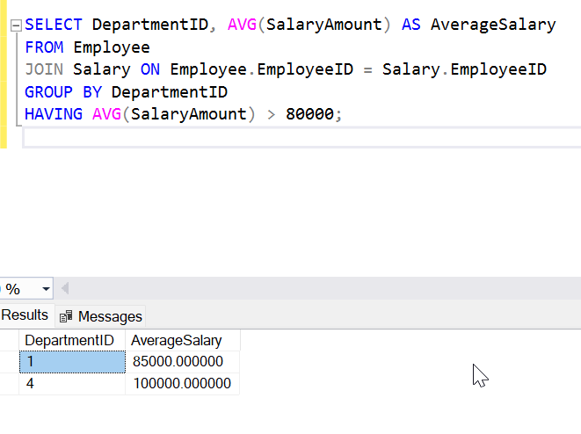

1. Drop



3. Stored Procedure

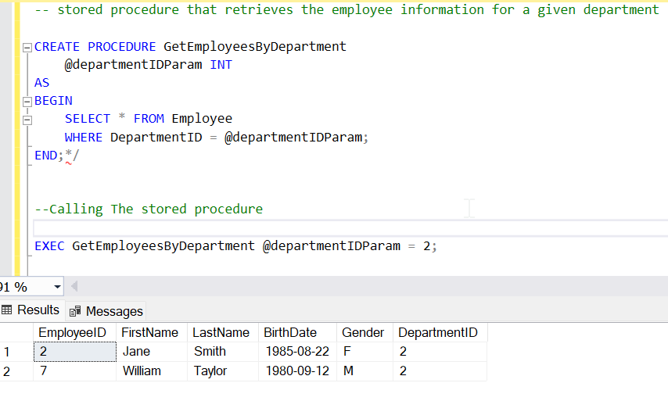

4. Concept of Normalization:

Normalization involves arranging data within a database systematically. Its purpose is to reduce redundancy within a relation or a group of relations and to eliminate undesirable traits such as Insertion, Update, and Deletion Anomalies. This process divides a larger table into smaller ones and establishes connections between them through relationships. The utilization of normal forms helps decrease redundancy in the database table.

Normalization is essential to address and eliminate anomalies in database relations. Failure to do so can lead to issues such as data redundancy, compromised data integrity, and other problems as the database expands. The primary purpose of normalization is to provide a set of guidelines for creating a robust database structure.

Data modification anomalies come in three main types:

1. Insertion Anomaly: This occurs when it is impossible to insert a new tuple into a relationship due to missing data.

2. Deletion Anomaly: A deletion anomaly happens when the removal of data inadvertently results in the loss of other crucial data.

3. Updatation Anomaly: An update anomaly occurs when updating a single data value necessitates the update of multiple rows of data.

By adhering to normalization principles, these anomalies can be mitigated, ensuring a more efficient and reliable database structure.

**Types of Normal Forms**

