TEST PLAN

## Project Name: Note Master Application

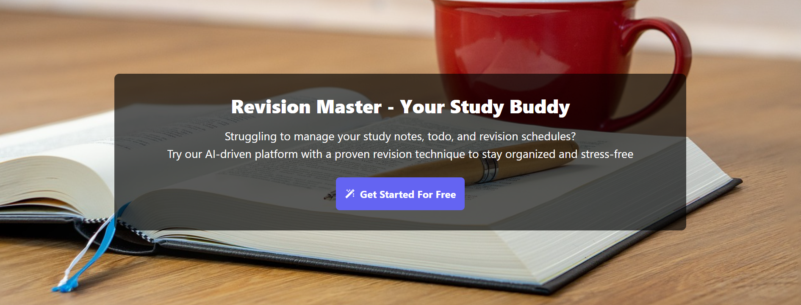

Prepared By: Shubham Giri Date: Apr 2, 2024

1

#### Table of Contents

Introduction 2

objective 2

Scope 2

Testable features 2

Testing approach 3

Roles/Responsibilities 4

Test Schedule 5

Test Deliverables 6

Entry & Exit Criteria 7

Tools 8

Risks and Mitigation plans 8

Approvals 8

# Introduction

This document outlines the testing approach, strategies, and scope for Note Master Application. It details the objectives, schedule, resource allocations, test deliverables, and reports.

##### AUT <https://notes-makers.vercel.app/>

**Objectives**

Update to cover key e-commerce functionalities, such as:

* User Registration and Login
* Profile Management
* Write Notes
* Create Notebook
* Todo
* Dashboard

# All Notes

# All Notes Book

# Logout

# Scope

Ensure it includes testing for Note Master workflows, Revision Master - Your Study Buddy

Struggling to manage your study notes, todo, and revision schedules? Try our AI-driven platform with a proven revision technique to stay organized and stress-free

# Testable features:

* User Registration and Login
* Profile Management
* Write Notes
* Create Notebook
* Todo
* Dashboard

# All Notes

# Logout

# Testing Approach:

###### Testing Types

* Functional Testing
* Compatibility Testing
* API Testing

###### Testing Methodologies

* Black-box Testing
* White-box Testing
* Regression Testing
* User Acceptance Testing (UAT)

###### Testing Environment

* UAT
* Pre-Prod

###### Operating System

* Windows 10 and above
* Browsers: [Chrome]
* Testing Tools: [Mind Map, Microsoft teams, Excel, word ,Selenium(for automation)]

# Roles/Responsibilities

|  |  |  |
| --- | --- | --- |
| **Name** | **Role** | **Responsibilities** |
| Pooja Yadav | Test Manager | * Manage budget and resources. * Allocating additional support resource. * Assess and prioritize project risks/tasks. * Monitoring project progress. * Resolve communication issues and conflicts effectively. |
| Shubham | Test Lead | * Develop test plans and strategies in alignment with project objectives and requirements. * Assign tasks, set priorities, and provide and support to team members. * Review test results and provide feedback to team members. * Monitor and manage risks throughout the testing life cycle. |
| Shubham | Test Engineer | * Understand customer requirements * Write Test scenarios & Test cases * Executing the Test cases. * Performing root cause analysis to identify underlying issues. * Defect tracking and reporting. |
| Shubham | Test Engineer | * Understand customer requirements * Configuring and Setting up test environment. * Management of Automation tools. * Executing Regression Test cases. * File Closure activity. |

|  |  |  |
| --- | --- | --- |
| Shubham | Test Engineer | * Understand areas for regression testing feasibility. * Responsible for writing automation scripts. * Conducts Smoke, Functional, Integration, System. * Collaboration with on shore subject matter experts. |

# Test Schedule

Following is the test schedule planned for the project:

|  |  |
| --- | --- |
| **Task** | **Time Duration** |
| Test Plan creation | 2 Apr 2025 |
| Test Scenario creation | 2 Apr 2025 |
| Test case creation | 2 Apr 2025 |
| Test case Execution | 2 Apr 2025 |
| Summary Report Submission | 2 Apr 2025 |

# Test Deliverables

The following are to be delivered to the client:

|  |  |  |  |
| --- | --- | --- | --- |
| **Deliverables** | **Description** | **Responsible Owner** | **Target Completion**  **Date** |
| Test Plan | Outlines the testing approach, strategies, and scope for the Data Structure and Algorithm application. | Masai | 2 Apr 2025 |
| Test Cases | Test Cases created for both functional testing and  compatibility testing | Masai | 2 Apr 2025 |
| Defect Reports | Detailed description of the defects identified in different versions of application. | Masai | 2 Apr 2025 |

**Entry and Exit Criteria**

The below are the entry and exit criteria for every phase of Software Testing Life Cycle:

###### Requirement Analysis

###### Entry Criteria:

Once the testing team receives the Requirements documents and use documents of the project Includes what functions needs to be tested and how the software should behave.

###### Exit Criteria:

The testing team should thoroughly explore and understand each requirement listed in the documents Any doubts or uncertainties regarding the requirements should be addressed and clarified to ensure that the testing team has a clear understanding of what needs to be tested and how it should behave.

###### Test Planning

###### Entry Criteria:

Testable Requirements derived from the given Requirements documents . Test Plan document includes the Test Strategy, which provides a high-level overview of

how testing will be conducted.

###### Exit Criteria:

Test Plan is signed-off by the Client (Data Structure and Algorithm)

###### Test Designing

###### Entry Criteria:

The Test Plan document needs to be reviewed and approved by the client and then Test Plan Document is signed-off by the Client

###### Exit Criteria:

Test Scenarios and Test Cases Documents are prepared, they need to be reviewed and signed-off by the Client.

###### Test Execution

###### Entry Criteria:

Test Scenarios and Test Cases document needs to be reviewed and approved by the client and documents are signed-off by the Client. Application is ready for further Testing.

###### Exit Criteria:

Test Case Reports, Defect Reports are ready

###### Test Closure

###### Entry Criteria:

Test Case Reports, Defect Reports are ready

###### Exit Criteria:

Test Summary Reports, it overviews of the entire testing process

# Tools

The following are the list of Tools we will be using in this Project:

* + Microsoft Teams – collaboration
  + Excel
  + word
  + Mind map
* Manual Testing Tools: Chrome Inspect, Browser
* Automation Testing Tool : Selenium
* Project Management: Jira, Zephyr

# Risks and Mitigation plans:

The following are the list of risks possible and the ways to mitigate them:

|  |  |
| --- | --- |
| **Risk** | **Mitigation plans** |
| Lack of Automation Testers | Backup Resource Planning |
| No detailed Requirements available | Subject matter experts available for  deep understanding of functionalities |

# Approvals

Masai will send different types of documents for Client Approval like below:

* + Test Plan
  + Test Scenarios
  + Bug Reports
  + Summary of Test Execution Report
  + Mind map
  + Test Cases

Testing will only continue to the next steps once these approvals are done