**FERGUSSON COLLEGE(AUTONOMUS), PUNE**

PROJECT REPORT:

**BANKING**

**MANAGEMENT SYSTEM**

**PROJECT BY**: SHUBHAM PRALHAD JAYBHAYE

**ROLL.NO**: 2111023

MSc DATA SCIENCE

FIRST YEAR SEM-1

CSD4103:DATA STRUCTURES

C.E.-II

**PROJECT GUIDE: PROF.SWATI SATPUTE**

INTRODUCTION

The banking management system sector has seen some greatest expansion in the past year and with the number of customer interactions increasing the day it has totally all the records in the database.

When it comes to managing the money or valuable assets it automatically becomes a crucial matter for the service provider and the client as well for the trustworthiness. The banking management system is one of the most complex systems because the things it covered under the roof for transparency among the customers.

From managing the customer information, account information to the transaction happening every minute or second. It does not only preserve the details of the transaction and other information but generates the report to further banking functions. In this banking management system, there are many operations that are automated which ease the work for the working of the bank.

This reduces the requirement for manual labour and the automated tasks will be error-free as they will only work as they are programmed whereas doing work manually there is always a possibility of human error.

PROBLEM DEFINITION

The bank management system is an application for maintaining a person's account in a bank. The system provides the access to the customer to create an account, deposit/withdraw the cash from his account, also to view their account balance and close their account from bank.

CONCEPTS USED

**DataBase Connection**: For database connection with python mysql-connector is used . mysql-connector provides almost all the features that MySQL serves. As the Banking management system needs the data to store in data base. Using database connection with python data based is accessed.

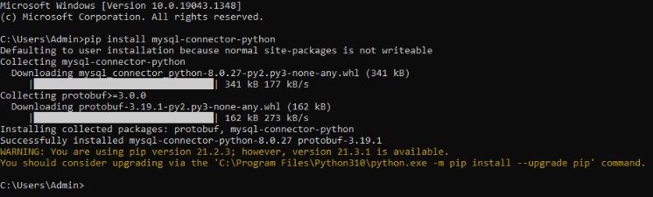

Methods used in **Database Connection:**

The MySQL **Cursor()** is used to execute statements to communicate with the MySQL database.

**execute()**

This method accepts a MySQL query as a parameter and executes the given query

**fetchone()**

This method fetches the next row in the result of a query and returns it as a tuple

CONCLUSION

This project is developed to nurture the needs of a user in a banking sector by embedding all the tasks of transactions taking place in a bank. Bank management system is a **virtualization of transactions in banking system**. The banking system are used manual working but when we used online banking system it is totally virtualization process which avoid manual process and converts it in automatic process

REFERENCES

* <https://www.tutorialspoint.com/>
* <https://www.irjet.net/>
* <https://www.lovelycoding.org/>
* <https://youtube.com/>