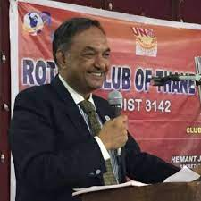

Chairperson – By laws and MOP

Pramod Ambekar

RC Pune Bavdhan Elite

Software Deveopment

14 June

24 June

9320557334

[Pramod_ambekar@yahoo.com](mailto:Pramod_ambekar@yahoo.com)

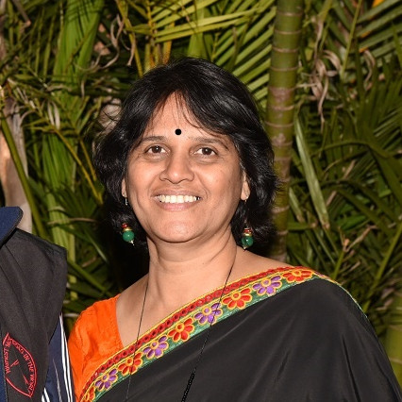

Director

Ujjwala Barve

RC Pune Gandhi Bhavan

Journalist Journalism

27 june

13 july

9881464677

[ujjwalabarve@gmail.com](mailto:ujjwalabarve@gmail.com)

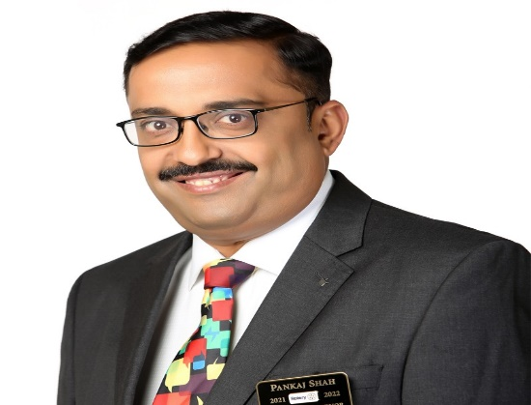

Chairman

DG Pankaj Shah

RC Pune Sarasbaug

Healthcare

29 March

11 December

9822057299

[Rotary.pankajshah@gmail.com](mailto:Rotary.pankajshah@gmail.com)

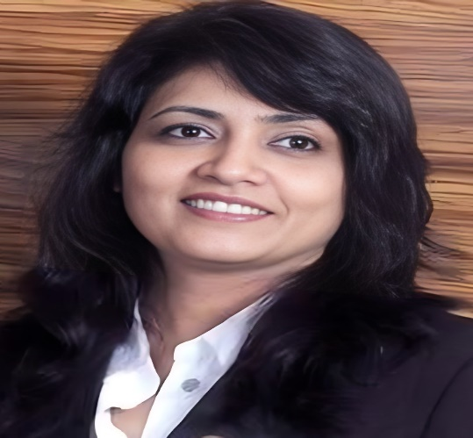

DGN

DGN Manjoo Phadke

RC Pune Deccan Gymkhana

Education & Training

22 April

9 October

9881798787

[Dgnmanjoo2324@gmail.com](mailto:Dgnmanjoo2324@gmail.com)

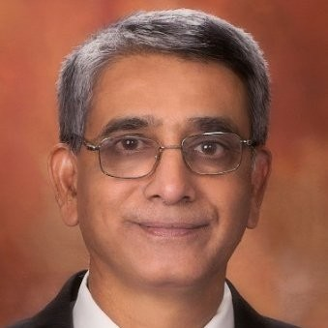

Invitee

PDG Pramod Jejurikar

RC Pune Kothrud

IT Software Services

01 April

29 June

9922429475

[pramodjejurikar@gmail.com](mailto:pramodjejurikar@gmail.com)

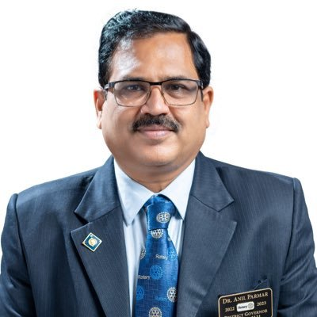

DGE

DGE Anil Parmar

RC New Panvel

Medicine Cardiology

15 March

08 June

9322218978

[Dr.anilparmar@gmail.com](mailto:Dr.anilparmar@gmail.com)

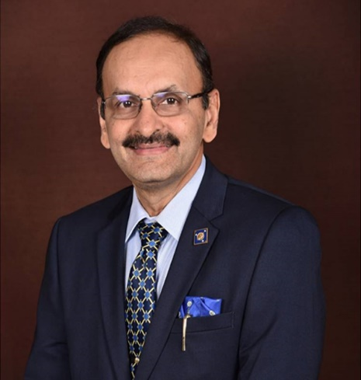

Invitee

PDG Dr. Deepak Purohit

RC Panvel

Medicine Orthopaedics

19 October

01 June

9820977773

[dmpurohit@gmail.com](mailto:dmpurohit@gmail.com)

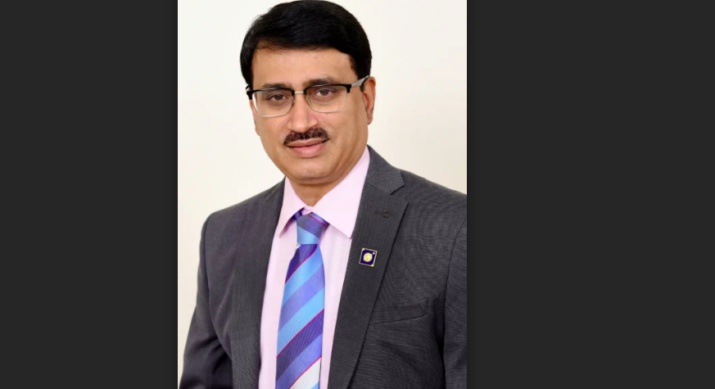

Invitee

PDG Dr. shailesh Palekar

RC Panvel

General Medicine

11 april

28 June

982087993

shaileshpalekar@gmail.com

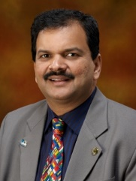

Vice Governor

PDG Deepak Shikarpur

RC Pune Shivajinagar

IT Promotion

30 June

30 Nov

9822044533

[deepak@deepakshikarpur.com](mailto:deepak@deepakshikarpur.com)

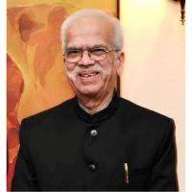

Special Advisor to DG

PDG Dr. Mukund Abhyankar

RC Pune Shivajinagar

Journalism

12 Feb

19 May

9011070020

Mukund_abhyankar@yahoo.com