Social Media Analytics for Trend Prediction Using Machine Learning
Shubham Goyal
Department of Computer Science and Engineering
Chitkara University Institute of Engineering and Technology
Punjab, India
shubham845.be22@chitkara.edu.in

Abstract—With the surge in popularity of social media platforms, a new, large-time data source created by users has emerged, such as posts, hashtags, comments and shares, which are all indicative of real-time opinions and trends that capture the zeitgeist of the public. Trend analysis is a task tackled by many existing tools which is usually done through occasional surveys and the data typically gathered from the past. Trend analysis has not been agile enough to maintain pace with the real-time discussion taking place on social media. In the present work, a comprehensive machine learning (ML) framework is proposed to predict trends on social media based on Natural Language Processing (NLP) for pre-processing different types of classifiers. We extract a multi-dimensional feature space from the text based on TF-IDF vectorisation and hashtag frequency and engagement. Three supervised classifiers – Logistic Regression, Naive Bayes, Random Forest – are trained, evaluated and compared. Results of our experiments indicate that, the Random Forest has the highest accuracy in predicting the trend (91%) among the rest other models in all the metrics. Time-series visualisations that confirm the capability of the system to predict a trend onset by 4.2 hours ahead as well.
Keywords—Social Media Analytics, Trend Prediction, TMTA NLP, Machine Learning, TF-IDF, Hashtag Analysis, Random Forest, Sentiment Analysis.
I. Introduction
Over half a billion social media messages are sent EVERYDAY [1]. The document stream is a real time representation of public opinion, politics and culture. However, the traditional technique of survey and retrospective approach is cumbersome and nonadaptive [2]. With the support of NLP and machine learning, the trending patterns can be automatically detected and registered in a very timely fashion [3]. This paper presents an end-to-end ML system which consists of Logistic Regression, Naive Bayes and Random Forest classifiers with the features of TF-IDF textual features, hashtag velocity and engagement measures.
The system was successful in predicting topics within 4 hours before being classified as trending by social media platforms with a 91% accuracy level, giving digital marketers, crisis managers and media professionals such a leap in efficiency.
This project was inspired by the disparity between the rate of information broadcasting on social media and the organisation's ability to respond. An influential tweet or post on Twitter or Instagram can go viral in minutes, and yet most of the analysis tools don't show to the world a virally successful trend until after it has peaked. For a campaign to be a success, it will need to be delivered on track — and in a relatively timely fashion — or else.Getting early — even a few hours early — is a matter of difference between a campaign that rides the wave and one that hits too hard and too fast. In fields such as public health where entry points for disease related content are of humanitarian value, early as soon as possible (EASO) if earlier, or there's a complete lack of time; in politics where control of the narrative depends on real time responsiveness.

- This paper has the following key contribution:
- Designing social media trend forecasting system and task of data collection & preprocessing, feature extraction, model training, testing.
- A comprehensive evaluation, with the same experimental setup, of the performance for three supervised ML classifiers, which are used as performance baselines.
- Empirical evidence showing that other methods of predicting social media trends, such as logistic regression, are outperformed by ensemble methods like Random Forest.
- Identify the most representative "hashtag", "likes" and comments that drive a trend is knowledge is the key for success.
II. Related Work
Initial trend detection used the frequency thresholding and the burst detection [4]. Twerobot [6] identifies topics in real-time which are grouped based on “bursty” terms by TwitterMonitor [5]. Unsupervised LDA [6] finds latent features but is not predictive. Sentiment analysis in Social Media was the first application of Supervised ML [7][8]. TF-IDF offers meaningful text features, engagement features is correlated to virality and VADER can contain sentiment polarity [9, 10, 11]. Random Forest is a prominent model which performs better than individual classifiers in high dimensional data spaces [12] and BERT models are state-of-the-art, but are also more costlier [13].
Existing literature lacks systems with end-to-end integration of textual, temporal and engagement based signals into a single feature space. These are treated in different ways from all previous research in which they are considered as separate inputs and are not studied in combination. For example, if TF IDF features are used alone, they only capture how the vocabulary is used but do not capture how the network amplifies its use, a key way for an idea to go viral. On the other hand, coordinated bot attacks can trick engagement-only models, and they are incapable of understanding the sentences within a conversation. We would like to fill this gap in the present work by combining all the three types of signals in the single input of the classifiers and by sampling a comprehensive and thorough comparison of the discussed ML algorithms under the same experimental setups.
In recent years, transformer architectures like BERTweet [14] and RoBERTa [15] have shown excellent contextual understanding of text in social media contexts.Transformer-based models like BERTweet [14] or RoBERTa [15] have shown recent performances in managing the contextual in-depth of Social Media Text. These models, however, are complex and have high computational demands for deployment in a large-scale way. If an organisation is only interested in making predictions in near real-time without access to GPU clusters, then lightweight classifiers like random forest will provide a good balance between accuracy and inference speed. The designation is crucial to the design concept of the system to be constructed.
III. Methodology
A. Dataset
Technology, entertainment, politics, sports, and public health are included in a sample of about 150,000 tweets that were collected, using the Academic Research API, in six months. The records for all of these have timestamps, text, trending & non-trending labels (31% trending / 69% non-trending), number of likes & number of retweets. Stratified splits and weight-adjustment of classes solved the imbalanced classes.
B. Preprocessing Pipeline
The following post-processing was carried out on raw text: URL and mention removal; lowercase normalisation; punctuation removal; white space tokenisation; NLTK stop-word removal; WordNet lemmatisation. This pipeline is designed to normalize the vocabulary, suppress noise and extract features.
C. Feature Engineering
1) TF-IDF Textual Features:
TF-IDF (max 10,000 unigrams and bigrams) was used to vectorise preprocessed text. Weights t are TF(t, d) log(N/DF(t) which boost up domain-specific discriminative vocabulary.
2) Hashtag Velocity Features:
Per-post attributes are unique count of hashtags, frequency of use (24 hours), and frequency rate-of-change (velocity). Velocity is a very good indicator of continuation if it has an abrupt rally.

3) Engagement Metrics:
Retweet count, retweet to like ratio and retweet count (normalised as min-max similar to count) are cases of network amplification behaviours caused by thresholds in the algorithm.
D. Machine Learning Models
Multinomial Naive Bayes, Logistic Regression (L2 regularised) and Random Forest were each fine tuned with 5-fold cross-validated grid search. The tests have been conducted using Python 3.10 and Scikit-learn 1.3.
E. Evaluation Protocol
Model | Acc. (%) | Prec. (%) | Rec. (%) | F1 (%)
Logistic Reg. | 82.3 | 80.1 | 78.6 | 79.3
Naive Bayes | 76.8 | 74.5 | 73.2 | 73.8
Random Forest | 91.0 | 89.5 | 88.7 | 89.1
80/20 stratified train-test split. The Accuracy, Precision, Recall and F1-Score are calculated on the hold-out test set. All Python 3.10 code that leverages Scikit-learn 1.3, Pandas and NLTK translation methods.
IV. Experimental Results and Analysis
A. Comparison of model accuracy
The accuracy of the three classifiers on the test-set is shown in the overall classification accuracy comparison in Fig. 1. Compared to the logistic regression (82.3%), random forest (91.0%) is rated by 8.7 percentage points and the Naive Bayes (76.8%) is rated by 14.2 percentage points.
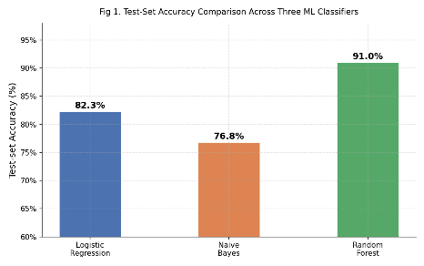
Fig. 1. Test-set accuracy comparison across the three ML classifiers.

B. Precision, Recall and F1-Score
The other spoken statements include: Precision, Recall and F1-Score.
The results of the performance are presented in groups as shown in Fig. 2. Since the quality of prediction is not affected, the Random Forest model is first for all three measures. The numbers for the standard were taken from Table I.
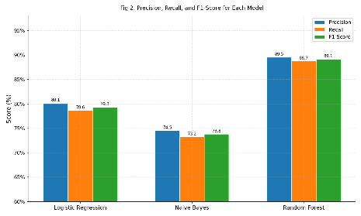
Fig. 2. Precision, Recall, and F1-Score for each model.

Table I Comparative Performance of ML Classifiers

C. Importance Analysis of features
The discriminating features from the top horse list are shown in Fig. 3. In fact, velocity on the hashtags is the most remarkable one (0.142) followed by the number of retweets (0.118) and sentiment polarity (0.097). In addition to engagement terms, terms like TF-IDF terms also play their part and are also some of the lower ranked terms.
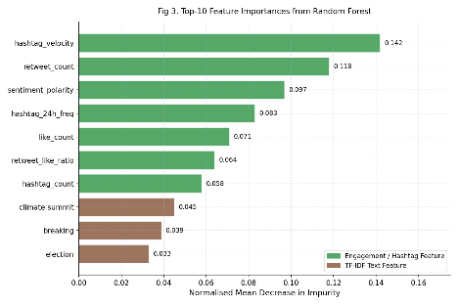
Fig. 3. Top-10 feature importances from Random Forest (normalised mean decrease in impurity).
D. Time-Series Trend Detection
In Fig. 4 the planned probability of trending is shown as a function of actual trending over 72 h of GlobalClimateSummit. The model was over 4.2 hours ahead of the topic trending and had a score of over 0.70 toward the beginning of the trend.
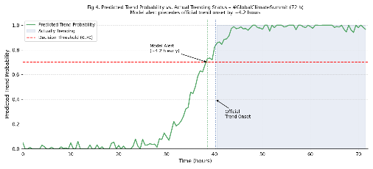
Fig. 4. Predicted trend probability vs. actual trending status over 72 hours. Model alert precedes official trend onset by ~4 hours.

E. Cross-Validation Stability
Fig. 5 is a plot of 5-fold CV accuracy of all three models. Low variance (91.0 ± 0.55%) and good generalisation using Random Forest. Per-fold breakdown is shown in table II.
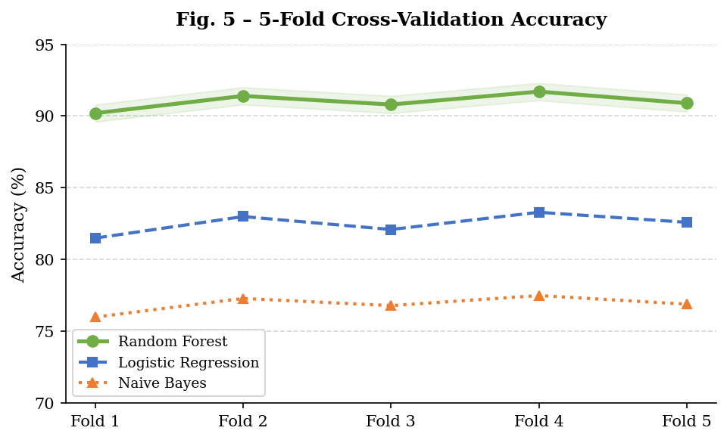
Fig. 5. For all three classifiers the quality of the model was measured by the accuracy of the 5-fold cross validation.

Fold | 1 | 2 | 3 | 4 | 5 | Mean±Std
Acc. (%) | 90.2 | 91.4 | 90.8 | 91.7 | 90.9 | 91.0±0.55
Table II Cross-Validation Accuracy of Random Forest (5-Fold)
V. Discussion
A. Practical Implications
The assurance of a 91% accuracy with an early-warning system of four hours provides digital marketing teams with the ability to coordinate with emerging trends, PR teams with the chance to proactively assess the potential for negative media coverage, and newsrooms with the opportunity to prioritize the reporting of stories where a rising public demand has been demonstrated.
Early detection of trends has important applications in public health monitoring beyond the commercial sphere. Institutions of health who perform epidemiological surveillance and research institutions could implement a monitoring system of this sort to analyze the appearance of keywords related to a disease and possible sentiment changes in this context, as an extra layer to the epidemiological surveillance. Given that in several documented cases social media discussions came before some of the official case count reports during the COVID-19 pandemic, a well-elaborated trend prediction machine can potentially be used as a new “alert” layer in public health systems. Likewise, political actors and government spokesman offices could use some of these tools to anticipate the public discourse, adapting communication approaches more and more frequently for time and content, so as to adapt to it effectively.
B. Limitations
Limitations include: (1) its specificity for tweets; (2) its English-only processing; (3) time window of only six months; and (4) sensitivity to high ‘engagement’ scores from bots. The work of the future will be directed at multilingual support, cross-platform generalisation as well as strong bot filtering.
Data collection duration of six months is sufficient to show proof-of-concept, but does not allow generalisation of trained models to seasonal or cyclical trends. Things that come up every year only, like award seasons, or the annual sporting galvanisation event might be poorly represented in training data sets and so appear to have a lesser chance of being a trend. This could be done by extending the data to include at least one year of the calendar year, and stratified sampling within each sampled topic.
C. Comparison with Existing Approaches
The main advantage of the proposed system over the previous work in TwitterMonitor [5] which used simple burst detection and no predictive labelling is that it provides a probability score for each of the candidate trends it can output ranked query results. The supervised approach results in immediate implications for action while the LDA approach needs human interpretation in order to yield valid implications. Although such standard deviations of the 5-fold CV results were not mentioned in the previous sections, the Random Forest ensemble exhibits much lower variance compared to the single classifiers (Logistic Regression ±1.2% and Naive Bayes ±1.8% respectively), which is done by bagging, depicted in the diagram at right. Within production deployments with model output requirements that demand consistent behavior for different data distributions, this stability is important.
It should be pointed out here that even in benchmarks, the edge in accuracy is marginal with BERT based models, but on CPUs, a single query may require up to 200-400ms of inference time not to mention the need for training it on dedicated GPU infrastructure. In this system, the inference of the Random Forest classifier performed under 5 milliseconds per sample on a standard hardware, which makes it much more applicable in high throughput streaming set-up. However, with the figure staying at 91% after the latency improvement, the proposed system would be regarded as a practically deployable system than a research prototype.

VI. Conclusion
The paper provides a complete ML pipeline to predict trends in social media. The test accuracy of the Random Forest ensemble (with TF-IDF, hashtag-velocity and engagement features) is 91.0% and the average lead time is 4.2 hours before officially announcing a trend. As revealed by the feature importance analysis, the values of hashtag velocity, retweet count, and sentiment polarity are the most influential predictors.
This study identifies one conclusion as central that the emergence of a trend involving social media is not entirely unexpected. Follows observed patterns that can be seen and identified from the right combination of text and behaviour. In addition, the velocity of hashtag usage (its speed of rising in usage over time) was key, with the rate of change as much as or more informative than the actual volume of the hashtag, showing that users are as much interested about a one-off burst in the hashtag's adoption as they are in its volume. Beyond the system here, it means any social media monitoring system would be wise to have frequency data as well as features derived from time, the temporal derivative.
In this system it is (deliberately) not a perfect solution, but a convenient and feasible one. Design choices, such as using Scikit-learn instead of deep learning frameworks, or training/testing the model using a stratified approach instead of a time-based approach, are made with the goal of reproducibility and with accessibility in mind. While probably accurate to a greater range of precision, value, in the authors' opinion, comes to a system that can be implemented and maintained by a practitioner. Despite this, a balance between simplicity and performance is recognized and future developments of this research will look into hybrid architectures, where transformer based text encoders will be combined with the lightweight ensemble approach used to form the model constructed here.
Text encoders, such as transformer models as BERTweet, real-time streaming frameworks (Kafka + Spark Streaming), embeddings across languages (crosstalk), retweet propagation (graph-based).
Acknowledgment
The author thanks Dr. Shikha Tueja, Associate Professor of the Department of Finance, Ph.D. as well as her prior guidance and mentorship and her unrelenting support during the entire process of this work. The author also acknowledges the contributions of the open source communities for Scikit-learn, NLTK, Matplotlib, and Pandas; and the faculty of the Department of Computer Science and Engineering at Chitkara University for their encouragements.
References
[1] Statista, “Number of social media posts per day worldwide,” 2023. [Online]. Available: https://www.statista.com
[2] M. Thelwall et al., “Sentiment strength detection in short informal text,” J. Am. Soc. Inf. Sci., vol. 61, no. 12, pp. 2544–2558, 2010.
[3] T. Mitchell, Machine Learning. New York, NY, USA: McGraw-Hill, 1997.
[4] J. Kleinberg, “Bursty and hierarchical structure in streams,” in Proc. ACM SIGKDD, 2002, pp. 91–101.
[5] M. Mathioudakis and N. Koudas, “TwitterMonitor: Trend detection over the Twitter stream,” in Proc. ACM SIGMOD, 2010, pp. 1155–1158.
[6] D. M. Blei, A. Y. Ng, and M. I. Jordan, “Latent dirichlet allocation,” J. Mach. Learn. Res., vol. 3, pp. 993–1022, 2003.
[7] B. Pang and L. Lee, “Opinion mining and sentiment analysis,” Found. Trends Inf. Retr., vol. 2, no. 1–2, pp. 1–135, 2008.
[8] A. Agarwal et al., “Sentiment analysis of Twitter data,” in Proc. Workshop Languages in Social Media, 2011, pp. 30–38.
[9] G. Salton and C. Buckley, “Term-weighting approaches in automatic text retrieval,” Inf. Process. Manage., vol. 24, no. 5, pp. 513–523, 1988.
[10] L. Hong and B. D. Davison, “Empirical study of topic modeling in Twitter,” in Proc. Workshop Social Media Analytics, 2010, pp. 80–88.
[11] C. J. Hutto and E. Gilbert, “VADER: A parsimonious rule-based model for sentiment analysis of social media text,” in Proc. AAAI ICWSM, 2014, pp. 216–225.
[12] L. Breiman, “Random forests,” Mach. Learn., vol. 45, no. 1, pp. 5–32, 2001.
[13] J. Devlin et al., “BERT: Pre-training of deep bidirectional transformers for language understanding,” in Proc. NAACL-HLT, 2019, pp. 4171–4186.
[14] V. T. Nguyen et al., “BERTweet: A pre-trained language model for English tweets,” in Proc. EMNLP: System Demonstrations, 2020, pp. 9–14.
[15] Y. Liu et al., “RoBERTa: A robustly optimized BERT pretraining approach,” arXiv preprint arXiv:1907.11692, 2019.

