**MODULE-1**

C-PROGRAM ON MULTIPLE PLATFORMS – PROJECT BASED LEARNING APPROACH

PROJECT:

BASIC UNIT CONVERTER

Submitted by:

SHUBHAM V MUGALI

**Table of Contents**

**1.0 DESCRIPTION** 2

**2.0 REQUIREMENTS** 3

2.1 High Level Requirements 3

2.2 Low Level Requirements 4

2.3 SWOT Analysis: 5

2.4 4W's & 1H 5

**3.0 ARCHITECTURE** 6

3.1 Structural Diagrams: 6

3.2 Behavioural Diagrams: 7

**4.0 TEST PLAN AND OUTPUT** 9

4.1 Test Plan 9

4.2 Table 9

4.2.1 Table : High level test plan 9

4.2.2 Table : Low level test plan 9

4.2.3 Output: 10

**5.0 CONCLUSION** 11

5.1 LEARNINGS: 11

# **1.0 DESCRIPTION**

The Basic Unit Converter is a simple converter where it includes mass converter, temperature converter and currency converter. The mass converter includes the conversion of ounces to grams and grams to ounces. The temperature converter includes the conversion of Fahrenheit to Celsius and Celsius to Fahrenheit. The currency converter incudes the conversion of USD to RMB, USD to EURO, USD to JPY. The unit converter has a simple layout and has a simple base system for the sake of conversion of the units and also it is easy to operate.

# **2.0 REQUIREMENTS**

## 2.1 High Level Requirements

| **ID** | **Description** |
| --- | --- |
| HR01 | The converter shall have a faster response rate. |
| HR02 | The converter design layout shall be normal and simple. |
| HR03 | The converter shall have a simple and easy base system. |
| HR04 | The converter shall be user friendly. |

## 2.2 Low Level Requirements

| **ID** | **Description** | **HLR ID** |
| --- | --- | --- |
| LR01 | The converter response rate will be higher. As soon as the user chooses any option the further instructions will be displayed. | HR01 |
| LR02 | The layout of the converter will be simple and easy to understand. | HR02 |
| LR03 | The converter uses a simple base system to convert the units from one unit to another unit. | HR03 |
| LR04 | The converter is easy to operate and is a simple one. | HR04 |

## 

## 2.3 SWOT Analysis:

STRENGTHS:

* Response rate is faster.
* Easy to operate.
* Conversion is faster.
* User friendly.

WEAKNESS:

* Sometimes it may give an incorrect response to the user.

OPPORTUNITIES:

* Can be used to get a quick response regarding the conversion rather than doing manually.

THREATS:

* The only threat is that sometimes it may give an incorrect response.

## 2.4 4W's & 1H

Who

* Can be used by any person.

What

* To convert currency, temperature and mass units.

When

* Anytime when user wants to use it.

Where

* Can be used anywhere.

How

* By implementing the code using C-program.

# **3.0 ARCHITECTURE**

## 3.1 Structural Diagrams:

* Structural Diagram:

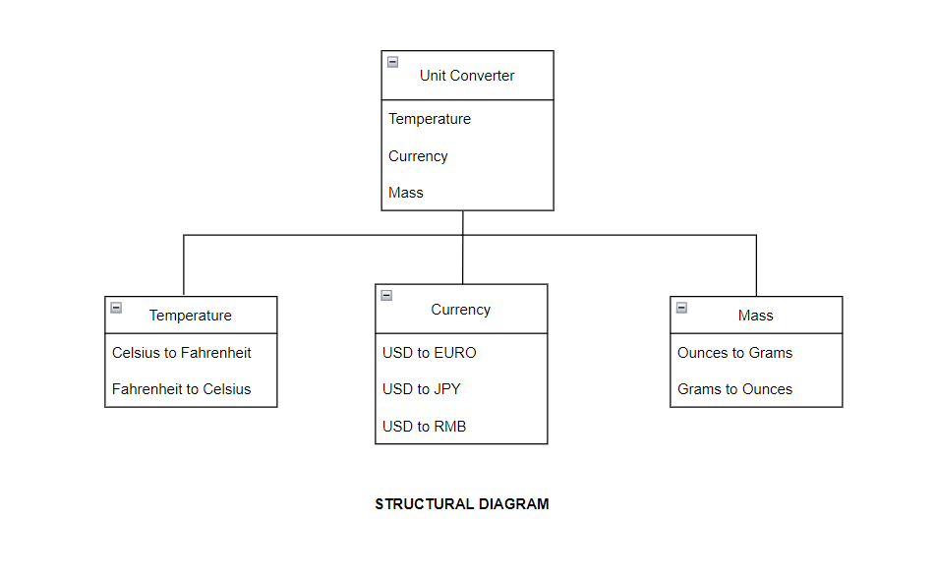

## 3.2 Behavioural Diagrams:

* USECASE Diagram:

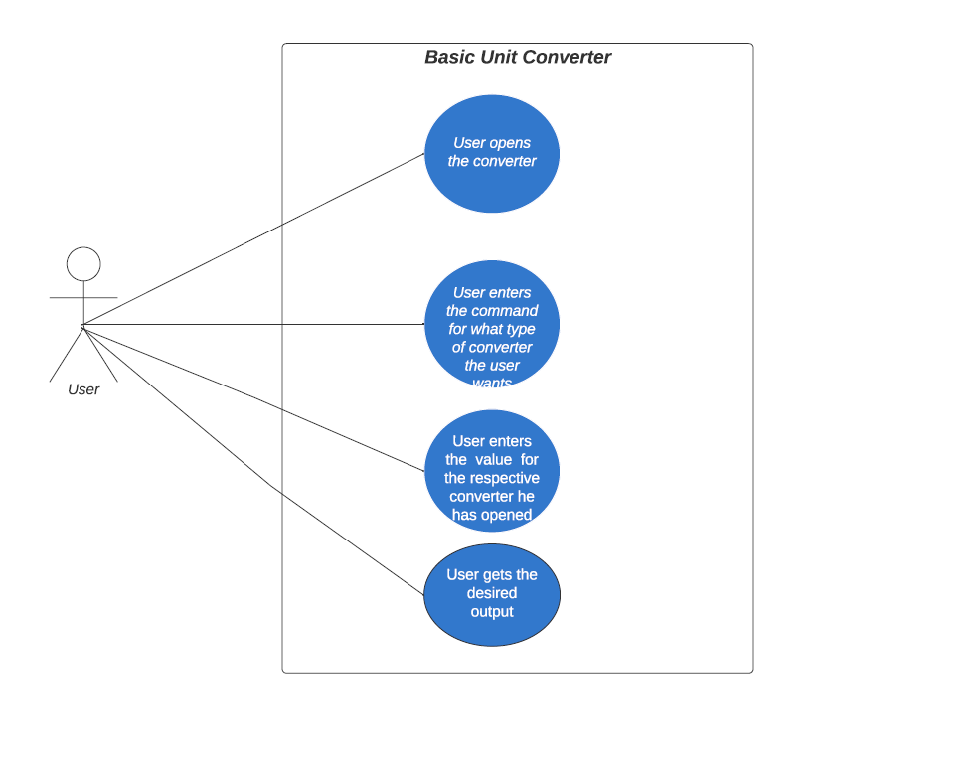

* Flowchart:

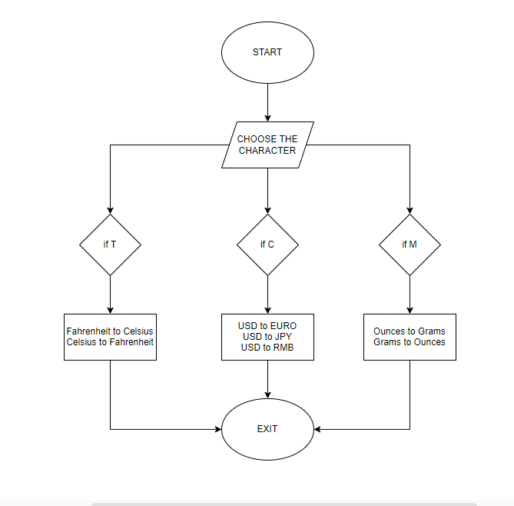

# **4.0 TEST PLAN AND OUTPUT**

## 4.1 Test Plan

* For every feature, define a test case
  + How to run that feature
  + Define expected behaviour
  + Capture the actual result

## 4.2 Table

* ID, Description of Test case, Input values, Expected Output, Actual Output

### 4.2.1 Table : High level test plan

| **Test ID** | **Description** | **Input values** | **Expected Output** |
| --- | --- | --- | --- |
| H_01 | Check if the menu is displayed | Choose the characters. | Sub menu is displayed |
| H_02 | Check if the user chooses the T,C or M. | 'X' or 'O' symbols as inputs from the player1/player2. | The player1/player2 won the game. |
| H_03 | Check if the output is displayed. | 9 inputs from player1 and player2 together. | Game Over. |

### 4.2.2 Table : Low level test plan

| **Test ID** | **Description** | **Input values** | **Expected Output** |
| --- | --- | --- | --- |
| L_01 | Checking if the proper conversion menu is displayed or not. | User has to choose the character. | Sub menu according to the user input is dispayed. |
| L_02 | Checks if the user opts for Temperature, Currency or Mass conversion. | Takes the character T,C or M. | The user input is converted accordingly. |
| L_03 | Check if the calculated output is displayed accordingly. | 9 inputs from (player1 + player2). | Exit. |

### 4.2.3 Output:

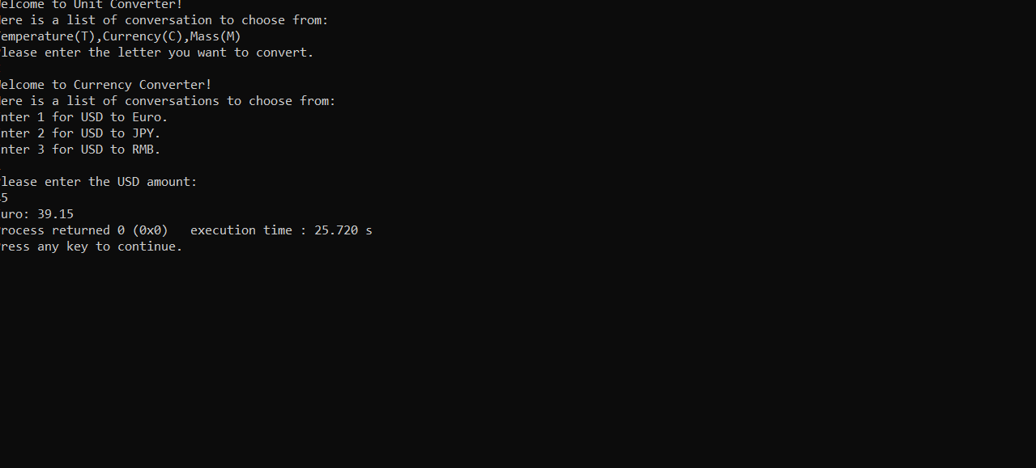

# **5.0 CONCLUSION**

## 5.1 LEARNINGS:

* The learnings that I have learned from Module 1 is that learned how to create a GitHub repository and how to properly structure the folder in the repository and also learned how to clone the GitHub repository with the Visual Studio Code. Apart from cloning the repository also learned apart from a single click to compile and run the program, I learned the back end process of how the compilation and the running of the program are done and how the errors are detected in the back end process and also the debugging the errors in the program and also a lot more about the course or the Module while working on the project.