MODULE-2

DESIGN AND SIMULATION

OF CIRCUITS AND EMBEDDED SYSTEMS

MINI PROJECT:

SOCIAL DISTANCING CAP

Submitted by:

Shubham V Mugali

1.0 ABSTRACT:

The project titled “Social Distancing Cap” encompasses the introduction of the project and after that requirement modeling and under the requirement modeling it comprises the high-level requirements and the low-level requirements after the requirements are captured then the block diagram is created and as we go on then we have added the flowchart for easy understanding of the working process of the program or workflow of the program. After the program flowchart is added then the description of the working of the model is described and also the components will be listed that are going to be used for this particular project. Lastly, the conclusion will be added like how the project is done and how can we overcome the social distancing.

2.0 INTRODUCTION

Given the current situation, the COVID-19 has been appearing in every corner of the world. We must aim to prevent the virus as much as possible. To achieve this we must make sure that proper social distancing needs to be implemented from person to person. To make sure that proper social distance is maintained from person to person I have come up with the idea of a social distancing cap with a small electroshock feature and the electroshock feature is for future reference.

SOCIAL DISTANCING CAP

The main aim of the cap is to make sure a proper distance is maintained among individuals so that the community spread of the virus can be diminished. Here ultrasonic sensors are installed on three sides of the cap to measure the minimum distance to be maintained by the individual in 360 degrees. Also, a buzzer is installed which alerts the individual by giving a buzzer upon not maintaining a minimum distance. The reason to design this social distancing reminder in form of a cap is that compared to a band or a belt this would be of easy use. A cap is a commonly used item by every person is it a child or an adult. In the case of a band, the band may not measure the distance in 360 degrees. And the sensors should be exposed so, in the case of a belt the person must tuck his shirt which may not be comfortable for everyone.

We are using 3 ultrasonic sensors which are placed on 3 sides of the cap. so using this we can maintain proper social distance among individuals. If the proper social distance is not maintained in three directions this cap will alert the person. To alert the person we are using a buzzer.

3.0 REQUIREMENT MODELLING

3.1 HIGH-LEVEL REQUIREMENTS

|  |  |
| --- | --- |
| HLR_NO | DESCRIPTION |
| HLR_01 | The sensor shall measure the distance between one another. |
| HLR_02 | The servo motor shall turn on if the distance is below the threshold range. |
| HLR_03 | The servo motor shall turn off if the person is out of the threshold range. |

3.2 LOW-LEVEL REQUIREMENTS

|  |  |
| --- | --- |
| LLR_NO | DESCRIPTION |
| LLR_01 | The ultrasonic sensor is used to measure the distance and it is turned on using a switch. |
| LLR_02 | Depending upon the distance if the person is within the threshold range the motor will turn on. |
| LLR_03 | If no one is within the range the motor will be in a turned-off state. |

4.0 BEHAVIOURAL DIAGRAMS

4.1 BLOCK DIAGRAM

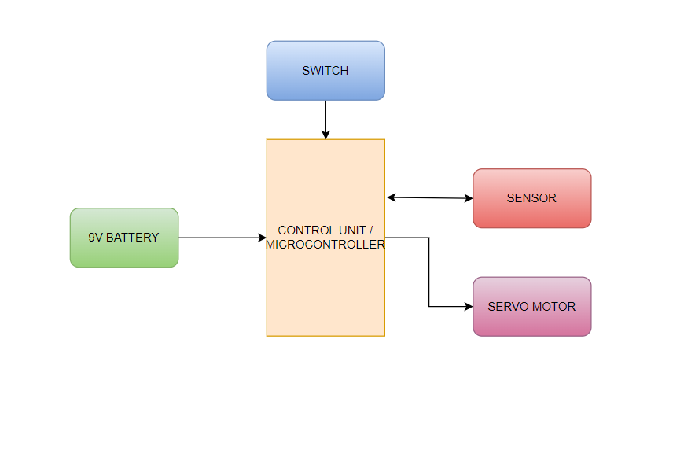

4.2 WORKING

The ultrasonic sensor is placed on the backside of the caps, which measures the distance between the sensor and the person who stood behind us. The cap is programmed using Arduino and through which the given variable can be modified accordingly in the given specific range. If the sensor senses a person below the threshold range then it sends a signal to the controller which actuates the servo motor that is placed adjacent to the person's ear.

4.3 SWOT ANALYSIS

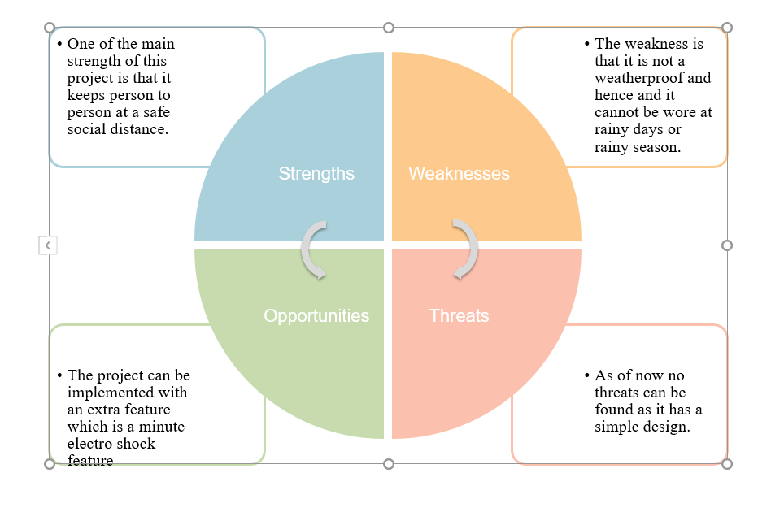

4.4 FLOWCHART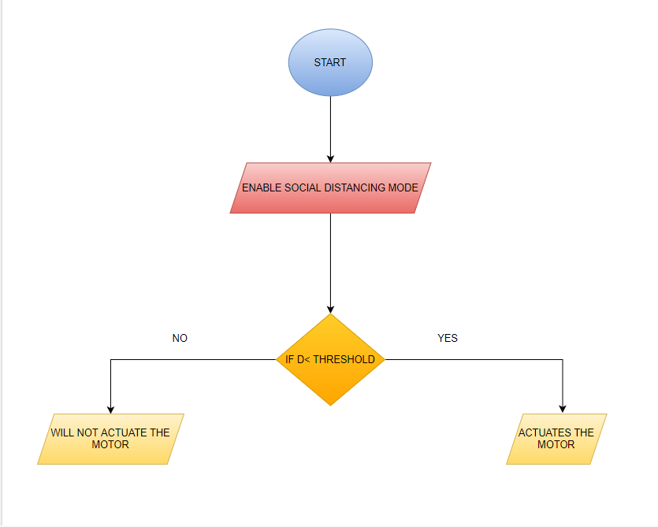

5.0 COMPONENTS

5.1 MAIN COMPONENT:

5.1.1 ARDUINO UNO:

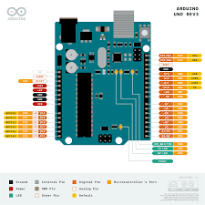

The Arduino Uno is a low-cost, flexible, and easy-to-use microcontroller board that can be integrated into various electronic projects.

* 1. SENSORS:

5.2.1 ULTRASONIC SENSOR HC-SR04:

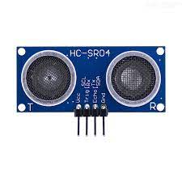

Ultrasonic is used to measure the distance between the object or in this case individual or person.

* 1. ACTUATORS:

5.3.1 SERVO MOTOR:

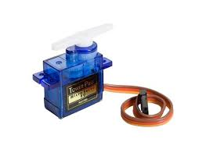

Servo motors are rotary or linear actuators that rotate or push parts of a machine with precision.

5.3.2 PIEZO BUZZER

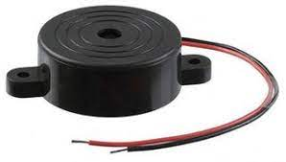

It is a simple electronic device that produces a tone, alarm, or sound.

* 1. OTHER COMPONENTS
     1. 9V BATTERY

