EXPERIMENT NO:02

Aim: To understand Version Control System / Source Code Management, install git and create a GitHub account.

Theory:

Introduction:
Version control and source code management (SCM) are essential tools in software development that help teams manage and track changes to their codebase. These systems provide a structured way to collaborate on software projects, enabling multiple developers to work on the same codebase simultaneously.

VERSION CONTROL SYSTEM:
Version control, or source control, is a foundational practice in software development for efficiently tracking and managing code changes over time. Teams use version control systems to collaborate, record additions, modifications, and deletions. It enables developers to revert to previous states, address issues, and roll back to specific versions. Features like branching support independent work, and merging ensures smooth integration. Valuable for DevOps teams, version control accelerates development, reduces time, and increases deployment success.
Benefits of the version control system:
- Enhances project development speed and collaboration efficiency.
- Reduces errors and conflicts through effective change tracking.
- Enables contribution from anywhere, maintaining separate working copies.

SOURCE CODE MANAGEMENT:
Source Code Management (SCM) is a comprehensive framework encompassing version control for the entire source code lifecycle. SCM systems ensure effective version tracking and centralized repository management, fostering seamless collaboration. Access control mechanisms regulate permissions, and auditing/logging functionalities record contributor details, timestamps, and changes, ensuring accountability and traceability in source code management.
Benefits of the source code management:
- Collaboration: Allows simultaneous work on the same codebase by multiple developers.
- Versioning:Maintains a reliable history for tracking and reverting to previous code versions.
- Error Reduction: Minimizes errors and conflicts, streamlining development with a structured approach.
REQUIREMENTS:
- A computer running Windows,macOS or Linux
- Internet Connection
- Web Browser

Step 1:
Install Git Git is a free and open-source Version Control System that can be installed on Windows, macOS, and Linux. Follow the instructions below to install Git:
1. Go to the official Git website: https://git-scm.com/
2. Download the appropriate version of Git for your operating system.
3. Double-click on the downloaded file and follow the installation wizard.
4. During the installation process, choose the default options.

Step 2:
Create a GitHub account GitHub is a web-based hosting service for Git repositories. It provides a graphical user interface for managing Git repositories and allows developers to collaborate on code. Follow the instructions below to create a GitHub account:
1. Go to the GitHub website: https://github.com/
2. Click on the "Sign up" button in the top right corner of the page.
3. Enter your username, email address, and password in the sign-up form.
4. Click on the "Create account" button.
5. Verify your email address by clicking on the link in the confirmation email sent by GitHub.

Step 3:
Configure Git Before using Git, you need to configure it with your name and email address. Follow the instructions below to configure Git:
1. Open a terminal or command prompt.
2. Type the following command to set your name:

3. Type the following command to set your email addressi
4. Verify that Git is configured correctly by typing the following command:

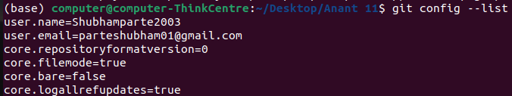
This will display your Git configuration.

Step 4:
Create a Git repository A Git repository is a directory that contains your source code and the
necessary Git files to track changes. Follow the instructions below to create a Git repository:
1. Create a new directory for your project.
2. Open a terminal or command prompt and navigate to the directory.
3. Type the following command to initialize a new Git repository:

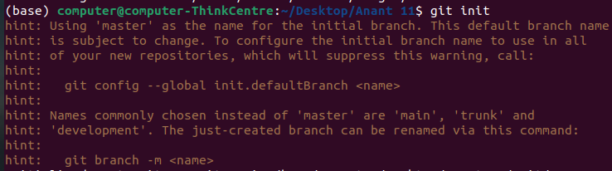
This will create a new .git subdirectory in your project directory.

Step 5:
Add files to the repository Before you can start tracking changes, you need to add files to the
repository. Follow the instructions below to add files to the repository:
1. Copy or create files in your project directory.
2. Type the following command to add the files to the repository:

This will stage all files in the current directory for the next commit.

Step 6:
Commit changes to the repository After adding files to the repository, you need to commit the
changes to the repository. Follow the instructions below to commit changes to the repository:
1. Type the following command to commit the changes:

This will create a new commit with the message "Initial commit".

Step 7:
Push changes to GitHub After committing changes to the repository, you need to push the
changes to your GitHub account. Follow the instructions below to push changes to GitHub:
1. Go to your GitHub account and create a new repository.
2. Copy the repository URL.
3. Type the following command to add the
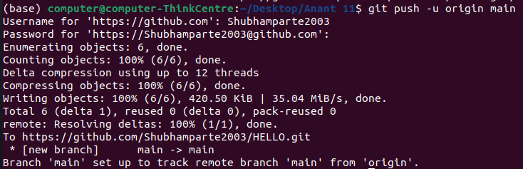

Conclusion:
Thus, we have successfully performed Version Control System / Source Code Management, install git and create a GitHub acco

