Name: Sakshi Shende
Roll No.: Aiml_107
Batch: B1
Date: 1-02-2024
EXPERIMENT NO.03:

Aim: To perform various GIT operations on local and remote repositories using GIT Cheat-Sheet.

Theory:

Introduction:
Git Cheat Sheet is a comprehensive quick guide for learning Git concepts, from very basic to advanced levels. By this Git Cheat Sheet, our aim is to provide a handy reference tool for both beginners and experienced developers/DevOps engineers. This git cheat sheet not only makes it easier for newcomers to get started but also serves as a refresher for experienced professionals.Git and GitHub are essential tools for developers to efficiently manage their code, collaborate with others, and to contribute in open-source projects.
Here’s a cheat sheet for some common GIT commands for working with local and remote repositories:
Initializing a repository
To start tracking changes to a project, you need to create a new Git repository:
Staging changes
Before you commit changes to your repository, you need to stage them. To stage changes to all files in your working directory:
To stage specific files:
Committing changes
After staging changes, you can commit them to your local repository:
Branching
You can create a new branch to work on new features or bug fixes without affecting the main code:
To switch to a branch:
Merging
To merge changes from one branch to another:
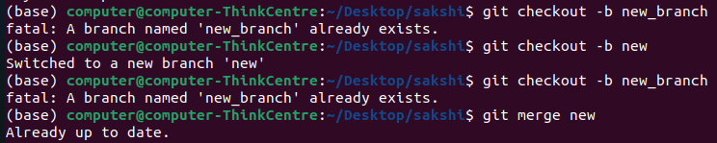
Pulling and pushing changes

To download changes from a remote repository:
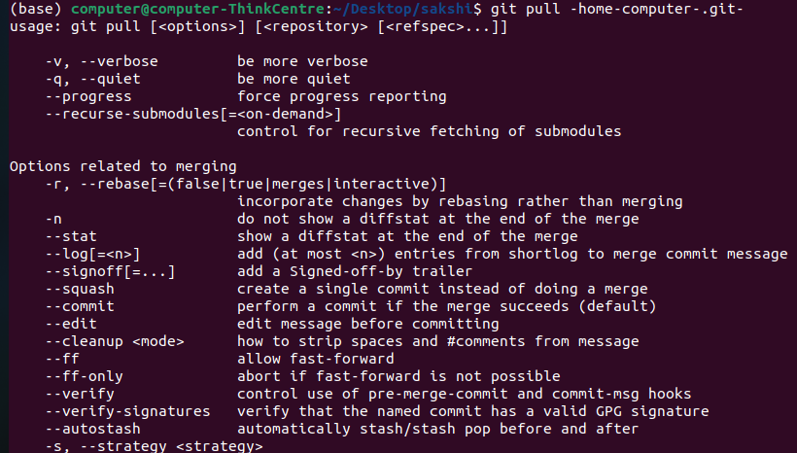

To upload changes to a remote repository:
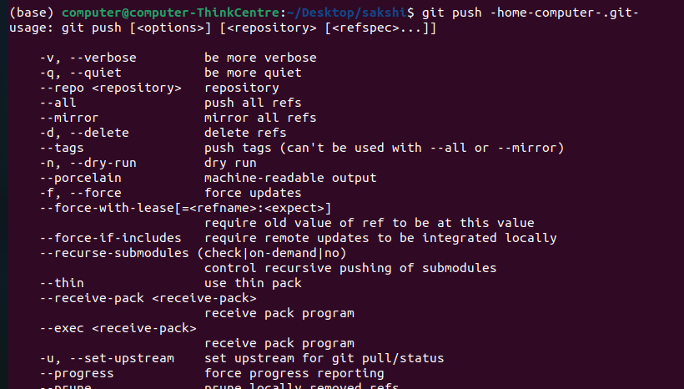
Checking status and history

To check the status of your repository:
To view the commit history:
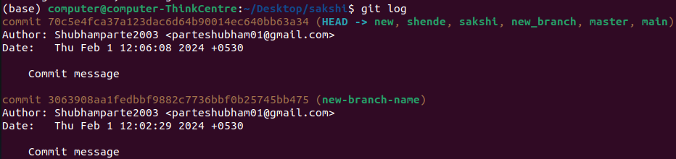
This is just a small subset of Git commands, but they should cover the most common tasks
you'll need to perform. If you need more information, you can consult the Git documentation
or use the git help command.

Conclusion: Thus, we have successfully performed various GIT operations on local and remote repositories using GIT Cheat-Sheet.

