**Title: Revealing Sales Insights for Atliq Hardware with Power BI**

At Atliq Hardware sales were dropping, and sales director weren’t getting enough insights from regional sales managers. The Sales Director needed a clear view of our sales data to make better decisions and save time on manual data collection.

**Problem**

sales were declining, and the regional managers were not providing enough information about their areas. This made it hard for the Sales Director to make informed decisions.

**Goal**

goal was to find hidden sales insights that the sales team could use to make better decisions. they also wanted to automate data collection to save time.

**Data Source**

I used SQL data from GitHub for my analysis to solve this problem and give meaningful insights.

**Process and Tools**

I used Power BI to analyze the data. The steps included:

- Data Cleaning: Making sure the data was accurate and organized.

- Dashboard Creation: Creating easy-to-understand dashboards to show key metrics and trends.

**Key Findings**

Here are some of the key insights from our analysis:

- Total Revenue and Sales Quantity: atliq hardware made INR 142.22M in revenue and sold 350K units. The Delhi market generated the highest revenue at INR 77.73M.

- Monthly Revenue Trends: Revenue peaked in early 2020 and then declined.

- Profit Margins by Zone: The South zone had the highest profit margins at 38.42%.even if Delhi market generated highest revenue it doesn’t meant it given highest profit. Here Bhubaneshwar has highest profit % that is 10.5%

- Top Customers and Products: Surge Stores was our top customer. Prod279 and Prod278 were the top-selling products.

**Challenges and Solutions**

I faced issues with inconsistent and missing data, currency was not standardized. By cleaning the data, I ensured the analysis was accurate.

**Impact**

my analysis provided actionable insights to improve sales strategies, manage inventory better, and target customers more effectively. Automating data collection also saved the sales team a lot of time.

**Visuals**

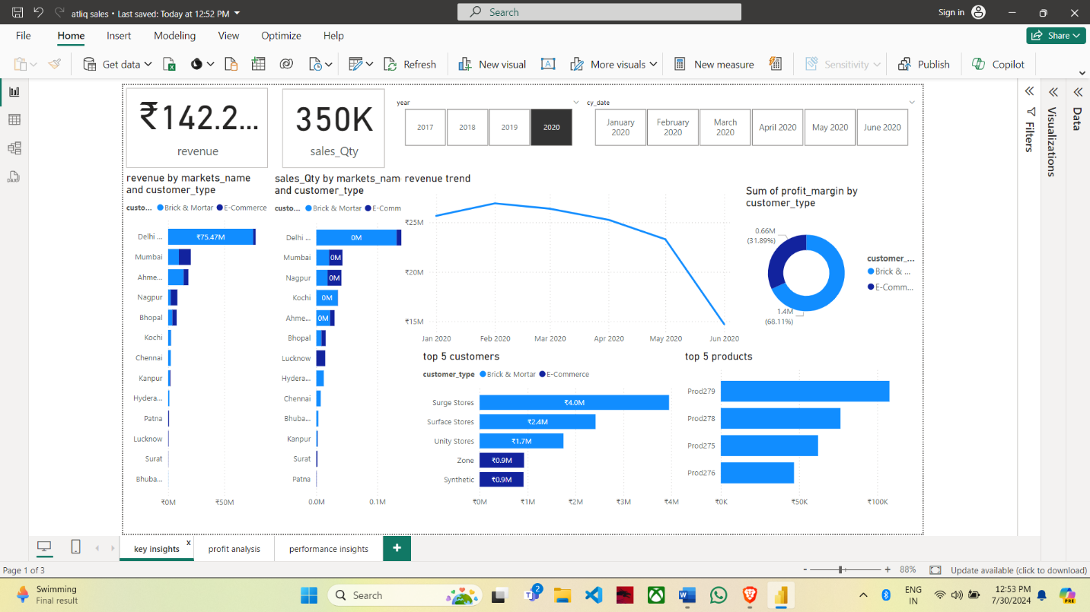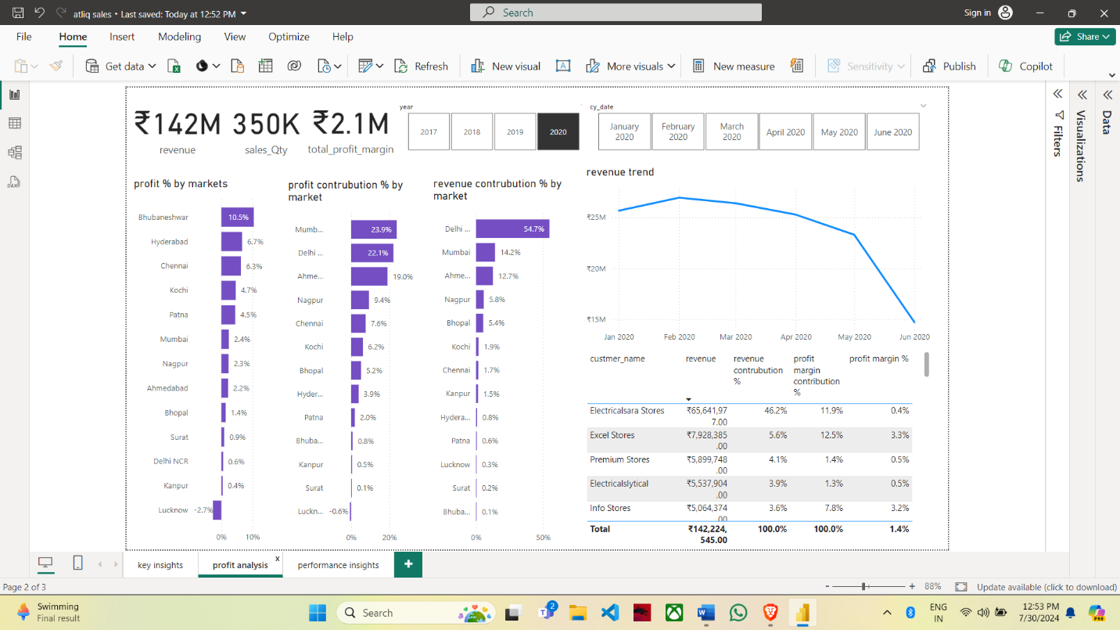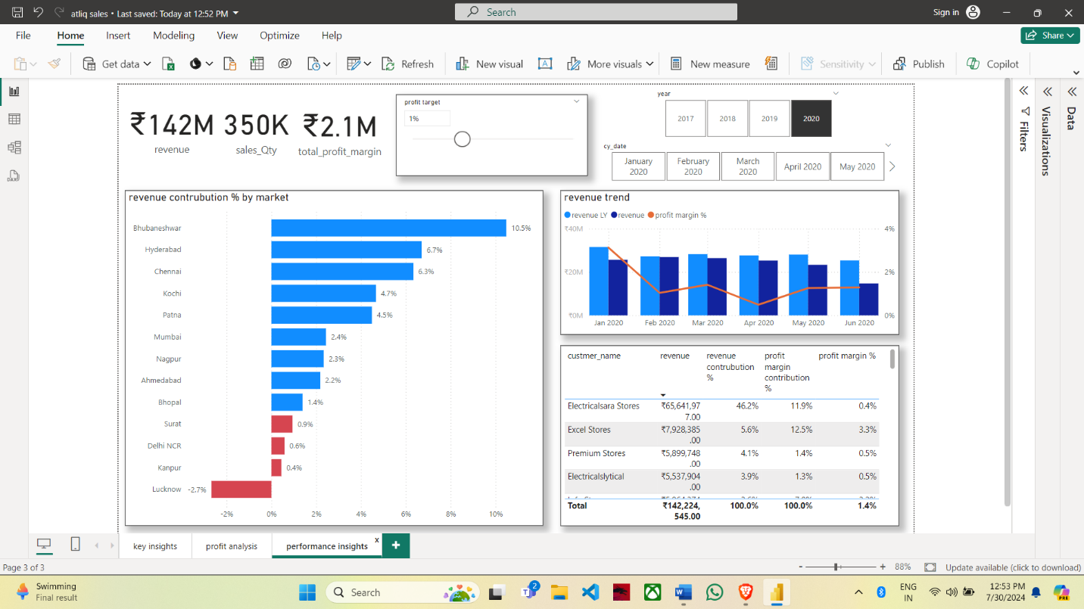

**How to Use This Repository**

1. **Clone the Repository**: git clone https://github.com/yourusername/atliq-hardware-sales-analysis.git
2. **Open the Power BI File**: Use Power BI Desktop to open and interact with the .pbix file included in this repository.
3. **Review the Findings**: Explore the dashboards and insights to understand the key metrics and trends.

**Conclusion**

This project highlighted the importance of data analytics for making better business decisions. With Power BI, Atliq Hardware can now plan better for the future and reduce time spent on manual tasks.

Feel free to reach out if you have any suggestions and improvements that I can make in this project.