A stack is a linear data structure that follows the Last-In-First-Out (LIFO) principle. It behaves like a stack of plates, where the last plate added is the first one to be removed.

**Stack**

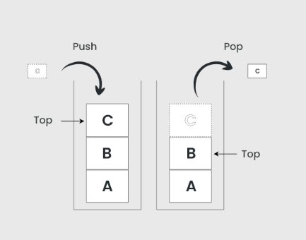

Key Operations on Stack Data Structures

* Push: Adds an element to the top of the stack.
* Pop: Removes the top element from the stack.
* Peek: Returns the top element without removing it.
* IsEmpty: Checks if the stack is empty.
* IsFull: Checks if the stack is full (in case of fixed-size arrays).

Applications of Stack Data Structures

* Recursion
* Expression Evaluation and Parsing
* Depth-First Search (DFS)
* Undo/Redo Operations
* Browser History
* Function Calls