Question 1:- https://leetcode.com/problems/palindrome-linked-list/
Solution: - https://leetcode.com/problems/palindrome-linked-list/submissions/2023143057/
Screenshot:-
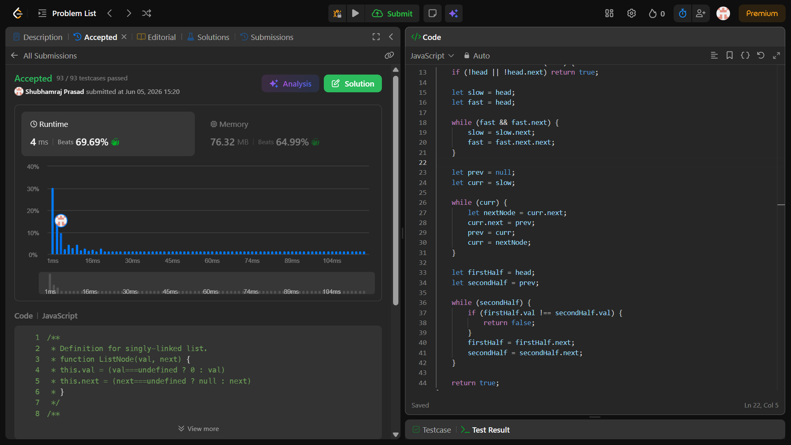
Description: -
- Time Complexity: O(n) — Finding the middle takes O(n/2) time, reversing the second half takes O(n/2) time, and comparing the two halves takes at most O(n/2) operations. This simplifies to a linear time complexity.
- Space Complexity: O(1) — The mutations and reversals are performed entirely in-place by changing the node pointers, modifying no extra memory allocations.

Question 2:- https://leetcode.com/problems/remove-nth-node-from-end-of-list/
Solution: - https://leetcode.com/problems/remove-nth-node-from-end-of-list/submissions/2023161138/
Screenshot:-
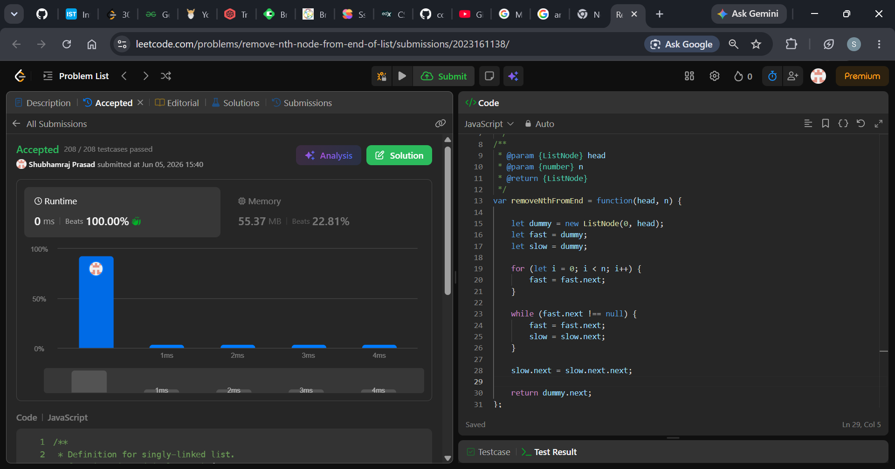
Description: -
- Time Complexity: O(M) where M is the number of nodes in the linked list. The list s traversed exactly once.
- Space Complexity: O(1) because we only use a few pointer variables, satisfying the optimal memory constraint.

Question 3:- https://leetcode.com/problems/valid-parentheses/description/
Solution: - https://leetcode.com/problems/valid-parentheses/submissions/2023530890/
Screenshot:-
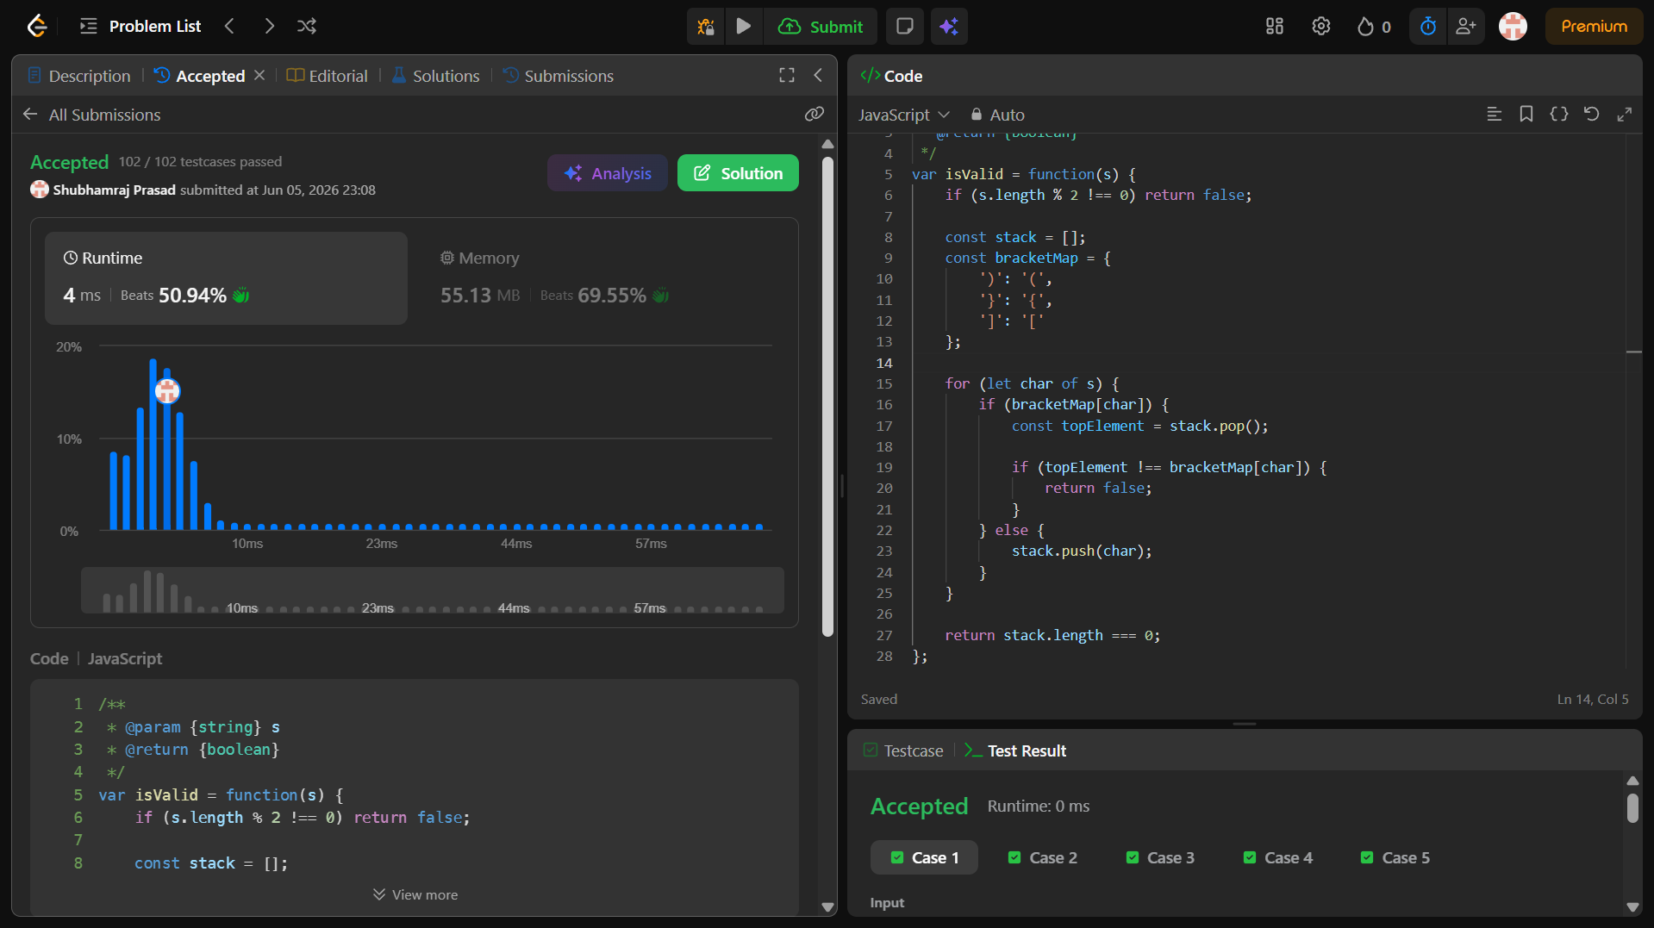
Description: -
- Time Complexity: O(n) - Linear time. The code iterates through the string of length n exactly once. Hash map lookups, pushing, and popping elements take constant O(1) time per character.
- Space Complexity: O(n) - Linear space. In the worst-case scenario (e.g., an input with all opening brackets like "((((("), every character is pushed onto the stack, making its size proportional to the input length.

Question 4:- https://leetcode.com/problems/next-greater-element-i/description/
Solution: - https://leetcode.com/problems/next-greater-element-i/submissions/2024098649/
Screenshot:-
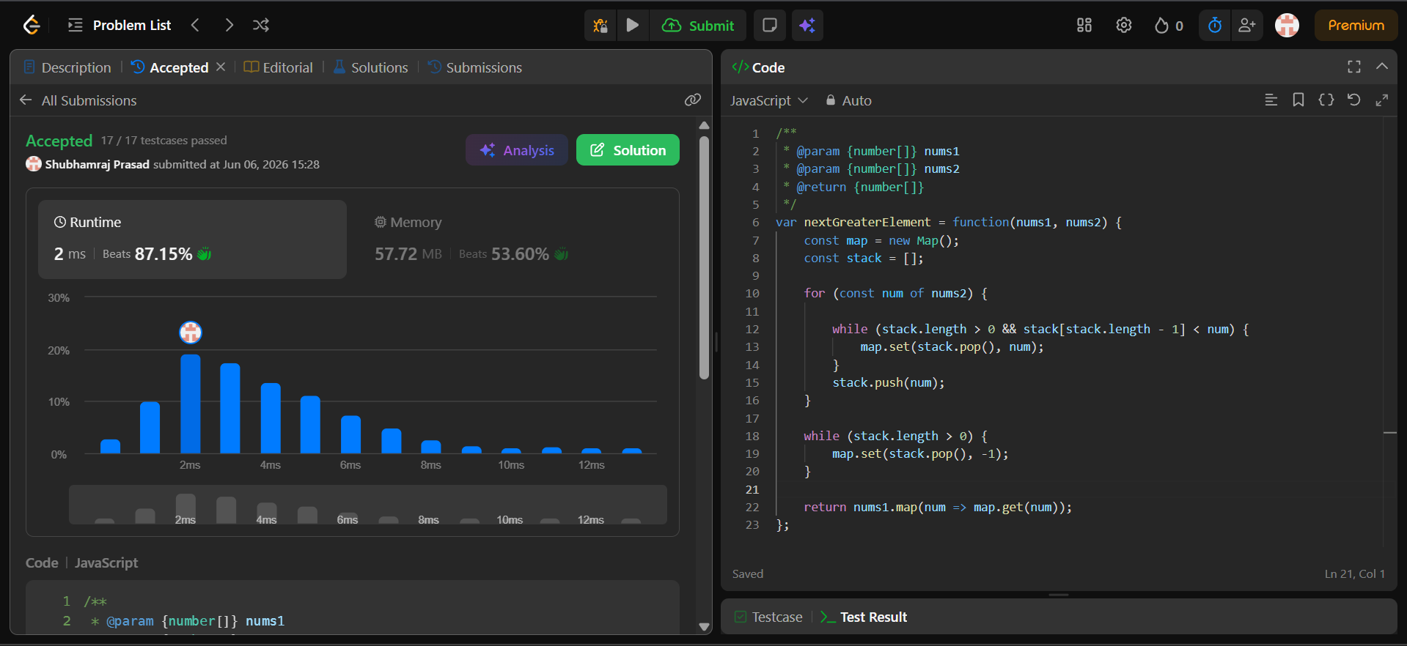
Description: -
- Time Complexity: O(n) — Every element is pushed and popped from the stack at most once.
- Space Complexity: O(n) — To store the elements in the stack and the map lookup

Question 5:- https://leetcode.com/problems/minimum-depth-of-binary-tree/description/
Solution: - https://leetcode.com/problems/minimum-depth-of-binary-tree/submissions/2025974021/
Screenshot:-
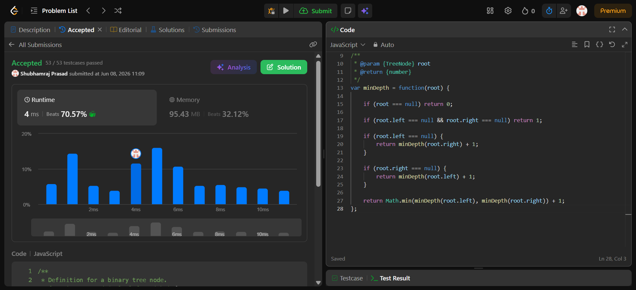
Description: -
- Time Complexity: O(n) - You must visit every node exactly once in the worst case.
- Space Complexity: O(h) - Uses memory on the call stack proportional to the tree's height (O(n) for a straight-line tree, O(log n) if perfectly balanced).

Question 6:- https://leetcode.com/problems/binary-tree-postorder-traversal/
Solution: - https://leetcode.com/problems/binary-tree-postorder-traversal/submissions/2025993893/
Screenshot:-
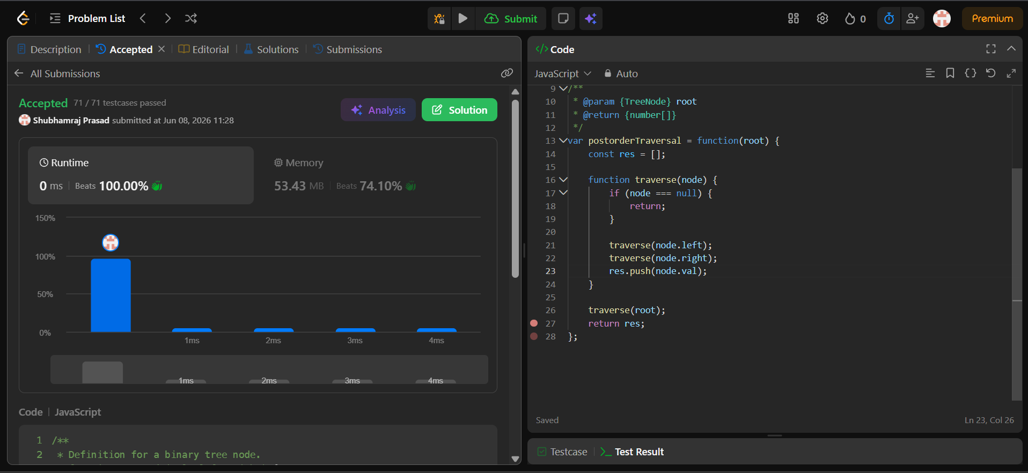
Description: -
- Time Complexity: O(n) => The algorithm visits every single node in the binary tree exactly once. Inside each node, it only performs quick, constant-time operations (checking for null and pushing a value to an array).
- Space Complexity: O(n) =>
  - 1. Output: The result array stores all n node values, using O(n) space.
  - 2. Call Stack: In the worst-case scenario (a skewed tree that looks like a single long line), the recursive call stack will grow to a depth of n functions. In a perfectly balanced tree O(log n), but the total space remains O(n) due to the output array.

Question 7:- https://leetcode.com/problems/delete-node-in-a-linked-list/description/
Solution: - https://leetcode.com/problems/delete-node-in-a-linked-list/submissions/2026000037/
Screenshot:-
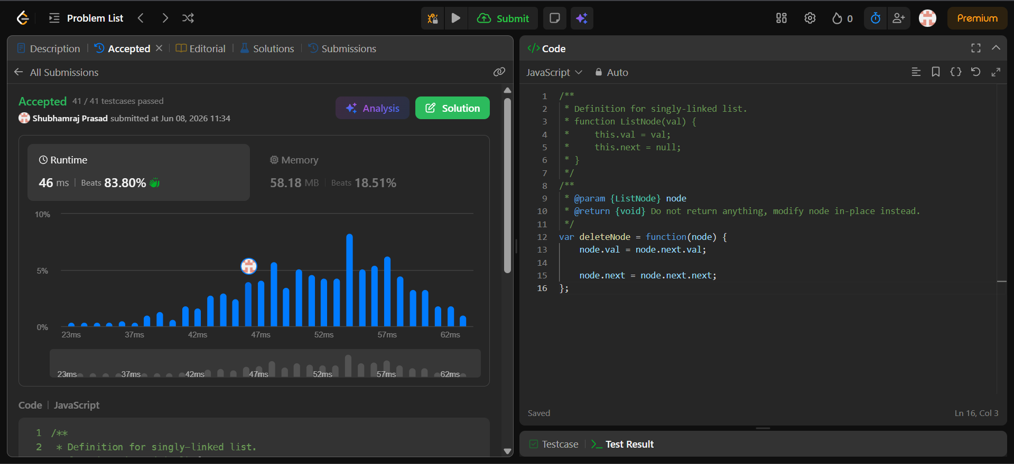
Description: -
- Time Complexity: O(1) => It takes a constant amount of time since we only perform two pointer/value reassignments.
- Space Complexity: O(1) => No additional memory is allocated.

