Commands

1) git help: It provides frequently used several git commands

2)git help It opens the documentation of that particular command

3) git init: It is used to create empty repository or re-initialize existing repo 4) git status: This command will display the status of current repository

Files:

1) Stage files; Files which are added and they are aligible to commit Displayed in green colour

2) Un-staged files: I Modified files will be displayed here, we need to statge these files to commit Displayed in Red colour

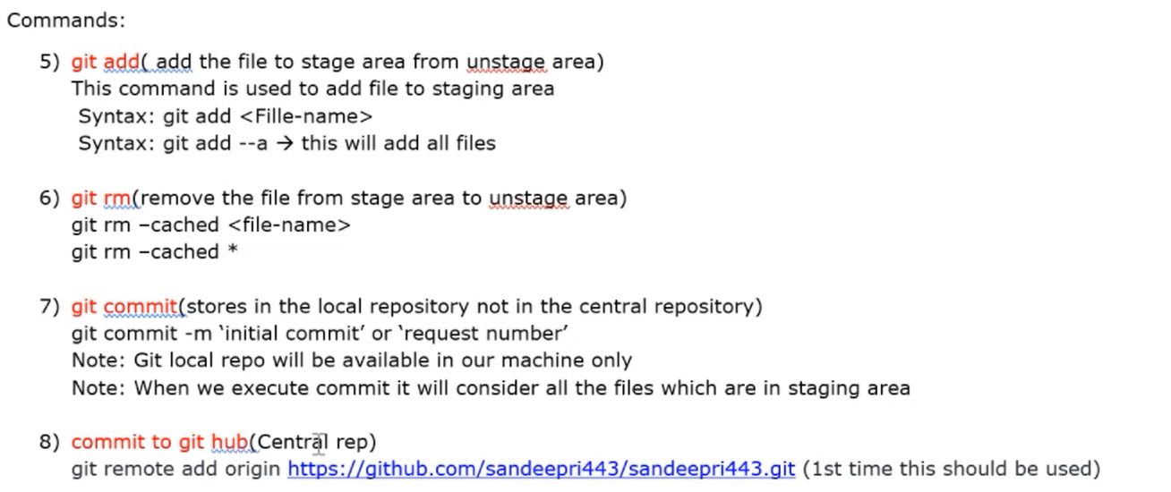

8) commit to git hub(Central rep)

git remote add origin https://github.com/_____________________.git (1st time this should be used)

9) git config --global user.email sandeepri443@gmail.com git config --global user name "your-github_username" git config --global user email "your.github_email" git config -1

10) Git Push (generate token) git push-u origin master(Used to move changes from local to central) git push(2nd time onwards)

In case of errors

11) git reset( it is used to unstage a file) git reset HEAD

12) git checkout (used to discard changes done in a file) git checkout -filename commit-id: whenever we commit, git will generate commit-id(7 characters) commit ID contains 40 alphanumeric characters from 40 alphanumeric characters it will display first 7 characters to us.

Check History of the commit:

Syntax: Git log Git log -onetime

Git log -3

In logs it will display below details

* commit-id
* author
* timestamp