ASSIGNMENT NO.3

Gaurav_bodkhe_2124UCEM1041

1. Introduction

In this program, we will create a simple app that allows users to make phone calls by typing a mobile number. The user can enter the phone number they wish to call into a text field. After entering the number, they can press a "Call" button to initiate the call. This app provides a straightforward way for users to dial a number and make a call directly, without the need for selecting contacts from a list.

2. Tools & Technologies Used
- Android Studio
- Java
- Emulator

3. Procedure & Steps

Step 1: Create a New Project
- Open Android Studio and create a new project.
- Choose an Empty Views Activity template.
- Set the project name and package name of your Application
- Select the programming language (Java).
- Screenshot:
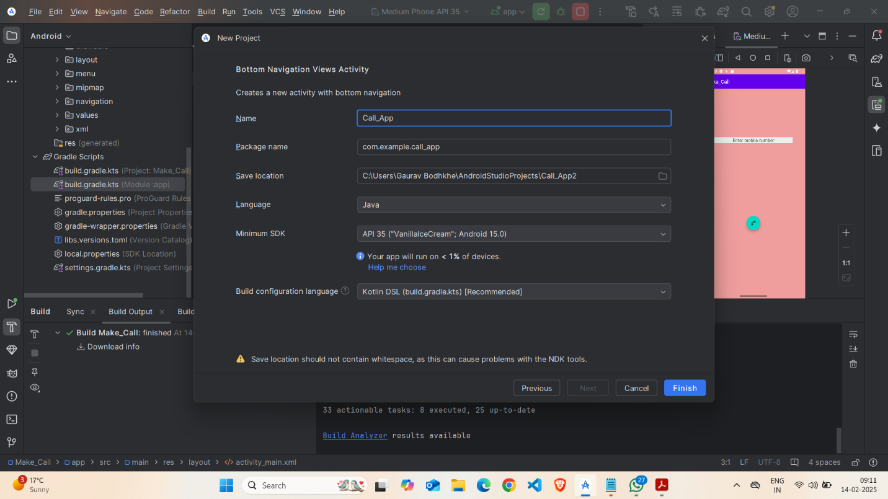

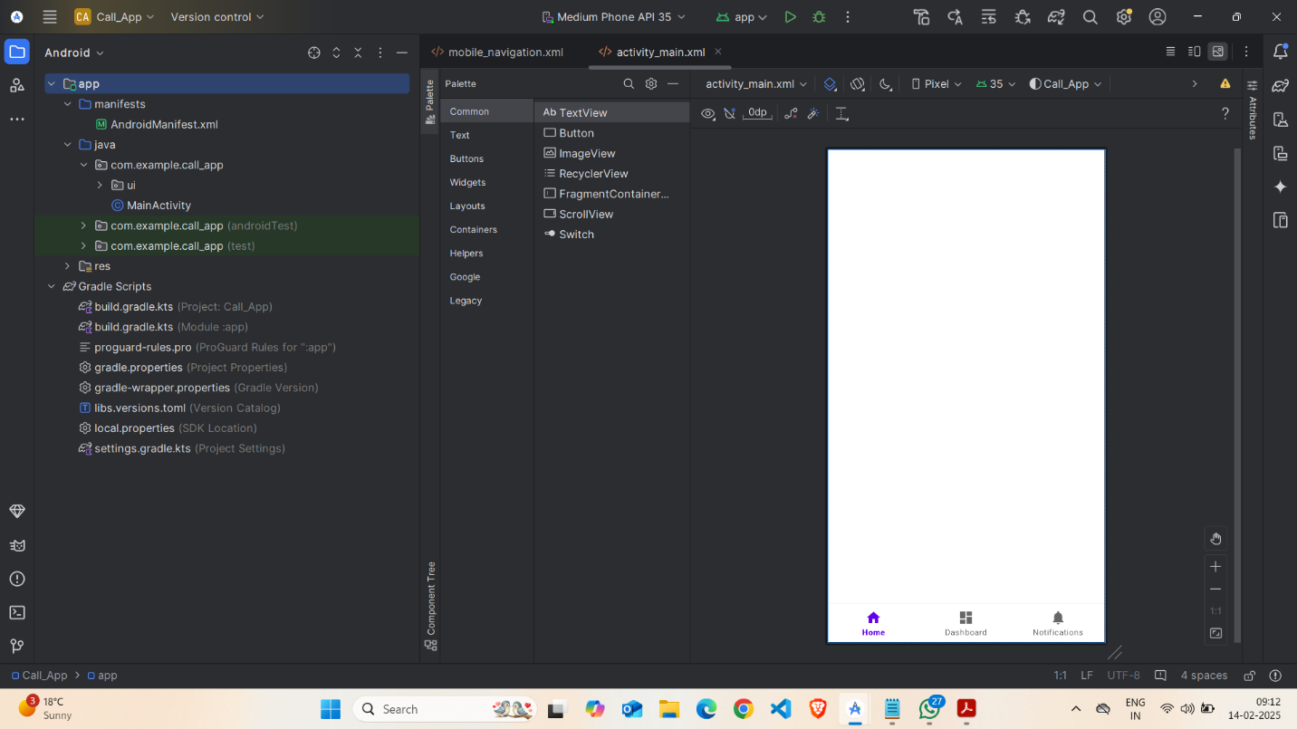

Step 2: Designing the UI
- Open activity_main.xml and design the layout using XML.
- Add UI comwponents such as Ab Phone Text, EditText,TextView CallButton, etc.
Screenshot:
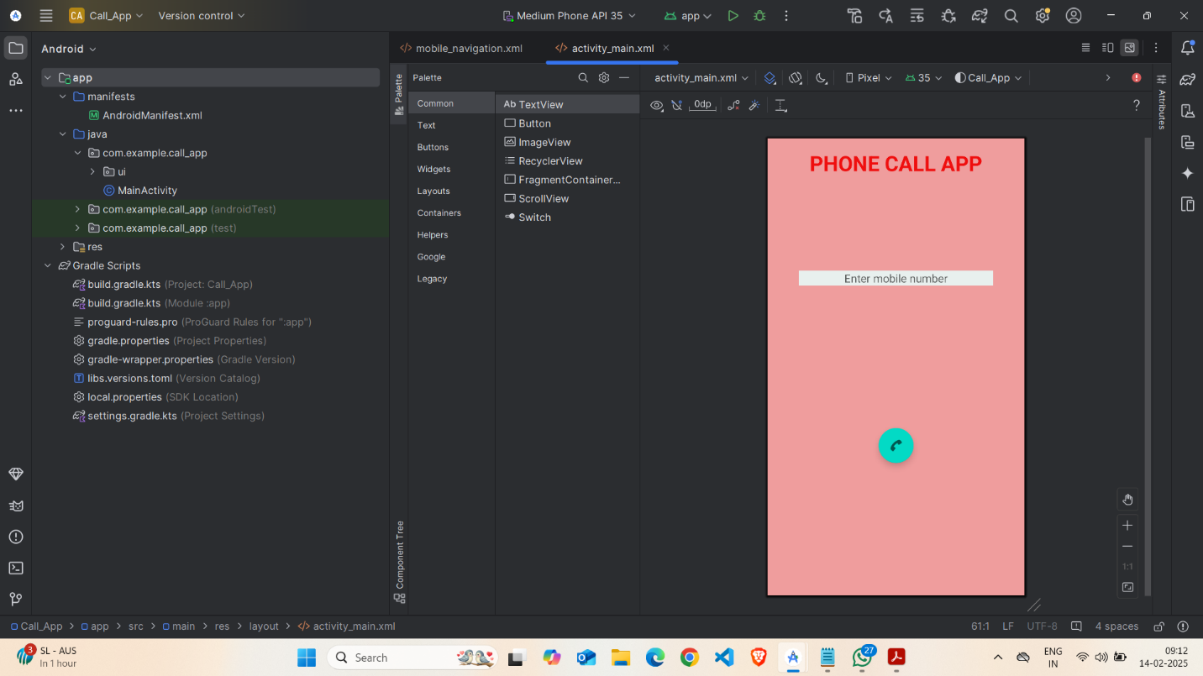

Step 3: Writing the Code
- Open Activity_main.xml
- Implement functionality such as Enter Mobile No, floating action button,
- Use necessary Android components like Intents, RecyclerView, Fragments, etc
- Screenshot:
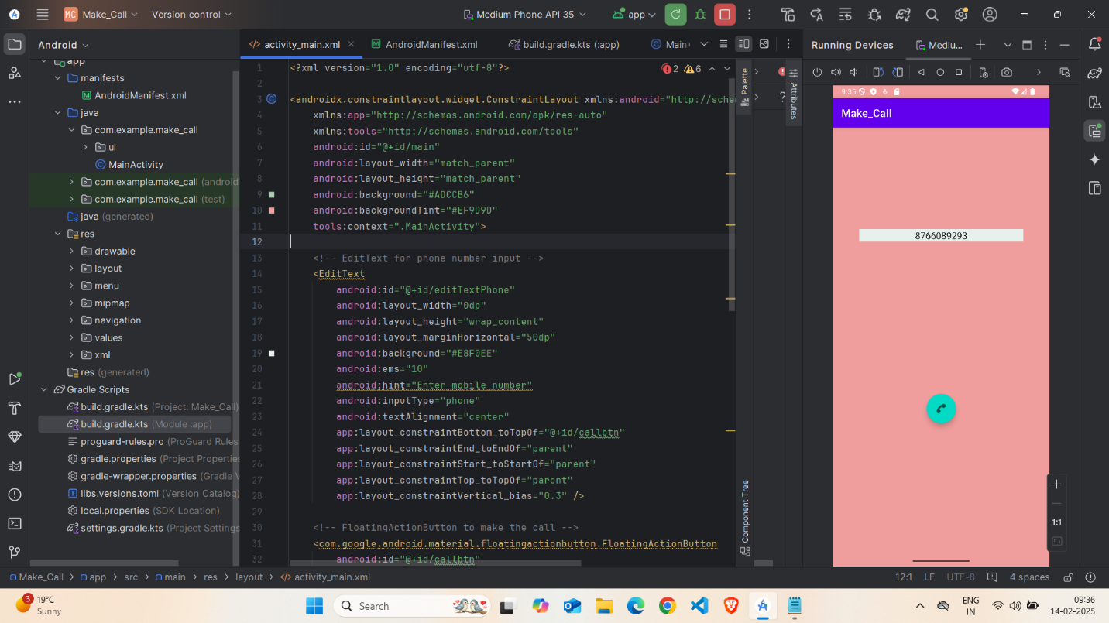
- XML
<?xml version="1.0" encoding="utf-8"?>

<androidx.constraintlayout.widget.ConstraintLayout xmlns:android="http://schemas.android.com/apk/res/android"

xmlns:app="http://schemas.android.com/apk/res-auto"

xmlns:tools="http://schemas.android.com/tools"

android:id="@+id/main"

android:layout_width="match_parent"

android:layout_height="match_parent"

android:background="#ADCCB6"

android:backgroundTint="#EF9D9D"

tools:context=".MainActivity">

<!-- EditText for phone number input -->

<EditText

android:id="@+id/editTextPhone"

android:layout_width="0dp"

android:layout_height="wrap_content"

android:layout_marginHorizontal="50dp"

android:background="#E8F0EE"

android:ems="10"

android:hint="Enter mobile number"

android:inputType="phone"

android:textAlignment="center"

app:layout_constraintBottom_toTopOf="@+id/callbtn"

app:layout_constraintEnd_toEndOf="parent"

app:layout_constraintStart_toStartOf="parent"

app:layout_constraintTop_toTopOf="parent"

app:layout_constraintVertical_bias="0.3" />

<!-- FloatingActionButton to make the call -->

<com.google.android.material.floatingactionbutton.FloatingActionButton

android:id="@+id/callbtn"

android:layout_width="wrap_content"

android:layout_height="wrap_content"

android:layout_marginTop="16dp"

android:src="@android:drawable/ic_menu_call"

app:layout_constraintBottom_toBottomOf="parent"

app:layout_constraintEnd_toEndOf="parent"

app:layout_constraintHorizontal_bias="0.5"

app:layout_constraintStart_toStartOf="parent"

app:layout_constraintTop_toBottomOf="@+id/editTextPhone"

app:layout_constraintVertical_bias="0.5" />

<!-- TextView for displaying app name -->

<TextView

android:id="@+id/textView"

android:layout_width="wrap_content"

android:layout_height="wrap_content"

android:text="PHONE CALL APP"

android:textAlignment="center"

android:textColor="#EF0E0E"

android:textSize="34sp"

android:textStyle="bold"

app:layout_constraintBottom_toTopOf="@+id/editTextPhone"

app:layout_constraintEnd_toEndOf="parent"

app:layout_constraintStart_toStartOf="parent"

app:layout_constraintTop_toTopOf="parent"

app:layout_constraintVertical_bias="0.1" />

</androidx.constraintlayout.widget.ConstraintLayout>

Step 4: Writing the Code (For Uses Permission)
- Open AndroidManifest.xml
- Implement functionality get Uses Permission Android-Permission for Call_App

Screenshot:

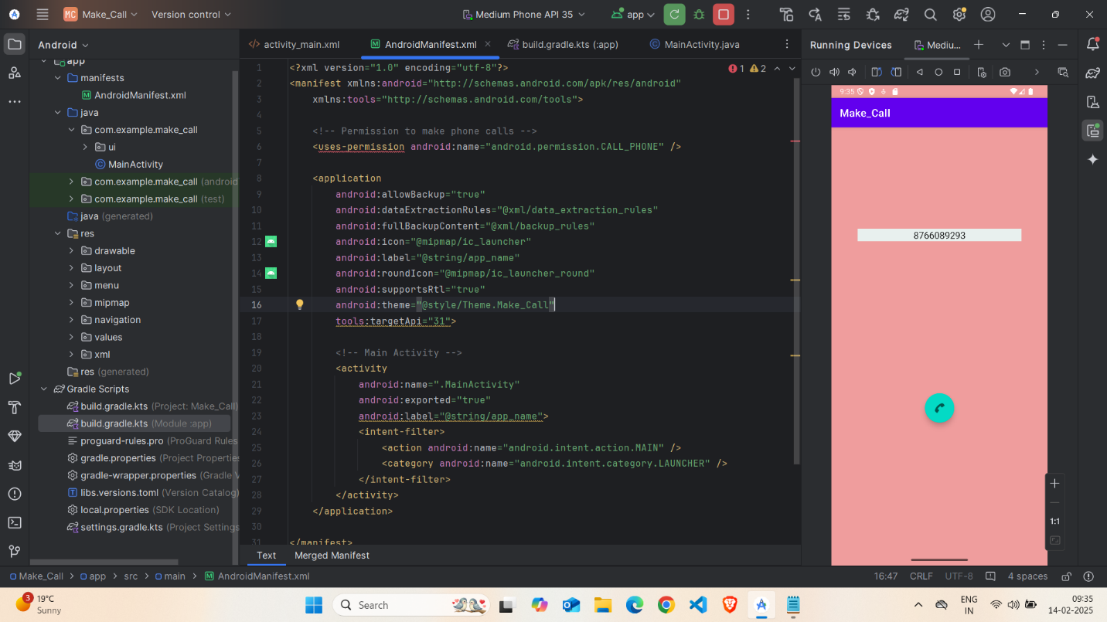

- Code( AndroidManifest.xml)

<?xml version="1.0" encoding="utf-8"?>
<manifest xmlns:android=http://schemas.android.com/apk/res/android
xmlns:tools="http://schemas.android.com/tools">
<!-- Permission to make phone calls -->
<uses-permission android:name="android.permission.CALL_PHONE" />

<application

android:allowBackup="true"

android:dataExtractionRules="@xml/data_extraction_rules"

android:fullBackupContent="@xml/backup_rules"

android:icon="@mipmap/ic_launcher"

android:label="@string/app_name"

android:roundIcon="@mipmap/ic_launcher_round"

android:supportsRtl="true"

android:theme="@style/Theme.Make_Call"

tools:targetApi="31">

<!-- Main Activity -->

<activity

android:name=".MainActivity"

android:exported="true"

android:label="@string/app_name">

<intent-filter>

<action android:name="android.intent.action.MAIN" />

<category android:name="android.intent.category.LAUNCHER" />

</intent-filter>

</activity>

</application>

</manifest>

Step 5: Writing the Backend Code (java)
- Open MainActivity.java
- Implement functionality such as By Click on Call Button The Call get started.
Screenshot:
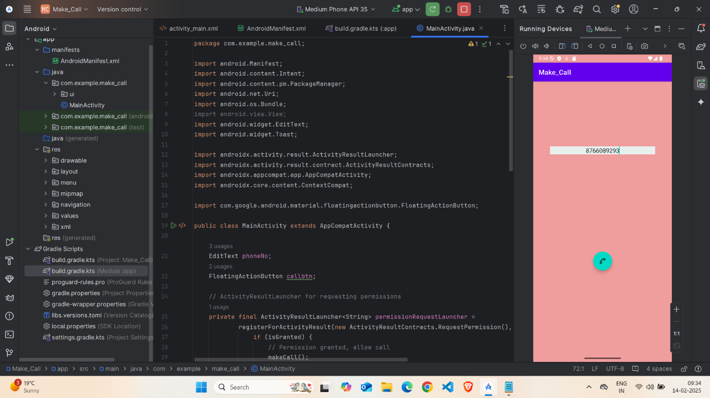

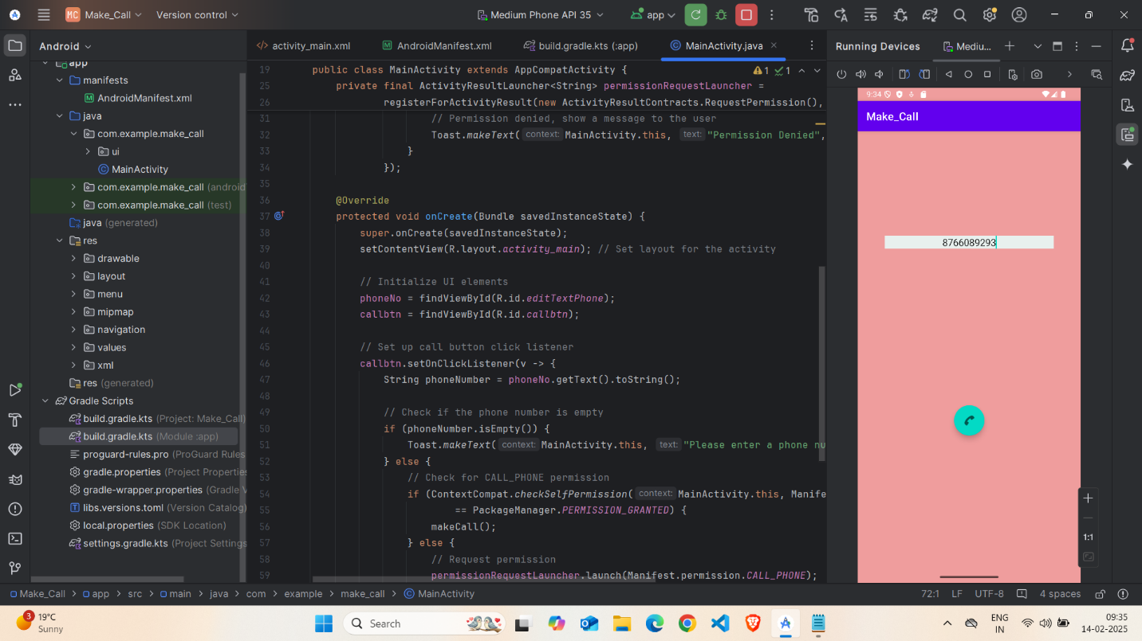

Code(java):
package com.example.make_call;

import android.Manifest;
import android.content.Intent;
import android.content.pm.PackageManager;
import android.net.Uri;
import android.os.Bundle;
import android.view.View;
import android.widget.EditText;
import android.widget.Toast;

import androidx.activity.result.ActivityResultLauncher;
import androidx.activity.result.contract.ActivityResultContracts;
import androidx.appcompat.app.AppCompatActivity;
import androidx.core.content.ContextCompat;

import com.google.android.material.floatingactionbutton.FloatingActionButton;

public class MainActivity extends AppCompatActivity {

EditText phoneNo;
FloatingActionButton callbtn;

// ActivityResultLauncher for requesting permissions
private final ActivityResultLauncher<String> permissionRequestLauncher =
registerForActivityResult(new ActivityResultContracts.RequestPermission(), isGranted -> {
if (isGranted) {
// Permission granted, allow call
makeCall();
} else {
// Permission denied, show a message to the user
Toast.makeText(MainActivity.this, "Permission Denied", Toast.LENGTH_SHORT).show();
}
});

@Override
protected void onCreate(Bundle savedInstanceState) {
super.onCreate(savedInstanceState);
setContentView(R.layout.activity_main); // Set layout for the activity

// Initialize UI elements
phoneNo = findViewById(R.id.editTextPhone);
callbtn = findViewById(R.id.callbtn);

// Set up call button click listener
callbtn.setOnClickListener(v -> {
String phoneNumber = phoneNo.getText().toString();

// Check if the phone number is empty
if (phoneNumber.isEmpty()) {
Toast.makeText(MainActivity.this, "Please enter a phone number", Toast.LENGTH_SHORT).show();
} else {
// Check for CALL_PHONE permission
if (ContextCompat.checkSelfPermission(MainActivity.this, Manifest.permission.CALL_PHONE)
== PackageManager.PERMISSION_GRANTED) {
makeCall();
} else {
// Request permission
permissionRequestLauncher.launch(Manifest.permission.CALL_PHONE);
}
}
});
}

private void makeCall() {
String phoneNumber = phoneNo.getText().toString();
Intent intent = new Intent(Intent.ACTION_CALL);
intent.setData(Uri.parse("tel:" + phoneNumber));
startActivity(intent); // Start the activity to make the call
}
}

Step 6: Running the Application on Emulator
- Click on the Run button in Android Studio.
- Select the emulator and launch the app.
Screenshot:
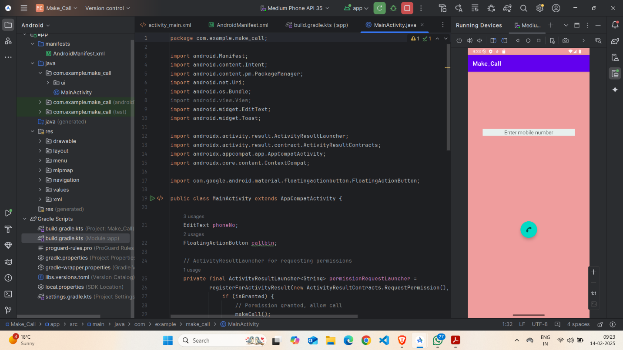

Step 5: Testing & Output
- Test different functionalities of the app.
- Capture the output results.
- Screenshot:

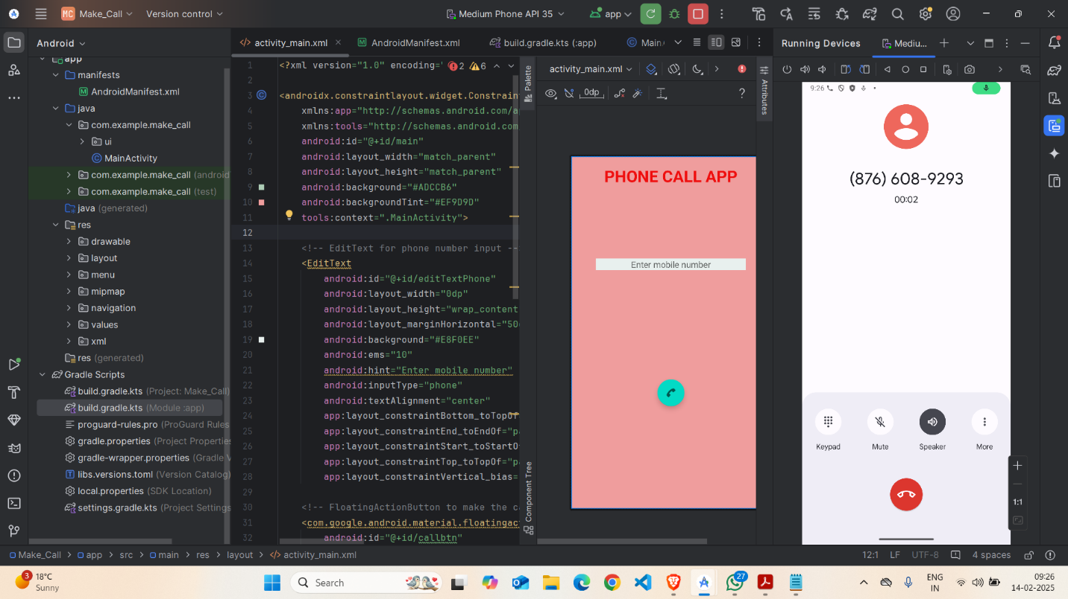

4. Conclusion
I learned a lot about creating a simple phone dialing app using Java for Android development. I gained valuable skills in designing a user-friendly interface where users can input a phone number and press a "Call" button to make a call. One challenge I faced was organizing the layout and ensuring the button worked properly, but I solved these issues by researching and experimenting with the code. By the end, I felt more confident in building apps with basic functionality and fixing layout problems. This experience also helped me improve my problem-solving skills and manage my time better.
窗体顶端
窗体底端
.

