ASSIGNMENT NO.5

Gaurav_bodkhe_2124UCEM1041

1. Introduction

In this program, we'll develop a simple Android app that navigates users to a destination using Google Maps. The app will prompt users to enter their current location and desired destination. Upon clicking the "Get Direction" button, the app will open Google Maps on the emulator, displaying the optimal route between the two locations. This app demonstrates how to integrate Google Maps into an Android application, providing users with a convenient navigation tool.

2. Tools & Technologies Used
- Android Studio
- Java
- Emulator

3. Procedure & Steps

Step 1: Create a New Project
- Open Android Studio and create a new project.
- Choose an Empty Views Activity template.
- Set the project name and package name of your Application
- Select the programming language (Java).
Screenshot:
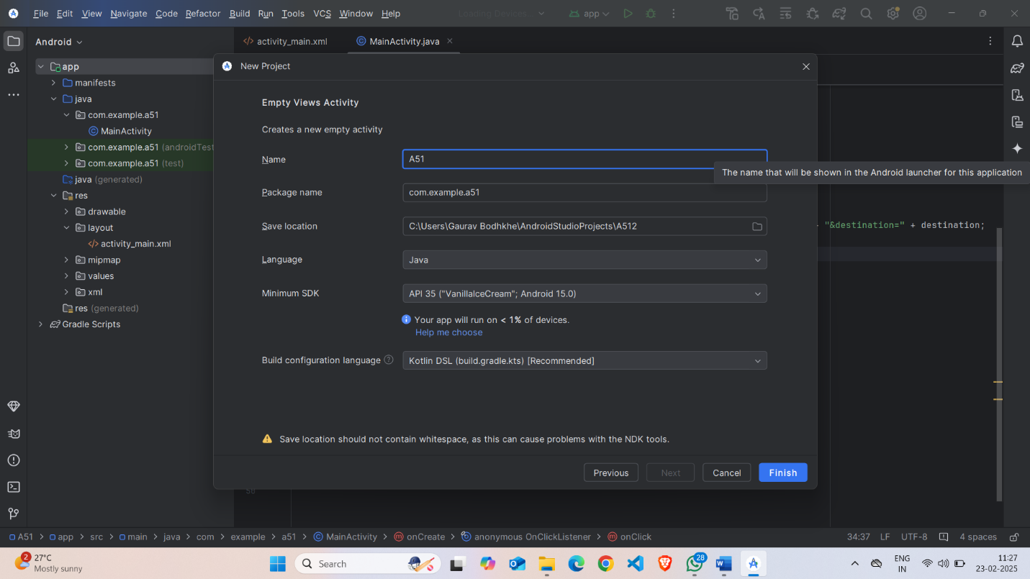

Step 2: Designing the UI
- Open activity_main.xml and design the layout using XML.
- Add UI components such as EditText, EditText, Button, etc.
Screenshot:
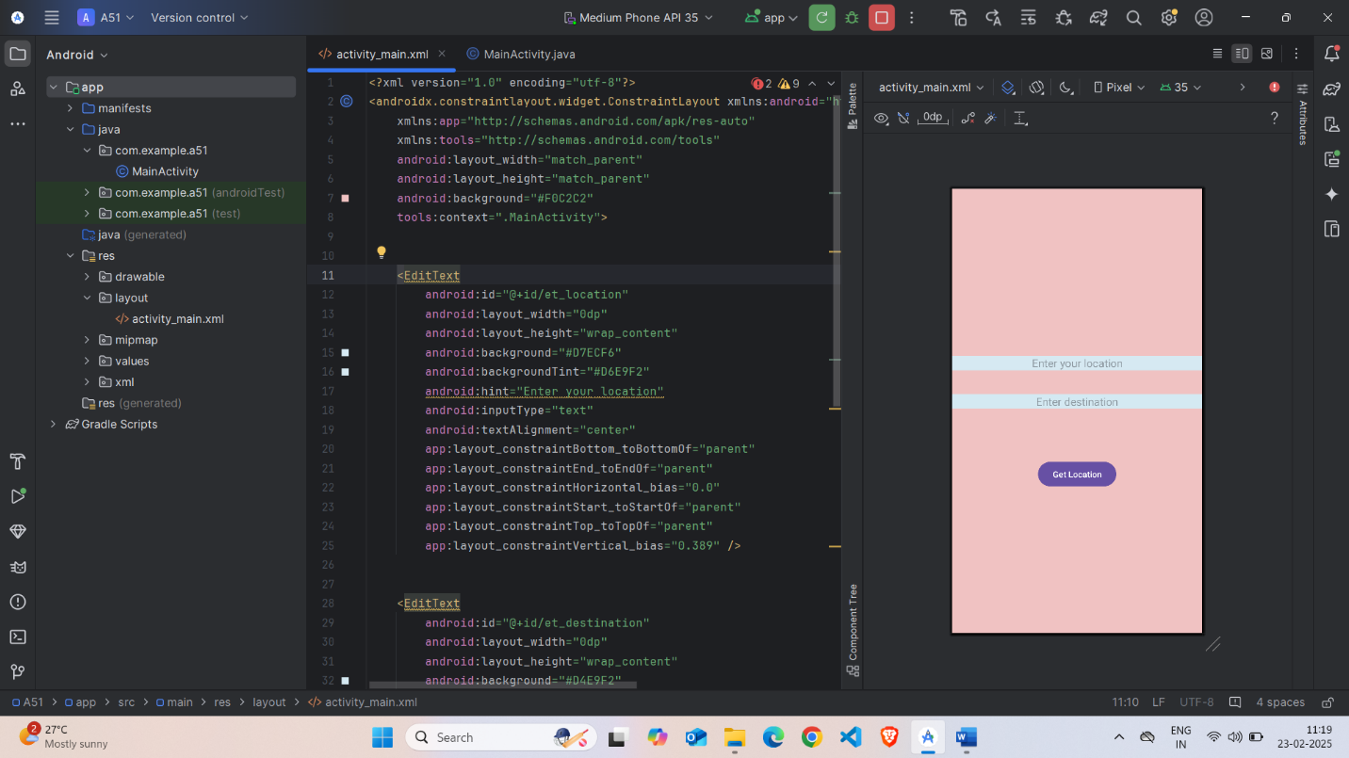

Step 3: Writing the Code
- Open Activity_main.xml
- Implement functionality such as Enter Your Location, Enter Destination, Get Direction.
- Use necessary Android components like Textviews, Edittext, Buttons, etc
- Screenshot:

- XML

<?xml version="1.0" encoding="utf-8"?>

<androidx.constraintlayout.widget.ConstraintLayout xmlns:android="http://schemas.android.com/apk/res/android"

xmlns:app="http://schemas.android.com/apk/res-auto"

xmlns:tools="http://schemas.android.com/tools"

android:layout_width="match_parent"

android:layout_height="match_parent"

android:background="#F0C2C2"

tools:context=".MainActivity">

<EditText

android:id="@+id/et_location"

android:layout_width="0dp"

android:layout_height="wrap_content"

android:background="#D7ECF6"

android:backgroundTint="#D6E9F2"

android:hint="Enter your location"

android:inputType="text"

android:textAlignment="center"

app:layout_constraintBottom_toBottomOf="parent"

app:layout_constraintEnd_toEndOf="parent"

app:layout_constraintHorizontal_bias="0.0"

app:layout_constraintStart_toStartOf="parent"

app:layout_constraintTop_toTopOf="parent"

app:layout_constraintVertical_bias="0.389" />

<EditText

android:id="@+id/et_destination"

android:layout_width="0dp"

android:layout_height="wrap_content"

android:background="#D4E9F2"

android:hint="Enter destination"

android:inputType="text"

android:textAlignment="center"

app:layout_constraintBottom_toBottomOf="parent"

app:layout_constraintEnd_toEndOf="parent"

app:layout_constraintHorizontal_bias="0.0"

app:layout_constraintStart_toStartOf="parent"

app:layout_constraintTop_toTopOf="parent"

app:layout_constraintVertical_bias="0.478" />

<Button

android:id="@+id/btn_get_location"

android:layout_width="wrap_content"

android:layout_height="wrap_content"

android:text="Get Location"

app:layout_constraintBottom_toBottomOf="parent"

app:layout_constraintEnd_toEndOf="parent"

app:layout_constraintStart_toStartOf="parent"

app:layout_constraintTop_toTopOf="parent"

app:layout_constraintVertical_bias="0.653" />

</androidx.constraintlayout.widget.ConstraintLayout>

Step 4: Writing the Backend Code (java)
- Open MainActivity.java
- Implement functionality such as By Click on Get direction the Google Map is get open and they shows the direction as getting input of Current Location and destination.

Screenshot:
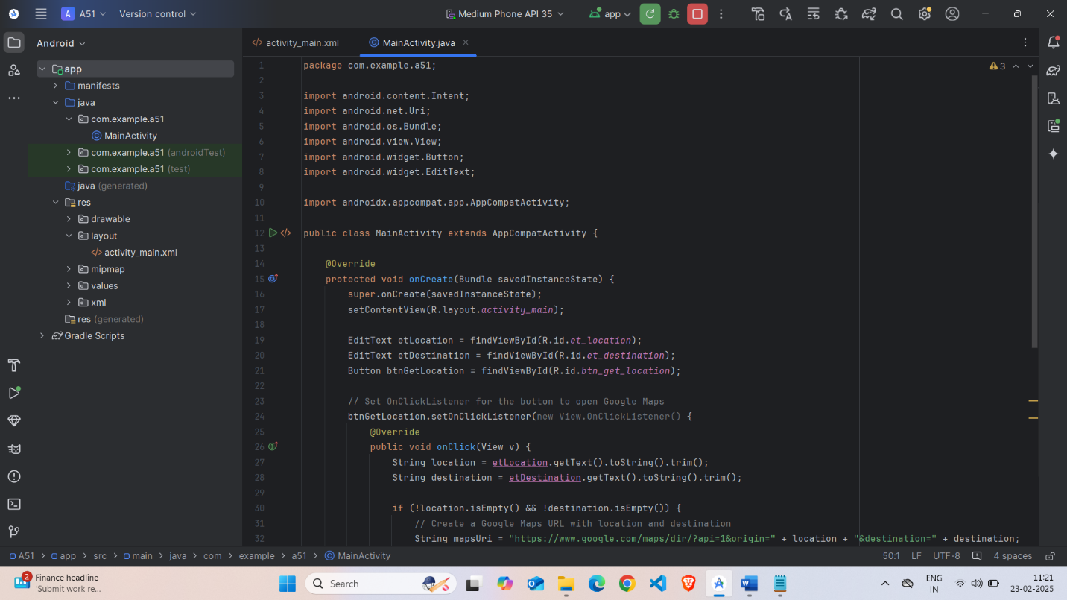

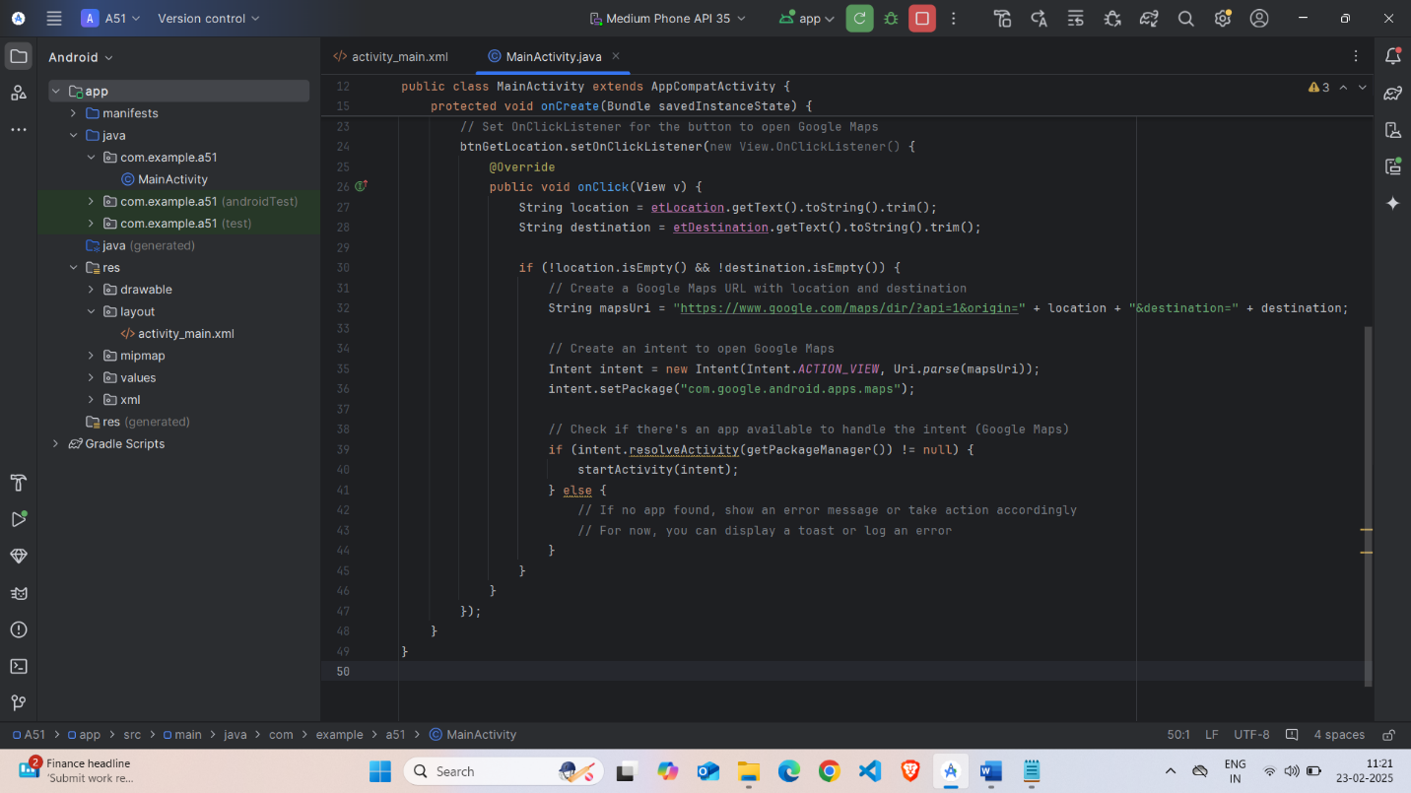

Code(java):
package com.example.a51;

import android.content.Intent;
import android.net.Uri;
import android.os.Bundle;
import android.view.View;
import android.widget.Button;
import android.widget.EditText;

import androidx.appcompat.app.AppCompatActivity;

public class MainActivity extends AppCompatActivity {

@Override
protected void onCreate(Bundle savedInstanceState) {
super.onCreate(savedInstanceState);
setContentView(R.layout.activity_main);

EditText etLocation = findViewById(R.id.et_location);
EditText etDestination = findViewById(R.id.et_destination);
Button btnGetLocation = findViewById(R.id.btn_get_location);

// Set OnClickListener for the button to open Google Maps
btnGetLocation.setOnClickListener(new View.OnClickListener() {
@Override
public void onClick(View v) {
String location = etLocation.getText().toString().trim();
String destination = etDestination.getText().toString().trim();

if (!location.isEmpty() && !destination.isEmpty()) {
// Create a Google Maps URL with location and destination
String mapsUri = "https://www.google.com/maps/dir/?api=1&origin=" + location + "&destination=" + destination;

// Create an intent to open Google Maps
Intent intent = new Intent(Intent.ACTION_VIEW, Uri.parse(mapsUri));
intent.setPackage("com.google.android.apps.maps");

// Check if there's an app available to handle the intent (Google Maps)
if (intent.resolveActivity(getPackageManager()) != null) {
startActivity(intent);
} else {
// If no app found, show an error message or take action accordingly
// For now, you can display a toast or log an error
}
}
}
});
}
}

Step 5: Running the Application on Emulator
- Click on the Run button in Android Studio.
- Select the emulator and launch the app.
Screenshot:
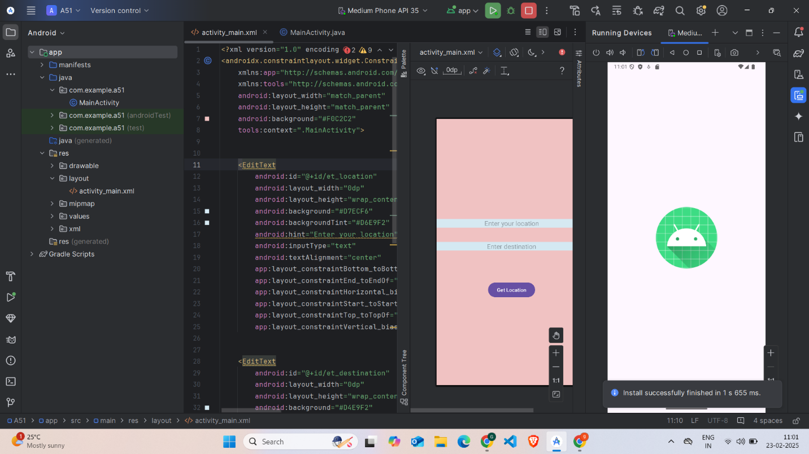

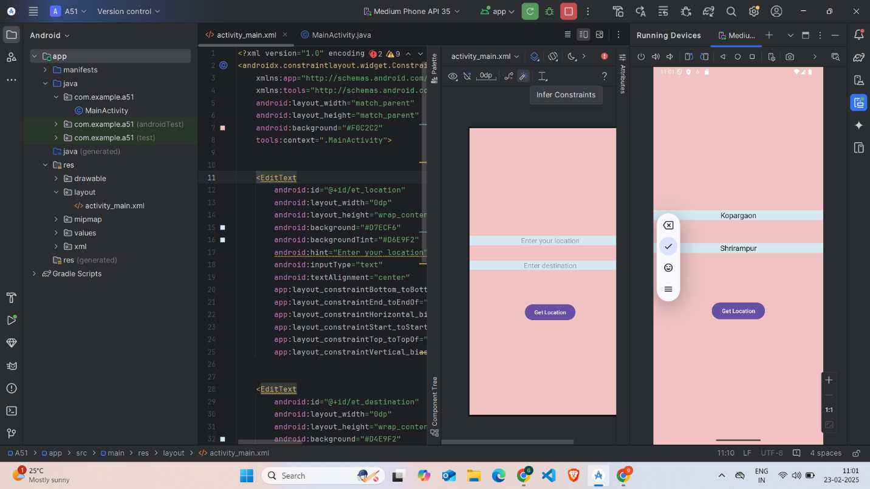

Step 6: Testing & Output
- Test different functionalities of the app.
- Capture the output results.
- Screenshot:

After clicking on Get Direction=
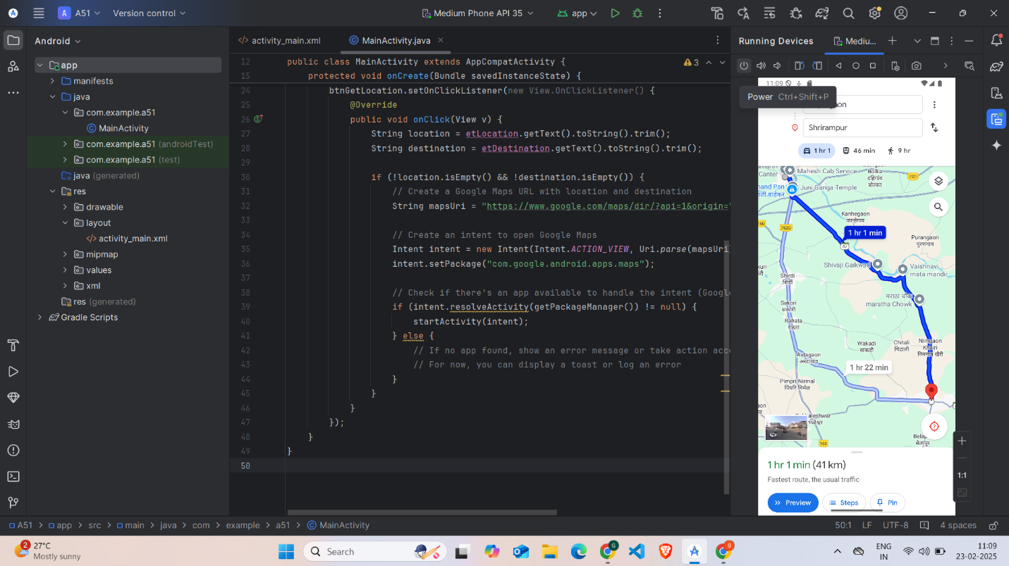

4. Conclusion

I successfully developed a simple Android app that utilizes Google Maps for navigation. Through this project, I gained hands-on experience with integrating Google Maps into an Android application. I learned how to design an intuitive interface that accepts user input for current location and destination, and then displays the route on Google Maps.

One challenge I encountered was handling location permissions and ensuring accurate location data. However, I overcame these obstacles by researching Android documentation and implementing the necessary code changes.

This project enhanced my skills in Android development, particularly in integrating third-party services like Google Maps. I also improved my problem-solving abilities, debugging skills, and understanding of Android permissions. Overall, this experience has boosted my confidence in building more complex Android apps.

