ASSIGNMENT NO.7

Gaurav_bodkhe_2124UCEM1041

1. Introduction

In this program, we will develop a simple video player application that plays a pre-selected video file. The app will feature a user-friendly interface with Play, Pause, Forward, and Rewind buttons to control video playback. The video player will automatically load and play the designated video, allowing users to control the playback experience using the provided controls. This project demonstrates how to build a basic video player application with a fixed video source, providing a straightforward way to display video content.

2. Tools & Technologies Used
- Android Studio
- Java
- Emulator

3. Procedure & Steps

Step 1: Create a New Project
- Open Android Studio and create a new project.
- Choose an Empty Views Activity template.
- Set the project name and package name of your Application
- Select the programming language (Java).
Screenshot:

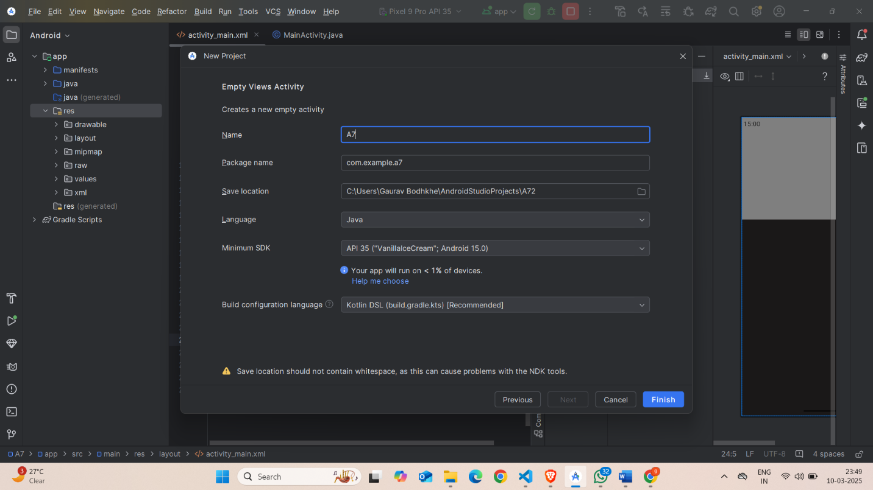

Step 2: Designing the UI
- Open activity_main.xml and design the layout using XML.
- Add UI components such as LinearLayout, VideoView etc.
Screenshot:
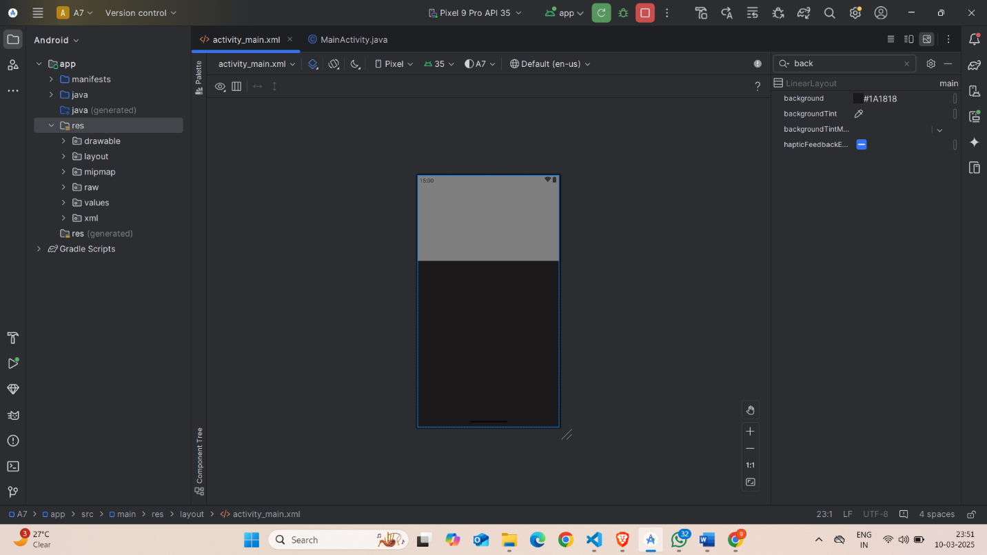

Step 3: Writing the Code
- Open Activity_main.xml
- Implement functionality such as. LinearLayout, VideoView etc.
- Use necessary Android components like LinearLayout, VideoView etc
- Screenshot:

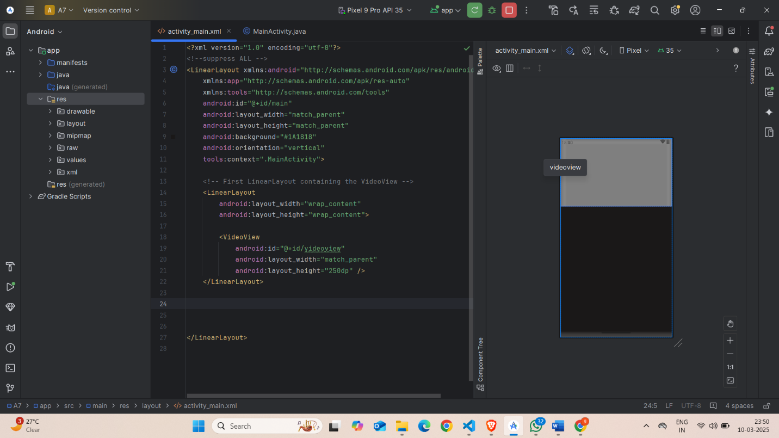

- XML
<?xml version="1.0" encoding="utf-8"?>
<!--suppress ALL -->
<LinearLayout xmlns:android="http://schemas.android.com/apk/res/android"
xmlns:app="http://schemas.android.com/apk/res-auto"
xmlns:tools="http://schemas.android.com/tools"
android:id="@+id/main"
android:layout_width="match_parent"
android:layout_height="match_parent"
android:background="#1A1818"
android:orientation="vertical"
tools:context=".MainActivity">
<!-- First LinearLayout containing the VideoView -->
<LinearLayout
android:layout_width="wrap_content"
android:layout_height="wrap_content">
<VideoView
android:id="@+id/videoview"
android:layout_width="match_parent"
android:layout_height="250dp" />
</LinearLayout>
</LinearLayout>

Step 4: Writing the Backend Code (java)
- Open MainActivity.java
- Implement functionality such as By Click on Play the Song is Get Start , when Click on The Forward the Video is get Forworded by some time(10 sec) Whereas On Click the Rewind the song is get Rewind by Some Time(10 sec) And when clicking on pause they get Pause.

Screenshot:

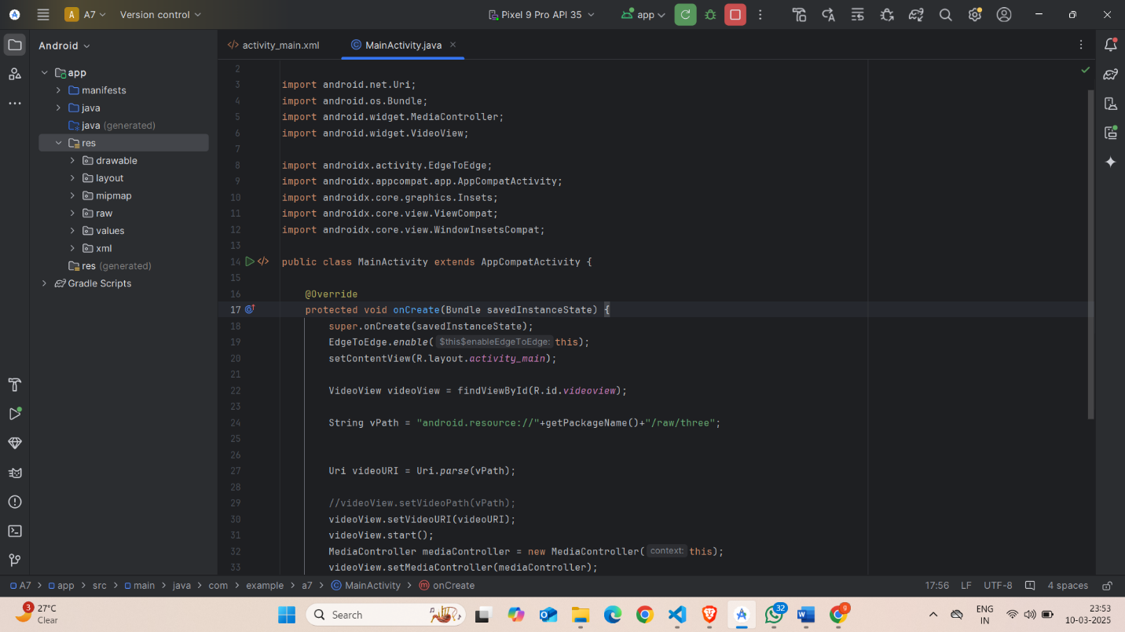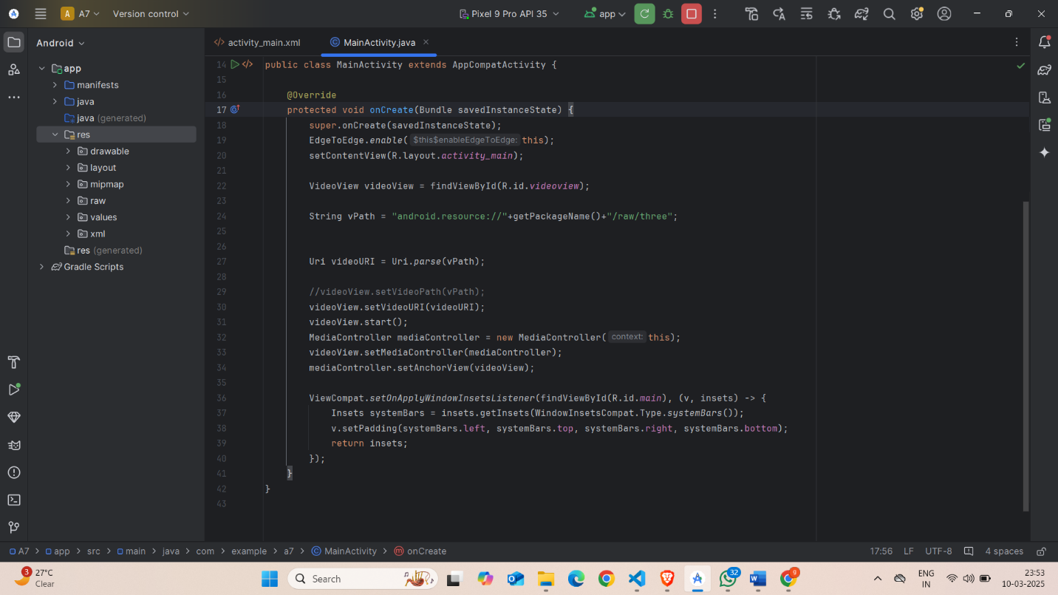

Code(java):
package com.example.a7;
import android.net.Uri;
import android.os.Bundle;
import android.widget.MediaController;
import android.widget.VideoView;
import androidx.activity.EdgeToEdge;
import androidx.appcompat.app.AppCompatActivity;
import androidx.core.graphics.Insets;
import androidx.core.view.ViewCompat;
import androidx.core.view.WindowInsetsCompat;
public class MainActivity extends AppCompatActivity {
@Override
protected void onCreate(Bundle savedInstanceState) {
super.onCreate(savedInstanceState);
EdgeToEdge.enable(this);
setContentView(R.layout.activity_main);
VideoView videoView = findViewById(R.id.videoview);
String vPath = "android.resource://"+getPackageName()+"/raw/three";
Uri videoURI = Uri.parse(vPath);
//videoView.setVideoPath(vPath);
videoView.setVideoURI(videoURI);
videoView.start();
MediaController mediaController = new MediaController(this);
videoView.setMediaController(mediaController);
mediaController.setAnchorView(videoView);
ViewCompat.setOnApplyWindowInsetsListener(findViewById(R.id.main), (v, insets) -> {
Insets systemBars = insets.getInsets(WindowInsetsCompat.Type.systemBars());
v.setPadding(systemBars.left, systemBars.top, systemBars.right, systemBars.bottom);
return insets;
});
}
}

Step 5: Adding an Video
- Right click on the Res file present in the app folder after that create an Another Android Resource directory name as raw
- In that raw file put an mp4 Video and give the Address in MainActivity.java Folder
Screenshot:

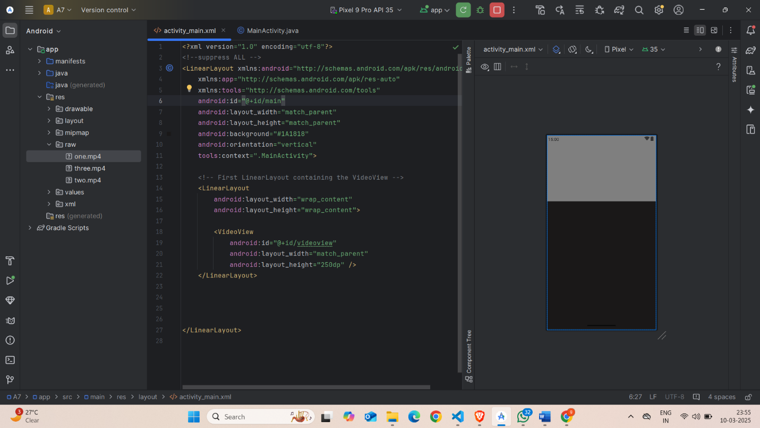

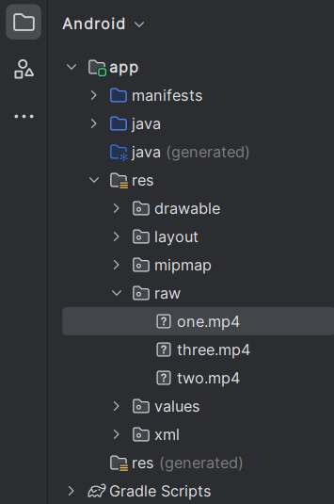

Step 6: Running the Application on Emulator
- Click on the Run button in Android Studio.
- Select the emulator and launch the app.
Screenshot:

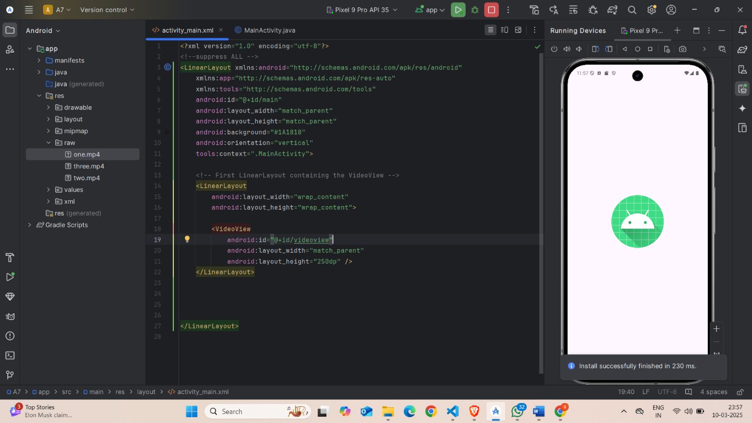

Step 6: Testing & Output
- Test different functionalities of the app.
- Capture the output results.

Screenshot:
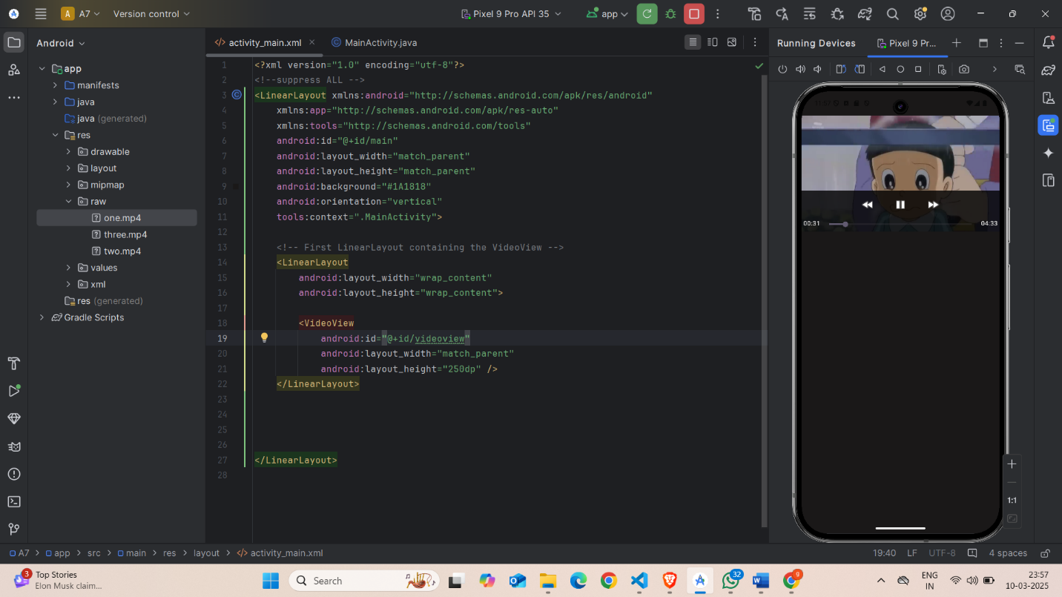
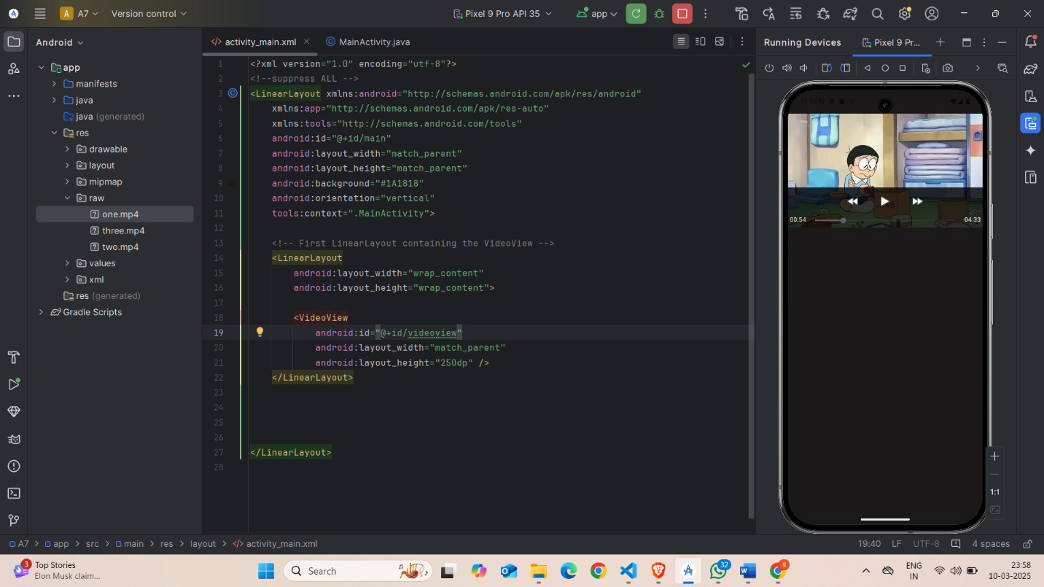

4. Conclusion

In this assignment, I successfully developed an Android app that plays Video files with basic control functionalities such as Play, Pause, Forward and Rewind. I learned how to handle media playback in Android using the Video Player class and how to manage different Video files stored in the res/raw directory.

During development, I encountered challenges related to managing media resources and ensuring smooth Video playback, but I overcame them by researching relevant documentation and experimenting with various methods. This project improved my understanding of Android media handling and user interface design.

Overall, this assignment was a valuable experience that enhanced my skills in Android development and helped me understand how to implement a simple media player in a mobile application.

