ASSIGNMENT NO.9
SHUBHAM_SONAWANE_2124UCSM1086
Introduction
An SMS sending program is a software application designed to enable users to send text messages directly from their mobile devices. It serves as a simple yet essential tool for communication, allowing users to input a phone number and message, and send the SMS with the click of a button. In this project, we will create an app that allows users to enter a recipient's phone number and compose a message, then click a "Send" button to deliver the SMS. The program will incorporate a user-friendly interface with fields for the phone number and message, along with a button to trigger the sending of the SMS. This functionality provides users with a convenient way to send text messages, utilizing the built-in telephony services of the Android platform.

Tools & Technologies Used
- Android Studio
- Java
- Emulator

Procedure & Steps

Step 1: Create a New Project
- Open Android Studio and create a new project.
- Choose an Empty Views Activity template.
- Set the project name and package name of your Application ● Select the programming language (Java).
Screenshot:
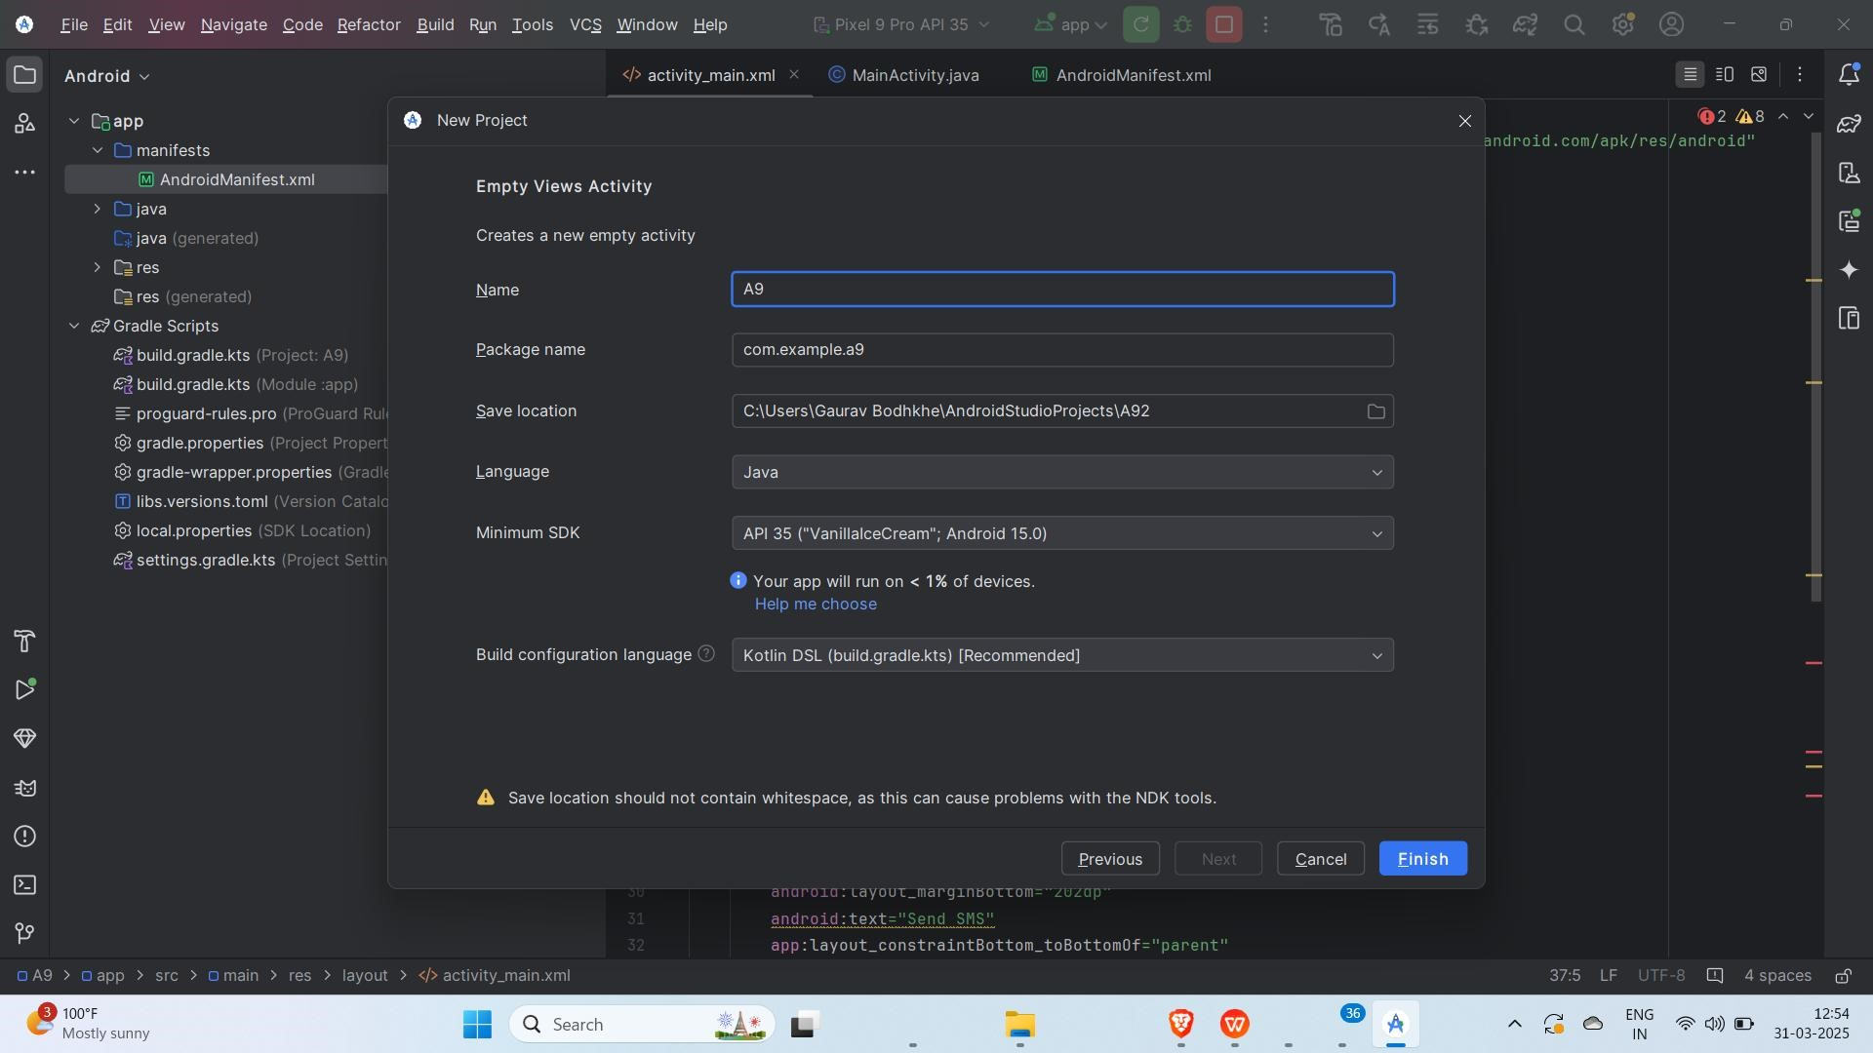

Step 2: Designing the UI
● Open activity_main.xml and design the layout using XML.
Add UI components such as EditText for phone number and message, and a Button to send the SMS
Screenshot:
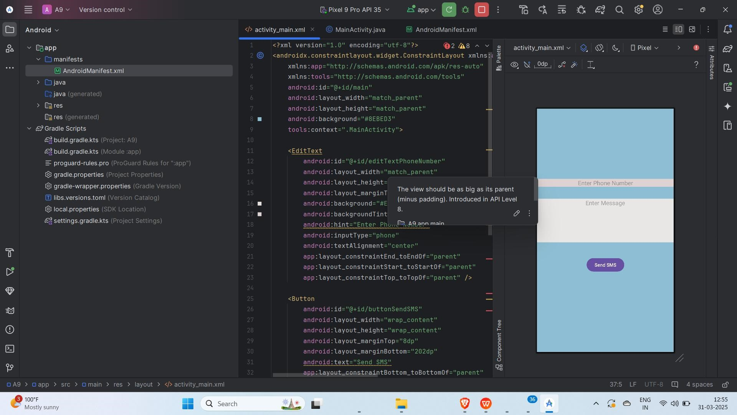

Step 3: Writing the Code
- Open Activity_main.xml
- Implement functionality such as Button,Textview. ● Use necessary Android components like Buttons,textview etc
- Screenshot:

- XML
<?xml version="1.0" encoding="utf-8"?>
<androidx.constraintlayout.widget.ConstraintLayout xmlns:android="http://schemas.android.com/apk/res/android" xmlns:app="http://schemas.android.com/apk/res-auto" xmlns:tools="http://schemas.android.com/tools" android:id="@+id/main" android:layout_width="match_parent" android:layout_height="match_parent" android:background="#8EBED3" tools:context=".MainActivity">
<EditText
android:id="@+id/editTextPhoneNumber" android:layout_width="match_parent" android:layout_height="wrap_content" android:layout_marginTop="211dp" android:background="#E7DDDD" android:backgroundTint="#DED2D2" android:hint="Enter Phone Number" android:inputType="phone" android:textAlignment="center" app:layout_constraintEnd_toEndOf="parent" app:layout_constraintStart_toStartOf="parent" app:layout_constraintTop_toTopOf="parent" />
<Button android:id="@+id/buttonSendSMS" android:layout_width="wrap_content" android:layout_height="wrap_content" android:layout_marginTop="8dp" android:layout_marginBottom="202dp" android:text="Send SMS" app:layout_constraintBottom_toBottomOf="parent" app:layout_constraintEnd_toEndOf="parent" app:layout_constraintStart_toStartOf="parent" app:layout_constraintTop_toBottomOf="@+id/editTextMessage" /> <EditText android:id="@+id/editTextMessage" android:layout_width="411dp" android:layout_height="131dp" android:background="#E9E6E6" android:ems="10" android:gravity="start|top" android:hint="Enter Message" android:inputType="textMultiLine" android:textAlignment="center" app:layout_constraintBottom_toTopOf="@+id/buttonSendSMS" app:layout_constraintTop_toBottomOf="@+id/editTextPhoneNumber" tools:layout_editor_absoluteX="0dp" />
</androidx.constraintlayout.widget.ConstraintLayout>

Step 4: Writing the Backend Code (java)
- Open MainActivity.java
- Implement Futionalities like When we give the Input of Mobile number As well as the message it will be get Delivered to that phone Number when Click on “Send SMS” .
Screenshot:
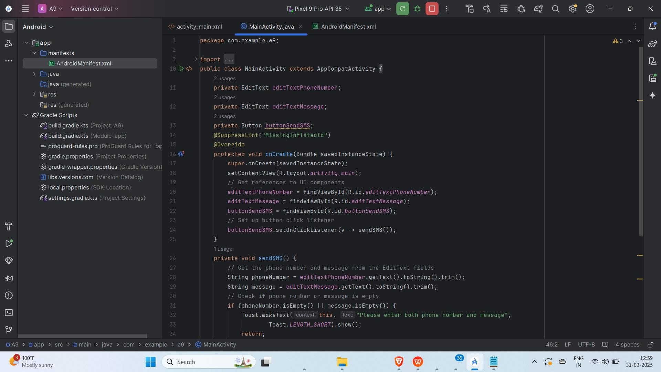
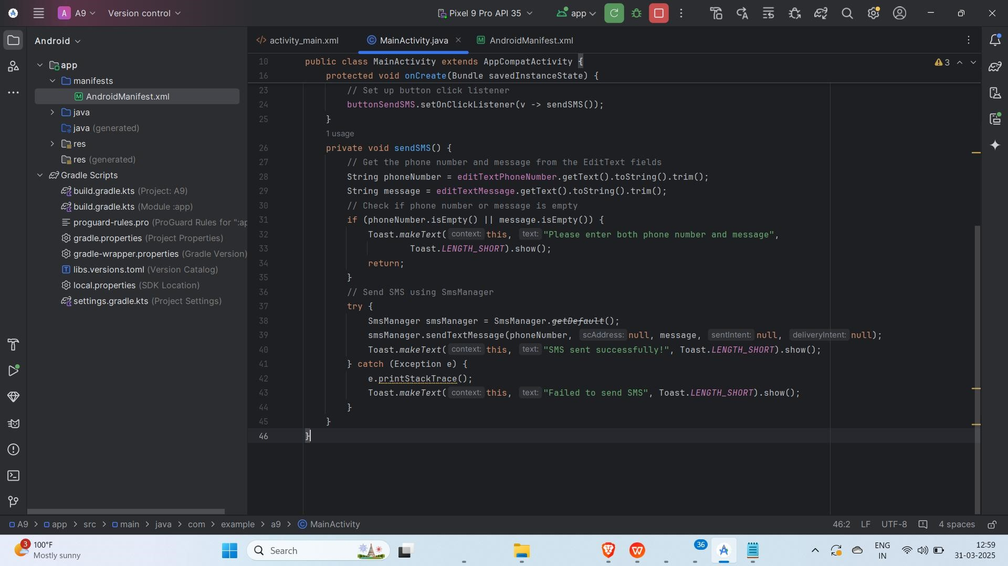
Code(java):
package com.example.a9; import android.annotation.SuppressLint; import android.os.Bundle; import android.telephony.SmsManager; import android.widget.Button; import android.widget.EditText; import android.widget.Toast; import androidx.appcompat.app.AppCompatActivity; public class MainActivity extends AppCompatActivity { private EditText editTextPhoneNumber; private EditText editTextMessage; private Button buttonSendSMS;
@SuppressLint("MissingInflatedId")
@Override protected void onCreate(Bundle savedInstanceState) { super.onCreate(savedInstanceState); setContentView(R.layout.activity_main); // Get references to UI components editTextPhoneNumber = findViewById(R.id.editTextPhoneNumber); editTextMessage = findViewById(R.id.editTextMessage); buttonSendSMS = findViewById(R.id.buttonSendSMS);
// Set up button click listener buttonSendSMS.setOnClickListener(v -> sendSMS());
}
private void sendSMS() {
// Get the phone number and message from the EditText fields
String phoneNumber = editTextPhoneNumber.getText().toString().trim();
String message = editTextMessage.getText().toString().trim();
// Check if phone number or message is empty if (phoneNumber.isEmpty() || message.isEmpty()) {
Toast.makeText(this, "Please enter both phone number and message",
Toast.LENGTH_SHORT).show();
return;
}
// Send SMS using SmsManager
try {
SmsManager smsManager = SmsManager.getDefault(); smsManager.sendTextMessage(phoneNumber, null, message, null, null);
Toast.makeText(this, "SMS sent successfully!", Toast.LENGTH_SHORT).show();
} catch (Exception e) {
e.printStackTrace();
Toast.makeText(this, "Failed to send SMS", Toast.LENGTH_SHORT).show();
}
}
}

Step 5: Taking Permission To open the Camera
- Open AndroidManifest.xml
- Write the code for the Giving Permission to Sending the SMS Screenshot:
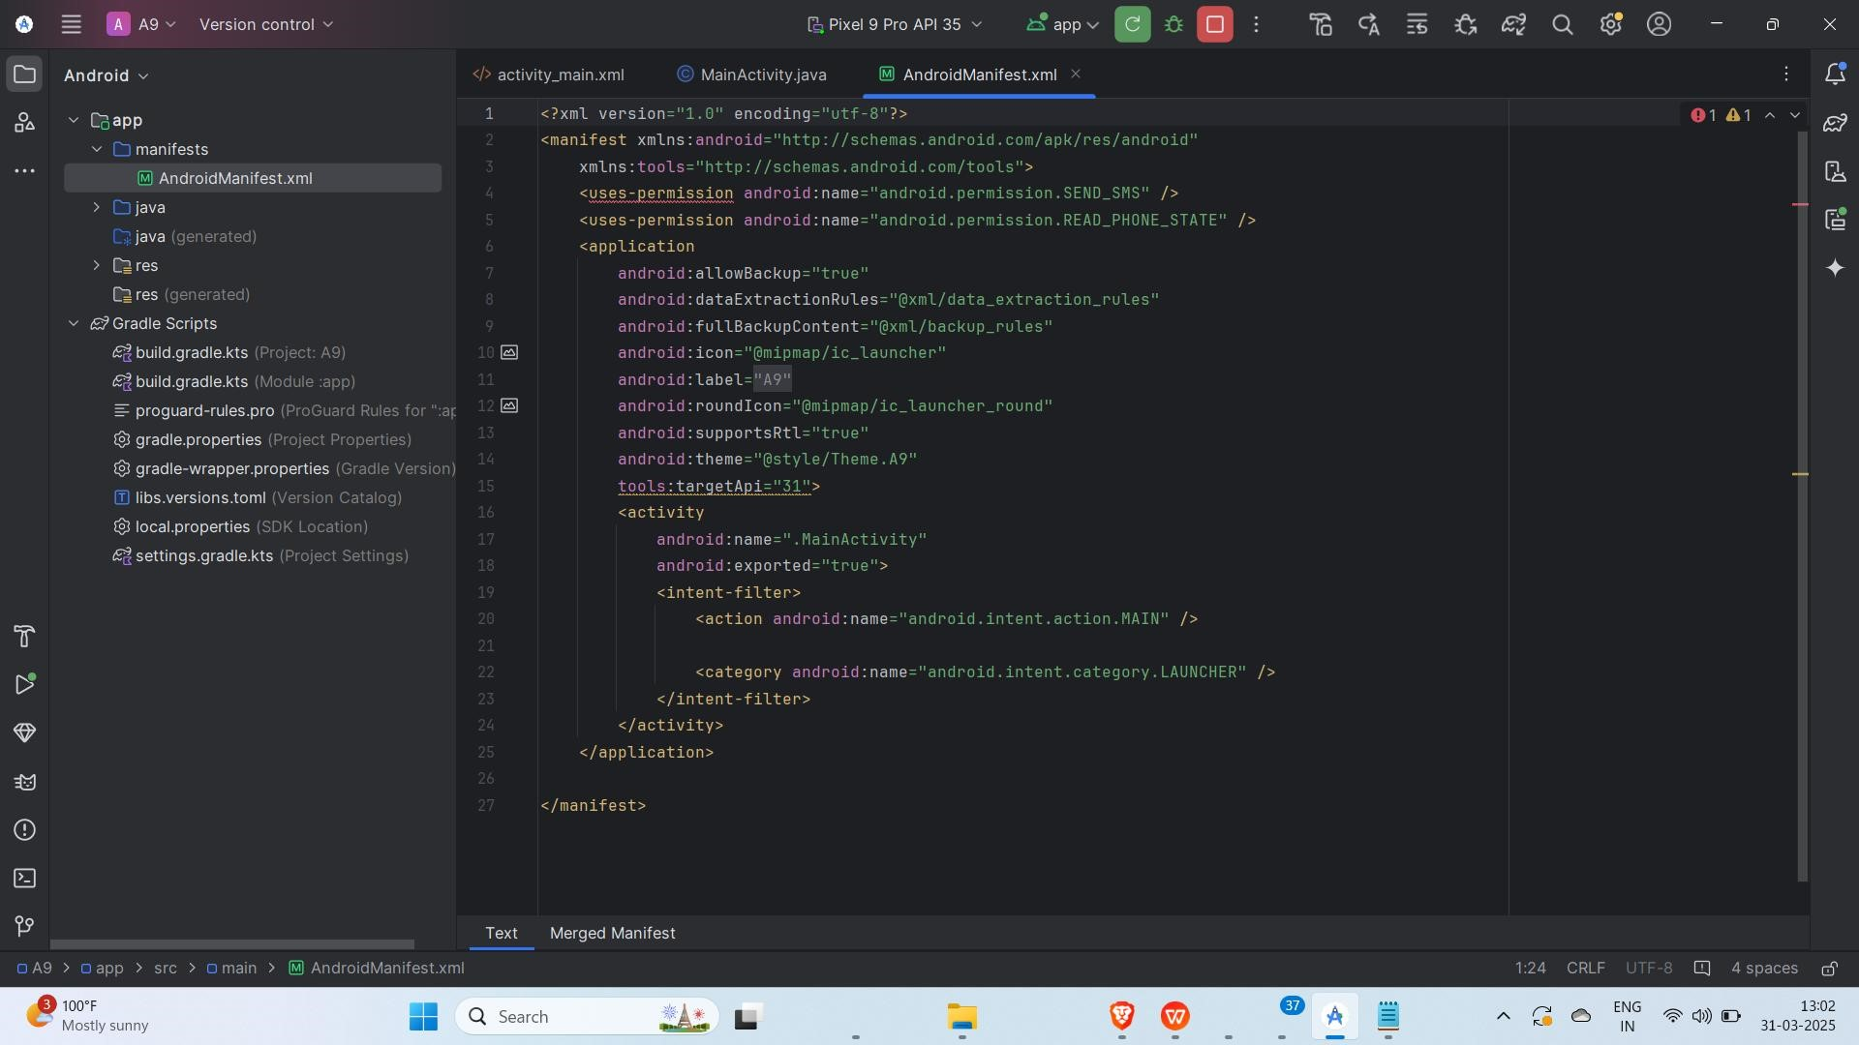
Code:
<?xml version="1.0" encoding="utf-8"?>
<manifest xmlns:android="http://schemas.android.com/apk/res/android" xmlns:tools="http://schemas.android.com/tools">
<uses-permission android:name="android.permission.SEND_SMS" />
<uses-permission android:name="android.permission.READ_PHONE_STATE" />
<application android:allowBackup="true" android:dataExtractionRules="@xml/data_extraction_rules" android:fullBackupContent="@xml/backup_rules" android:icon="@mipmap/ic_launcher" android:label="@string/app_name" android:roundIcon="@mipmap/ic_launcher_round" android:supportsRtl="true" android:theme="@style/Theme.A9" tools:targetApi="31">
<activity android:name=".MainActivity" android:exported="true">
<intent-filter>
<action android:name="android.intent.action.MAIN" />
<category android:name="android.intent.category.LAUNCHER" />
</intent-filter>
</activity>
</application>
</manifest>

Step 6: Running the Application on Emulator
● Click on the Run button in Android Studio. ● Select the emulator and launch the app.
Screenshot:
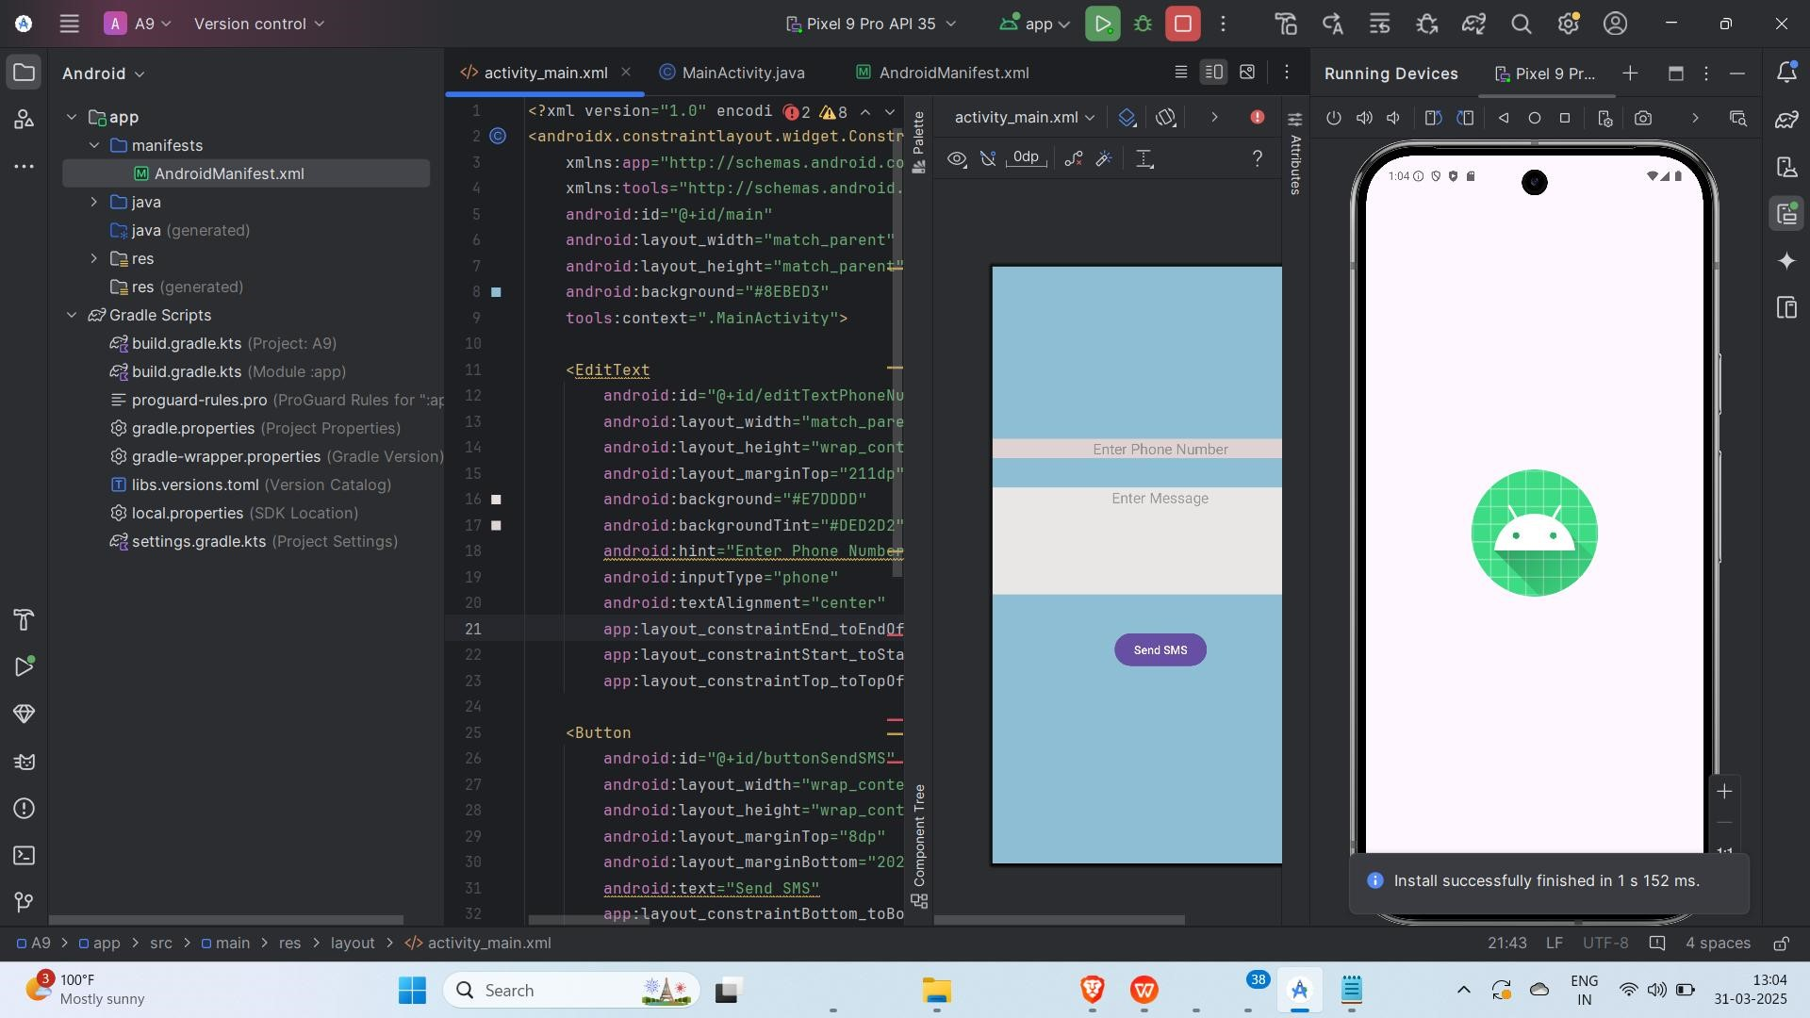

Step 6: Testing & Output
- Test different functionalities of the app.
- Giving Input of Mobile Number and SMS Message.
- Screenshot:


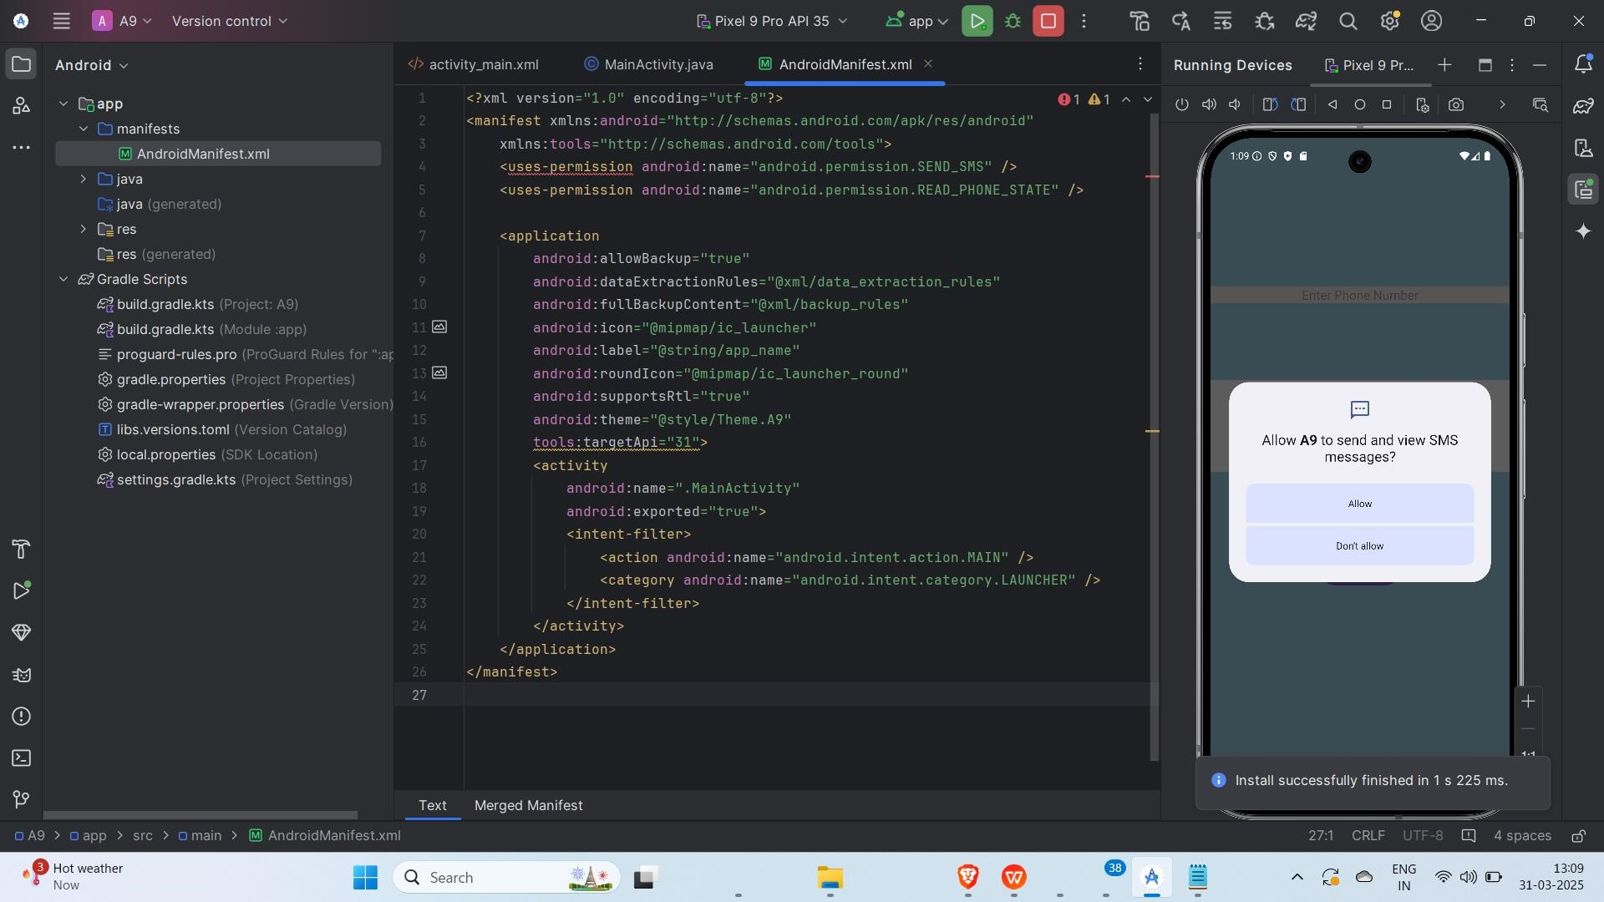

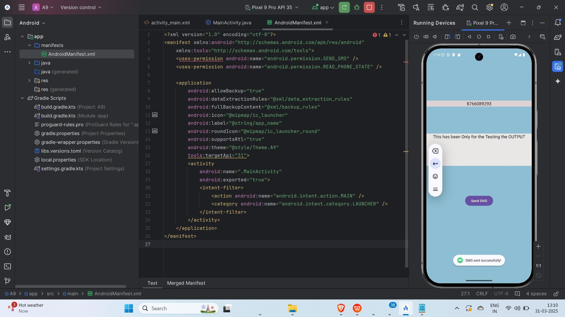

Conclusion
I successfully developed a simple Android app that allows users to send SMS messages. Through this project, I gained hands-on experience in implementing SMS functionality using
SmsManager in Android. I designed an intuitive interface where users can enter a phone number and message, then send it with a single click.
One challenge I encountered was handling SMS permissions, especially for newer Android versions that require runtime permission requests. However, I overcame this by studying Android documentation and implementing the necessary permission-handling logic.
This project enhanced my Android development skills, particularly in working with system services like SMS. I also improved my understanding of Android permissions, UI design, and debugging. Overall, this experience has increased my confidence in building more functional and user-friendly Android application.

