Outlook Draft Bot — Beginner Workbook
How to run, customize, and operate the deterministic (no-LLM) drafting workflow
Generated: 2026-02-24 13:52

High-level workflow
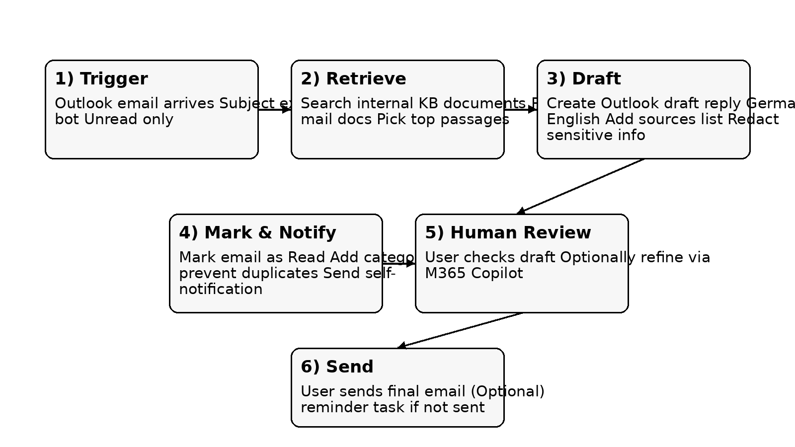

1. What this project does
- The project watches a specific Outlook folder for emails that match a strict trigger condition (e.g., subject exactly “bot”).
- When triggered, it searches a local Knowledge Base (KB) folder of internal documents, extracts the most relevant passages, and creates a reply as an Outlook draft.
- It marks the original email as read and assigns a category to avoid duplicate drafting (especially when multiple users run the bot).
- It sends a self-notification that a draft exists and optionally creates an Outlook Task reminder (e.g., 2 days) to nudge you if the draft hasn’t been sent.

2. Core constraints and why they matter
- Windows-only: Outlook automation uses COM, which requires Outlook on Windows and a logged-in user session.
- Deterministic (no LLM): Works without external AI keys. It is safer/compliant but less “semantic” than an LLM.
- Document hygiene: The KB quality controls answer quality. If a relevant standard is missing from the KB folder, the bot cannot invent it.

3. Folder layout and files
- KB folder: contains authoritative documents (.docx/.pdf/.xlsx/.txt). Avoid mail threads here.
- Scripts (typical):
- • Main bot script: reads Outlook, searches KB, drafts replies.
- • Attachment collector: extracts PDFs/images from .msg files (optional).
- • PDF/image extraction: converts attachments into text or .docx for later KB ingestion (optional).

4. Environment setup (VS Code + Jupyter)
- Recommended: VS Code with the Python extension + Jupyter extension.
- Kernel: ensure the notebook kernel uses the same Python you installed packages into.
- If you see 'unrecognized arguments: --f=…kernel…json', you ran an argparse script inside a notebook. Use a notebook-safe version (no argparse) or run from terminal.
- Confirm your Python version and site-packages location before installing libraries.

5. Required libraries (and what they do)
- pywin32: Outlook COM automation (reading emails, creating drafts).
- python-docx: read/write .docx documents (KB ingestion or output exports).
- pdfplumber or pypdf: extract text from PDFs (KB ingestion).
- openpyxl: read .xlsx spreadsheets for KB ingestion.
- extract-msg: parse .msg files when collecting attachments.

6. What the bot considers a valid trigger
- Subject must match exactly: “bot” (case-insensitive). Prefixes like “RE: bot” are ignored.
- Email must be Unread (optional setting).
- Email must not already contain the processed category (duplicate-prevention).
- Limit scanning and processing per run: SCAN_LIMIT and PROCESS_PER_RUN prevent long runs.

7. Customization checklist (what you must change for your account)
- TARGET_MAILBOX: set to your mailbox / store identifier.
- WATCH_FOLDER_NAME: set to Inbox or a subfolder name.
- KB_DIR: set to your KB folder path.
- SELF_NOTIFY_TO: set to your mailbox if you want self-notifications.
- PROCESSED_CATEGORY: pick a unique category name your team agrees on.

8. Improving answer quality without LLMs
- Keep the KB authoritative: standards, policies, definitions, templates. Avoid conversational mail threads.
- Add definitions/glossary documents for common acronyms (e.g., PPA).
- De-prioritize mail-like docs: filenames starting with AW_, RE_, FW_, WG_ should be penalized in ranking.
- Chunking matters: split long documents into coherent paragraphs (the code usually does this automatically).
- If a question references a specific standard, make sure that standard name appears in the KB text (PDFs must be text-extractable).

9. Operating procedure (for a non-technical user)
- 1) Ensure Outlook is open and you are logged in.
- 2) Place/maintain the KB documents in the KB_DIR folder.
- 3) Send an email to the bot mailbox with subject exactly “bot” and your question in the top message.
- 4) Run the bot once (run_bot_once()).
- 5) Open Outlook Drafts, review the draft, and send manually.
- 6) If needed, use M365 Copilot 'Rewrite' or 'Translate' on the draft (manual step).

10. Scheduling (hourly / daily) and permissions
- Best option on Windows: Task Scheduler running under your user session (Outlook COM is most reliable when you are logged on).
- If you do not have permission for Task Scheduler in your corporate environment, run the bot manually once per day.
- Power Automate cloud flows cannot reliably drive local Outlook COM. Power Automate Desktop can, but it depends on corporate policy and unattended-run permissions.

11. Troubleshooting quick guide
- No draft created: check trigger conditions (subject, unread, category).
- 401 Unauthorized: that is an Azure/OpenAI auth problem; use no-LLM mode or fix the corporate endpoint/key.
- Empty PDF text: the PDF is likely scanned. You need OCR (e.g., Tesseract) — if blocked, request an approved OCR tool.
- Path too long errors: shorten output folder names or enable long paths in Windows (policy-dependent).

12. Improvement plan (pragmatic roadmap)
- Phase 1: Clean KB; add a definitions/glossary doc for common acronyms; reduce mail-thread noise.
- Phase 2: Add attachment ingestion pipeline (collect PDFs/images from .msg, convert, then curate into KB).
- Phase 3: Optional: approved translation service (Azure Translator) or internal Copilot workflow for DE/EN.
- Phase 4: Optional: approved internal LLM endpoint with strict grounding + citations + redaction.

YouTube / learning resources (search terms)
- VS Code Jupyter: select Python interpreter and kernel
- Windows Task Scheduler: run Python script every hour
- pywin32 Outlook COM automation tutorial
- pdfplumber extract text from PDF python
- python-docx write tables and headings
- extract-msg parse .msg attachments python

Where to change your personal details
Setting | What it controls | Example value
TARGET_MAILBOX | Which Outlook mailbox/store is targeted | firstname.lastname@company.com
WATCH_FOLDER_NAME | Which folder to watch | Inbox or 'BotRequests'
KB_DIR | Where KB documents live | C:\...\Project Chatbot\KB
SELF_NOTIFY_TO | Where to notify after draft creation | your mailbox address
PROCESSED_CATEGORY | Duplicate-prevention label | Drafted-NoLLM-TeamX

