Report
Of
Java Full Stack Developer Virtual Internship
Submitted
To
School of Computer Science and Engineering
IILM University, Greater Noida, U.P.
In partial fulfilment of the requirement of degree of
B.Tech CSE

By
Roll Number of Student: 2410031595
Name of Student: SHUBHAM KUMAR
Batch: 2026-27

CANDIDATE'S DECLARATION
I, SHUBHAM KUMAR, do hereby declare that the internship report titled “Java Full Stack Developer Virtual Internship” has been completed by me to fulfil the requirement for the award of the degree of Bachelor of Technology in CSE. All the references have been quoted and I have not taken as such any material from any other source. I affirm to you that this report is my own and has not been submitted to any other institute for any degree/diploma requirement and further I shall be solely responsible for any kind of copyright violation in this regard.

Signature
Student Name: SHUBHAM KUMAR
Roll No.: 2410031595
ACKNOWLEDGEMENT
I am using this opportunity to express my gratitude to everyone who supported me throughout the Internship Program. I am thankful for their aspiring guidance, invaluably constructive criticism and friendly advice during this work. I am sincerely grateful to AICTE, the Ministry of Education's National Internship Portal, and EduSkills Academy for organising and supporting this virtual internship, and to my faculty at IILM University for their continued encouragement.
I express my gratitude to my parents for their blessings.

Signature
Student Name: SHUBHAM KUMAR
Roll No.: 2410031595
TABLE OF CONTENTS
Chapter No. | Chapter Name | Page Nos.
 | Cover Page | ---
1. | Candidate's Declaration | i
2. | Acknowledgment | ii
3. | Internship Completion Certificate | iii
4. | Project Description  4.1 Introduction  4.2 Organization Profile  4.3 Problem Statement  4.4 Project Objectives  4.5 Scope of the Project  4.6 Technologies and Tools Used  4.7 System Architecture  4.8 Methodology  4.9 Expected Outcomes  4.10 Certificate of Completion | 1 onwards
5. | Bibliography/References | Last
CHAPTER 3: INTERNSHIP COMPLETION CERTIFICATE
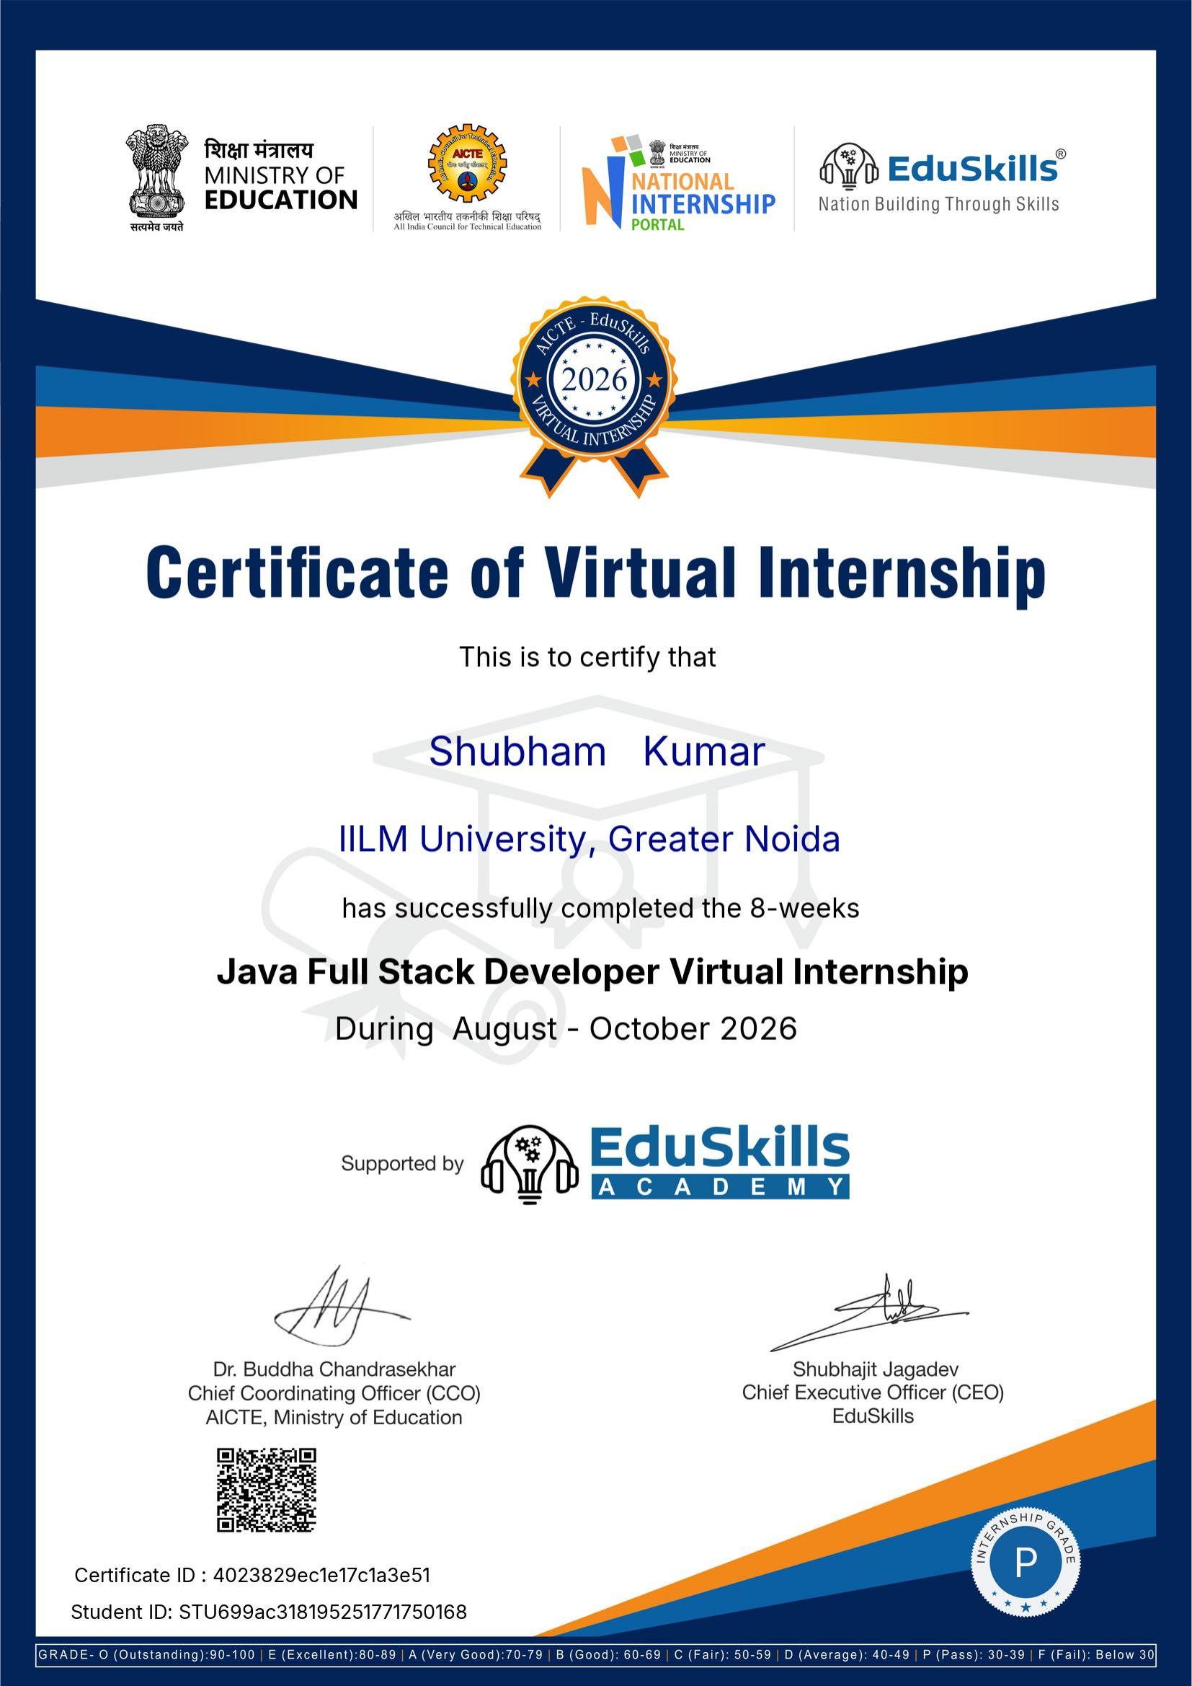

CHAPTER 4: PROJECT DESCRIPTION
4.1 Introduction
This report presents the work undertaken during the Java Full Stack Developer Virtual Internship, an 8-week program organised under the National Internship Portal of the Ministry of Education, in partnership with AICTE and EduSkills Academy. The internship was designed to build practical, industry-relevant skills in full stack Java development, covering both front-end and back-end technologies, and was completed between August and October 2026, culminating in a Certificate of Virtual Internship awarded to Shubham Kumar of IILM University, Greater Noida.
4.2 Organization Profile
The internship was conducted under the aegis of the All India Council for Technical Education (AICTE), Ministry of Education, through its National Internship Portal, in association with EduSkills Academy — an organisation focused on “Nation Building Through Skills” by delivering industry-aligned virtual internship programs to engineering students across India. EduSkills partners with technology providers and academic institutions to design curricula that mirror real-world software development practices, giving students structured, mentor-guided exposure to in-demand technology stacks such as Java full stack development.
4.3 Problem Statement
Many engineering graduates enter the job market with strong theoretical knowledge but limited hands-on experience in building complete, end-to-end web applications. The Java Full Stack Developer Virtual Internship was structured to address this gap by guiding participants through the design and development of a full stack application — covering front-end interfaces, back-end logic, and database integration — using Java-based tools and frameworks, so that participants could bridge the divide between classroom learning and industry-ready development skills.
4.4 Project Objectives
- To gain practical, hands-on experience in developing full stack web applications using Java-based technologies.
- To understand and apply front-end fundamentals (HTML, CSS, JavaScript) alongside back-end development in Java.
- To learn how to design, connect, and query relational databases as part of a complete application stack.
- To build and deploy a working full stack project following industry-standard development practices.
- To develop problem-solving and debugging skills relevant to real-world software engineering roles.
4.5 Scope of the Project
The scope of the internship covered the core layers of full stack Java development: client-side interface design, server-side application logic, and persistent data storage. The program was delivered virtually over eight weeks with structured modules, assignments, and assessments, and was limited to the guided curriculum and sample projects provided under the internship; it did not involve deployment to live production systems or access to any organisation's proprietary codebase.
4.6 Technologies and Tools Used
- Java – core programming language for back-end application development.
- HTML, CSS, and JavaScript – for building responsive front-end user interfaces.
- Spring / Spring Boot framework – for building back-end REST APIs and business logic.
- Relational database (SQL) – for data modelling, storage, and querying.
- Integrated Development Environment (IDE) and version control – for writing, testing, and managing project code.
4.7 System Architecture
The application developed during the internship followed a standard three-tier full stack architecture: a presentation layer built with HTML, CSS, and JavaScript for the user interface; an application layer built in Java (using the Spring/Spring Boot framework) that handled business logic and exposed REST APIs; and a data layer using a relational database for persistent storage. The three layers communicated through well-defined API endpoints, following the client–server model commonly used in production-grade full stack applications.
4.8 Methodology
- Completed structured learning modules covering front-end basics, Java fundamentals, and full stack concepts.
- Designed the front-end interface using HTML, CSS, and JavaScript.
- Developed back-end services and REST APIs using Java and the Spring Boot framework.
- Designed the database schema and integrated it with the back-end application.
- Tested and debugged the application to ensure the front-end, back-end, and database layers worked together correctly.
- Submitted assignments and project work through the National Internship Portal for evaluation, leading to the award of the completion certificate.
4.9 Expected Outcomes
On completion of the internship, the following outcomes were achieved: a working understanding of full stack Java development across the front-end, back-end, and database layers; hands-on experience with the Spring/Spring Boot framework and REST API development; improved debugging and problem-solving skills applicable to real-world software projects; and a Certificate of Virtual Internship (Grade: P – Pass) jointly issued by AICTE, the Ministry of Education's National Internship Portal, and EduSkills Academy, validating the skills developed during the 8-week program.
4.10 Certificate of Completion and Other Communication
The Certificate of Virtual Internship issued jointly by AICTE (Ministry of Education) and EduSkills Academy, confirming successful completion of the 8-week Java Full Stack Developer Virtual Internship (August–October 2026), is attached in Chapter 3 of this report.
CHAPTER 5: BIBLIOGRAPHY/REFERENCES
AICTE, Ministry of Education. (2026). National Internship Portal. Retrieved from https://internship.aicte-india.org
EduSkills Academy. (2026). Java Full Stack Developer Virtual Internship – Program Overview. Retrieved from https://eduskillsfoundation.org
EduSkills Academy – AICTE. (2026). Certificate of Virtual Internship, issued to Shubham Kumar, IILM University, Greater Noida (Certificate ID: 4023829ec1e17c1a3e51).

