Detecting Pitcher Fatigue Using TrackMan Biomechanical Deviations from Baseline
By: Shubhan Tamhane

Abstract
This study examines pitcher fatigue in UConn Baseball using pitch-by-pitch TrackMan data collected across five games against Arizona and Arizona State in February 2025. Fatigue is operationalized as a systematic deviation from each pitcher's personalized early-game baseline across eight biomechanical features: velocity, spin rate, induced vertical break (IVB), effective velocity, horizontal break, plate height, plate side, and extension. For each pitcher-game combination, an ordinary least squares (OLS) regression was used to estimate the rate of velocity decline across a game. A composite fatigue score was also constructed by z-scoring and averaging five key deviation features. Additionally, two logistic regression models were evaluated to assess whether these deviation signals can predict pitch ineffectiveness. Results indicate that fatigue, as measured by velocity decline, worsens as the season progresses, and that extension deviation is the strongest biomechanical indicator of reduced effectiveness in the threshold-based classification model. These findings provide a repeatable framework for real-time fatigue monitoring applicable to pitching staff management.

Goal / Motivation
The primary goal of this project is to detect and quantify pitcher fatigue using objective, pitch-level data from the TrackMan tracking system. Managing starter and reliever workloads is one of the most important decisions a coach makes, and decisions are often based on subjective observation or simple pitch count thresholds. This analysis attempts to replace intuition with a data-driven framework and constructs a baseline for each pitcher segmented by pitch type.
By identifying which biomechanical features are most sensitive to fatigue, and which pitchers show the steepest performance degradation, the coaching staff can make better-informed decisions about when to pull starters, how to structure bullpen use, which pitchers may benefit from adjusted workloads, and alleviate injury concerns.

Data
Data were collected from TrackMan, the pitch-tracking system used by UConn Baseball, across five games in February 2026. The games included:
- February 17 — UConn vs. Arizona
- February 19 — UConn vs. Arizona
- February 20 — UConn vs. Arizona
- February 21 — UConn vs. Arizona
- February 22 — UConn vs. Arizona
In total, the dataset includes 1,702 pitches thrown by 33 unique pitchers across all five games. After filtering to pitchers with at least 10 fastballs per outing (for OLS modeling), 25 pitcher-game combinations were retained. The pitch type distribution across all games was as follows:

Pitch Type | Count
Fastball | 661
Slider | 339
ChangeUp | 239
Cutter | 208
Curveball | 129
Sinker | 99
Splitter | 27
Total | 1,702
Table 1: Pitch Type Frequency Across All Five Games
The TrackMan data included pitch-level variables such as release speed (RelSpeed), spin rate (SpinRate), induced vertical break (InducedVertBreak), effective velocity (EffectiveVelo), horizontal break (HorzBreak), plate location (PlateLocHeight, PlateLocSide), and extension. Pitch type was recorded using the TaggedPitchType field.

Methods

Personalized Baseline Construction
One key decision was to avoid comparing pitchers to each other or to a league average. Instead, each pitcher's early-game performance serves as their own baseline. For each pitcher-game-pitch type combination, the first 20% of pitches thrown in that outing were used to compute average values across all eight tracked features. These averages constitute the personalized baseline for each player.
Deviation features were then computed pitch-by-pitch by subtracting the baseline value from the observed value. For example, VeloDev = RelSpeed - BaselineVelo. A negative VeloDev indicates a pitch thrown below the pitcher's typical early-game velocity, which is the primary signal of interest for fatigue detection. This approach ensures that differences in natural pitcher ability are removed from the analysis, and only within-game degradation is measured.

OLS Velocity Slope Test
To quantify the rate of velocity decline within a game, an OLS linear regression was fit for each pitcher-game pair (restricted to fastballs only, with a minimum of 10 pitches). The model regressed VeloDev on within-game pitch count. The resulting slope coefficient captures the average change in velocity deviation per additional pitch thrown, serving as a pitcher-specific fatigue rate. A negative slope indicates velocity decline over the course of a game.

Composite Fatigue Score
To consolidate information across multiple biomechanical channels, a composite fatigue score was constructed using five deviation features: VeloDev, SpinDev, IVBDev, EffectiveVeloDev, and ExtensionDev. Each feature was z-scored across all pitches and games, then averaged. The sign was flipped (multiplied by -1) so that higher scores indicate greater fatigue. A pitch that deviates more from the pitcher's baseline in a direction consistent with less effectiveness is assigned a higher fatigue score.

Logistic Regression Models
Two logistic regression models were trained to assess whether the deviation features predict pitch ineffectiveness. In the outcome-based model, ineffectiveness was defined by the pitch receiving a BallCalled designation, representing a pitch that missed the strike zone. In the threshold-based model, ineffectiveness was defined as VeloDev < -1 mph, capturing pitches with meaningful velocity loss regardless of outcome. Both models were trained with balanced class weights to account for class imbalance and evaluated using a standard 80/20 train-test split.

Results

Figure 1: Velocity Deviation From Baseline (All Pitchers, 2/22)
The scatter plot of velocity deviation across all pitchers in the most recent game (February 22) shows substantial variability at lower pitch counts, with a general downward trend as pitch count increases. The binned average overlay (blue line) confirms a consistent negative drift: the average velocity deviation falls from near zero in the early portion of the game to approximately -1 to -2 mph by pitch 50-80. This aggregate pattern holds across pitchers, suggesting fatigue is a shared phenomenon rather than an outlier effect.
[Figure 1: Average Velocity Deviation by Pitch Count Bin (2/22)]
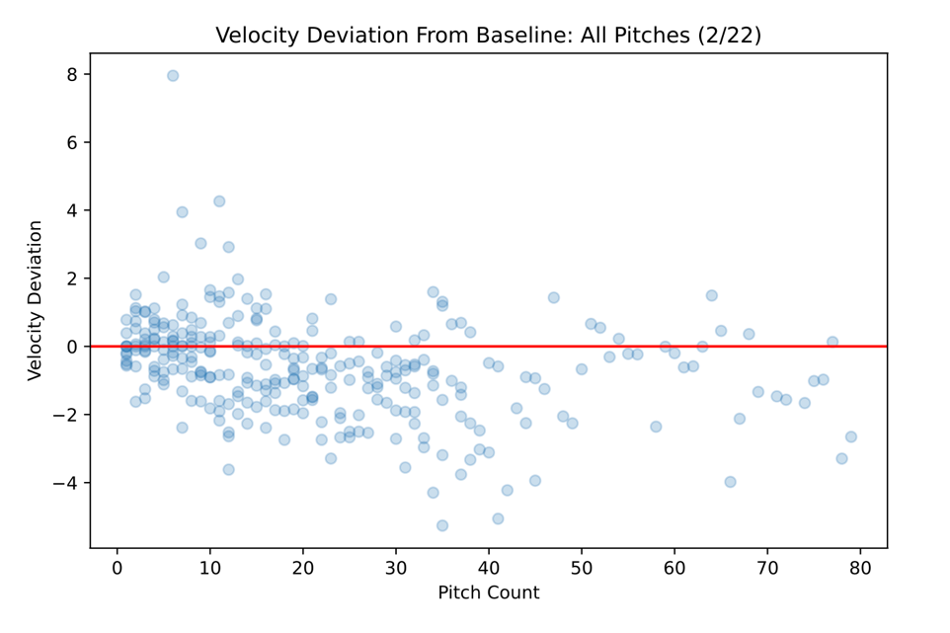

Case Study: Oliver Pudvar
Oliver Pudvar's outing from February 19 illustrates how individual pitcher profiles can be examined in detail. Across velocity, spin rate, IVB, horizontal break, and extension, his deviation profiles reveal a mixed pattern. Velocity deviation shows an early dip around pitch 4-5, followed by stabilization — consistent with a pitcher settling into his mechanics. Spin rate deviation declines substantially around pitch 10-12 before partially recovering. Horizontal break deviation rises markedly in the middle portion of his outing before falling late, while extension deviation shows an upward spike near pitch 15-17 followed by a sharp drop, suggesting mechanical inconsistency late in the outing.
[Figure 2: Fastball Velocity Deviation — Pudvar, Oliver (2/19)]
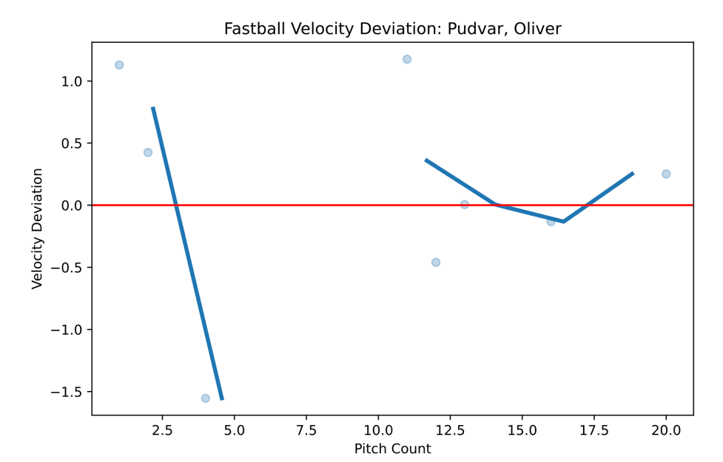
[Figure 3: Fastball Spin Rate Deviation — Pudvar, Oliver (2/19)]
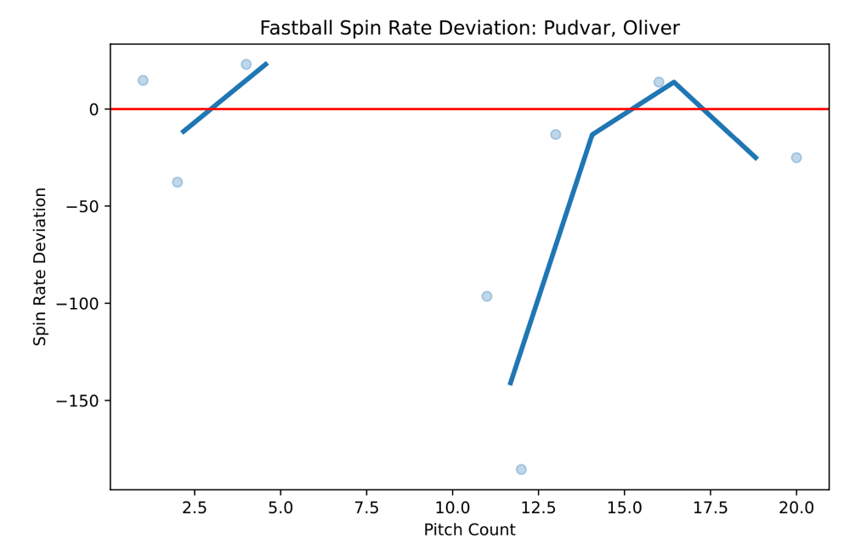
[Figure 4: Fastball IVB Deviation — Pudvar, Oliver (2/19)]
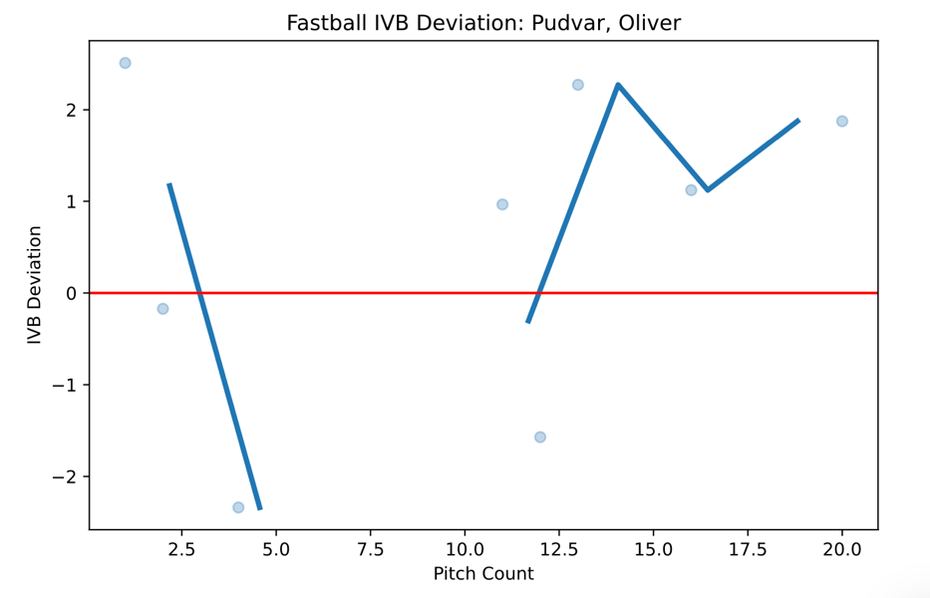
[Figure 5: Fastball Horizontal Break Deviation — Pudvar, Oliver (2/19)]
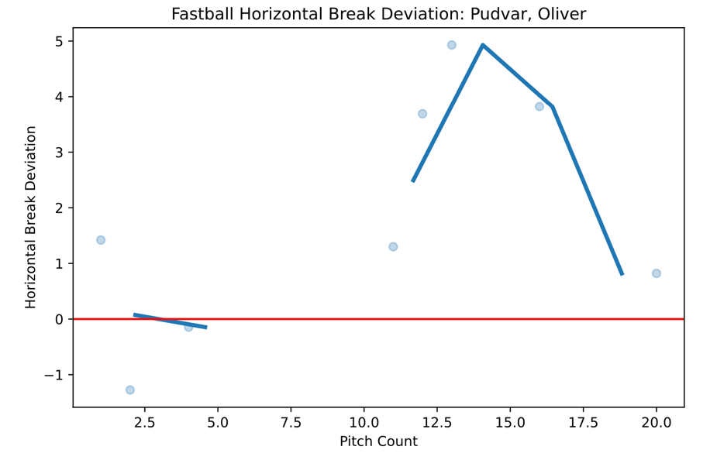
[Figure 6: Fastball Extension Deviation — Pudvar, Oliver (2/19)]
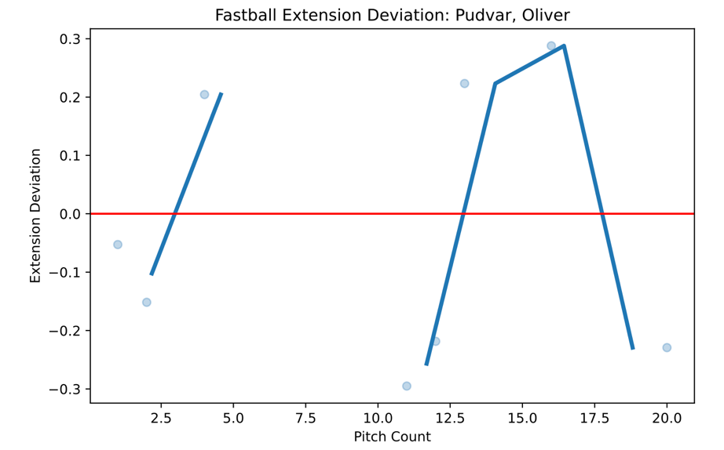

OLS Fatigue Slope Summary
The table below summarizes the OLS velocity slope estimates for the 25 pitcher-game combinations with at least 10 fastballs. The slopes are sorted from least (greatest fatigue) to greatest The majority of pitchers (20 out of 25) showed a negative slope, indicating declining velocity across their outing. Taylor Penn in Game 1 had the steepest decline (slope = -0.105, p < 0.001), followed by Smith Drew (slope = -0.100) and Jack Lafflam (slope = -0.096).
The mean slope across all 25 observations was -0.034 mph per pitch.

Pitcher | Game | Slope | p-value | Late-Game VeloDev | N Pitches
Penn, Taylor | 2_17 | -0.105 | <0.001 | -4.06 | 29
Smith, Drew | 2_17 | -0.100 | 0.003 | -1.86 | 15
Lafflam, Jack | 2_22 | -0.096 | <0.001 | -2.54 | 19
McKinney, Collin | 2_22 | -0.090 | <0.001 | -3.38 | 20
Morris, Patrick | 2_19 | -0.081 | 0.003 | -1.76 | 16
Bailey, Smith | 2_21 | -0.055 | <0.001 | -3.29 | 36
West, Charles | 2_20 | -0.024 | <0.001 | -2.00 | 35
Peters, Kyle | 2_17 | -0.024 | 0.003 | -0.92 | 37
Suchy, Cayden | 2_21 | -0.013 | 0.009 | -1.09 | 40
Pudvar, Oliver | 2_22 | -0.011 | 0.197 | -1.17 | 32
Roberts, Maclain | 2_20 | +0.019 | 0.036 | +0.73 | 38
Guy, Colby | 2_17 | +0.047 | 0.135 | +1.35 | 10
Table 2: OLS Velocity Slope Estimates by Pitcher-Game (Selected)

Fatigue Slope Across Games
Aggregating slopes by game reveals a worrying trend: average velocity decline worsens as the series progresses. Game 3 is a modest exception, but Game 4 and Game 5 show the steepest average declines.

Game Number | Date | Avg. Slope | Std. Dev. | Pitchers
1 | 2/17 | -0.020 | 0.057 | 8
2 | 2/19 | -0.026 | 0.041 | 4
3 | 2/20 | -0.019 | 0.027 | 4
4 | 2_21 | -0.043 | 0.021 | 4
5 | 2/22 | -0.067 | 0.034 | 5
Table 3: Average Velocity Fatigue Slope by Game
A second OLS regression of average slope on game number yielded a coefficient of -0.0105 (p = 0.060, R² = 0.145), suggesting a statistically significant and directionally consistent trend toward greater fatigue in later games. This could reflect cumulative physical fatigue across consecutive games.
[Figure 7: Average Fatigue Slope Across Games (1–5)]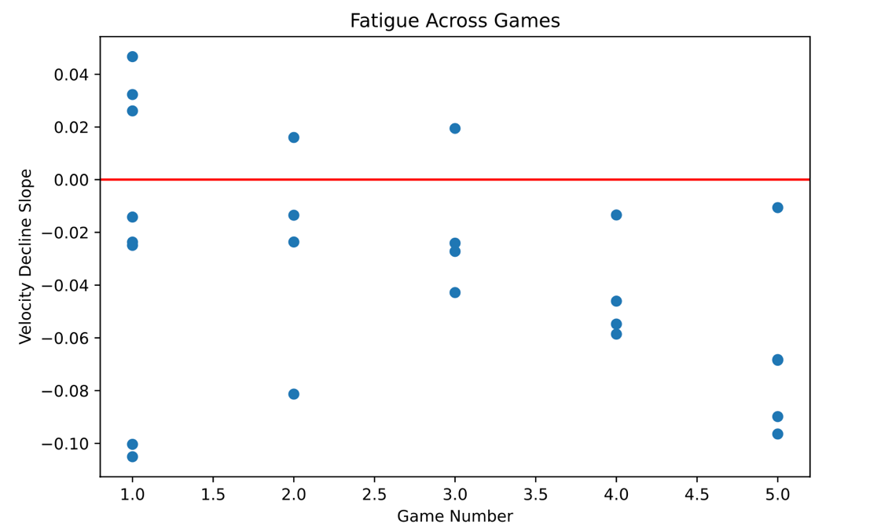

Composite Fatigue Score
The composite fatigue score, constructed from z-scored deviations in velocity, spin rate, IVB, effective velocity, and extension, shows a gradual upward trend across the pitch count range from 0 to approximately 100. While individual pitches exhibit high variability, the binned average trend line increases from near zero early in games to approximately +0.5 to +0.7 by the 80-100 pitch range, consistent with building up biomechanical fatigue across a game.
[Figure 8: Composite Fatigue Score Across All Games (Binned Average)]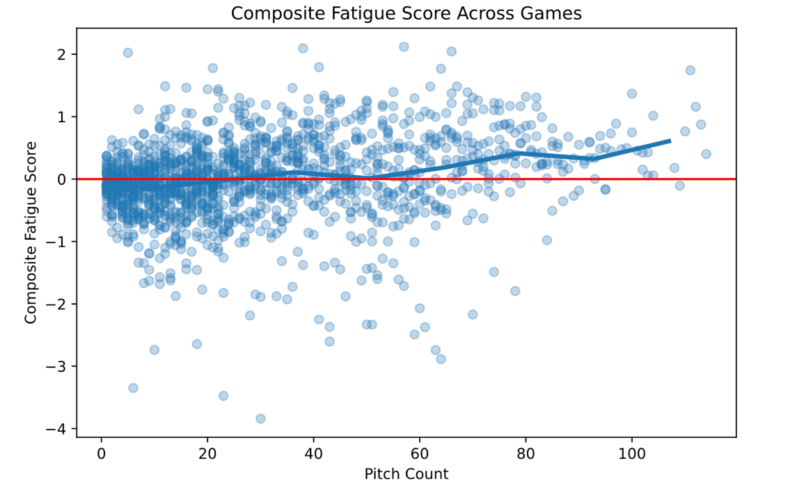

Logistic Regression Results
Two logistic regression models were evaluated. The outcome-based model, predicting whether a pitch received a BallCalled designation from deviation features, performed only modestly: ROC-AUC = 0.564, overall accuracy = 55%. This is unsurprising, as pitch location outcomes are influenced heavily by pitch intent and batter behavior, not just fatigue.
The threshold-based model, predicting whether a pitch was thrown more than 1 mph below the pitcher's baseline velocity, performed substantially better: ROC-AUC = 0.976, overall accuracy = 90%, with precision of 0.81 and recall of 0.92 for the fatigued class (class 1). The dominant predictor in this model was ExtensionDev (positive coefficient ~+5), indicating that pitches thrown with greater extension tend to accompany velocity above baseline, while EffectiveVeloDev had a large negative coefficient (~-4), reflecting that effective velocity drops as perceived effort increases with fatigue. This model confirms that extension and effective velocity are the most informative biomechanical signals for classifying fatigue-related velocity loss.
[Figure 9: Logistic Regression Coefficients — Threshold-Based Model]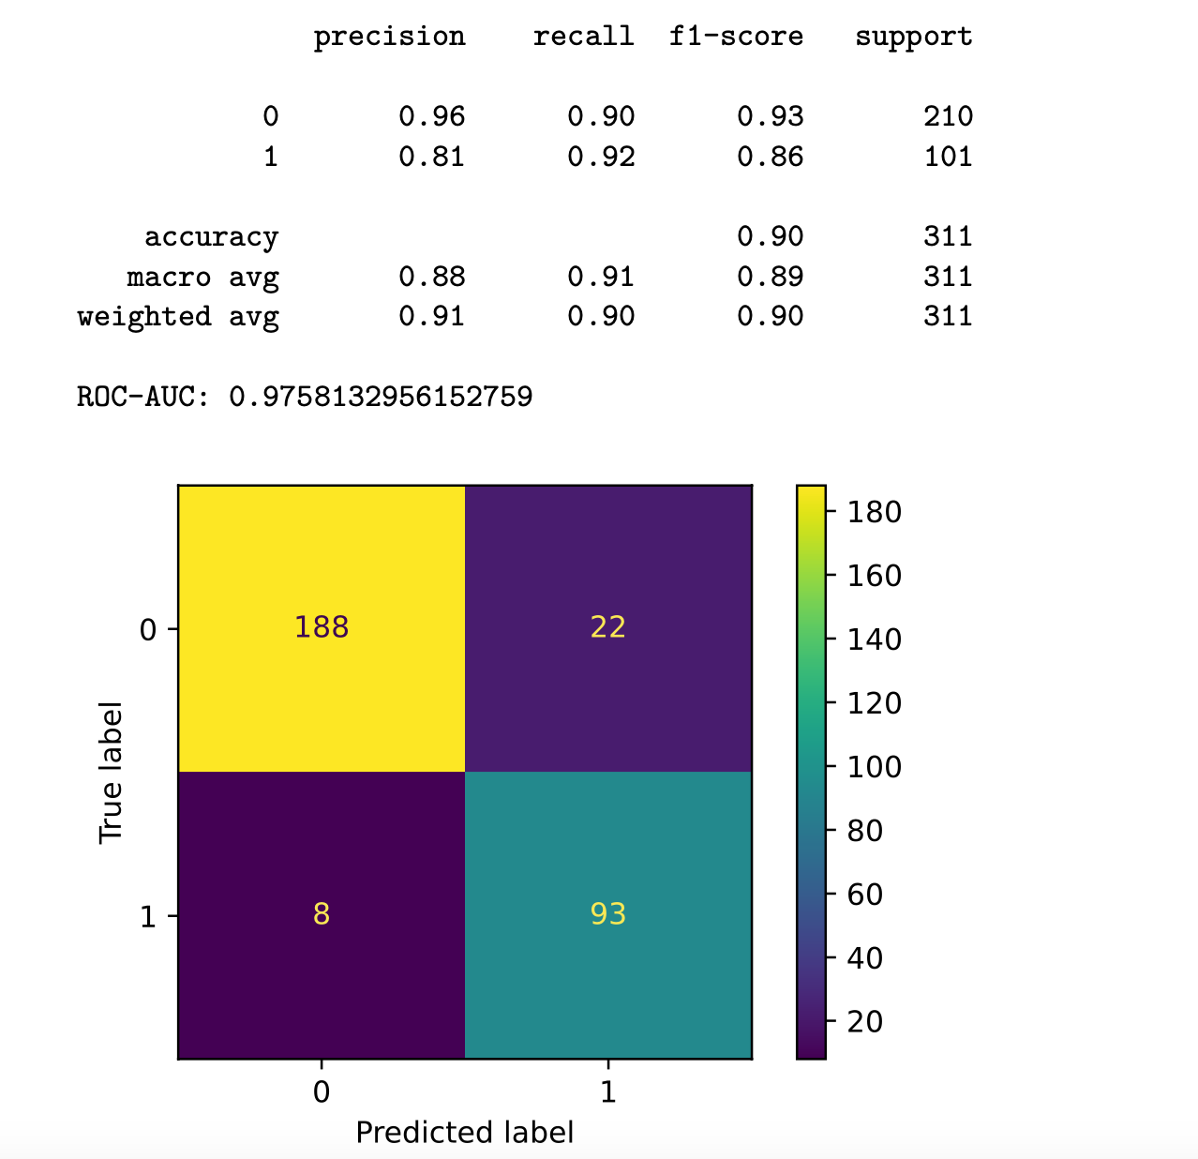

Discussion
Several key findings emerged from this analysis that have practical implications for how the coaching staff monitors and manages pitching staff.
- The personalized baseline framework successfully isolates within-game fatigue from natural between-pitcher differences. By anchoring each pitcher's baseline to their own first 20% of pitches per pitch type, the deviations measured reflect degradation rather than ability. This is critical for a team with diverse arm talent spanning different velocity ranges and pitch arsenals.
- Velocity decline is near-universal but highly variable. Twenty of 25 pitcher-game combinations show a negative OLS slope, confirming that velocity loss is a real and measurable phenomenon across the roster. However, slopes range from -0.105 to +0.047 mph per pitch. This variability suggests that fatigue thresholds will need to be individualized, a single pitch-count cutoff is a poor proxy for a metric that varies this much across pitchers.
- The cumulative trend across five consecutive games is interesting. Average velocity decline worsens from Game 1 through Game 5, with the final game showing slopes roughly three times steeper than the first three games (-0.067 vs. approximately -0.021). While five games is too small a sample to establish significance with confidence, the pattern is consistent with the expectation that a multi-game series would generate fatigue for a pitcher’s arm.
- Extension is the most actionable biomechanical signal. Across both logistic regression models and the individual feature plots, extension deviation consistently emerges as a meaningful predictor. Reduced extension (a shorter stride toward the plate) is a known mechanical consequence of arm fatigue, as pitchers protect their arm by pulling back. The threshold-based model's large positive coefficient on ExtensionDev confirms that when pitchers are not yet fatigued, they extend further than their baseline, while fatigued pitches show the opposite. Coaches observing delivery mechanics in real time can use extension as a visual cue to flag pitchers for removal.
- The outcome-based logistic model's low performance (ROC-AUC = 0.564) is not a failure of the features, but rather a reflection of the task's difficulty. A BallCalled outcome depends heavily on the pitcher's intention, the batter's eye, the umpire's zone, and the game situation. Using pitch outcomes as a direct proxy for fatigue quality conflates too many variables. The threshold-based approach, which treats consistent velocity loss as the fatigue signal itself, is far better specified for this purpose and may be the correct framing for future classification work.

Conclusion
This analysis establishes a framework for quantifying pitcher fatigue using personalized baselines from TrackMan data. By focusing on within-game deviations from early-outing norms, the approach isolates fatigue signals without confounding them with pitcher-level ability differences. Across five games involving 33 pitchers and 1,702 pitches, velocity decline was observed in 80% of pitcher-game outings, and a concerning cumulative trend toward steeper decline was documented across consecutive games.
The composite fatigue score and OLS slope framework provide two complementary tools: the slope is useful for ranking pitcher fatigue within a game, while the composite score integrates multiple biomechanical channels for a richer picture of overall degradation. The threshold-based logistic regression demonstrated strong classification performance (ROC-AUC = 0.976), and identified extension deviation as the feature most predictive of velocity-loss events.
Future work should expand this framework to a full season of games, enabling pitcher-specific fatigue curves and workload management profiles to be built over time. Building a composite fatigue index that is calibrated per pitcher — rather than using global z-scores — would further improve personalization. Classification models using non-linear methods (e.g., random forests or gradient boosting) may also capture interaction effects between fatigue features that logistic regression misses. Ultimately, this framework is designed to support real-time coaching decisions: with streaming TrackMan data, these deviation metrics could be computed pitch-by-pitch to provide live fatigue alerts during a game.

