Case Study in Queuing Model for ATM Facility

Shreyash P. Prasad¹, Vivekananda S. Gogi², Sunil R. Yalamalle³
^{1,2,3} Department of Industrial Engineering and Management, R.V College of Engineering, Bangalore, India.

Abstract - ATM enables the customers perform financial transactions without the need for a human cashier, clerk or bank teller. Queuing is the activity where customers avail the desired service, which could be processed or distributed one at a time. Thus, to maintain the customers, the service time needs to be improved. In this paper we analyze how queuing theory can be used to accurately predict the arrival rate of the customers and service rate of service facility. We collected data from an ATM in the city. The M/M/1 queuing model has been used to obtain the average arrival rate of 0.75 and the average service rate of 1.20. The results of the analytic model are compared with the simulation model developed using MATLAB. The benefits of a queuing model are also discussed.

Keywords – Arrival rate, Service rate, Queuing Model, ATM.

1. INTRODUCTION

Queuing Theory is mainly seen as a branch of applied probability theory. Its applications are in different fields, e.g. communication networks, computer systems, machine plants and so forth. For this area there exists a huge body of publications. Queue is a common word that means a waiting line or the act of joining a line. A.K. Erlang initially proposed queuing theory in 1903. It optimizes the number of service facilities and adjusts the times of services . Queuing theory is the study of queue or waiting lines. Some of the results that can be derived using queuing theory include the expected waiting time in the queue, the average time in the system, the expected queue length as well as the probability of the system to be in certain states, such as empty or full. There are many real-life situations in which queuing theory can provide solutions. Queueing theory is the study of waiting in all these various guises. It uses queueing models to represent the various types of queueing systems (systems that involve queues of some kind) that arise in practice. Formulas for each model indicate how the corresponding queueing system should perform.Therefore, these queueing models are very helpful for determining how to operate a queueing system in the most effective way. Providing too much service capacity to operate the system involves excessive costs. But not providing enough service capacity results in excessive waiting and all its unfortunate consequences. The models enable finding an appropriate balance between the cost of service and the amount of waiting.
In this paper we use M/M/I queuing model to derive the waiting time in the queue and the total waiting time in the system.
The analytical results are compared with the stochastic MATLAB results.

2. LITERATURE REVIEW

The queuing theory is an operational research technique that models a system-allowing queue, calculates its performances and determines its properties in order to help managers in decision-making. Queuing theory is an important branch of applied probability theory that has been a subject of study since the beginning of the 20TH century. It is an interesting area of research with applications in industries, operations research, information science and telecommunication networks.

A.K Erlang is regarded as the father of modern queuing theory, a Danish Mathematician, who in 1909, published "‘The Theory of Probabilities and Telephone Conversations".

The development of the queuing theory until 1940s was directed mainly by the problems encountered in the design of automatic telephone exchanges. Bhat in “Sixty years of queuing theory,” had written extensively on queuing theory with respect to its three constituent problems i.e. behavioral, statistical and operational. Bhat has cited 94 references in his publication, which is a good overview of the literature on queuing theory within its first sixty years of existence.

Gross and Harris have discussed 6 characteristics that in most cases are adequate to describe a queuing system:
- Arrival pattern of customers
- Service pattern of servers
- Queue discipline
- System capacity
- Number of service channels
- Number of service stages.

Many theorems in queue theory can be proved by reducing queues to mathematical systems known as Markov chains, first described by Andrey Markov in his 1906 paper.

The M/M/1 queue is a model where a single server serves jobs that arrive according to a Poisson process and have exponentially distributed service requirements. In an M/G/1 queue the G stands for general and indicates an arbitrary probability distribution. The M/G/1 model was solved by Felix Pollaczek in 1930, a solution later recast in probabilistic terms by Aleksandr Khinchin and now known as the Pollaczek–Khinchine formula. Operations Researchers further advanced the analytic development of queuing theory. The terminology of queuing theory reflects the origins of the field (Prieger, 2001).Today, we encounter a myriad of queues everyday of our lives, and queuing theory when it can, helps us to navigate around these.

Simulation with queuing model for various applications other than the ATM problem has been worked upon previously.According to Pieter Tjerk de Boer (1983), estimation of overflow probabilities in queuing networks has received substantial importance in sampling simulation literature. S. S. Lavenberg (1989) in his article discussed that simulation was found to be a viable tool for numerically studying a complex queuing model, which is not analytically tractable.Heuristic approaches: E.g. Simulation Model (SA). For example, Brame and Simchi. Levi (1995) introduced the location-based heuristic for general queuing problem, which is based on formulating the queuing problem as a location problem, commonly called the capacitated concentrator location problem.Simulation is a robust tool for analyzing a new system or improving the current system and also recommending the needed reforms in controlling system and operational roles. Simulation is an approved tool for accurate and evidence-based decision making and provides excellent outcomes in assessing and planning complicated and uncertain systems such as health systems. The technique increases our perception of the main problems and it's possible solutions through modeling.
Simulation also has some important problems, though. First of all, it can be very time-consuming: in order to estimate the probability of an event of interest accurately, one needs to collect many (almost) independent observations of it in the simulation run. Furthermore, one such a simulation run in principle only yields an estimate for one set of values of the model’s parameters.

3. METHODOLOGY

This model is based on certain assumptions about the queuing system:
- Arrivals are described by Poisson probability distribution and come from an infinite calling population.
- Single waiting line and each arrival waits to be served regardless of the length of the queue and there is no balking and reneging.
- Queue discipline is first-come first-served
- Customer arrival is independent but the arrival rate (average number of arrivals) does not change over time.
- The average service time is more than the arrival rate.
STEP 1: Collect the raw data by observation.
STEP 2: Make logical inferences based on the data collected.
STEP 3: Calculate the average total waiting time and average waiting queue time by the analytical method.
STEP 4: Develop a MATLAB simulation model for the ATM model.
STEP 5: Analyze the result of the simulation model.
STEP 6: Compare the results of the simulation model with the analytical model and make logical conclusion based on the results.

4. OBSERVATION AND ANALYSIS

We collected the single month daily customer data by observation during banking time, as shown in Table-I
Table. I Monthly customers count
. 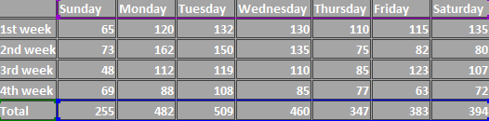

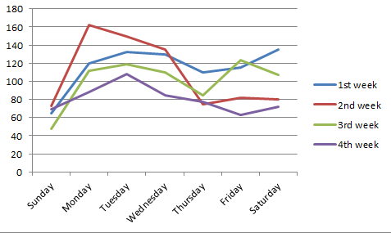
Fig.1 one-month daily customers count
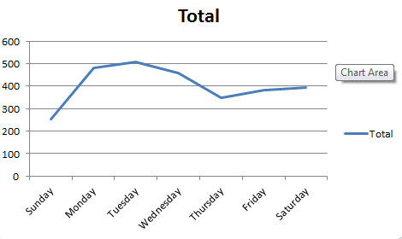
Fig.2 one-month total customers count
We can infer from the above data that, the maximum customers arrive during Mondays and Tuesdays. It is very apparent from the above graphs that, Tuesday onwards the number of customers visiting the ATM start decreasing slowly as the week progresses. On Thursdays, it is least and on Fridays and Saturdays, it stays slightly more than Thursdays. This is because the next day will be a holiday. Since maximum ATM usage is on Mondays and Tuesdays, therefore, we will consider the data obtained on these two days only.

5. CALCULATION

We also observed that on Mondays and Tuesdays an average of 45 people arrived on the ATM (W) and 72 people received service per hour.

Hence,

$$λ=\frac{45}{60}=0.75 customers/minute(cpm)$$
$$μ=\frac{72}{60}=\frac{1.20customers}{minute\left(cpm\right)}$$
$Wq=\frac{λ}{μ\left(μ-λ\right)}=\frac{0.75}{1.2\left(1.2-0.75\right)}=1.38$ 9
$$W=\frac{1}{μ-λ}=\frac{1}{1.2-0.75}=2.223$$
So, the average total waiting time and average waiting queue time is 2.223(cpm) and 1.389(cpm) respectively.

6. SIMULATION RESULTS

Now, we will develop a MATLAB simulation model for the ATM model. By developing a simulation model, we will be able to confirm the results of the analytical model that we develop in this paper. The simulation model can mirror the actual operation of the ATM more closely.
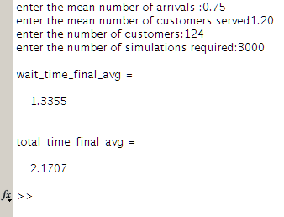
Fig.3 Simulation result
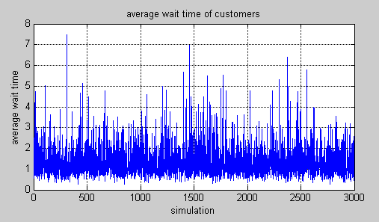
Fig.4 Average wait time of customers
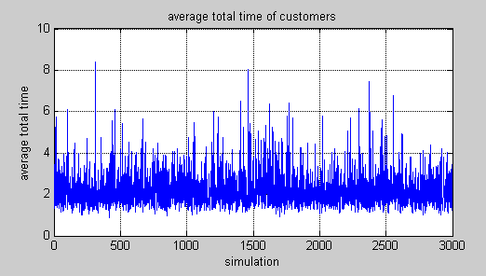
Fig.5 Average total time of customers

7. CONCLUSION

The arrival and service rate followed Poisson and Exponential distributions respectively. Other studies have found similar results and are consistent with the given study. An analytical method and a simulation were used to calculate the average waiting time (W) and the average total time (Wq). From the simulation it can be inferred that the average waiting time and the average total time spent by the customers in the queue and the system are 1.3355(cpm) and 2.1707(cpm) respectively. Using the analytical method the average waiting time and the average total time the customers spent in the queue and the system are 1.389(cpm) and 2.223(cpm) respectively.
W(analytical)-W(simulation)=1.389-1.335=0.054cpm.
Wq (analytical)-Wq (simulation)=2.223-2.1707=0.0523cpm.
It is evident that there is not much difference between the average waiting time (W) and the average total time (Wq) values obtained from the two methods.

8. REFERENCES

N. K. Tiwari & Shishir K. Shandilya, Operations Research. Third Edition, ISBN 978-81-203-2966-9. Eastern Economy Edition, 2009. Nita H. Shah, Ravi M. Gor, Hardik Soni, Operations Research. 4th Edition, ISBN 978-81- 203-3128-0. Eastern Economy Edition, 2010. K. Sanjay Bose, “An Introduction to queuing system”, Springer, 2002. J. D. C. Little, “A Proof for the Queuing Formula: ”, Operations Research, vol. 9(3), 1961, pp. 383-387, doi: 10.2307/167570 J.H. Reed, Computer simulation: A tool to teach queuing theory, Experiential Learning Enters the Eighties 7 (1980), pp. 63-66. J.K Sharma, “Operations Research: Theory and Applications”. Fifth Edition, ISBN: 9789350593363 U. N. Bhat. (1969, Feb.). Sixty years of queuing theory. Management Science, pp. B280-B294. Available: http://www.jstor.org/stable/2628922. D. Gross and C. M. Harris. (1985). Fundamentals of queuing theory. John Wiley & Sons, New York. A.A. Markov, Extension of the law of large numbers to dependent quantities, Izvestiia Fiz.-Matem. Obsch. Kazan Univ., (2nd Ser.), 15(1906), pp. 135–156 [Also [37], pp. 339–361. Kingman, J. F. C. (2009). "The first Erlang century—and the next". Queuing Systems.

