**Online Classified Advertising & Shopping Platform(EmoVend*)***

Prasheesh Negi

Krishnakant Pande

Shubhangam Tripathi

**INDEX**

|  |  |  |
| --- | --- | --- |
| **Sr. No** | **TITLE** | **Page No** |
| 1. | Introduction of Project | 3 |
| 2. | Abstract | 4-6 |
| 3. | Manifesto | 7 |
| 4. | DFD | 8-12 |
| 5. | ER | 13 |
| 6.  7. | Methodologies  ETVX | 14  15 |

**Introduction of Project**

**Online classifieds**  are used to provide the user with a bulk of information . This is used to advertise the products with images. One can easily login to get any kind of information. Here the user is also facilitated to directly interact with the consumer.

He can get the desired product with different rates and quality. The main goal is to provide the customer with various goods just by sitting in front of a computer .He can get the goods easily without moving from place to place. Consumers can also have a chance of introducing their products not only in a single place but throughout the world using online classifieds.

It is used to provide the customers with huge amount of information. This is a site to login to get the latest updates of the automobiles, matrimony and real-estate. An easy way to buy a product just sitting in front of your computers by registering into our site.

This is to facilitate all people who are busy with their works and have no time to get their desired goods. We are here to provide you all the best and suitable places for sale. If once you register into our site, then you are benefitted with our latest updates of the sales!

This is used to advertise the products with images. One can easily login to get any kind of information. Here the user is also facilitated to directly interact with the consumer. He can get the desired product with different rates and quality.

**Abstract**

**Objective and scope**

To provide a platform which is helpful for the students to sell, buy & share their used stuff as well as on rental basis too within a campus.

**Existing System**

* We cannot directly interact with the consumer through newspaper as it is possible with online classifieds.
* We don’t even have a clear image of the product

**Proposed System along with intended objectives**

* Create a website dynamic in nature.
* Create a User friendly interface.
* Emphasis on homepage to make it interactive.
* Easy accessible by every person

**Project Objective**

* To Increase number of subscriptions.
* Every time accessibility online.
* Enhancement in the existing business structure

**Vision**  
This software is aimed at making data entry, management, updating, storage and retrieval easier and faster. The following objectives have been kept in mind:

• Practicality: The system is quite stable and can be operated by the people with average intelligence.

• Efficiency: I tried to involve accuracy, timeliness and comprehensiveness of the system output.

• Cost: It is desirable to aim for the system with a minimum cost subject to the condition that it must satisfy the entire requirements.

• Flexibility: I have tried that the system should be modifiable depending on the changing needs of the user. Such modifications should entail extensive reconstructing or recreation of software. It should also be portable to different computer systems.

• Security: This is a very important aspect and I have tried to cover the areas of hardware reliability, fallback procedures, and physical security of data.

**MANIFESTO**

We are uncovering better ways of developing software by doing it and helping others do it. Through this work, we have come to value −

* Individuals and interactions over Processes and tools
* Working software over Comprehensive documentation
* Customer collaboration over Contract negotiation
* Responding to change over Following a plan

That is, while there is value in the items on the right, we value the items on the left more.

**USER REQUIREMENTS**

i. The system should be fast.

ii. Smooth transaction of products.

iii. Redundancy of data must be avoided

iv Efficiency in data retrieval and management.

v. Product record keeping must be managed in a proper way.

vi. Maintaining security of data.

**FEASIBILITY STUDY**

In preliminary investigation feasibility study has three aspects..

* Technical Feasibilty
* Operational Feasibilty
* Economical Feasibility

**Technical Feasibility**

Technical issues involved are the necessary technology existence, technical guarantees of accuracy, reliability, ease of access, data security, aspects of future expansion.

1. Technology exists to develop a system.
2. The proposed system is capable of holding data to be used.
3. The proposed system is capable of providing adequate response and regardless of the number of users.
4. The proposed system being modular to the administrator, if he/she wants can add more features in the future and as well as be able to expand the system.
5. As far as the hardware and software is concerned, the proposed system is completely liable with proper backup and security.

Hence, we can say that the proposed system is technically feasible.

**Operational Feasibility**

If the system meets the requirements of the customers and the administrator we can say that the system is operationally feasible.

The proposed system will be beneficial only if it can be turned into a system which will meet the requirements of the store when it is developed and installed, and there is sufficient support from the users.

1. The proposed system will improve the total performance.
2. Customers here are the most important part of the system and the proposed system will provide them with a convenient mode of operation for them.
3. The proposed system will be available to the customers throughout the globe.
4. The proposed system will provide a better market for different dealers.

Hence, the proposed system is operationally feasible.

**Economical Feasibility**

Economic Feasibility is the most frequently used method for evaluating the effectiveness of the proposed system if the benefits of the proposed system outweighs the cost then the decision is made to design and implement the system.

i. The cost of hardware and software is affordable.

ii. High increase in the amount of profit earned by going global.

iii. Easy and cheap maintenance of the system possible.

iv. Very cheap price for going global.

Hence, the proposed system is economically feasible.

**FEATURES OF THE PROPOSED SYSTEM**

1. The proposed system is flexible both for the administrators and the customers visiting the website.
2. The proposed system provides a unique platform for different silk vendors to interact using the same platform.
3. The proposed system allows easy promotion of the site through emails and newsletters.
4. The proposed system gives information about the delivery and present status of their orders.
5. Management of data is easy.
6. Security is provided wherever necessary.

**PROPOSED SYSTEM**

In the proposed website there are different parts or modules which are summarized as follows

***CUSTOMER REGISTRATION:***

Customers are required to register on the website before they can do the shopping. The website also provides several features for the non-registered user. Here they can choose their id and all the details regarding them are collected and a mail is sent to the email address for confirmation.

***SHOPPING CART:***

Shopping cart module tries to simulate the working of a store where user can view each design, color, size and price of the product available. The items they like can be added to the logical cart and can be removed if not required later. Billing and other payment related matters are handled here.

***ADMINISTRATION:***

This is the part of the website where the administrators can add delete or update the product information. Administrators are also responsible for adding and deleting the customers from the website. In addition, newsletter and promotions are also handled by the site administrator via e-mail.

***SEARCH :***

This facility is provided to both registered and unregistered user. User can search for the availability and type of products available on the website.

***EMAILING:***

Emailing module is concerned about promotions and newsletter and is handled by the administrator. This module is also concerned about sending activation and warning mails.

**DATA FLOW DIAGRAMS (DFD):-**

A DFD i.e. Data Flow Diagram is a graphical tool, which has the purpose of clarifying system requirements and identifying major transformation that will be programs in the system design. It depicts the information flow and transformation that occurs, as data moves from input to output. The DFD provides a mechanism for functional modeling as well as information flow modeling.

An external entity which can be a source or a destiny is represented by a solid square. It lies outside the context of the system. A process indicates the work that is performed on data. A circle represents a process. Data flow takes place between various components of the system & hence represented by an arrow mark. A data store is a repository for data. It is represented by an open-ended rectangle.

## Theory

[https://upload.wikimedia.org/wikipedia/commons/thumb/c/c8/DataFlowDiagram_Example.png/360px-DataFlowDiagram_Example.png](https://en.wikipedia.org/wiki/File:DataFlowDiagram_Example.png)

Data flow diagram example

[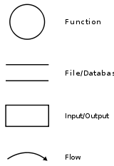](https://en.wikipedia.org/wiki/File:Data-flow-diagram-notation.svg)

**Customer**

**Administrator**

**Create & Update information**

**Information**

**Shopping & Queries**

**Information**

**CONTEXT DIAGRAM OF ‘ONLINE SHOPPING’**

**LEVEL 1 DFD**

Keyword

Keyword

Product Info

Login Info

Email Info

Mail Information

Order Info

CRUD

Operation

Response

CRUD

Operation

Reading

Valid Login

Administrator

Products Table

Customer

Login Information

User Query

Response

Login

Information

Search Item

Valid

Login

Registration

Info

Browse for

Product

Product

Detail

Match

Login

Register

Registration Table

Adm. Login Table

Database

Match Login

Login Info

# 

**Methodologies**

Out of all the methodologies Feature Driven Development methodology is the best foot toward our project. This is a model-driven, short-iteration process that was built around software engineering and is the best practices such as domain object modeling, developing by feature, and code ownership. The blending of these practices that resulted in a cohesive whole is the best characteristic of FDD.

Some key features of FDD are:-

* Development of an overall model
* Building a feature list
* Planning by feature
* Designing by feature
* Building by feature

FDD begins by establishing an overall model shape, which will result in a feature list. It then continues with a series of two-week “plan by feature, design by feature, build by feature” iterations. The features are small, “useful in the eyes of the client” results. If they will take more than two weeks to build, then they will have to be broken down into smaller features.

Goal of FDD:-

FDD’s main purpose is to deliver tangible, working software in a timely manner, repeatedly.

Advantages

1. It can be deployed to large group of teams due to the concept of “just enough design initially” (JEDI).
2. It is a great solution to maintain control for incremental and inherently complex agile project management.

Disadvantages

Iterations are not well defined by the process as other agile methodologies

**Development Strategy: -**

Online Collaboration System is designed using ‘The waterfall model’. The waterfall model was the first structured approach to systems development. The waterfall model is just a time-ordered list of activities to be performed to obtain an IT system.

### Maintenance

Implementation

**Test**

### Code

### Design

### System Analysis

**Fig.- System development Life Cycle of Online Collaboration System**

The activities in waterfall model are: -

**System Analysis:** The step refers to the gathering of system requirements, with the goal of determining how this requirement will be integrated in the system. Extensive communication between the customer and the development team is essential. During System Analysis Feasibility Studies are also carried.

**System Design:** Once the requirements have been collected and analyzed, it is necessary to identify in detail how the system will be constructed to perform the necessary tasks. More specifically, the system design phase is focused on the data requirement (what is processed by the system), the software construction (how will the

Application be constructed) and the interface design and coding (what will the system look like?)

**Coding:** Also known as programming, this step involves the system software. Requirement and system specification are translated into computer code. Computer programs are written using a conventional programming language or an application generator. Programming tools like Compilers, Interpreter, Debuggers are used to generate the code. Different high level programming language like C, C++, Pascal, Java, C# are used for coding. With respect to the type of application, the right programming language is chosen.

**Testing:** As the software is created and added to the developing system, testing is performed to ensure that it is working correctly and efficiently. Testing is generally focused on two areas, internal efficiency and external effectiveness. The goal of external effectiveness testing is to verify that the software is functioning according to system design, and that it is performing all the required functions. The goal of internal testing is to make sure that the computer code is efficient, standardized, and well documented.

**Implementation:** After the code is tested, if it meets all the system requirements, it is handed over to the customer.

**Maintenance:** Inevitably the system will need maintenance. Software will definitely undergo change once it is delivered to the customer. Change could happen because of some unexpected input values into the system. The change in the system could directly affect the software operations. The software should be developed to accommodate changes that could happen during the post implementation period.

LEVEL 2 DFD PROCESS 1

User Information

Registration Info (after Shopping)

Validation Failed

Valid Validation Info

Registration Info

Temporary

Information

User Info File

Confirm Registration

User Response Info

Confirmation Detail

Browse for product.

**LEVEL 2 DFD PROCESS 1**

LEVEL 2 DFD PROCESSES 3

Keyword

Product ID

Category Id

Invalid

Keyword

Category Id &

Keyword

Keyword

Image Info

Product Table

Product

Detail

Image Directory

Image

Detail

**LEVEL 2 DFD PROCESSES 3**

LEVEL 2 DFD PROCESSES 4

Product Info

Temporary Storage

Product Table

Browse for Product

(Unregistered)

Order Info.

Product Info

Browse (Regis)

Product Id

Browse (before

Login)

Order Info.

Product Id

Order Info

Order Detail

Order Detail

Order Info

User Info

Orders Table

Registration Table

**LEVEL 2 DFD PROCESSES 4**

LEVEL 2 DFD PROCES 4.3

TempStorage Table

Product Information

Product Id

Product Id

Product Information

TempStorage Table

Product Information

Product Id

TempStorage Table

**LEVEL 2 DFD PROCESS 4.3**

LEVEL 2 DFD PROCES 4.4

Order & Payment Info

Order Info

Order Id

Order Detail Tab

Orders Table

Orders Detail

Order Detail

Order Info

Order Info

Address Info

Regis_cust Table

On-Line Shopping Id

Order Detail

**LEVEL 2 DFD**

LEVEL 2 DFD OF PROCESS 7

User Information

Valid Login

Login Information

Registration

Table

Administrator

Table

Sale Information

Order Information

Update Statement

Delete Statement

Product Information

Valid Login

Valid Login

Valid Login

Valid Login

Product Table

Valid Login

Product Table

Product Table

Order Table

Sell Table

Valid Login

**LEVEL 2 DFD OF PROCESS 7**

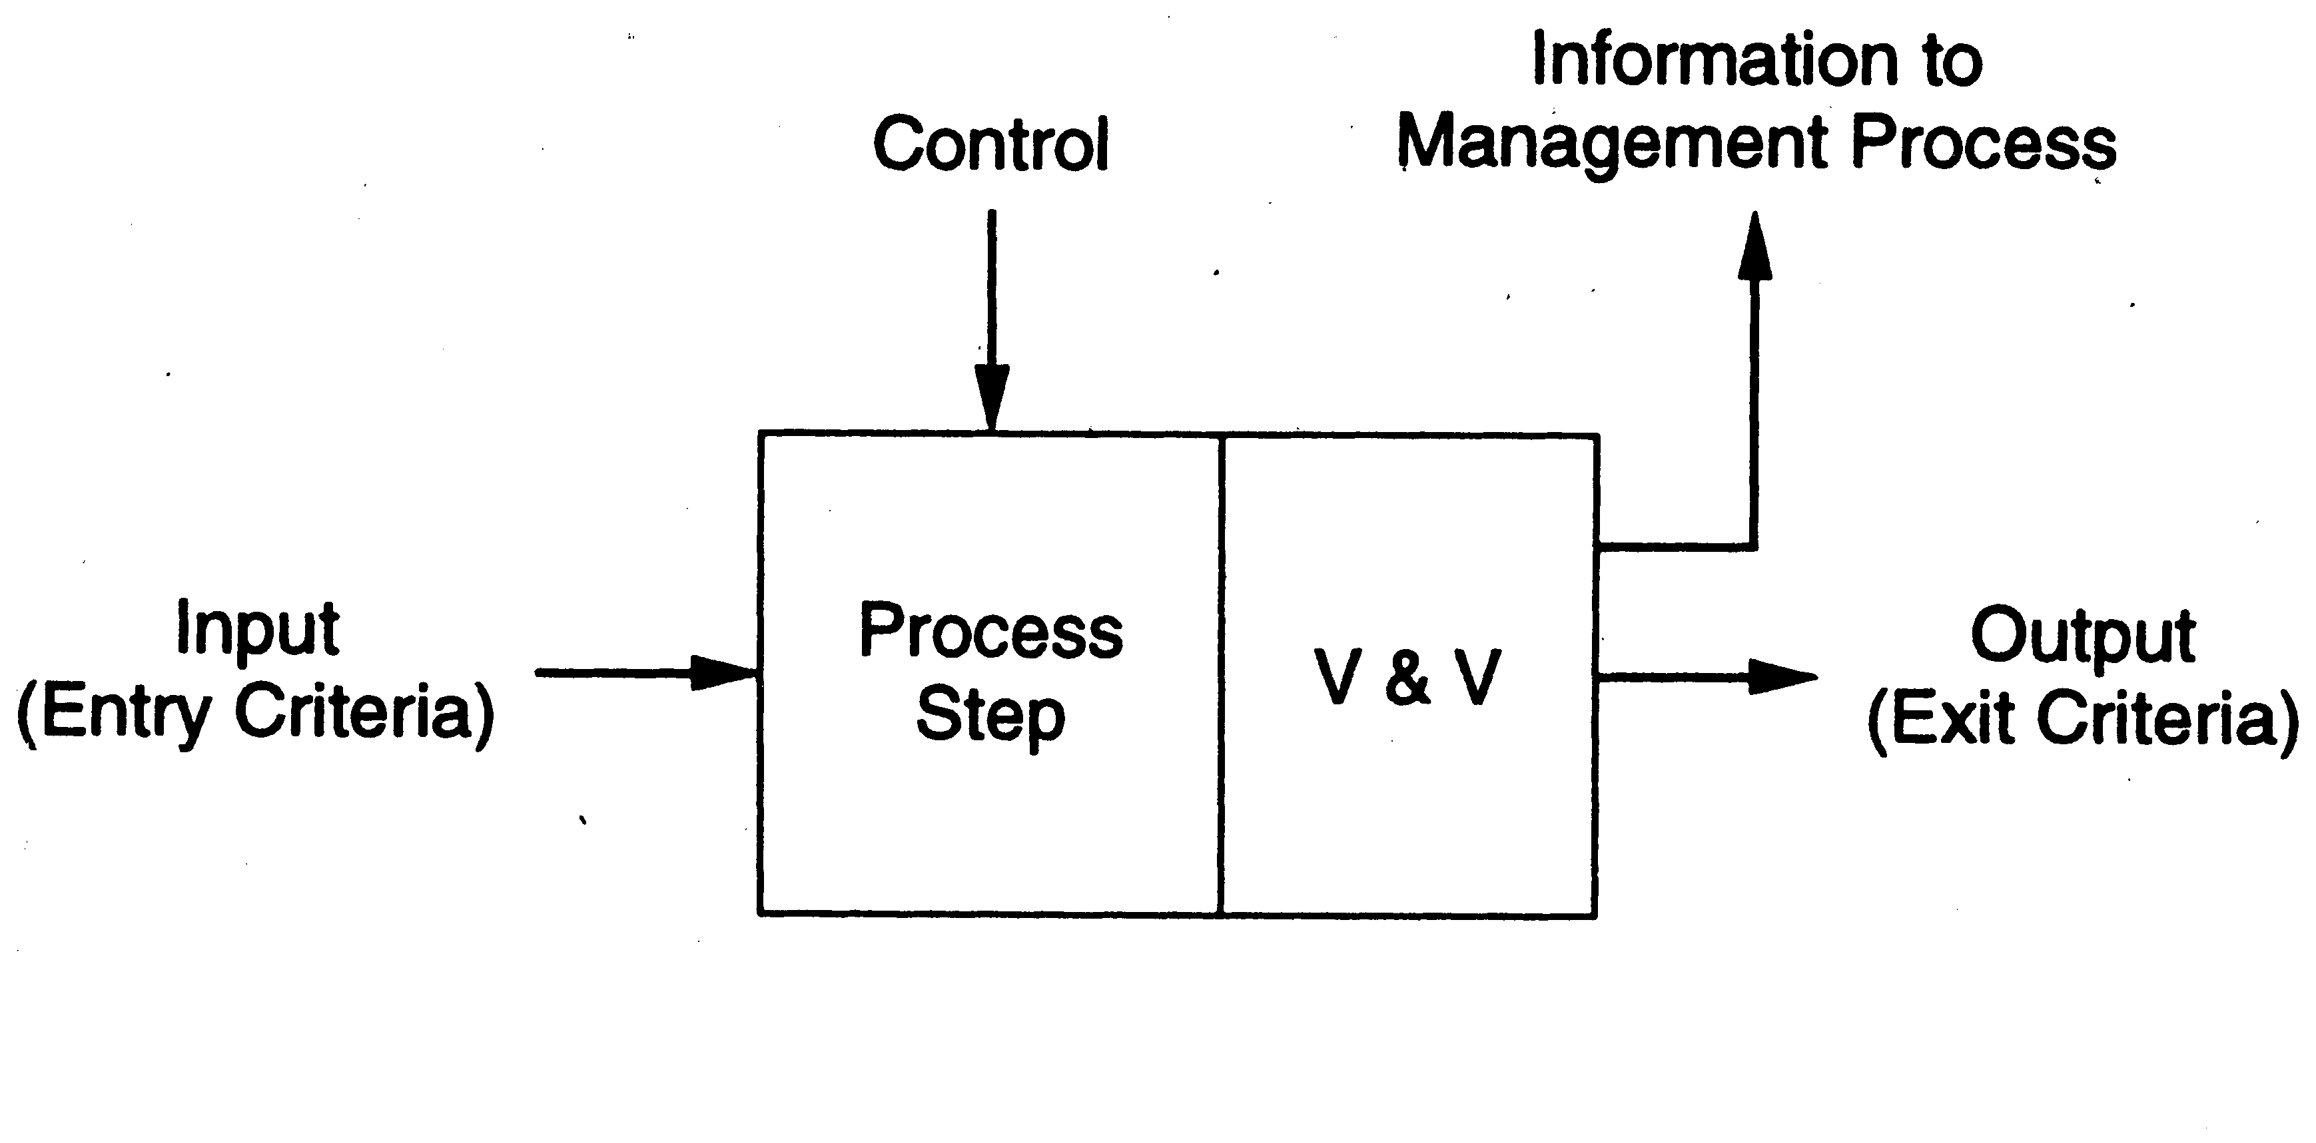

**SOFTWARE REQUIREMENT SPECIFICATION (SRS)**

After collecting all the required information regarding the software to be developed I made the SRS document. The SRS document usually contains all the user requirements in an informal form.

**1. Introduction: -**

* 1. Background and overall description: -

The proposed system has been developed in order to build the electronic counterpart of teamwork. And also to help team member to keep their important messages, files, etc at one place so that they can be available whenever needed.

* 1. Environmental characteristics: -
     1. Hardware: - For developing the proposed system the hardware requirement at the minimum will be 10gb hard disk and 64 mb RAM but for better performance higher configuration is suggested.
     2. Client side requirement: - For using the proposed system the browser is the basic requirement.
     3. People: - Since the proposed system basically deals with working online in a team. So the people interacting with the system will be at least a internet knowing person. Hence the system has to be developed by keeping that in mind and since the user will be internet knowing person the task of developing become little easy.

2.Goals of implementation: -

The proposed system should be built in such a way that it should fulfill the following goals: -

1. The code should be easily manageable.

1. The code should be reusable.
2. The performance rate should be higher. It should be fast.

3. Functional Requirements: -The system contains following functional requirement: -

1. Creating a team.
2. Adding a member to team.
3. Team management.
4. Sending and receiving messages.
5. File sharing.

**ETVX approach to specify a step**

* Entry criteria: what conditions must be satisfied for initiating this phase
* Task: what is to be done in this phase
* Verification: the checks done on the outputs of this phase
* eXit criteria: when can this phase be considered done successfully

Service aaAuthentication

Online Shopping

Reg Customer

Identity Provider

Web Customers

Credit Payment

New Customer

UPI,DIGITAL PAYMENT