Dr. Shubhangi Kharche

**Azure Project 1**

**Scenario**

According to recent research, 40-75% of employees are using Dropbox to share files inside and outside of their businesses. Half of those Dropbox users do this even though they know it's against the rules. More than 40% of businesses have experienced the exposure of confidential information and the estimated average cost of a data breach equaled $5.5 Million in 2011.

These files, containing sensitive company and customer data, are stored in a public cloud outside of the businesses' control - possibly even outside of the country. The potential for data leakage and security breaches is enormous and companies need to stay compliant with their own policies and procedures for security and governance

**Architecture diagram**

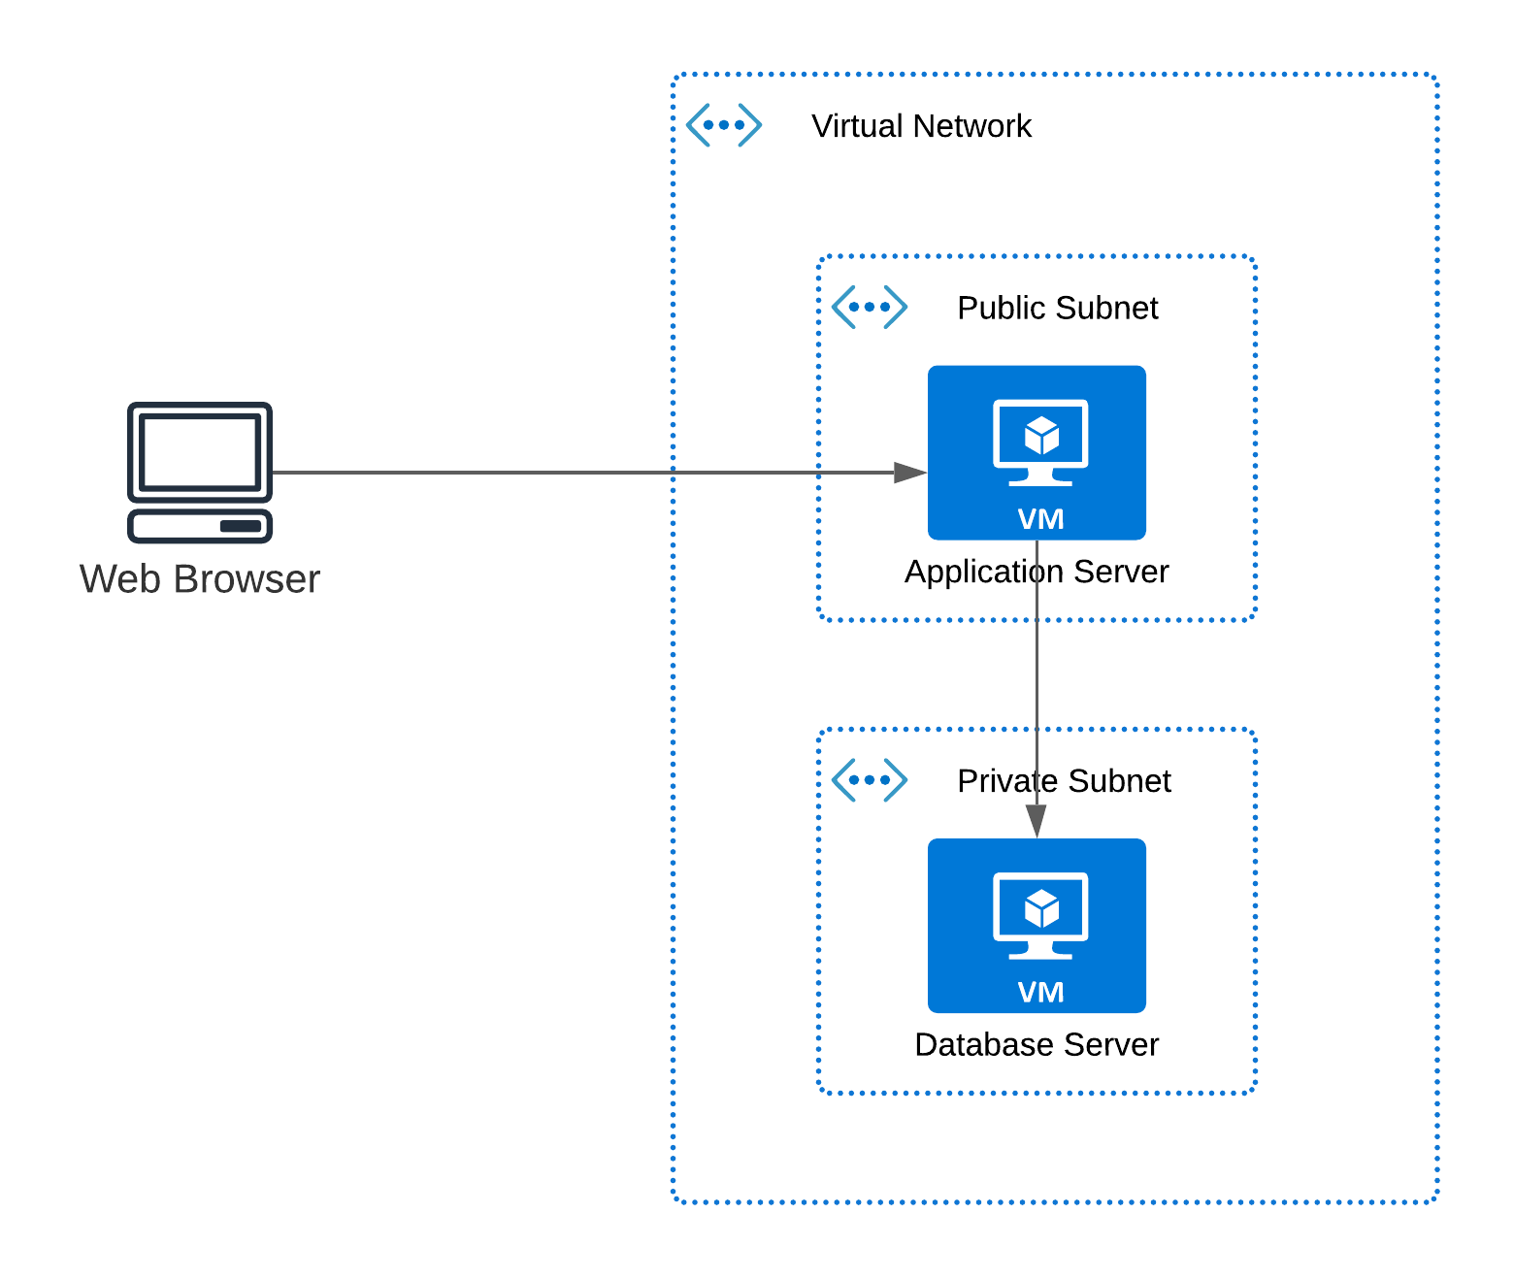

|  |  |
| --- | --- |
| **Architecture Implementation** | |
| 1 | Implement 2 different subnets (one public and the other private) in a virtual network |
| 2 | Install and configure MySQL on an Ubuntu 18.04 virtual machine on the private subnet using the instructions provided. (Hint: Use a bastion host and a NAT gateway) |
| 3 | Install and configure OwnCloud on an Ubuntu 18.04 virtual machine on the public subnet using the provided instructions. |
| 4 | Configure the network security groups to allow the required ports |
| 5 | Test the installation by accessing the IP of the application server in a browser |

**Step 1: VPC and Subnet Creation**

|  |  |  |  |
| --- | --- | --- | --- |
| Step number | a |  |  |
| Step name | Creation of Virtual Network |  |  |
| Instructions | 1) Create a new resource group. You need to use this resource group to deploy all the resources in this exercise   1. Search for resource groups using the search bar at the top of the screen 2. Click on Create 3. Enter a name and region of your choice. Remember to use the same region for all deployments in this exercise. 4. Click on Review +Create and create the resource group   2) Navigate to Virtual Networks and click on Create   1. Name : P1VNET 2. IPv4 CIDR Block : 10.0.0.0/16 3. Delete the default created subnet and add the following subnets    1. Public subnet with CIDR 10.0.1.0/24    2. Private subnet with CIDR 10.0.2.0/24 4. The rest of the options can be set to the default values 5. Click on Create to create the virtual network |  |  |
| Expected screenshots | 1. Created virtual network with properties visible 2. Properties of public subnet 3. Properties of private subnet |  |  |

**<Insert Screenshot a(1) here>**

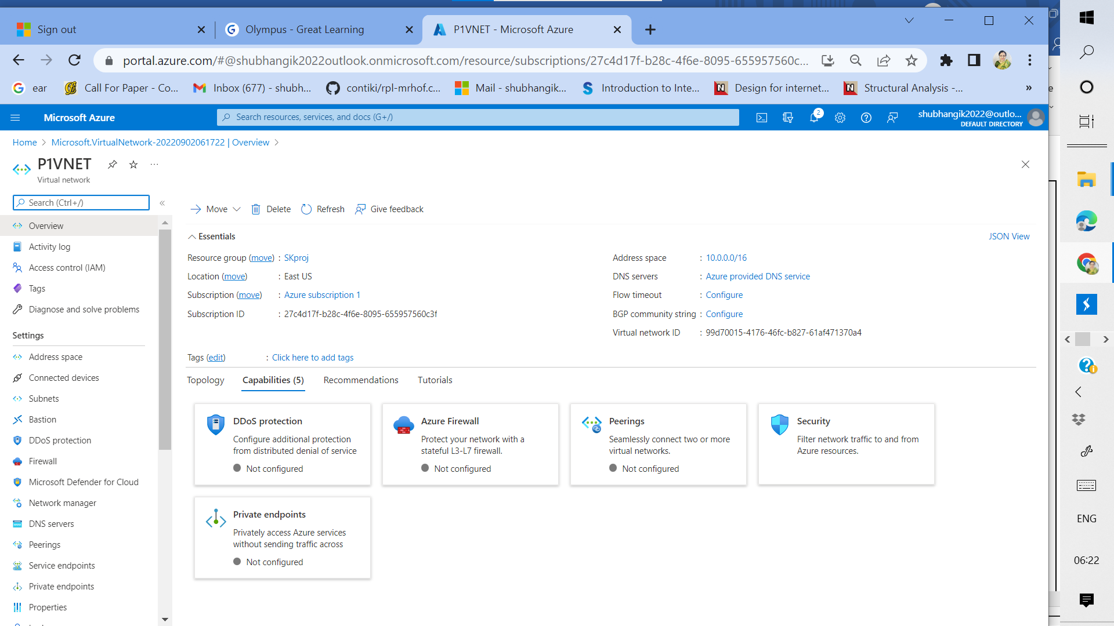

**Figure 1:** Created virtual network with properties visible

**<Insert Screenshot a(2) here>**

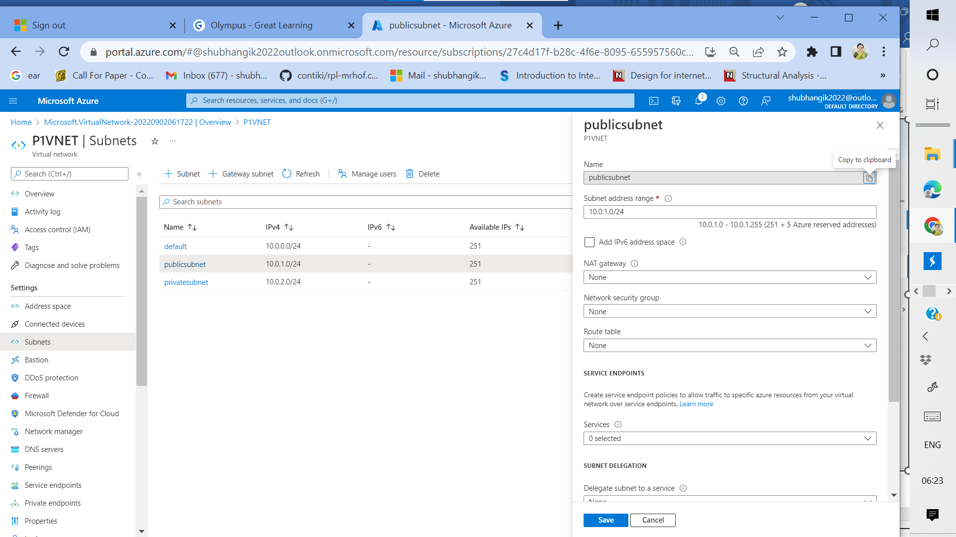

**Figure 2:** Properties of public subnet

**<Insert Screenshot a(3) here>**

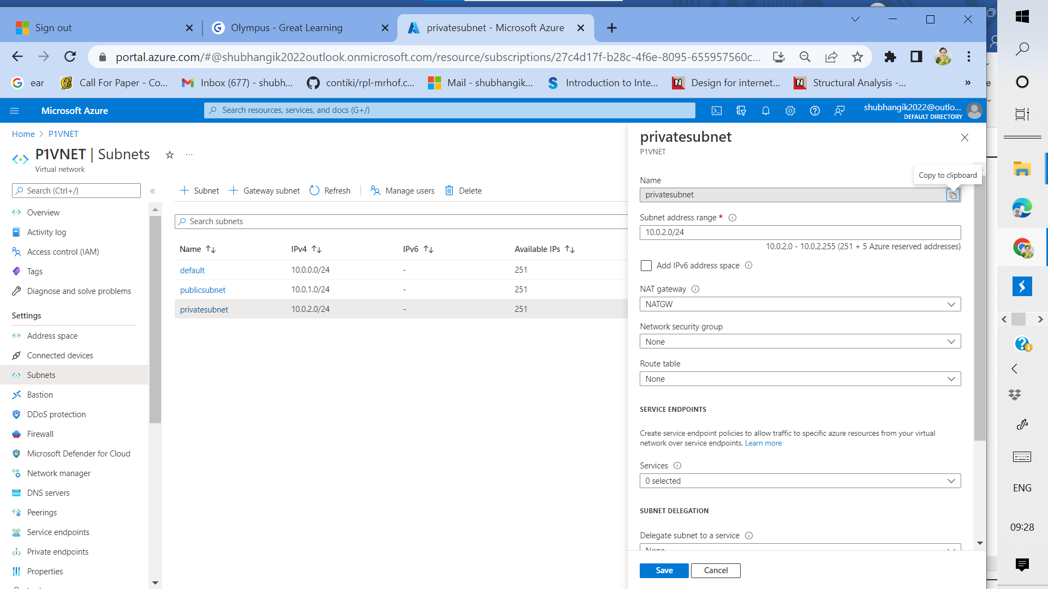

**Figure 3:** Properties of private subnet

|  |  |  |
| --- | --- | --- |
| Step number | b |  |
| Step name | Creation of NAT Gateway |  |
| Instructions | 1) Navigate to NAT Gateways  2) Click on "Create"   1. Use the resource group created above and the same region it is deployed in 2. Use a new public IP and public IP prefix for the NAT gateway. Ensure that the public IP prefix has a CIDR size of /30 🡪/30 is not accepted in azure free trial subscription. So used pay as U go service 3. When asked to select the subnet, select the private subnet created above 4. Click on Create   3) Navigate to virtual network and select the network created above  4) Select the private subnet created under Subnets in the menu on the left of the screen.  5) Under NAT Gateway, select the gateway created just now and select Save. |  |
| Expected screenshots | 1. Created NAT gateway |  |

**<Insert Screenshot b(1) here>**

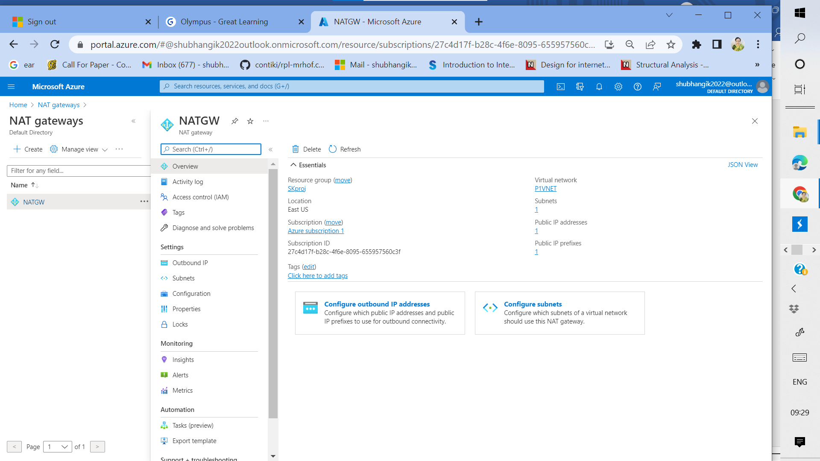

**Figure 4:** Created NAT Gateway

|  |  |
| --- | --- |
| Step number | c |
| Step name | Creation and configuration of Network security groups |
| Instructions | 1) Navigate to Network Security Groups  2) Click on Create   1. Resource Group: Use the one previously created 2. Enter the name: AppNSG 3. Region: Same as the resource group   4) Click on Create  5) Create another security group with the name DbNSG  6) Navigate to the security group AppNSG  7) Add inbound rules for ports 22 and 80 for any sources and destinations  8) Navigate to the security group DbNSG  9) Add inbound rules for ports 3306 and 22 for any sources and destinations |
| Expected screenshots | 1. AppNSG security rules 2. DbNSG security rules |

**<Insert Screenshot c(1) here>**

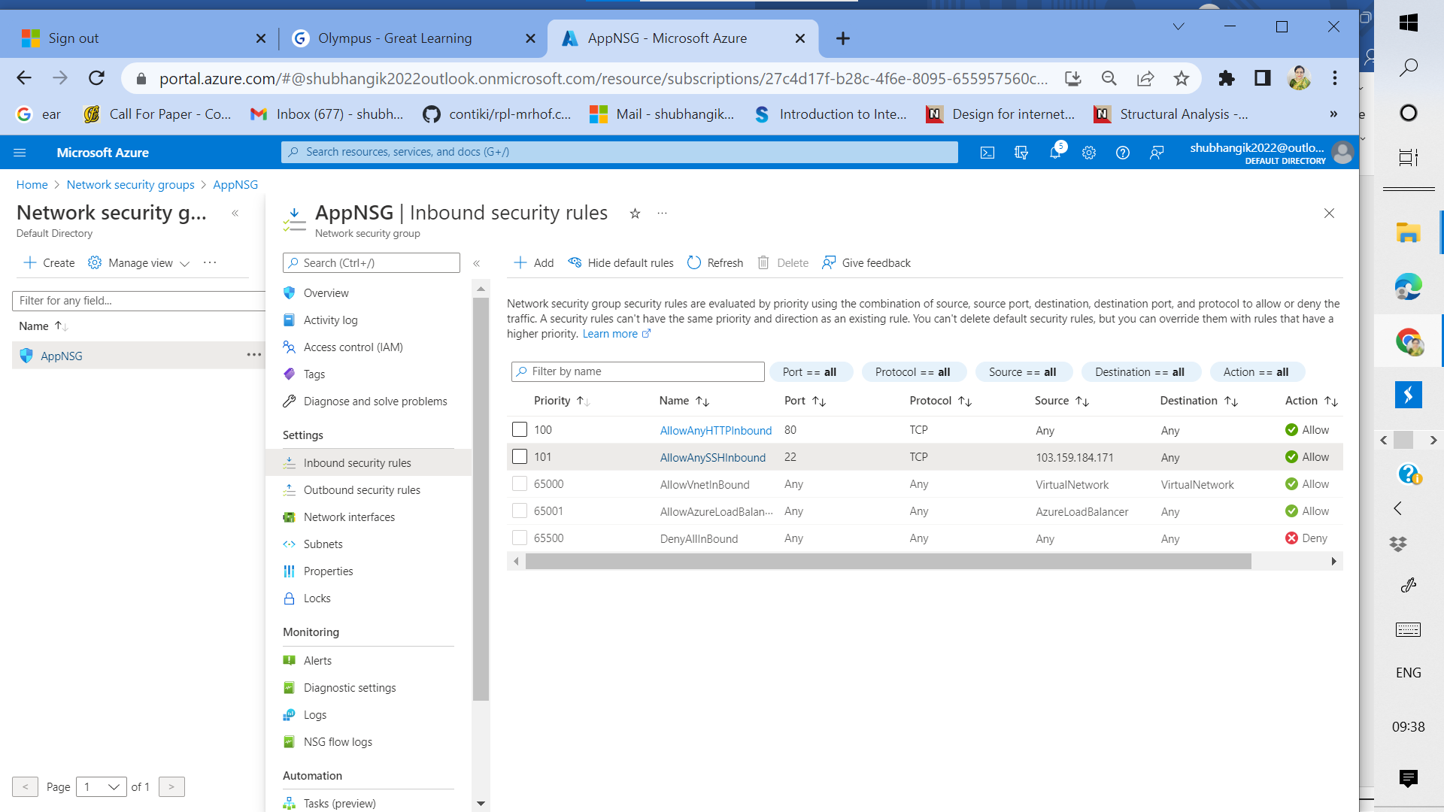

**Figure 5: AppNSG security rules**

**<Insert Screenshot c(2) here>**

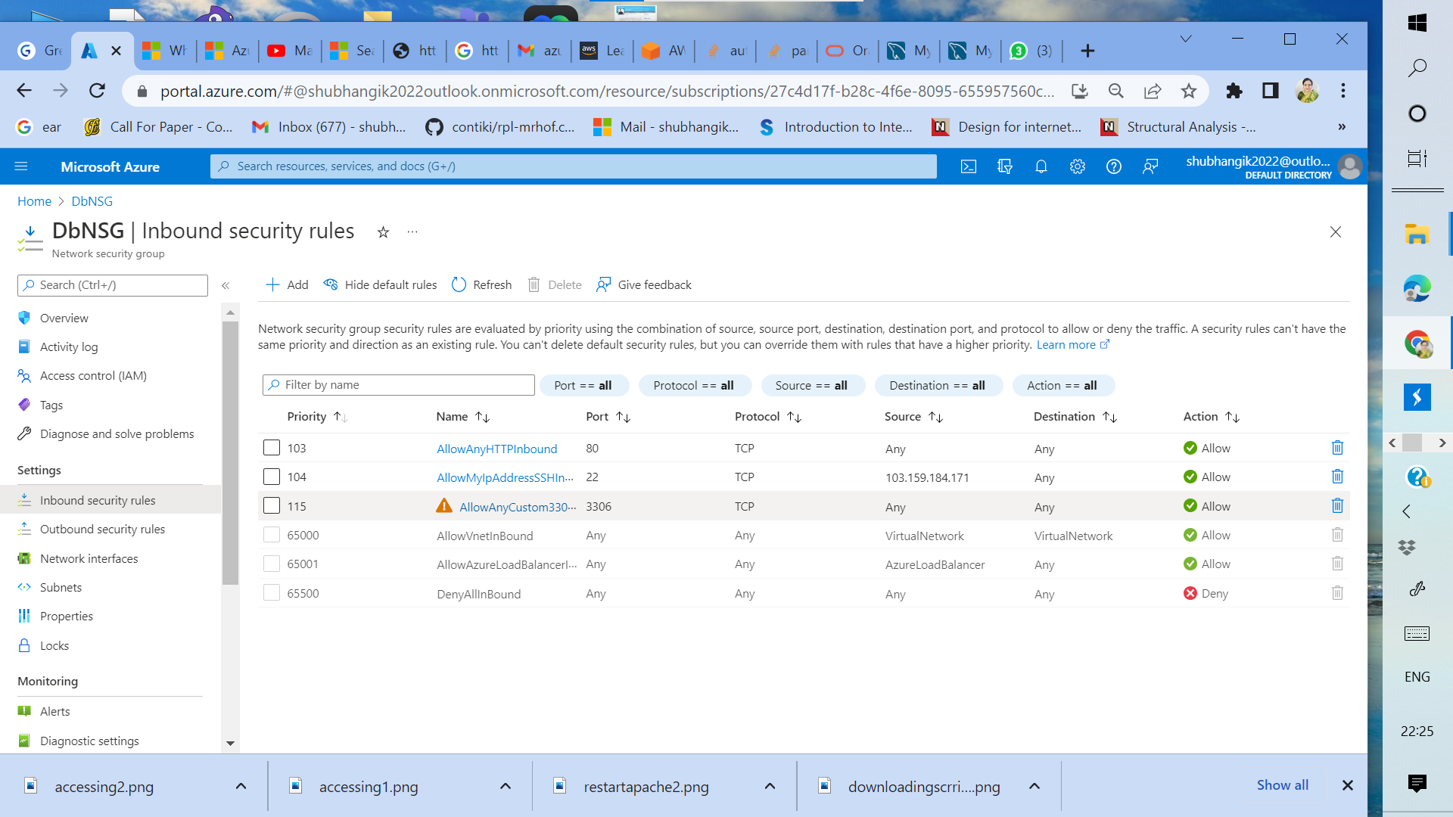

**Figure 6: DbNSG security rules**

**Step 2 : Instance Creation**

|  |  |  |
| --- | --- | --- |
| Step number | a |  |
| Step name | Creation of Application server |  |
| Instructions | 1) Navigate to Virtual machines  2) Click on "Create"  3) Create a virtual machine with the following properties   1. Resource Group: As Created above 2. Region: Same as used before 3. Image: Ubuntu 18.04 LTS 4. Authentication type: SSH public key 5. Username: ubuntu 6. Create a new key pair 7. Inbound rules: Allow 22 and 80 8. Virtual Network : P1VNET 9. Subnet : Public subnet create above 10. Create a new public IP 11. Network security group: Select Advanced and then pick AppNSG from the dropdown 12. The rest of the options can be set to their default Values |  |
| Expected screenshots | 1. Created Application server Overview page |  |

**<Insert Screenshot a(1) here >**

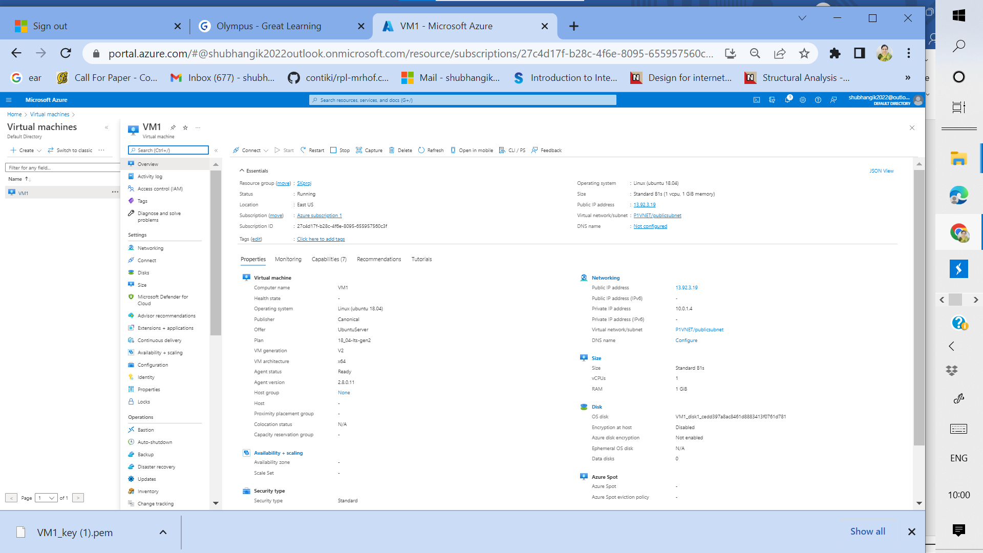

**Figure 7: Created Application server Overview page**

|  |  |  |
| --- | --- | --- |
| Step number | b |  |
| Step name | Creation of Database server |  |
| Instructions | 1) Create a virtual machine with the following properties   1. Resource Group: As Created above 2. Region: Same as used before 3. Image : Ubuntu 18.04 LTS 4. Authentication type: SSH public key 5. Username: ubuntu 6. Create a new key pair (or reuse the one created for the application server) 7. Inbound rules: Allow 22 and 80 8. Virtual Network : P1VNET 9. Subnet : Private subnet create above 10. No public IP is required here 11. Network security group: Select Advanced and then pick DbNSG from the dropdown 12. The rest of the options can be set to their default Values |  |
| Expected screenshots | 1. Created Database server overview page |  |

**<Insert Screenshot 2(b) here>**

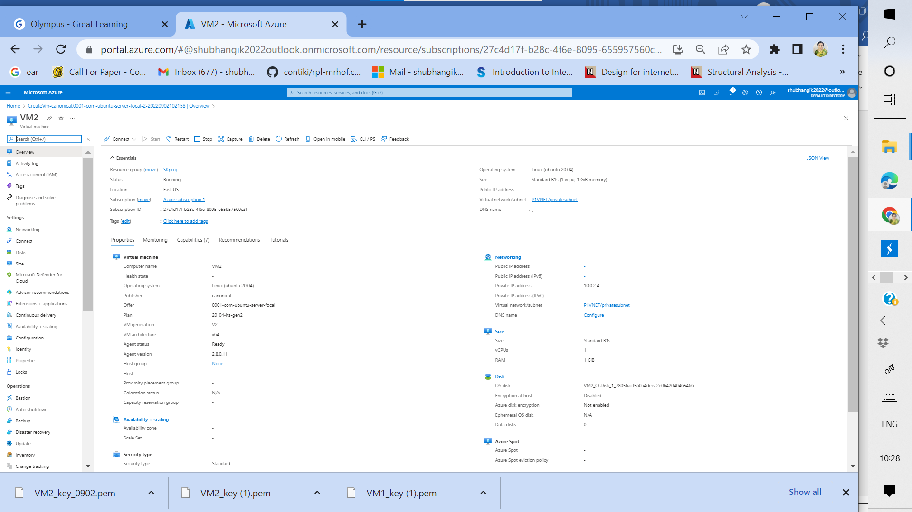

**Figure 8: Created Database server overview page**

**Step 4: Application and Database Installation and Testing**

|  |  |  |  |  |
| --- | --- | --- | --- | --- |
| Step number | a |  |  |  |
| Step name | Installation and configuration of MySQL |  |  |  |
| Instructions | 1) Copy the database pem file into the application server using the below command  *scp -i <application server pem file> <database server pem file > ubuntu@<application server public IP>:/home/ubuntu*  2) Log into the application server using your SSH client of choice  3) From the application server, log into the database server using the pem file copied in step 1and the private IP address of the database server with the following command  *ssh -i <database server pem file> ubuntu@<private IP of database server>*  4) Enter the following commands to install and configure MySQL on the database server *sudo apt update*  *sudo apt install dos2unix -y*  *wget* [*https://d6opu47qoi4ee.cloudfront.net/azure_install_mysql.sh*](https://d6opu47qoi4ee.cloudfront.net/azure_install_mysql.sh)  *sudo chmod 700 azure_install_mysql.sh sudo dos2unix azure_install_mysql.sh*  *sudo ./azure_install_mysql.sh*  5) Type *exit* to exit the database server and go back to the application server | | | |
| Expected screenshots | 1. Downloading of the provided script 2. Executing the script |  |  |  |

**<Insert screenshot a(1) here>**

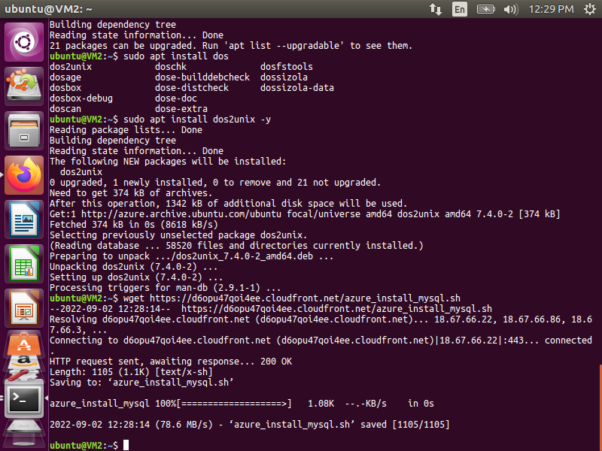

**Figure 9: Downloading of the provided script**

**<Insert screenshot b(1) here>**

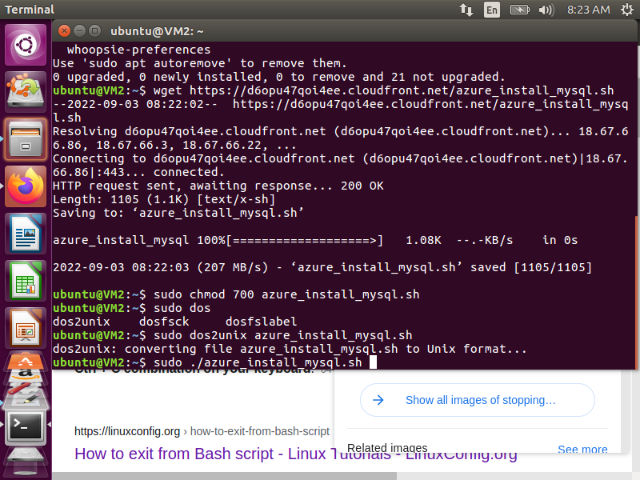

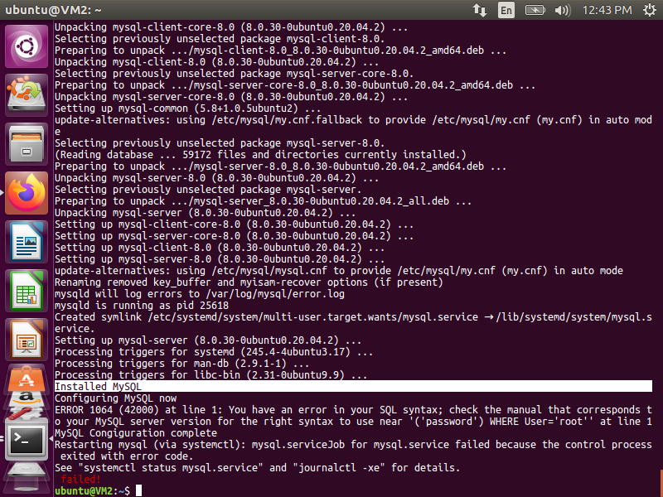

**Figure 10: Executing the script**

|  |  |  |  |  |
| --- | --- | --- | --- | --- |
| Step number | b |  |  |  |
| Step name | Installation and configuration of Mattermost |  |  |  |
| Instructions | 1) Enter the following commands after logging into the application server via SSH to install and configure Mattermost  Learning Tip: The version of Owncloud has no bearing on this project. When migrating a legacy version of an application to the cloud, it might not be possible to update the application to current technological trends.  *sudo apt update  sudo apt install dos2unix -y wget* [*https://d6opu47qoi4ee.cloudfront.net/install_owncloud.sh*](https://d6opu47qoi4ee.cloudfront.net/install_owncloud.sh) *sudo dos2unix install_owncloud.sh*  *sudo chmod 700 install_owncloud.sh*  *sudo ./install_owncloud.sh*  *sudo systemctl restart apache2*  2) Check whether the server has been successfully deployed by visiting the public IP of the web server in the web browser. | | | |
|  |
|  |
|  |
|  |
|  |
|  |
|  |
|  |
|  |  |  |  |  |
| Expected screenshots | 1. Downloading the script 2. Executing the script 3. Accessing the application via web browser |  |  |  |

**<Insert screenshot b(1) here>**

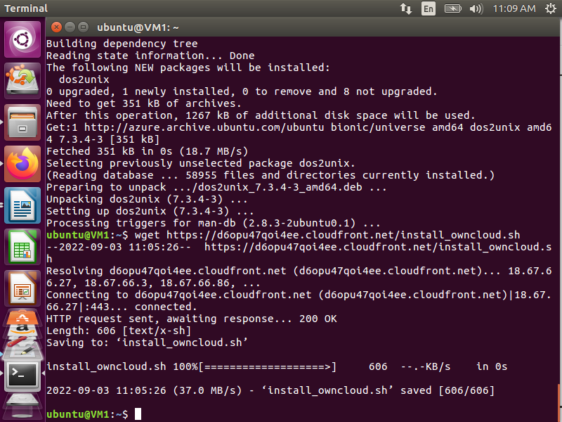

**Figure 11: Downloading the script**

**<Insert screenshot b(2) here>**

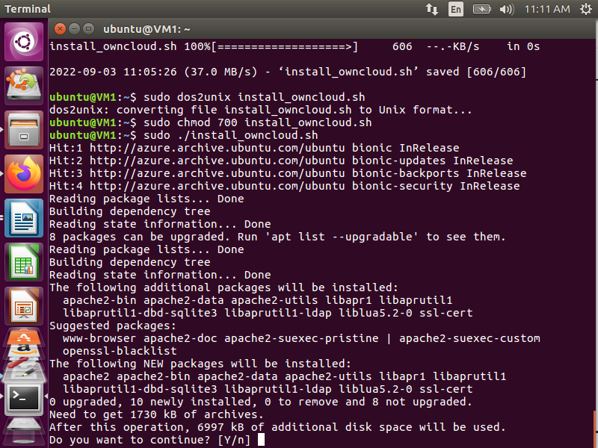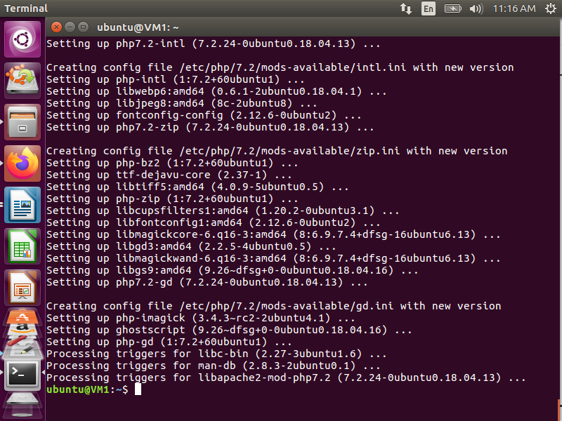

**Figure 12: Executing the script**

**<Insert screenshot b(3) here>**

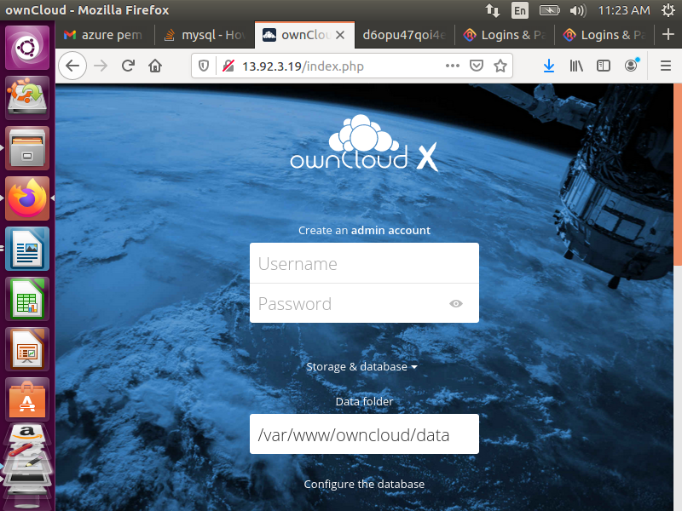

**Figure 13: Accessing the application via web browser**

**Step 5: Answer the following questions**

1. Which of the following resources is optional at the time of VM creation?
   1. **Public IP address**
   2. Virtual Network
   3. Network Interface
   4. Resource Group

**Answer 1 a) Public IP address**

1. Network Security group rules are evaluated in order of ________.
   1. **Priority**
   2. Name (Alphabetical)
   3. Direction
   4. Port number

**Answer 2 a) Priority**

1. Which of the following properties may change depending on the size of the VM?
   1. **All of these**
   2. Max number of disks
   3. Memory
   4. vCPUs

**Answer 3 a) All of these**

1. Which of the following qualifies as a destination for inbound NSG rules?
   1. **NIC**
   2. Virtual Network
   3. Resource Group
   4. Virtual machine

**Answer 4 a) NIC**

1. Which of the following is not true about local VNET Peering?
   1. It is transitive
   2. It is commutative
   3. The 2 networks need to be in the same region
   4. **All of these**

**Answer 5d) All of these**

1. Which of the following would qualify as a point-to-site VPN connection?
   1. **Local machine to VPN gateway**
   2. VM to VM within the same virtual network
   3. VM to VM within the different virtual network
   4. VM to MySQL deployment within the same virtual network

**Answer 6 a) Local machine to VPN gateway**

1. Which of the following is not a property of an incoming load balancer request?
   1. Source IP
   2. Protocol
   3. Destination port
   4. **Name of virtual network**

**Answer 7d) Name of virtual network**