Autonomous Social Media Content Studio
5-Day Implementation Roadmap | Backend: LangGraph + FastAPI
Python | LangGraph | LangChain | Pydantic | FastAPI + Uvicorn | OpenAI / Anthropic Effort: 5 days x 8 hrs = 40 hrs

1. Project at a Glance
One idea or blog goes in. A team of AI agents, led by a Content Manager, turns it into publish-ready LinkedIn, X and Instagram content. A Review Agent critiques the drafts and the weak ones are rewritten before the final package is returned.
In scope: built in Days 1-5 | Designed for now, built later (not in the 5 days)
LangGraph workflow (state machine)  Manager, LinkedIn, X, Instagram and Review agents  Plan-Act-Check loop with reflection (max 2 revisions)  FastAPI backend, error handling, optimization  Tests, demo and documentation | Frontend: web UI that calls the same API  Authentication: API key or JWT on the routes  Observability: tracing, metrics, dashboards  The architecture leaves clear plug-in points for these (see Section 6).

2. System Architecture
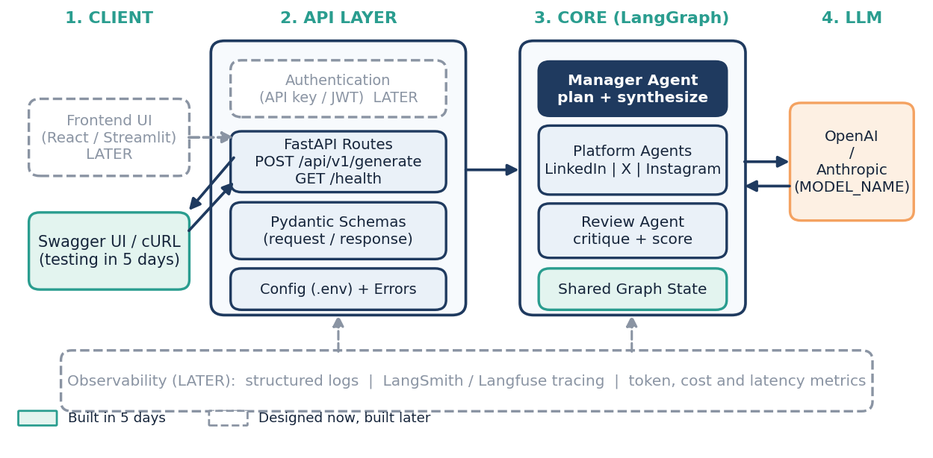
Figure 1: Layered architecture. Solid boxes are built in 5 days; dashed boxes are future extensions.
How a request flows: Client sends the idea to POST /api/v1/generate. FastAPI validates it with Pydantic, runs the LangGraph workflow once, and returns the final content package. The graph is built once at startup and reused for every request.

3. Backend Folder Structure
backend/  app/  main.py FastAPI app, startup  config.py .env settings  schemas.py Pydantic models  llm.py model factory + retries  api/routes.py /generate, /health  prompts/ prompt text per agent  tests/, docs/, .env.example, requirements.txt | graph/state.py GraphState  graph/builder.py nodes + edges  graph/routing.py approve / revise logic  agents/manager.py plan + synthesize  agents/linkedin.py platform agent  agents/x.py platform agent  agents/instagram.py platform agent  agents/reviewer.py critique + score
Each agent is its own module, so prompts, logic and tests stay separate. Auth, tracing and a frontend can be added later without changing the graph code.

4. Agent Workflow (State Machine)
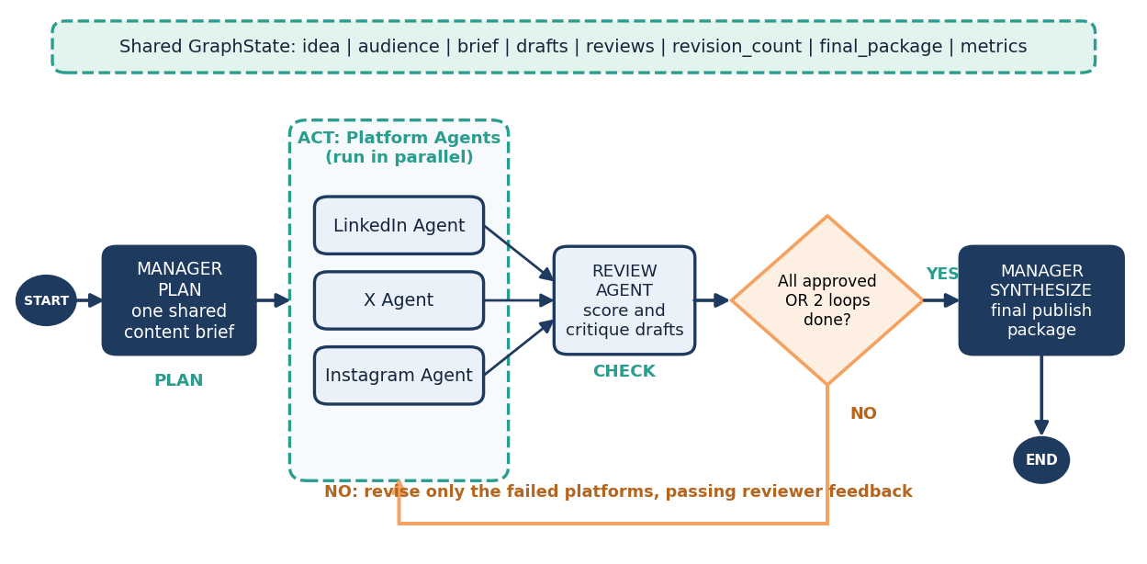
Figure 2: LangGraph state machine following the Plan - Act - Check pattern with a revision loop.
Agent / Node | Responsibility | Output (Pydantic model)
Content Manager (Plan) | Reads the idea, audience and platforms. Builds one shared content brief (key message, tone, facts, call to action). | ContentBrief
LinkedIn Agent | Professional tone, strong first line, short paragraphs, 3-5 hashtags. Ideal length about 1,300 characters. | PlatformDraft
X Agent | Punchy and direct. Hard limit of 280 characters per post (checked in code); optional thread of up to 5 posts. | PlatformDraft
Instagram Agent | Friendly and visual tone, emojis, a clear call to action and relevant hashtags. | PlatformDraft
Review Agent (Check) | One call scores all drafts (1-10), lists issues, checks cross-platform consistency. A draft is approved at score 8 or above. | ReviewResult
Content Manager (Synthesize) | Decides: approve or send back. Assembles the final package in plain code (no extra LLM call). | FinalPackage
Loop rule: if any draft is below the pass score, only those platforms are rewritten using the reviewer's feedback. The loop stops after 2 revisions, and any still-weak draft is returned with a warning, so the system can never loop forever.

5. Day-wise Implementation Plan
Each day ends with a working, testable result. Estimates assume 8 productive hours per day and include writing, running and fixing.
DAY 1: Foundation, State Design and Graph Skeleton |  |  | 8 hrs
Goal: A runnable LangGraph with placeholder nodes and all data models defined.
# | Task | What to do (output) | Est.
1 | Repo and environment setup | Create backend/ with venv, requirements.txt and .env.example (OPENAI_API_KEY, ANTHROPIC_API_KEY, MODEL_NAME, DEBUG_MODE). Load settings in config.py using dotenv. | 1 h
2 | Roles and contracts | Finalize each agent's input, output and rules in a short docs/agents.md. This is the reference for later days. | 1 h
3 | State and Pydantic models | Define GraphState, ContentBrief, PlatformDraft, ReviewResult, FinalPackage and the API request/response models. | 2 h
4 | LLM client wrapper | llm.py with a get_llm() factory (OpenAI or Anthropic via MODEL_NAME), a structured-output helper, timeouts and retries. | 1.5 h
5 | Graph skeleton | Add all nodes as stubs returning dummy data and wire the edges, including the conditional revise/approve edge. Run end to end from a local script. | 2 h
6 | Logging and debug flag | Basic logging; DEBUG_MODE prints each node's input and output. | 0.5 h
Exit check: Local script runs START to END with dummy data; state diagram saved in docs/.

DAY 2: Manager Plan Node and Platform Agents |  |  | 8 hrs
Goal: Three platform agents produce quality drafts from a shared content brief.
# | Task | What to do (output) | Est.
1 | Prompt design | Write a shared style guide plus one prompt per platform (tone, length, hashtags, call to action). Store in prompts/. | 1 h
2 | Manager Plan node | Turns raw idea, blog or transcript into one ContentBrief (message, audience, tone, key facts). Created once and reused by all agents to avoid repeated work. | 1.5 h
3 | LinkedIn Agent | Generate a structured PlatformDraft; add a length check in code. | 1.5 h
4 | X Agent | Same pattern; code check that every post is within 280 characters, with thread support. | 1.5 h
5 | Instagram Agent | Caption with emojis, hashtags and call to action; code check on hashtag count and length. | 1.5 h
6 | Agent tests | Unit tests with a mocked LLM plus one manual run on a sample blog. | 1 h
Exit check: Sample blog returns three valid drafts that follow each platform's rules.

DAY 3: Review Agent, Reflection Loop and Manager Control |  |  | 8 hrs
Goal: The full Plan - Act - Check loop works with controlled revisions.
# | Task | What to do (output) | Est.
1 | Review Agent | One call reviews all drafts: score 1-10, issues, suggestions, approved flag, plus a consistency check across platforms (same message and facts). | 2 h
2 | Parallel fan-out and fan-in | Run the three platform agents in parallel using LangGraph's Send API; merge drafts into state with a reducer. | 1.5 h
3 | Revision routing | Conditional edge: approve if all scores are at least 8, else route only the failed platforms back with feedback. Track revision_count; stop at MAX_REVISIONS = 2. | 2 h
4 | Manager Synthesize node | Build FinalPackage: final posts, scores, revision history and any warnings. Pure code, no LLM call. | 1.5 h
5 | Scenario testing | Test 3 inputs (long blog, short idea, transcript). Confirm the loop triggers, improves a weak draft and stops correctly. | 1 h
Exit check: A weak draft is rewritten once or twice, then the final package is returned.

DAY 4: FastAPI Backend, Error Handling and Optimization |  |  | 8 hrs
Goal: The workflow is available as a stable, tested API and runs efficiently.
# | Task | What to do (output) | Est.
1 | FastAPI skeleton | main.py with routers, GET /health, CORS settings; compile the graph once at startup. | 1 h
2 | Generate endpoint | POST /api/v1/generate: validate input (idea, audience, platforms, tone), run the graph, return the FinalPackage model. | 2 h
3 | Error handling | Custom exceptions, retry with backoff on LLM failures, partial result with a warning if one agent fails, clear 4xx/5xx responses. | 1.5 h
4 | Optimization pass | One shared brief, parallel agents, one batched review call, rewrite only failed platforms, max_tokens limits, optional cheaper model for review. Record llm_calls and latency in state. | 2 h
5 | API tests | pytest with FastAPI TestClient and a mocked LLM for success, bad input and failure cases. | 1.5 h
Exit check: curl or Swagger UI call returns a full content package in a clean JSON format.

DAY 5: Testing, Demonstration and Documentation |  |  | 8 hrs
Goal: Verified system, demo ready and documentation complete as the single source of truth.
# | Task | What to do (output) | Est.
1 | End-to-end testing | Run 4 real inputs (blog, idea, transcript, very short text) with the live LLM. Fix prompt and routing issues. | 1.5 h
2 | Performance analysis | Compare before and after optimization: LLM calls, latency and tokens per request. | 1 h
3 | Demonstration | Script showing multi-platform generation and one refinement example (draft, critique, improved draft). | 1.5 h
4 | Architecture and design docs | Final diagrams, agent roles, delegation logic, reasoning flow and design trade-offs. | 2 h
5 | README and cleanup | Setup steps, run commands, API examples; refactor, remove dead code, check error handling. | 1.5 h
6 | Buffer | Reserved time for fixes found in testing. | 0.5 h
Exit check: A new person can set up, run and understand the project using only the README and docs.

6. Ready for Extension (After Day 5)
Capability | Where it plugs in | Already prepared in core
Frontend | A web app calls POST /api/v1/generate and shows drafts and scores. | CORS enabled, stable response model, versioned /api/v1 path.
Authentication | A FastAPI dependency on the router (API key first, JWT later). | Routes grouped in one router so one dependency protects all.
Observability | LangSmith or Langfuse tracing passed through the graph run config; log shipping. | Logging module, request ID, and llm_calls / latency stored in state.

7. Risks and Deliverable Mapping
Risk | Mitigation
LLM returns badly formatted output | Use structured output with Pydantic and retry once on parse failure.
Endless revision loop or high cost | Hard cap of 2 revisions, max_tokens limits, rewrite only failed platforms.
Platform limits broken (e.g. X 280 characters) | Code-level validators run after generation, before review.
Schedule slips | Day 3 is the critical day. If late, move scenario testing into Day 5 buffer; keep optional extras out.

Project deliverable (from brief) | Delivered on
Functional multi-agent system with reflection loop | Days 2-3
Architecture and workflow design (diagrams, delegation logic) | Day 1 draft, Day 5 final
Optimization, refactoring and error handling | Day 4
Demonstration with iterative refinement example | Day 5
Documentation (roles, workflow, trade-offs) | Day 5
Definition of done: all four agents plus manager run in one LangGraph; the revision loop works and stops at the limit; the API passes its tests; docs and demo are complete.

