**Task 1: Data Modeling and Cleaning**

1. I have first uploaded all the CSV file in Power Query Editor.
2. Remove duplicate rows based on key columns (e.g., Customer_ID, Store_ID) from Remove rows option.
3. Format columns: Convert dates, ensure numeric types for Amount, Points, etc. by left clicking on column header
4. Handle missing or null values appropriately by replace value option.
5. Membership_Duration, I first select membership_date then from date option I clicked age it gives the days duration. After that custom column in Membership_duration = Divide(Day_duration,365,0). And change decimal to whole no.
6. Add a Transaction_Year and Transaction_Month column from Transaction_Date by Date menu in Addcolumn tab.
7. Data Model view - One-to-Many: Customer_Demographics → Transactions, Loyalty_Program, Churn_Labelled_Customers

○ Many-to-One: Transactions → Store_Locations. Made relationship and click on active relationship.

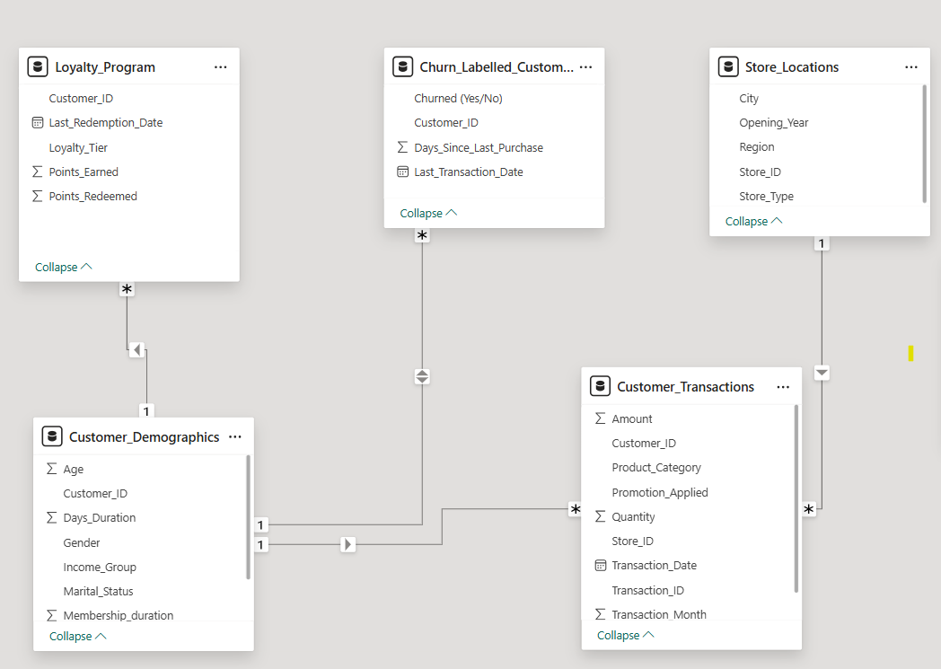

**Task 2: Churn and Retention Metrics**

1. Churn rate = Churned customer/Total customer *100

Customers Churned = CALCULATE(COUNT('Churn_Labelled_Customers'[Customer_ID]),'Churn_Labelled_Customers'[Churned (Yes/No)] = "Yes”)

Total Customers = DISTINCTCOUNT('Churn_Labelled_Customers'[Customer_ID])

1. Visualize churn rate by: ○ Region ○ Income Group ○ Store Type (via store join) ○ Identify top 5 segments with highest churn %
2. Create funnel chart: Total Customers → Repeat → Churned

**Task 3: Repeat Purchase Analysis**

1. Create a measure:

Low-Tier Customers: (2-4 purchases) = CALCULATE(

DISTINCTCOUNT(Customer_Transactions[Customer_ID]),

FILTER(

Customer_Transactions,

Customer_Transactions[PurchaseCount]>= 2 && Customer_Transactions[PurchaseCount] <= 4 )

)

Mid-Tier Customers: (5-10 purchases) = CALCULATE(

    DISTINCTCOUNT(Customer_Transactions[Customer_ID]),

    FILTER(

        Customer_Transactions,

        Customer_Transactions[PurchaseCount]>= 5 && Customer_Transactions[PurchaseCount] <= 10

    )

)

High-Tier Customers: (11+ purchases) = CALCULATE(DISTINCTCOUNT(Customer_Transactions[Customer_ID]), FILTER(Customer_Transactions, Customer_Transactions[PurchaseCount] >= 10))

1. Compare avg. purchase frequency by: ○ Region ○ Age Group ○ Loyalty Tier

AvgPurchaseFrequency =

AVERAGEX(

VALUES(Customer_Transactions[Customer_ID]),

CALCULATE(COUNT(Customer_Transactions[Transaction_ID]))

)

**Task 4: Promotion & Loyalty Impact**

1. Create Measure:

○ % of transactions where promotion was applied =

PromotionAppliedPercent =

DIVIDE(

CALCULATE(COUNT(Customer_Transactions[Transaction_ID]), Customer_Transactions[Promotion_Applied] = "Yes"),

COUNT(Customer_Transactions[Transaction_ID])

) * 100

○ Avg. purchase amount with vs without promotion

AvgAmountWithPromotion = CALCULATE(

    AVERAGE(Customer_Transactions[Amount]),

    Customer_Transactions[Promotion_Applied] = "Yes"

)

AvgAmountWithoutPromotion =

CALCULATE(

    AVERAGE(Customer_Transactions[Amount]),

    Customer_Transactions[Promotion_Applied] = "No"

)

1. Compare churn rate across loyalty tier.
2. Show Points Earned vs Redeemed by Tier using clustered column chart
3. Recommend how to improve redemption and retention

Platinum-tier customers show high churn despite loyalty status—indicating disengagement. Boost retention through exclusive experiences and personalized outreach. Gold-tier customers earn and redeem the most points—leverage this by offering targeted upsell rewards. Silver-tier needs motivation: introduce milestone bonuses to increase redemption and deepen loyalty.

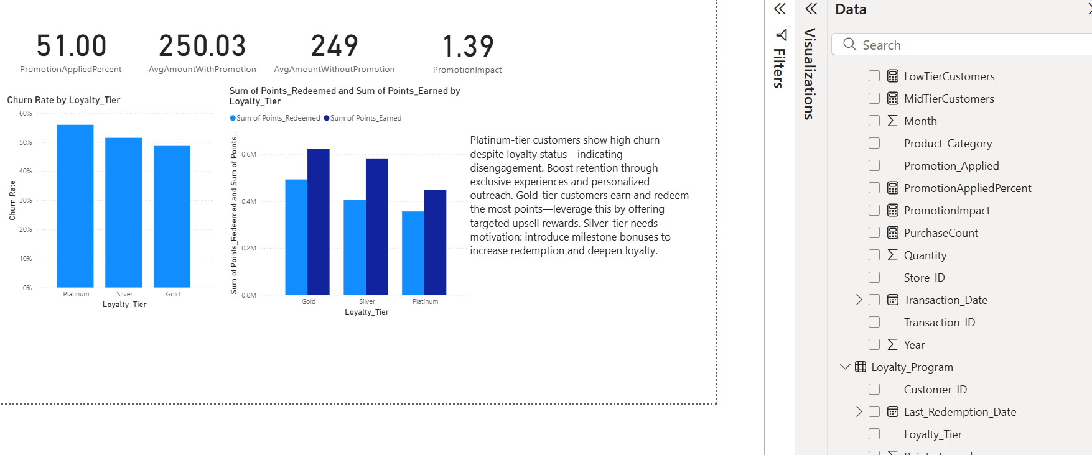

**Task 5: Store Performance vs Retention**

1. Merge Store_ID from transactions with Store_Locations
2. Visualize:

○ Avg. transaction amount by store type

○ Churn rate by store region

○ Correlation between store opening year and retention

1. Suggest where to run store-specific campaigns

Run store-specific campaigns in London locations with high amount sales of product .In loyalty tier we should go with platinum, target newer stores with low retention using welcome offers and local events. Boost Silver-tier redemption with milestone bonuses.

**Task 6 : Customer Value (CLV) Analysis**

1. Calculate CLV = Total Amount Spent / Membership Duration (in years)
2. Segment customers into: ○ Low (Bottom 25%) ○ Medium (Mid 50%) ○ High (Top 25%)

New column added

CLV = DIVIDE ( [TotalAmountSpent], Customer_Demographics[Membership_duration],

0)

CLV_25 = PERCENTILEX.INC(Customer_Demographics,Customer_Demographics[CLV],0.25)

CLV_75 = PERCENTILEX.INC(Customer_Demographics,Customer_Demographics[CLV],0.75)

CLV_Segment = SWITCH (

    TRUE(),

    [CLV] <= [CLV_25], "Low",

    [CLV] > [CLV_25] && [CLV] <= [CLV_75], "Medium",

    [CLV] > [CLV_75], "High")

1. Visualize: ○ CLV vs Days Since Last Purchase ○ CLV by Loyalty Tier and Region

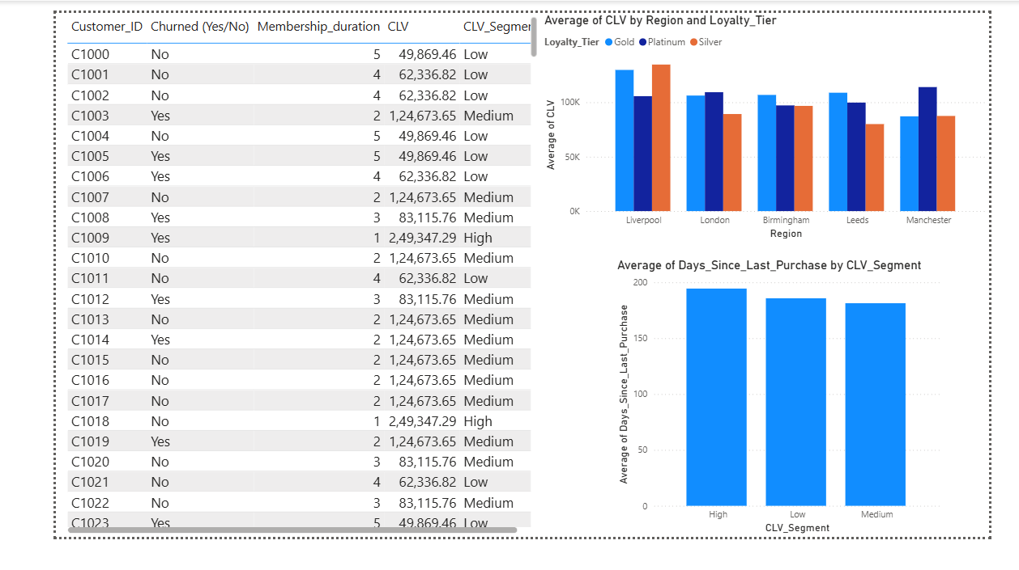

**Task 7: Final Dashboard and Executive summary**

**Create a multi-page Power BI report:**

○ Page 1: Overview KPIs (Churn, CLV, Repeat Rate)

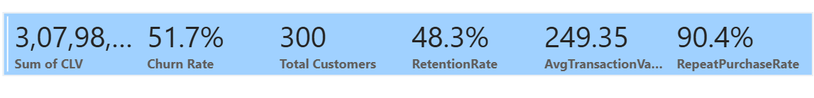

○ Page 2: Loyalty & Promotion Impact

○ Page 3: Store and Region Insights

○ Page 4: Customer Segmentation (Churned, Repeat, High-Value)

Add slicers: Region, Income Group, Loyalty Tier, Store Type

● Create a card or textbox summarizing top 3 recommendations:

● What should TESCO do to retain more customers?

TESCO should personalize loyalty rewards, enhance mobile and online experiences, and expand click-and-collect services. Strengthening community engagement and offering anticipatory services—like tailored promotions and expert support—can build trust. Segmenting customers by behavior and value ensures targeted retention strategies that boost satisfaction, repeat purchases, and long-term brand loyalty.

● Where should they focus next?

These areas will help Tesco deepen customer loyalty, reduce operational costs, and stay competitive in a rapidly evolving retail landscape. And product category for the age of 18-25 we can make more i.e. clothing, beverages, etc. Electronic product is much higher and we can now work on clothing also so that we can increase the purchase rate of clothing and branding of products. It can increase the loyality also.

Task 8: Video explaintation

Video link:

https://www.loom.com/share/cef4d735063c4cc4982b6a9b08fe14ce?sid=a228964d-7a3c-4865-8ab9-7b1b489a7fdf