

Functional design Of E-PAY MERCHANT PORTAL

August 2024

|  |  |
| --- | --- |
| **Document Control Sheet** | |
| **Current Version** | 1.1 |
| **Project Code** | CE_SBI_04_08_2024 |
| **Project Name** | SBI ePay Implementation |
| **Document Type** | ePay Merchant Portal |
| **Author** | Sagar |
| **Reviewed By** | Neeraj Durgapal |
| **Frequency of Document Review** | Next Revision of Standard Documents |
| **Document Creation Date** | 21-08-2024 |
| **Last Updated Date** | 26-08-2024 |

|  |  |  |  |
| --- | --- | --- | --- |
| **Revision History** | | | |
| **Version** | **Date** | **Name** | **Comments** |
| 1.0 | 21-08-2024 | Sagar T | Draft Version |
| 1.1 | 26-08-2024 | Sagar T | Addressed Review Comments |

**Table of Content**

Document Purpose 9

Scope 9

1. Merchant Service 9

2. Reporting 9

Business Requirement Mapping 10

Actors 10

Functions 10

Functional Flow 11

Functional Specifications 12

1. FS_MS_1 – Merchant Login 12

1.1 - Objective 12

1.1.1 - Merchant SignUp 12

1.1.2 - Merchant Login using Mobile Number 12

1.1.3 - Merchant Login using Email 12

1.1.4 - Merchant Login using UserID 12

Note: Merchant will be able to edit/change mobile number and email. User ID cannot be changed. 12

1.2 - Functional Flow / Mockup 12

1.3 - Functional Specification 13

1.3.1 - Validation 13

1.3.2 - Token Generation Logic 13

1.3.2.1 - Generate New Token 13

1.3.3 - Token Uniqueness 13

1.3.4 - Audit 14

1.3.5- Error Code 14

1.4 - Non - Functional Specification 14

2. FS_MS_2 – Merchant Dashboard 15

2.1 - Objective 15

2.1.1 – Overview of Merchant Profile 15

2.1.2 – Overview of Transactions 15

2.1.3 – Overview of Settlements 15

2.1.4 – Overview of Refunds 15

2.1.5 – Quick report downloads 15

2.1.6 – Payment mode health 15

2.2 - Functional Flow / Mock-Up 15

2.3 Functional Specification 16

2.3.1- Overview of profile 16

2.3.2- Overview of transaction 16

2.3.2.1 – Transaction summary for a Financial Year 16

2.3.2.2 – Transaction analysis 16

2.3.2.3 – Brief view 16

2.3.3 – Settlement overview 16

2.3.3.1 – Settlement details 16

2.3.3.2 – Previous Settlement 16

2.3.3.3 – Current Settlement 16

2.3.3.4 – Historic settlement 17

2.3.4 – Refund management 17

2.3.4.1 – Refund status 17

2.3.4.2 – Refund processing 17

2.3.5 – Transaction Limit 17

2.3.5.1 – Current Limit 17

2.3.5.2 – Limit alert 17

2.3.6 – Payment mode health 17

2.3.6.1 – Health status 17

2.3.6.2 – Issue Alerts 18

2.3.6.3 – Detail view 18

2.3.7 – Reports 18

2.3.7.1 – Quick report downloads 18

2.3.7.2 – Detail report 18

2.3.8- Validation 18

2.3.8.1 – Role-Based Access 18

2.4 - Non - Functional Specification 18

3. FS_MS_3 – Merchant User Management 19

3.1 - Objective 19

3.1.1 - Merchant User Management 19

3.1.2 - Merchant Key Management 19

3.2 - Functional Flow / Mockup 20

3.3 Functional Specification 20

3.3.1- Users 20

3.3.1.1 - Create new Merchant User 20

3.3.1.2 - Disable a Merchant User 21

3.3.1.3 - Edit roles 21

3.3.1.3.1 Merchant Users 21

3.4 - Non - Functional Specification 23

4. FS_MS_4 – Settlement 23

4.1 – Objective 23

4.1.1 – Settlement Tracking 23

4.1.2 – Settlement History 23

4.1.3 – Pending Settlement 23

4.2 - Functional Flow / MockUp 23

4.3 Functional Specification 23

4.3.1- Settlement Overview 24

4.3.1.1 – Real-Time Settlement Status 24

4.3.1.2 – Summary Dashboard 24

4.3.2- Settlement History 24

4.3.2.1 – Detailed Records 24

4.3.2.2 – Filtering Options 24

4.3.2.3 – Export Functionality 24

4.3.4- Pending Settlements 24

4.3.4.1 – Pending Settlement List 24

4.3.4.2 – Automated Alerts 24

4.4 - Non - Functional Specification 25

5. FS_MS_5 – Invoices 25

5.1 - Objective 25

5.1.1 - Listing Invoices 25

5.1.1 - Listing Invoices 25

5.2 - Functional Flow / Mockup 26

5.3 Functional Specification 26

5.4 - Non - Functional Specification 26

6. FS_MS_6 – Refunds 26

6.1 - Objective 26

6.1.1 - Refund Booking 26

6.1.2 - View Refund Requests and its details 26

6.2 - Functional Flow / Mockup 27

6.2.1 Refund Booking 27

6.3 Functional Specification 27

6.3.1 - Basic Validation Check 27

6.3.1.1 - Refund Eligibility 27

6.4 - Non - Functional Specification 30

7. FS_MS_7 – Merchant Key Management 30

7.1 - Objective 30

7.1.1 – Key Generation 30

7.1.2 – Key Regeneration and Revocation 30

7.1.3 – Key Download 30

7.1.4 – Audit trial 30

7.1 - *Process* 30

7.2 - Functional Flow / Mock Up 31

7.3 Functional Specification 31

7.4 - Non - Functional Specification 31

8. FS_MS_8 – Reports 31

8.1 - Objective 31

8.1.1 – Order reports 32

8.1.2 – Settlements reports 32

8.1.3 – Transaction reports 32

8.1.4 – Refund reports 32

8.1.5 – Bulk refund reports 32

8.1.6 – Payments reports 32

8.1.7 – Chargeback reports 32

8.2 - Functional Flow / Mock Up 32

8.3 Functional Specification 33

8.3.1- Order Reports 33

8.3.1.1 – Detailed Breakdown 33

8.3.1.2 – Filtering Options 33

8.3.2- Settlements Reports 33

8.3.2.1 – Settlement Summary 33

8.3.2.2 – Discrepancy Tracking 33

8.3.2.3 – Historical Data 33

8.3.3- Transactions Report 33

8.3.3.1 – Transaction Overview 33

8.3.3.2 – Detailed Insights 33

8.3.3.3 – Real-Time Data 33

8.3.4- Refunds Report 34

8.3.4.1 – Refund Status 34

8.3.4.2 – Refund Details 34

8.3.4.3 – Dispute Management 34

8.3.5- Bulk Refund Report 34

8.3.5.1 – Batch Processing Overview 34

8.3.5.2 – Detailed Batch Information 34

8.3.5.3 – Batch Filtering 34

8.3.6- Payments Report 34

8.3.6.1 – Payment Summary 34

8.3.6.2 – Payment Method Analysis 34

8.3.6.3 – Reconciliation Status 34

8.3.7- Chargeback Report 35

8.3.7.1 – Chargeback Details 35

8.3.7.2 – Chargeback Status 35

8.3.7.3 – Dispute Tracking 35

8.3.8- Validation 35

8.3.8.1 – Data Integrity 35

8.3.8.2 – Role-Based Access 35

8.3.9- Scheduling 35

8.3.9.1 – Schedules 35

8.3.9.2 – Notifications 35

8.3.9.3 – Customizable Notification Settings 35

8.4 - Non - Functional Specification 36

# Document Purpose

This document outlines the features to be covered in Merchant Dashboard that will enable merchants to have a holistic view of engagement with SBIePay.

# Scope

1. Merchant Service

The core responsibility of Merchant Microservices

* Login and Signup
  + Generate Token for Merchants and its partners with the right credentials for secure access to Merchant Portal
* Dashboard
  + Visual representation of summarized data like monthly transactions for Merchant Group user ID & Merchant user ID, Payment Modes Health, real time limit usage
* Merchant Key Management
  + View Current Keys
  + Request for key regeneration
* Merchant User Management
  + Create Merchant Users and its Permissions
* Settlement
  + View settled Transactions and its details
* Invoices
  + View or Download invoices generated
* Refunds
  + Initiate and fetch details for refund

1. Reporting

* Report Generation
  + Generate various reports useful for the Merchant & Partners

Business Requirement Mapping

|  |  |  |
| --- | --- | --- |
| FS | BRD | BRD Details |
| FS_MS_1 | BRD 3 | Merchant Login and Authentication |
| FS_MS_2 | Merchant Dashboard with multiple summary views |
| FS_MS_3 | Merchant User Management |
| FS_MS_4 | View Settlement Details |
| FS_MS_5 | View Generated Invoices and their payment details |
| FS_MS_6 | Refund Booking Requests and Refund Details |
| FS_MS_7 | Merchant Key Generation |
| FS_MS_8 | Generation and Scheduling of Reports |
| FS_RS_9 | Accounts & Settings |
| FS_MS_10 |  | Order Tracking & Search |
| FS_MS_11 |  | Transaction Tracking & Search |

Actors

|  |  |
| --- | --- |
| Actors | Functions |
| Merchant Group User ID | The individual manages its group merchants and its users.  Every merchant will have a Super user ID who will assign tools/functionalities to sub users. Multiple super User IDs comes under one group user ID. |
| Merchant Super user ID | The individual can access various features for that merchant created by the system. |
| Merchant user IDs | The individual who can access various features based on the role assigned by Merchant Super user ID or Merchant Group user ID for that specific Merchant |

# Functional Flow

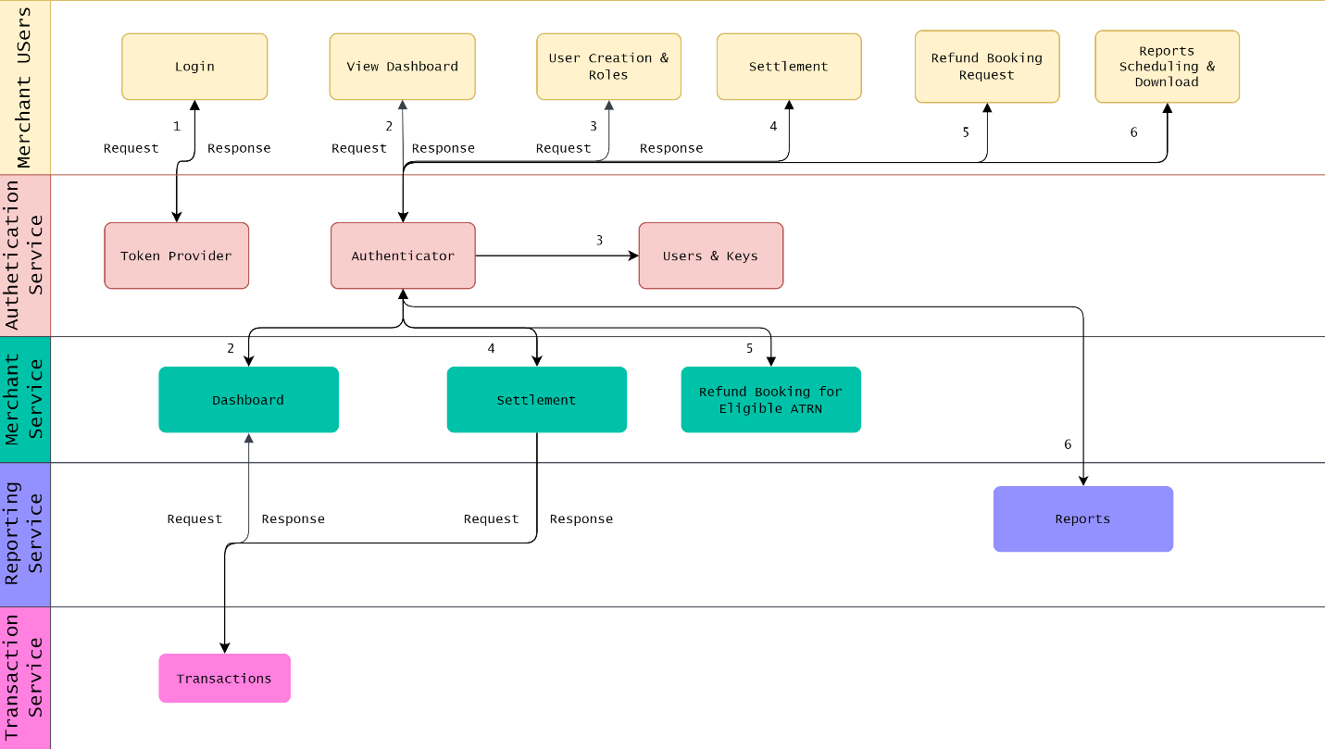

# Functional Specifications

## FS_MS_1 – Merchant Login

### 1.1 - Objective

Merchant should be able to login using their credentials provided during onboarding.

#### 1.1.1 - Merchant SignUp

#### 1.1.2 - Merchant Login using Mobile Number

#### 1.1.3 - Merchant Login using Email

#### 1.1.4 - Merchant Login using UserID

#### Note: Merchant will be able to edit/change mobile number and email. User ID cannot be changed.

### 1.2 - Functional Flow / Mockup

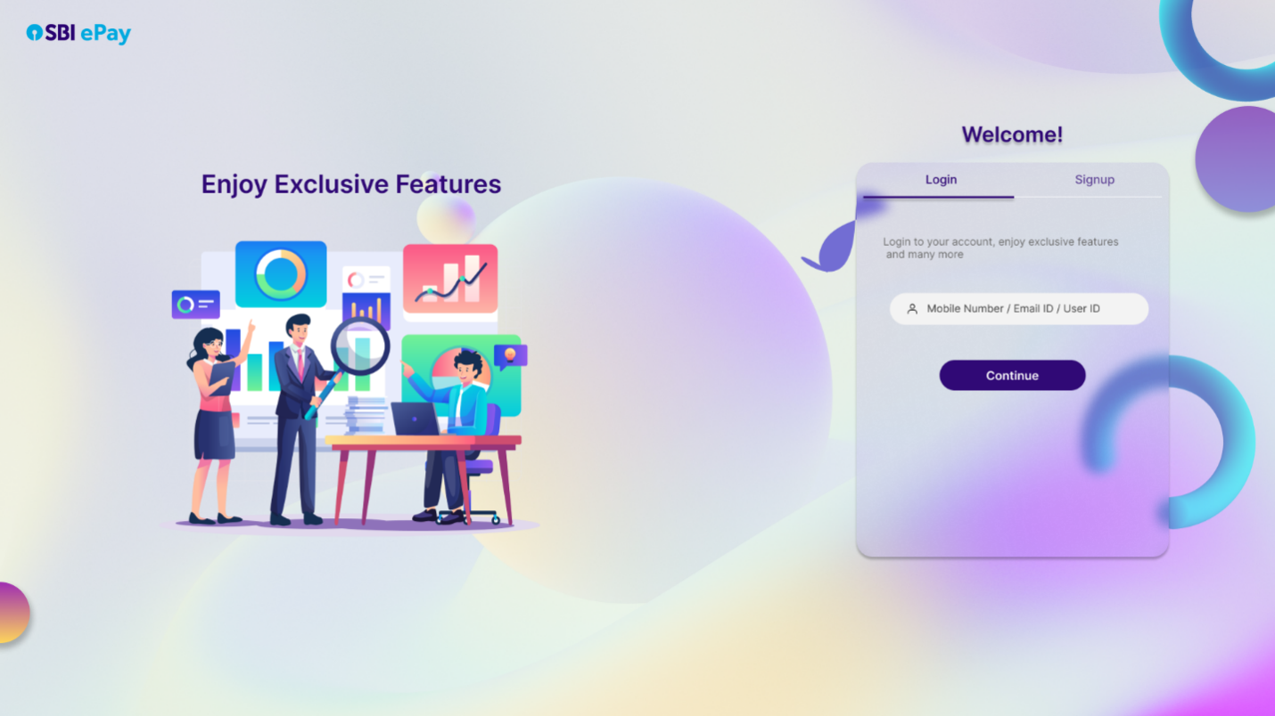

### 1.3 - Functional Specification

#### 1.3.1 - Validation

* + - Token request should have the below parameters

|  |  |  |
| --- | --- | --- |
| Parameter | Mandatory | Description |
| Email | Yes, if Phone is not provided | Merchant User’s Email |
| Phone | Yes, if Email is not provided | Merchant User’s Phone Number |
| Function Type | Yes | MerchantToken |

* + - OTP will be generated post email or phone number is validated and existence is confirmed.
    - If phone number or email ID exists and valid then to merchant registered mobile number.
    - Merchant User Information like Active, Merchant allowed for Login, Password is not expired etc.
    - Captcha will be displayed to merchant user while submitting the OTP for signup and sign in process

#### 1.3.2 - Token Generation Logic

##### 1.3.2.1 - Generate New Token

* + - * After invalidating any existing tokens, proceed with generating a new token as per the roles defined.

#### 1.3.3 - Token Uniqueness

* + - **Functionality Scope:** Limits to what the token can be used for (e.g. Reports, Refunds etc.).
    - **Expiration Time:** Define the validity period for the token based on the merchant's configuration.
    - **Unique Identifier:** A secure, unique identifier to ensure that the token is distinct and traceable.

#### 1.3.4 - Audit

* + - All Token Requests and Responses must be securely logged and stored in the Database Layer.

1.3.5- Error Code

* + - Maintain the proper Individual Error Code for each failure

### 1.4 - Non - Functional Specification

TBD

## FS_MS_2 – Merchant Dashboard

### 2.1 - Objective

The Merchant Dashboard should provide merchants with a detailed overview of their transactions, settlements, refunds, payments, transaction limits, payment mode health, reports etc.

Specification for Merchant Roles (e.g., Group user ID, Merchant User) have access to specific sections based on their designated role permissions.

#### 2.1.1 – Overview of Merchant Profile

#### 2.1.2 – Overview of Transactions

#### 2.1.3 – Overview of Settlements

#### 2.1.4 – Overview of Refunds

#### 2.1.5 – Quick report downloads

#### 2.1.6 – Payment mode health

### 2.2 - Functional Flow / Mock-Up

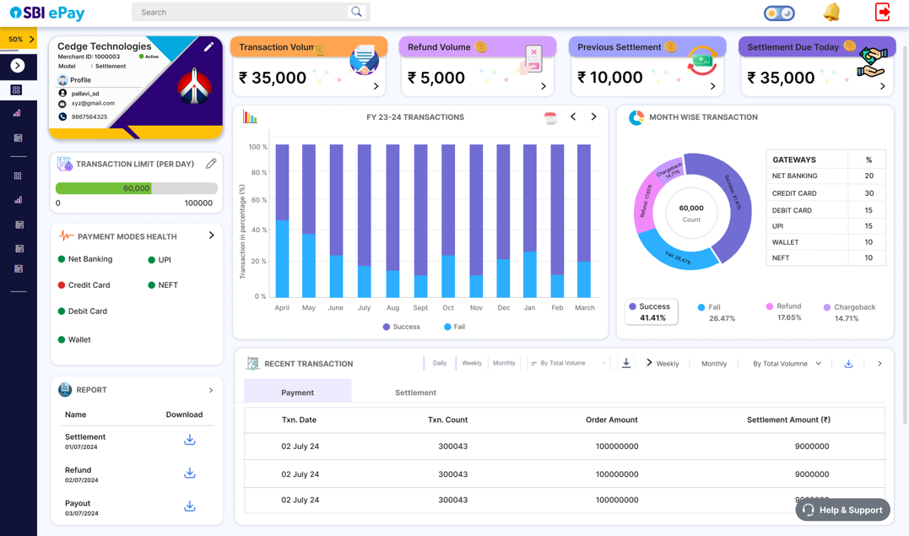

### 2.3 Functional Specification

#### 2.3.1- Overview of Merchant profile

##### 2.3.1.1 – Profile Details view

* + - * Display details like username, phone number, e-mail ID, merchant status (active/inactive)

##### 2.3.1.2 – Profile Details edit

* + - * Allow merchant to edit profile details like e-mail ID, phone number etc.
      * When user click on edit, It will lands to account & setting where he can change based the details.
      * Super user can change the user profile details and his profile details .

#### 2.3.2- Overview of transaction

##### 2.3.2.1 – Transaction summary for a Financial Year

* + - * Display a comprehensive month wise summary of all transactions, including successful and failed transactions.

##### 2.3.2.2 – Transaction analysis

* + - * Display a donut pie chart that visualizes the distribution of transaction types—Success, Failed, Refund, and Chargeback—along with their respective percentages.
      * For a selected transaction type, provide a segmented view of payment modes used in the transactions, each with their corresponding percentages.

##### 2.3.2.3 – Brief view

* + - * Display the transactions volume
      * Allow merchants to look into individual transactions for more brief information, including i.e. ATRN Number, Tx date, amount, payment method etc. and provide filter by frequency and volume.

#### 2.3.3 – Settlement overview

##### 2.3.3.1 – Settlement details

* Provide an overview of all settled transactions, pending settlements, and expected settlement amount.
* Provide ability to filter by frequency and volume

##### 2.3.3.2 – Previous Settlement

* Provide an overview of the previous settlement Amount

##### 2.3.3.3 – Current Settlement

* Provide an overview of the current settlement Amount

##### 2.3.3.4 – Historic settlement

* Provide detailed information about historic settlements

#### 2.3.4 – Refund management

##### 2.3.4.1 – Refund status

* Display the refunds volume – processed/pending

##### 2.3.4.2 – Refund processing

* Allow merchant to initiate and track refund requests in detail.

#### 2.3.5 – Transaction Limit

##### 2.3.5.1 – Current Limit

* Display the current exhausted transaction limit against the set limit for the merchant, including any thresholds for alerts
* If the limit reached, limit alert will be generated.
* Merchant can request to enhance the limit to SBI
* SBI ePay will check the request and reject or enhance the limit of merchant.
* Merchant limit are calculated on the basis of configuration done through SBI epay admin control panel while onboarding.

##### 2.3.5.2 – Limit alert

* Notify merchants via notification icon and notification on registered email ID and phone number when they are approaching (80%) and or have exceeded their transaction limits.

#### 2.3.6 – Payment mode health

##### 2.3.6.1 – Health status

* Monitor and display the health status of various payment modes (e.g., Credit Card, UPI, Net Banking) with metrics like uptime, downtime.
* If the payment mode is configured for downtime it will show in red mark otherwise it will be in green for uptime.

##### 2.3.6.2 – Issue Alerts

* Notify merchants of any issues or downtimes with specific payment modes.

##### 2.3.6.3 – Detail view

* Detail view for showing the health status of various payment modes and its channel partner with metrics like uptime, downtime and transaction success rates.

#### 2.3.7 – Reports

##### 2.3.7.1 – Quick report downloads

* Allow merchants to generate quick reports on transactions, settlements, refunds, and payout.
* If Merchant has scheduled the report, and report generated successfully merchant can download the report.
* As per LIFO mechanism last three scheduled reports will be displayed to user.
* If user have not scheduled any report, it shows blank.

##### 2.3.7.2 – Detail report

* Provide options for merchants to customize report criteria (e.g., date range, transaction type) and download them in various formats (e.g., csv,Excel).

#### 2.3.8- Validation

##### 2.3.8.1 – Role-Based Access

* + - * Restrict access to specific sections of the Dashboard to authorized users only.

### 2.4 - Non - Functional Specification

TBD

## FS_MS_3 – Merchant User Management

### 3.1 - Objective

To create, add Merchant Users and request for new merchant keys.

#### 3.1.1 - Merchant User Management

#### 3.1.2 - Merchant Key Management

### 3.2 - Functional Flow / Mockup

NA

### 3.3 Functional Specification

#### 3.3.1- Users

##### 3.3.1.1 - Create new Merchant User

* + - * **Merchant Group ID**
        + Merchant Group user ID will be created at the time of onboarding of merchant.
        + If merchant is registering the new MIF from merchant panel post login of group user ID, Merchant ID will be associated with that group user ID only.
        + Group user ID can be one for n number of merchant IDs.
        + Group user have an access to check all the merchant reports and details.
        + Group ID can access login for multiple super IDs but cannot delete or modify its details.
      * **Merchant Super User ID**
        + Merchant super user ID will be created at the time of onboarding of merchant, Merchant can login with provided email ID and password.
        + Login password will be notify to merchant once merchant ID is active at SBIePay end.
        + Merchant super ID is associated with merchant group ID.
        + Merchant super user have an access to create merchant user based on need.
        + Merchant user details will be captured while user creation.
        + Primary details will be Email, Phone Number. Post submitting the details merchant user will notified with registration and password email.
        + Merchant user ID password generation, regeneration and

Inactivation of user ID can be done by super user ID.

* + - * **Merchant User ID**
        + Merchant user ID can login through his secure credentials.
        + Once user is logged in, user can see the dashboard and reports.
        + User can use all the functionality available for that particular user.
        + Merchant user ID cannot create any new ID nor can modify any of the above mentioned IDs.

##### 3.3.1.2 - Disable a Merchant User

* + - * Merchant Group user id & Super user ID should be able to disable a Merchant user

##### 3.3.1.3 - Edit roles

##### 3.3.1.3.1 Merchant Users

* + - * + Merchant Group user ID

Merchant Group user ID will be able to access login and merchant dashboard functionality for all Super ID users mapped to it.

Merchant Group user ID cannot create new Super user ID but allows new MIF registration through it.

Will have access to generate all merchant Report or specific merchant (order/Transaction/refund/Chargeback) via Group Id report section in merchant panel dashboard

* + - * + Merchant Super ID

Merchant Super User ID will be able to create new Merchant user ID.

Merchant Super user ID will be able to access login and merchant dashboard functionality for all Merchant ID users mapped to it.

Will have access to Accounts and settings in merchant panel dashboard

* + - * + Merchant User ID

Merchant user ID cannot create any further user IDS.

Can access merchant panel functionality mapped to them.

Will not have access to Accounts and settings in merchant panel dashboard. Can view (graphs/reports etc) and download the reports.

*3.3.2- Keys*

3.3.2.1 - Request for Key Re-Generation

* + - * Merchant Group user ID & Super user ID
        + Merchant Group user ID can initiate a request for key regeneration (API access and encryption) via merchant dashboard.
        + This merchant encryption key will be available in PDF file.
        + Merchant key would be in encrypted format and KEK will be provided in plain text to merchant.
        + API Access Key and Secret Key will be in plain text and download in pdf file.
        + Merchant can regenerate the API access and encryption key.
        + While regenerating the API access key and encryption key merchant would have an option to expire the old key instant or within 24-48 hours.
        + If merchant opt the instant key expiry. Merchant need to change the key instantly at their end for transaction processing.
        + If merchant opt to expire the key post 24-48 hour. Merchant need to change the key within this time period.
      * Merchant user ID
        + Merchant user ID does not have access to key regeneration

### 3.4 - Non - Functional Specification

TBD

## FS_MS_4 – Settlement

### 4.1 – Objective

The Settlement module should provide merchants with a detailed overview and management capabilities for their settlement processes, including tracking settled amounts, pending settlements, and viewing settlement history.

#### 4.1.1 – Settlement Tracking

#### 4.1.2 – Settlement History

#### 4.1.3 – Settlement Alert

### 4.2 - Functional Flow / MockUp

NA

### 4.3 Functional Specification

#### 4.3.1- Settlement Overview

##### 4.3.1.1 – Real-Time Settlement Status

* + - * Display the current status of settlements, including settled amounts.

##### 4.3.1.2 – Summary Dashboard

* + - * A high-level view that provides an at-a-glance summary of settlement status, with quick links to more detailed views, provide filter by frequency and volume.

#### 4.3.2- Settlement History

##### 4.3.2.1 – Detailed Records

* + - * Maintain a comprehensive history of all settlements, including reference number/ATRN, settlement dates, amounts, and any associated notes or comments.

##### 4.3.2.2 – Filtering Options

* + - * Allow merchants to filter historical settlement data by date range, settlement id, or status.

##### 4.3.2.3 – Export Functionality

* + - * Enable merchants to export settlement history in various formats (e.g., CSV, XLS) for reporting.

#### 4.3.4- Settlement Alert

##### 4.3.4.2 – Automated Alerts

* + - * Notify merchants on merchant dashboard when a settlement process is completed for the current working day.

### 4.4 - Non - Functional Specification

TBD

## FS_MS_5 – Invoices

### 5.1 - Objective

View all invoices generated from the system to Merchant

#### 5.1.1 - Listing Invoices

* View all the invoices generated by system

### 5.2 - Functional Flow / Mockup

NA

### 5.3 Functional Specification

##### 5.3.1 – Detailed Records

* + - * Maintain a comprehensive history of all invoice, including transaction details, amounts, and status.

##### 5.3.2 – Filtering Options

* + - * Allow merchants to filter historical settlement data by date range and invoice id.

### 5.4 - Non - Functional Specification

TBD

## FS_MS_6 – Refunds

### 6.1 - Objective

Manage refunds initiated by different users

#### 6.1.1 - Refund Booking

#### 6.1.2 - View Refund Requests and its details

### 6.2 - Functional Flow / Mockup

6.2.1 Refund Booking

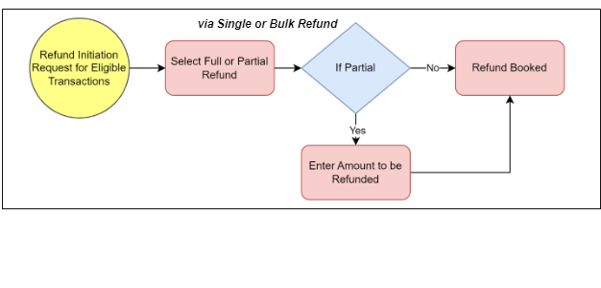

### 6.3 Functional Specification

#### 6.3.1 - Basic Validation Check

##### 6.3.1.1 - Refund Eligibility

* + - * Merchant can initiate a refund request through merchant panel.
      * Merchant can initiate refund as per payment channel refund window allowed in sbiepay

##### 6.3.1.2 - Refund Business Validation:

##### 6.3.1.2.1 Merchant Activation ;

##### This validation checks whether the merchant is active with SBI epay system.

##### 6.3.1.2.2 Transcation status :

##### This validation checks what is the current transaction status.

##### 6.3.1.2.3 Refunds eligibility window (in days) :

##### This validation checks the refund eligibility window i.e. the days till which refund can be raised.

##### 6.3.1.2.4 Chargeback ;

##### To check whether any chargeback is already raised (full or partial)

##### Refund will not be initiated if full chargeback is already raised for transaction order amount.

##### Partial Refund Will be initiated for available refund amount if partial chargeback is initiated.

* + **Process:**
* **Refund Initiation:** The merchant selects the transaction ATRN that is in the Settled status and submits a refund request through API & Merchant Panel(in transaction section, once clicked on ATRN a drawer will be displayed from right side which will display transaction details, status and Cancel/Refund button for selected ATRN) .
  + - **Validation:** The system validates that the ATRN meets the refund eligibility criteria as mentioned above. If it’s a partial refund, the system will additionally validate the amount available for the refund.
    - **Refund Processing:** Once validated, the system processes the refund request according to the merchant’s configured refund policies and workflows.
    - **Status Update:** The transaction status is updated to **Refund** once the refund process is initiated.
* **Cancellation Request**
  + Cancellation Request can be raised from merchant panel (in transaction section, once clicked on ATRN a drawer will be displayed from right side which will display transaction details, status and Cancel/Refund button for selected ATRN).
  + Eligibility Criteria:
    - A merchant can initiate a cancellation request if the ATRN is in the **Paid** status.
    - **Paid Status:** This indicates that the transaction has been processed and the payment captured, but it hasn't moved to settlement.
  + **Process:**
    - **Cancellation Initiation:** The merchant selects the transaction ATRN that is in the Paid status and submits a cancellation request.
    - **Validation:** The system checks if the ATRN meets the criteria for cancellation.
    - **Cancellation Processing:** Upon validation, the system processes the cancellation request.
    - **Status Update:** The transaction status is updated to **Cancelled** upon successful processing of the request.

### 6.4 - Non - Functional Specification

TBD

## FS_MS_7 – Merchant Key Management

### 7.1 - Objective

The Merchant Key Management module should provide merchants with a secure and efficient way to manage their API and Secret keys and other sensitive credentials required for their operations. This includes generating, revoking, and request new keys, ensuring that all key management activities are secure and logged.

#### 7.1.1 – Key Generation

#### 7.1.2 – Key Regeneration and Revocation

#### 7.1.3 – Key Download

#### 7.1.4 – Audit trial

### 7.1 - *Process*

* + - * Merchant Group user ID and super user ID can initiate a request for key generation and regeneration (API access and encryption) via merchant dashboard.
      * This merchant encryption key will be available in PDF file.
      * Merchant key would be in encrypted format and KEK will be provided in plain text to merchant.
      * API Access Key and Secret Key will be in plain text and download in pdf file.
        + Merchant can regenerate the API access and encryption key.
        + While regenerating the API access key and encryption key merchant would have an option to expire the old key instant or within 24-48 hours.
        + If merchant opt the instant key expiry. Merchant need to change the key instantly at their end for transaction processing.
        + If merchant opt to expire the key post 24-48 hour. Merchant need to change the key within this time period.

### 7.2 - Functional Flow / Mock Up

NA

### 7.3 Functional Specification

### 7.4 - Non - Functional Specification

TBD

## FS_MS_8 – Reports

### 8.1 - Objective

The Reports module should provide merchants with comprehensive and customizable reports on various aspects of their business, including Orders, Settlements, Transactions, Refunds, Bulk Refunds, Payments, and Chargebacks.

Specification for Merchant roles (e.g., Group user ID, Merchant User) have access to generate.

Group User ID can download the report based on merchant id or for all MID’s associated with them.

Super ID and user id can generate the report for their MID only. They have no option for filtering the MID

#### 8.1.1 – Order reports

#### 8.1.2 – Settlements reports

#### 8.1.3 – Transaction reports

#### 8.1.4 – Refund reports

#### 8.1.7 – Chargeback reports

### 8.2 - Functional Flow / Mock Up

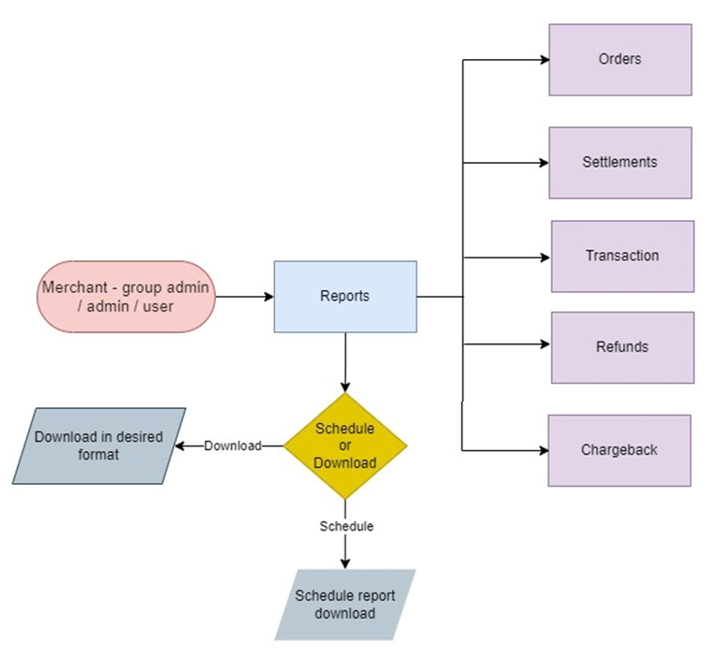

### 8.3 Functional Specification

* All reports mentioned below will be in CSV/excel/Txt format

#### 8.3.1- Order Reports

##### 8.3.1.1 – Detailed Breakdown

* + - * Include information such as order ID, date, amount, customer id, order status, and attempts.

##### 8.3.1.2 – Filtering Options

* + - * Allow merchants to filter orders by date range.
      * Merchant can select max date range till 30 days from the selecting day. If max day is minimum from current day it will allow to choose till current day only.

##### 8.3.1.3 – Sample report – Report will be available in csv , txt and .xls format.

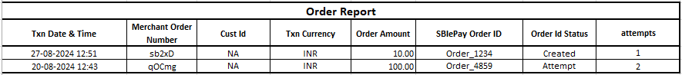

##### 

#### 8.3.2- Settlements Reports

##### 8.3.2.1 – Settlement Summary

* + - * Display detailed list of settled transactions, amounts, id, and settlement dates with transaction details.

##### 8.3.2.3 – Historical Data

* + - * Allow access to historical settlement data with filtering options by date range.
      * Merchant can select max date range till 30 days from the selecting day. If max day is minimum from current day it will allow to choose till current day only.

##### 8.3.2.3 – Sample Report - Report will be available in csv,txt and .xls format.



#### 8.3.3- Transactions Report

##### 8.3.3.1 – Transaction Overview

* + - * Provide a comprehensive list of all transactions, including transaction ID, date, amount, and status (successful, pending, and failed).

##### 8.3.3.2 – Detailed Insights

* + - * Drill down into specific transactions for more detailed information, including payment method and customer details.

##### 8.3.3.3 – Real-Time Data

* + - * Allow access to transaction data with filtering options by date range.
      * Merchant can select max date range till 30 days from the selecting day. If max day is minimum from current day it will allow to choose till current day only.

##### 8.3.3.4 – Transaction Report - Report will be available in csv, txt and .xls format.

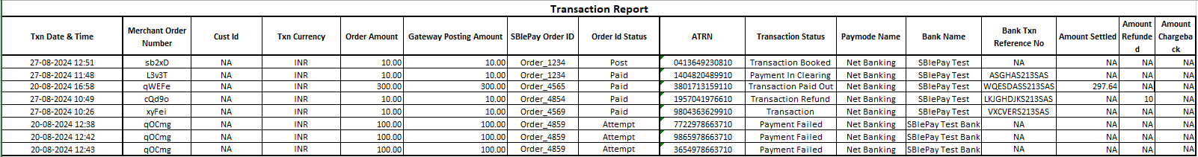

#### 8.3.4- Refunds Report

##### 8.3.4.1 – Refund Status

* + - * Show the status of all refunds, including processed, pending, and disputed refunds.

##### 8.3.4.2 – Refund Details

* + - * Include refund type, refund ID, transaction ID & details, refund amount, date, and reason for the refund.

##### 8.3.4.3 – Dispute Management

* + - * Provide tools to track and manage refund disputes, with notes on resolution status.

##### 8.3.4.4 – Historical Data

* + - * Allow access to refund transaction data with filtering options by date range.
      * Merchant can select max date range till 30 days from the selecting day. If max day is minimum from current day it will allow to choose till current day only.

##### 8.3.4.5 Sample Report - Report will be available in csv,txt and .xls format.



#### 

#### 8.3.6- Chargeback Report

##### 8.3.6.1 – Chargeback Details

* + - * Provide detailed information on chargebacks, including chargeback ID, transaction ID & Details, chargeback amount, date, and reason.

##### 8.3.6.2 – Chargeback Status

* + - * Track the status of each chargeback (e.g., initiated, under review, resolved) and include notes on resolution.

##### 8.3.6.3 – Dispute Tracking

* + - * Include tools for managing and resolving chargeback disputes, with a clear audit trail of actions taken.

##### 8.3.6.3 – Historical Data

* + - * Allow access to refund transaction data with filtering options by date range.
      * Merchant can select max date range till 30 days from the selecting day. If max day is minimum from current day it will allow to choose till current day only.

##### 8.3.6.4 - Sample Report - Report will be available in csv,txt and .xls format.



#### 8.3.7- Validation

##### 8.3.7.1 – Data Integrity

* + - * Validate the accuracy of all data included in reports, ensuring it reflects the latest updates and transactions.

##### 8.3.7.2 – Role-Based Access

* + - * Ensure that only authorized users can generate and view specific report.

#### 8.3.8- Scheduling

##### 8.3.8.1 – Schedules

* + - * Enable merchants to schedule the report download in multiple formats (e.g., CSV,TXT, XLS) for further analysis.
      * Merchant can schedule the report on daily or monthly basis only.
      * Merchant can select the time of schedule. Report will be generated at that time only.
      * Merchant can see schedule status is running or stop or deleted.
      * Merchant can edit or delete the schedule.
      * Deleted schedule cannot be edit or update, merchant can configure new schedules.

##### 8.3.8.2 – Notifications

* + - * Notify merchants in merchant panel notify icon when new reports are available or when a scheduled report has been generated.

### 8.4 - Non - Functional Specification

TBD

## FS_MS_9 – Account & Settings

### 9.1 – User profile change

* This option allows user to edit their user email ID, mobile number, username and password.
* Once user will modify the email, mobile number and username, Authentication with mobile OTP will be in place.
* Once OTP is triggered, a timer of 60 seconds will be initiated, along with a disabled ‘Resend OTP’ button. The button will be enabled after the timer is lapsed.

### 9.2 – User management

* Merchant Group user ID
  + Merchant Group user ID will be able to access login and merchant dashboard functionality for all Super ID users mapped to it.
  + Merchant Group user ID can fill new MIF registration through for creation of sub MID.
  + Will have access to partner Settings and individual MID Accounts and settings in merchant panel dashboard.
* Merchant Super ID
  + Merchant Super User ID will be able to create new Merchant user ID.
  + Merchant Super user ID will be able to access login and merchant dashboard functionality for all Merchant ID users mapped to it.
  + Will have access to Accounts and settings in merchant panel dashboard
* Merchant User ID
  + Merchant user ID cannot create any further user IDS.
  + Can access merchant panel functionality mapped to them.
  + Will not have access to Accounts and settings in merchant panel dashboard. Can view (graphs/reports etc) and download the reports.
* Unlock User
  + Super admin user will be able to unlock the merchant user id in case it is locked (for example in case if incorrect password attempted for three times user id gets locked)
* Activate User
  + Super admin user will be able to activate the merchant user id in case it is deactivated (for example in case if user ID validity date and time is expired)
* Delete user
  + Super admin user will be able to delete any merchant user id which has been created by this super user ID.
* Regenerate User password
  + Super admin user can regenerate the password of any merchant user id which has been created by this super user ID.

### 9.3 – Transaction limit change

* Merchant user with an access to edit transaction limit can place request to change the volume velocity limit for frequencies such as daily, weekly, monthly, quarterly, half yearly and yearly.
* This request will be processed by SBI ePay admin user.
* The requests pending for action will be displayed as pending.

### 9.4 – Bank account maintenance

* User can add a new bank account, edit/deactivate an existing bank account using this option. Status will be display as pending.
* Once new/updated bank account request is generated, Admin approval is required.
* Once Admin approved the bank account request, the same will be display to merchant that account request is approved.
* This option also allows user to make a bank account as their primary bank account.

### 9.5 – Key Management

* Merchant Group user ID and super user ID can initiate a request for key generation and regeneration (API access and encryption) via merchant dashboard.
* This merchant encryption key will be available in PDF file.
* Merchant key would be in encrypted format and KEK will be provided in plain text to merchant.
* API Access Key and Secret Key will be in plain text and download in pdf file.
* Merchant can regenerate the API access and encryption key.
* While regenerating the API access key and encryption key merchant would have an option to expire the old key instant or within 24-48 hours.
* If merchant opt the instant key expiry. Merchant need to change the key instantly at their end for transaction processing.
* If merchant opt to expire the key post 24-48 hour. Merchant need to change the key within this time period.