

DEVOPS CI/CD Document
APRIL 2025

Document Control Sheet
Current Version | 0.1
Project Code | NS_SBI_04_08_2024
Project Name | SBI ePay 3.0
Document Type | ePay DevOps
Author | Namdev Anantrao Gadve
First Reviewed By
Final Reviewed By
Approved By
Contact Person | Namdev Anantrao Gadve
Frequency of Document Review | Next Revision of Standard Documents
Document Creation Date | 01-11-2024
Last Updated Date | 15-11-2024

Revision History
Version | Date | Name | Comments
0.1
0.2

Table of Contents
1. Document Purpose 4
1.1 Terms and Definitions 4
2. GitLab CI/CD Pipeline 4
2.1 Version Operation – Managing Pre-Release Versions 5
2.2 Build Operation – Automated Build Pipeline 5
2.3 Test Operation – Automated Testing 7
2.4 SAST Operation 8
2.4.1 Advanced SAST Operations 9
2.4.2 GitLab Semgrep SAST Operations 9
2.5 Fortify Operation 9
2.6 Docker Operation – Building and Managing Docker Images 11
2.6.1 GitLab Commit Operation 12
2.7 Deployment Operation 12
2.8 Helm Deployment Operation 13

Document Purpose
The purpose of this document is to help the DevOps team understand and manage different stages of development and deployment using GitLab.
GitLab utilizes the following branch structure:
- Main Branch: Represents the stable, production-ready version of the application
- Develop Branch: The ongoing development branch, where features and bug fixes are integrated before they are released
- Feature/Hotfix Branches: Short-lived branches dedicated to individual features or bug fixes
- Pre-Release Branch (optional): A staging area for testing, pre-versions before production.

1.1 Terms and Definitions
Terms | Definitions
CI/CD | Continuous Integration/Continuous Delivery
SAST | Static Analysis Security Testing
XSS | Cross Site Scripting

GitLab CI/CD Pipeline
GitLab has the following stages in the CI/CD pipeline:
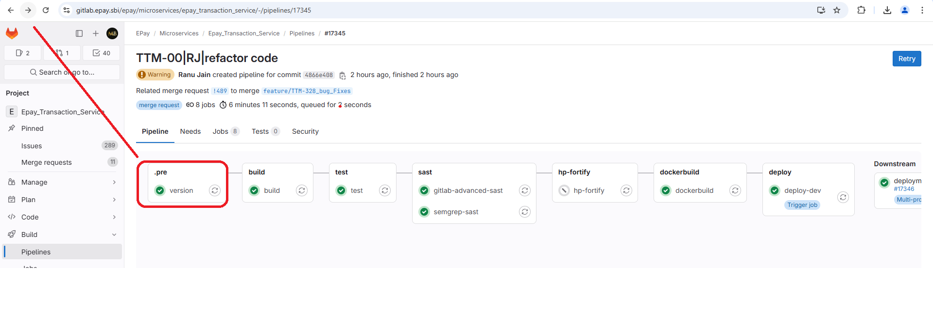
Note: You must have a valid login credentials to access the GitLab pipeline.

2.1 Version Operation – Managing Pre-Release Versions
Version stage in GitLab is commonly associated with managing versions of git commit. These versions are typically meant for testing, quality assurance, or beta releases before the final production-ready version is tagged and deployed.
To manage versions:
- Retrieve all the tags from GitLab. This is particularly useful when new tags are created in gitlab.
- Use the following command:
$ git fetch --tags
$ git tag –sort=-v:refname | head -n 1
$ if [[ "$CI_COMMIT_BRANCH" =~ ^(main|develop|release/.+)$ ]]; then
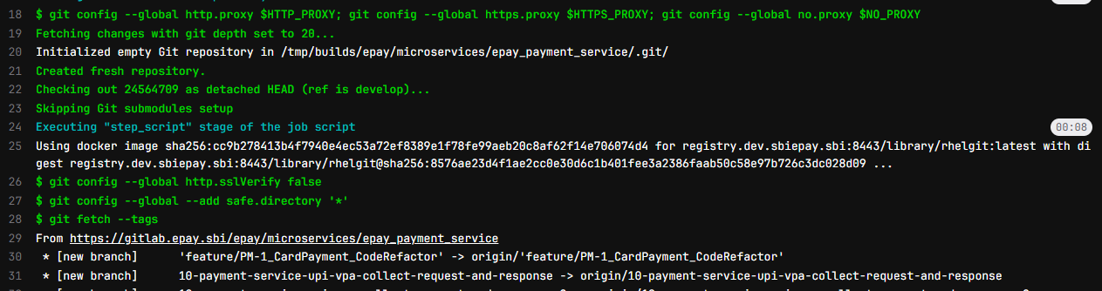
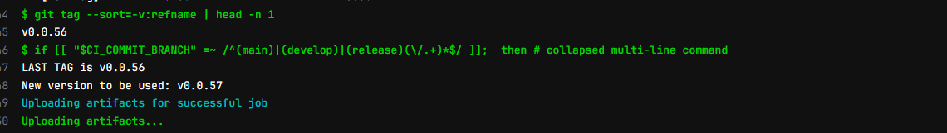
Note: git fetch --tags is used for the following reasons:
- Synchronizing Tags: Fetches tags created in the remote repository
- CI/CD Automation: Ensures that the latest release tag is available before automating builds or deployments
- Version Control: Helps in maintaining and tracking specific versions

2.2 Build Operation – Automated Build Pipeline
A GitLab build workflow involves automating the process of compiling, testing, and packaging your code into a deliverable artifact including Docker image, executable binary, or package through GitLab CI/CD.
To build a workflow:
- Push changes to your respective branches.
Note: GitLab triggers the pipeline automatically based on.gitlab-ci.yml
- Do the following tasks:
  - Install all the dependencies
  - Compile code
  - Execute tests
  - Generate build artifacts
- Ensure the build is successful and passes the automated tests.
- (Optional) deploy to a staging environment.
- Store the build artifacts for future use.
Example:
$ pwd
$ ls -la
$ if [ -n "$VERSION" ]; then # collapsed multi-line command
$ ls -lrth build/libs
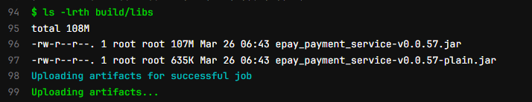

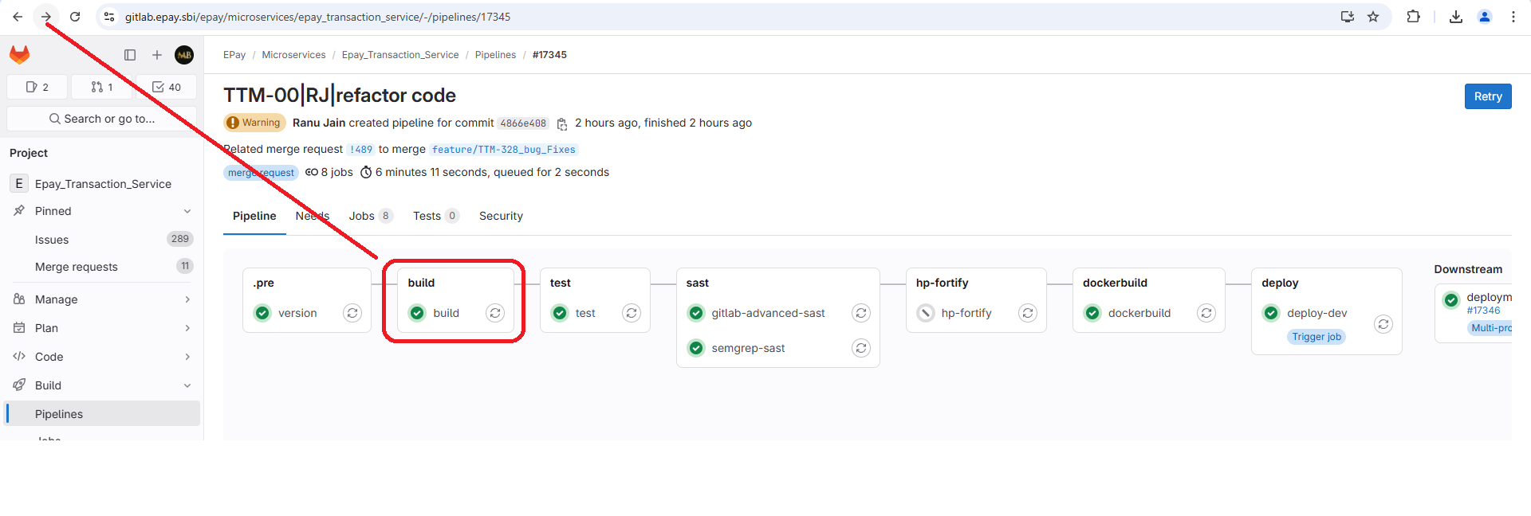
2.3 Test Operation – Automated Testing
A GitLab test workflow is focused on automating the process of running tests i.e., unit tests, integration tests, linting, etc. as part of the continuous integration (CI) pipeline in GitLab. It ensures that changes to the code base do not break the functionality and meet the quality standards before getting merged into production.
To do automated testing:
- Push changes to your respective branches.
Note: GitLab triggers the pipeline.
- Do the following tasks:
  - Run unit tests, integration tests, and linting
  - Validate code quality using testing frameworks
Note: Feedback is provided based on the test results.
Example:
$ pwd
$ ls -lrth
$ gradle test
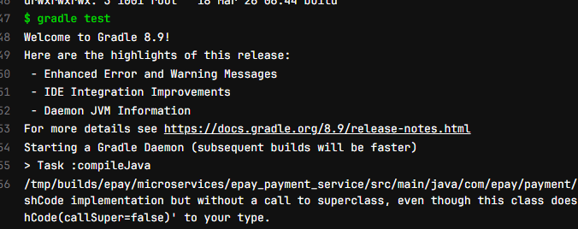

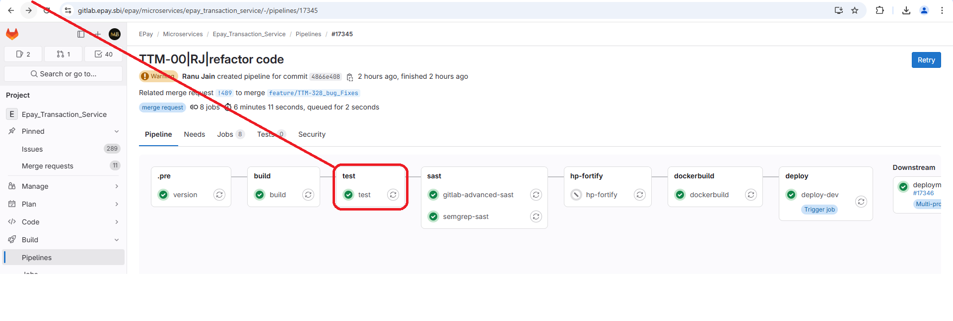
2.4 SAST Operation
Static Analysis Security Testing (SAST) helps you in automatically scan the code base for security vulnerabilities without running the application. It performs static analysis on your source code, identifying security issues such as SQL injection, XSS (cross-site scripting), and insecure dependencies, among others. SAST is a security scanning operation that detects vulnerabilities early in the development process.
To do SAST operation:
- Scan the source code for vulnerabilities such as SQL injection and XSS.
- SAST runs automatically as part of the CI/CD pipeline.
- GitLab provides detailed report on security issues.
Example:
$ /analyzer run
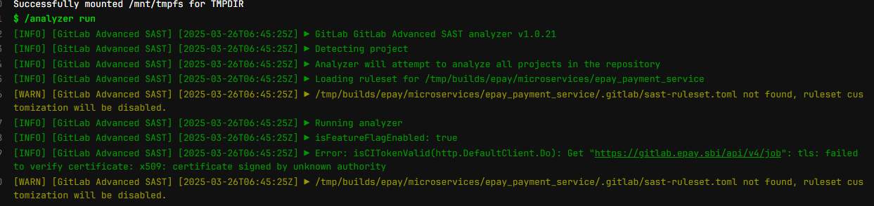

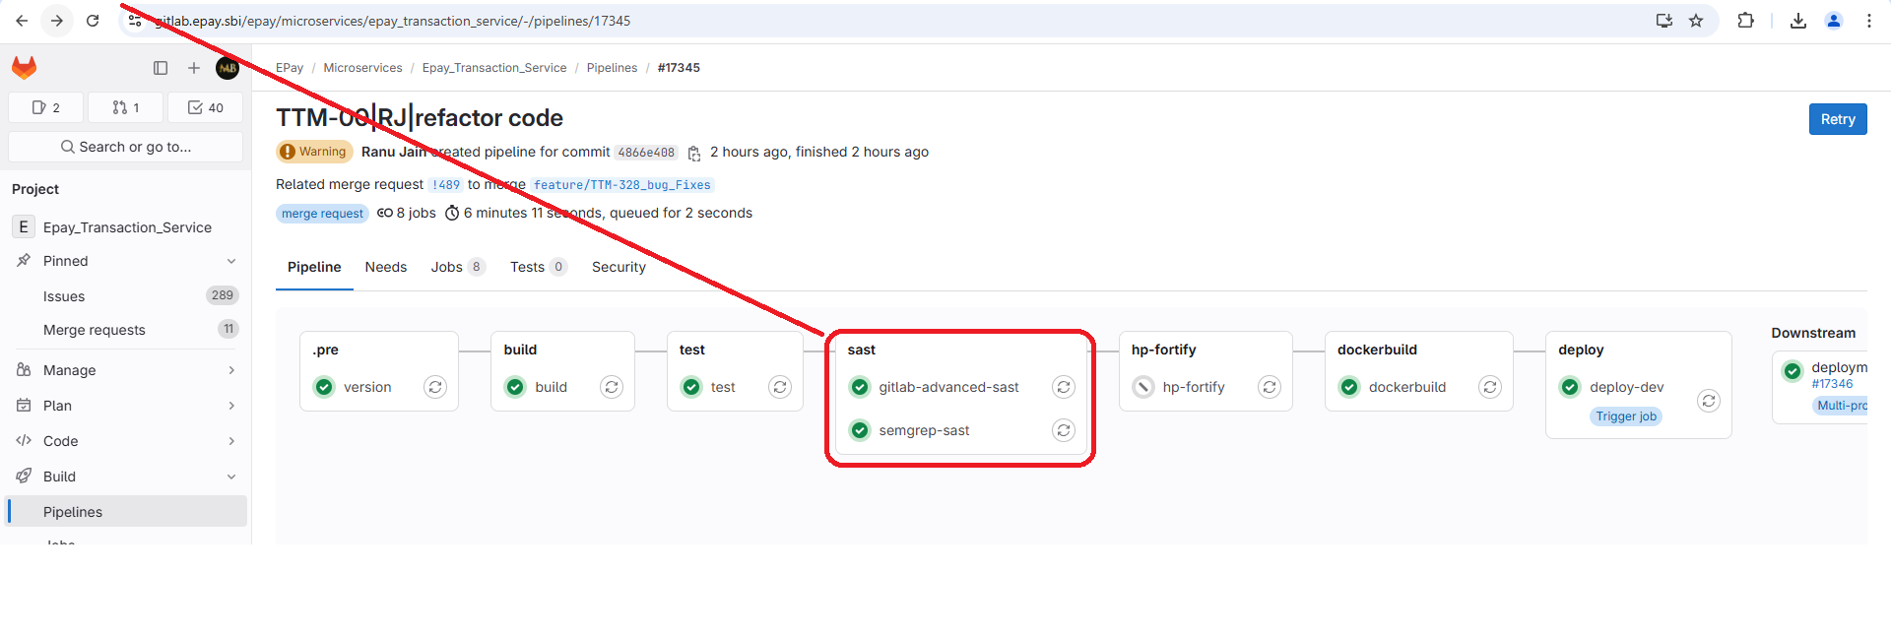
2.4.1 Advanced SAST Operations
GitLab Advanced SAST enhances the basic security scan by integrating third-party tools and providing customized rules and better coverage.
To do advanced SAST operation:
- Perform the advanced tool integration.
- Do the vulnerability reporting.

2.4.2 GitLab Semgrep SAST Operations
Semgrep is an open-source static analysis tool used for security scanning, bugs, and pattern detection in code.
To do semgrep SAST operation:
- Ensure that the source code and Semgrep rules are defined.
- Configure .gitlab-ci.yml to integrate Semgrep.
- Execute Semgrep scans on code.

2.5 Fortify Operation
The Fortify SAST solution scans the source code for known vulnerabilities such as SQL injection, cross-site scripting, insecure deserialization and security risks, providing a comprehensive report that helps identify and address issues early in the development process.
Fortify performs in-depth static analysis to detect vulnerabilities in code. This operation integrates Fortify’s scanning within the GitLab CI/CD pipeline.
To do fortify operation:
- Ensure that the source code and Fortify credentials are available.
- Run Fortify scans as part of the pipeline.
- Generate vulnerability reports.
Example:
$ $SOURCE_ANALYZER -b $FORTIFY_PROJECT -clean
$ $SOURCE_ANALYZER -b $FORTIFY_PROJECT "./" -verbose -exclude "${EXCLUDE_FILES}"

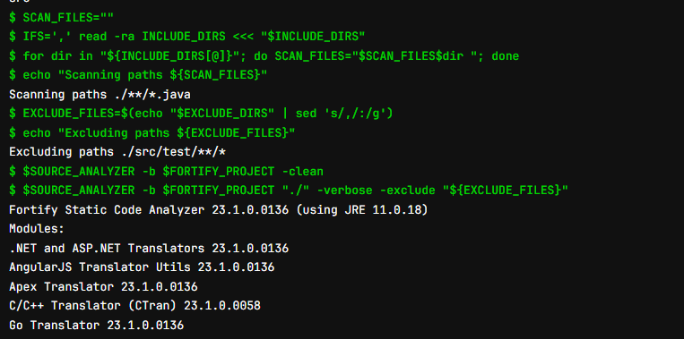

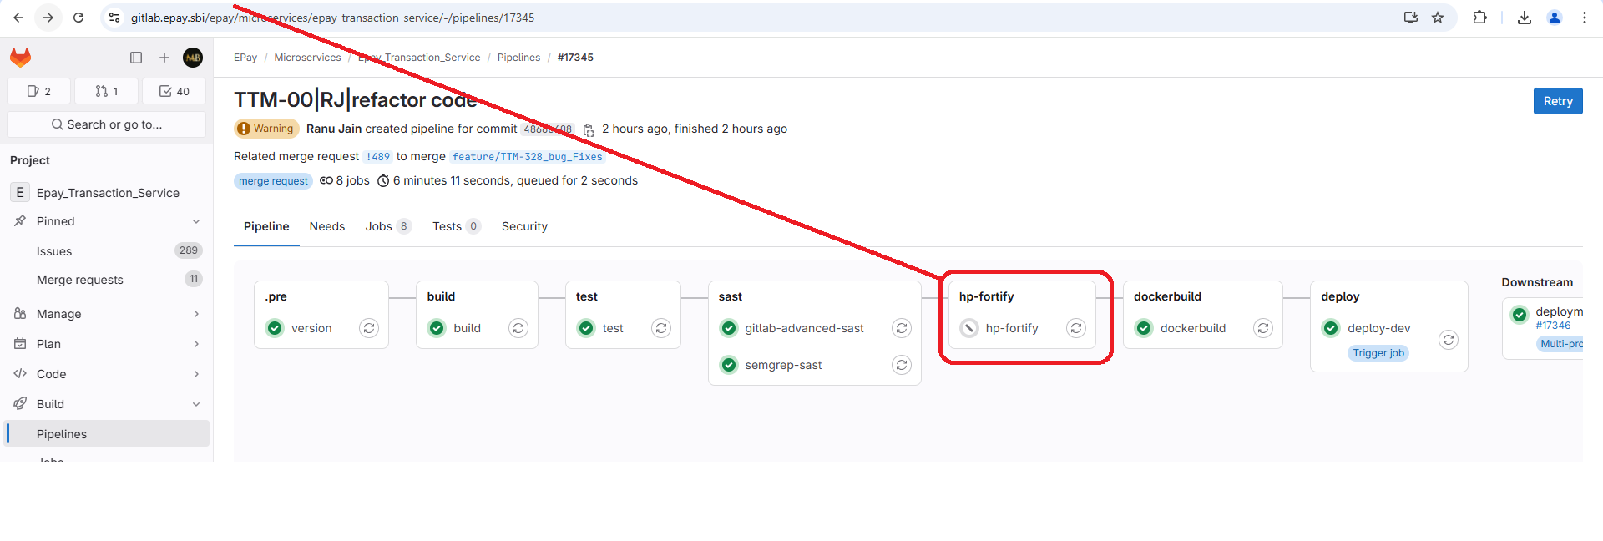
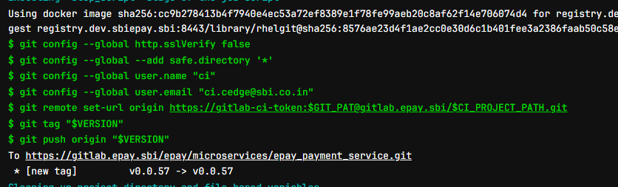
2.6 Docker Operation – Building and Managing Docker Images
The Docker build operation automates the creation, testing, and deployment of Docker images.
To build docker:
- Ensure that the repository includes source code and Docker file.
- Define jobs in .gitlab-ci.yml for building and tagging Docker images.
- Build the Docker image based on the Docker file.
- Push the built Docker image to a container registry.
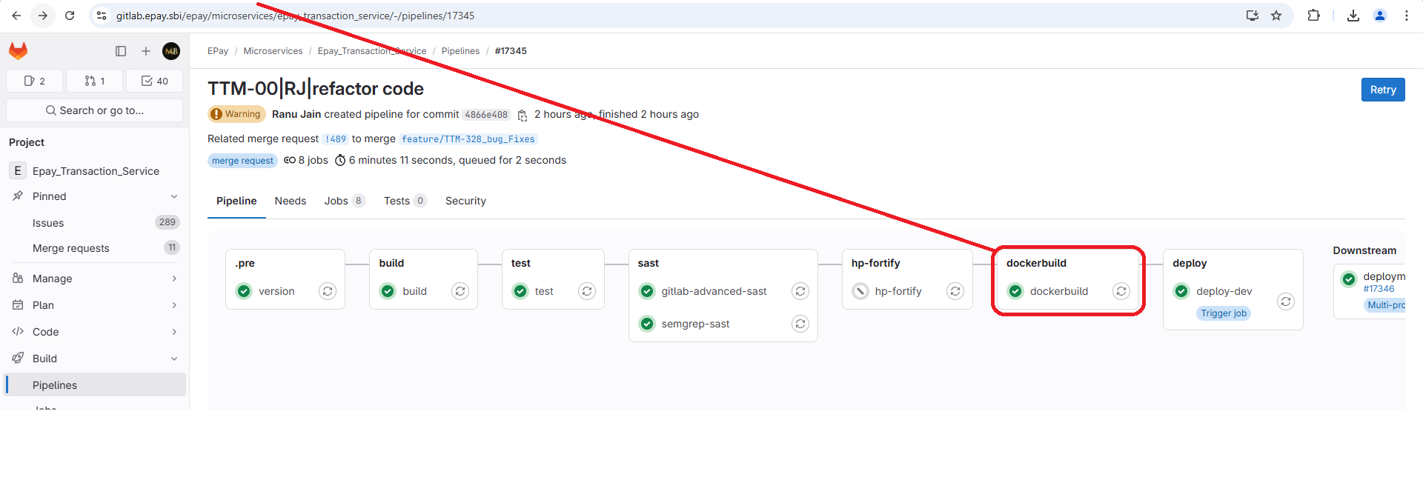

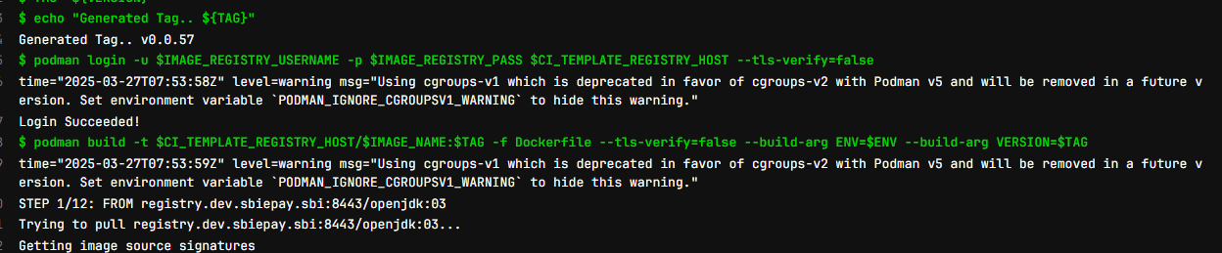
2.6.1 GitLab Commit Operation
The GitLab commit operation governs the entire commit process, automates build, test, and deployment tasks.
To commit code:
- Commit code locally and push it to GitLab.
Note: Pipeline is initiated automatically.
- Define jobs in .gitlab-ci.yml for building and tagging Docker images.
- Review and test the code.
- Merge and commit the code.

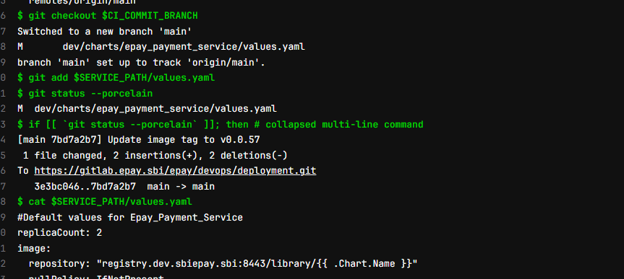
2.7 Deployment Operation
The GitLab commit workflow refers to a series of actions and processes that occur when a developer makes a commit in the GitLab repository. This workflow is central to the software development life cycle and is tightly integrated with GitLab's Continuous Integration/Continuous Deployment (CI/CD) pipeline. It automates key processes including testing, building, linting, and deploying code to ensure an optimum code quality and faster delivery.
The GitLab deployment operation automates the process of moving code to various environments.
To deploy code:
- Push changes to the repository.
Note: The pipeline is triggered to build, test, and deploy.
- Deploy the application to a staging environment.
- Deploy the application to production after approval.
- Monitor application health post-deployment.

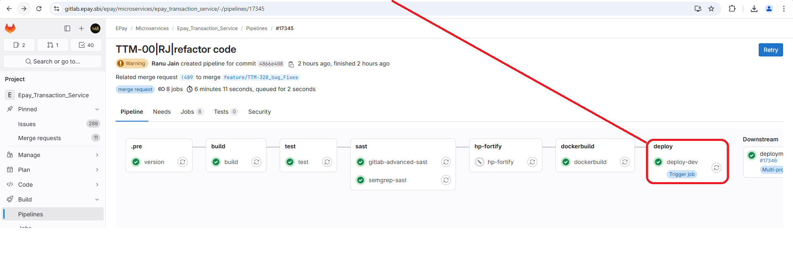

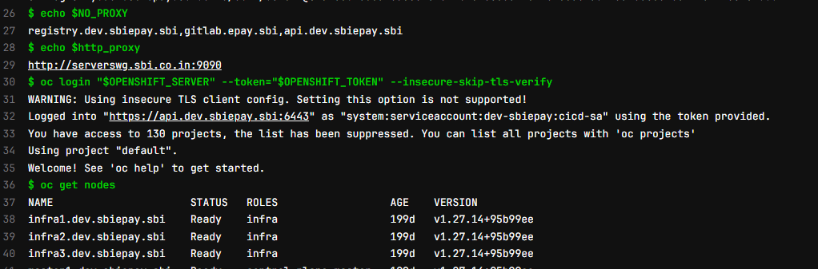
2.8 Helm Deployment Operation
Helm deploys applications to Kubernetes clusters and the Helm Deployment operation integrates Helm into GitLab for the automated Kubernetes deployments.
Helm charts are a collection of files that describe a Kubernetes application, making it easier for the package and deploy applications to Kubernetes clusters. By integrating Helm with GitLab CI/CD, you can ensure that your applications are deployed automatically whenever changes are made to the code base or configuration.
To do helm deployment:
- Repository setup - Store Helm chart files and Kubernetes configuration.
- CI/CD pipeline configuration - Define jobs in .gitlab-ci.yml to deploy via Helm.
- Helm chart build - Build the Helm chart to deploy the application.
- Helm deployment - Deploy the application to a Kubernetes cluster using Helm.

