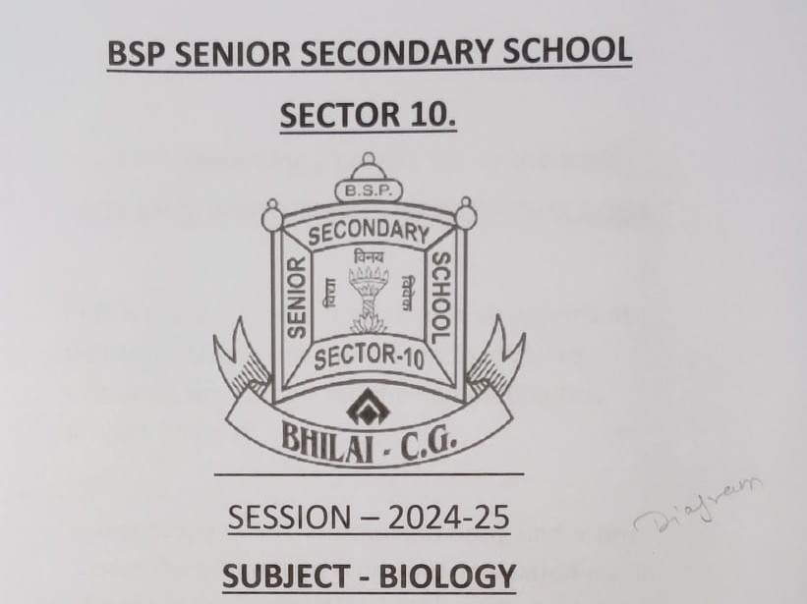
TOPIC – “PLANT KINGDOM”
Guided by- Submitted by-
Mr.A.K.Tiwari Shivaansh Dewangan
Roll no: 11633
Class/ sec: 11/F

